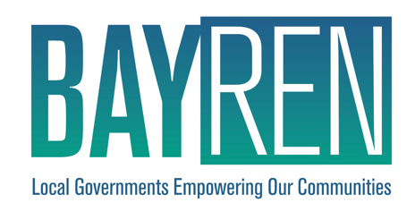

Bay Area Regional Energy Network (BayREN)

Targeted Decarbonization Services

Implementation Plan

PY2024 - 2027

October 2024

THIS PAGE INTENTIONALLY LEFT BLANK

**Contents**

Program Overview 3

Program Budget and Savings Information 3

Implementation Plan Narrative 5

1. Program Description 5

2. Program Delivery and Customer Services 6

Customers 6

Marketing and Outreach 6

Decarbonization Showcase Services 7

Decarbonization Education and Financing Services 7

3. Program Design and Best Practices 9

4. Innovation 11

5. Metrics 11

6. For Programs Claiming To-Code Savings 11

7. Pilots 11

8. Workforce Education and Training 12

9. Workforce Standards 12

10. Disadvantaged Worker Plan 12

11. Market Access Programs 12

12. Additional information 12

Supporting Documents 13

1. Program Manuals and Program Rules 13

2. Program Theory and Program Logic Model 13

3. Process Flow Chart 14

4. Incentive Tables, Workpapers, Software Tools 14

5. Quantitative Program Targets 14

6. Diagram of Program 15

7. Program Measurement & Verification (M&V) 15

8. Normalized Metered Energy Consumption (NMEC) 16

# Program Overview

The Bay Area Regional Energy Network’s (BayREN) Public Sector Targeted Decarbonization Services (TDS) Program will provide technical and financial support to local governments and special districts to advance the deployment of technologies and strategies needed to achieve building decarbonization. The program will implement a Decarbonization Showcase service to demonstrate approaches to building decarbonization in different public buildings throughout the Bay Area, gathering and sharing real-world data to support the broader adoption of these approaches across the region. The program will also include a Decarbonization Education and Financing service to educate local government staff about decarbonization technologies and financing, while exploring funding opportunities and incentive structures to support the widespread adoption of these solutions in the public sector. BayREN has designed its public sector offerings to strengthen the market for decarbonization equipment and demonstrate the feasibility of transitioning to low-carbon technologies in public buildings.

# Program Budget and Savings Information

1. Program and/or Sub-Program Name: **Targeted Decarbonization Services**

2. Program / Sub-Program ID number: **BayREN12**

3. Program / Sub-program Budget Table:

|  |  |  |  |  |  |
| --- | --- | --- | --- | --- | --- |
|  | **2024** | **2025** | **2026** | **2027** | **TOTALS** |
| **Administration** | $75,249.00 | $110,193.00 | $100,902.40 | $102,919.40 | $389,263.80 |
| **Implementation** | $562,044.00 | $668,654.00 | $815,533.00 | $1,044,360.00 | $3,090,591.00 |
| **Marketing** | $117,009.00 | $124,101.00 | $126,966.05 | $131,120.00 | $499,196.05 |
| **Incentives** | $0 | $246,488.00 | $490,655.00 | $490,655.00 | $1,227,798.00 |
| **TOTALS** | $754,302.00 | $1,149,436.00 | $1,534,056.45 | $1,769,054.40 | $5,206,848.85 |

4. Program / Sub-program Gross Impacts Table:

|  |  |  |  |  |  |  |  |  |  |  |  |  |
| --- | --- | --- | --- | --- | --- | --- | --- | --- | --- | --- | --- | --- |
| **PY** | **Total System Benefit** | **TRC** | **PAC** | **TRC (no admin)** | **PAC (no admin)** | **RIM** | **Gross kWh** | **Gross kW** | **Gross Therm** | **Net kWh** | **Net kW** | **Net Therm** |
| 2024 | N/A | N/A | N/A | N/A | N/A | N/A | N/A | N/A | N/A | N/A | N/A | N/A |
| 2025 | N/A | N/A | N/A | N/A | N/A | N/A | N/A | N/A | N/A | N/A | N/A | N/A |
| 2026 | N/A | N/A | N/A | N/A | N/A | N/A | N/A | N/A | N/A | N/A | N/A | N/A |
| 2027 | N/A | N/A | N/A | N/A | N/A | N/A | N/A | N/A | N/A | N/A | N/A | N/A |

*This program is not currently claiming energy savings.

5. Program / Sub-Program Cost Effectiveness (TRC): **N/A**

6. Program / Sub-Program Cost Effectiveness (PAC): **N/A**

7. Type of Program / Sub-Program Implementer (PA-delivered, third party-delivered or Partnership): **PA-delivered. Consultants will be hired for different services of the TDS Program, as appropriate, during program development. Additional consultants may be hired, as necessary, to support these services.**

* ***Portfolio Administrator: BayREN[1]***
* ***Program-Wide Administration, Data and Outreach: Frontier Energy***
* ***Decarbonization Education and Financing, training management and instruction components: Frontier Energy***
* ***Decarbonization Showcase management: The Energy Coalition***

***Program Implementer Type (IOU Core, Third-Party Solicited, REN/CCA): REN***

***Portfolio Segment (Resource Acquisition, Equity, Market Support, or Codes and Standards): Market Support***

8. Market Sector(s) (i.e., residential, commercial, industrial, agricultural, public): **Public Sector – Local Governments and Special Districts**

9. Program / Sub-program Type (i.e., Non-resource, Resource): **Non-resource**

10. Market channel(s) (i.e., downstream, midstream, and/or upstream) and Intervention Strategies (e.g. direct install, incentive, finance, audit, technical assistance, etc.), campaign goals and timeline.

* **Market channel: Downstream**
* **Intervention Strategies: Technical Assistance, Incentive**
* ***M&V Methods (e.g., Deemed, Custom, NMEC – Population, NMEC – Site, SEM, M&V, RCT, Other): M&V***

***Table 1. Campaign Timeline***

|  |  |  |
| --- | --- | --- |
| Phase | Key Deliverables | Dates |
| Launch Readiness | * Program design * Identify implementers * Implementation Plan * Program marketing materials | Q2–Q4 2024 |
| Program Ramp Up | * Program launch to customers for education and showcase components * Marketing and outreach * Program deliverable development | Q4 2024 – Q2 2025 |
| Program Steady State | * Program deliverable implementation for education and showcase * Program launch to customers and implementation for financing component | Q1 2025 – Q2 2027 |
| Program Ramp Down | * Program ramp down plan, as appropriate | Q3-Q4 2027 |

# Implementation Plan Narrative

## Program Description

The goal of the Targeted Decarbonization Services (TDS) program is to support local governments in efforts to advance the deployment of technologies and strategies needed to achieve building decarbonization. Building decarbonization, which includes energy efficiency, fuel-substitution, on-site renewable energy generation plus storage, grid integration and an aggressive Renewable Portfolio Standard (RPS), has emerged as a leading strategy to achieve deep greenhouse gas (GHG) reductions. In response to the climate crisis, the State has been quick to adopt building decarbonization policies to accelerate the transition to clean electric technologies, including SB 350, AB 3232, SB 1477, and CPUC Decisions 19-08-009 and 20-03-027.

Local governments and special districts are uniquely positioned to advance the State’s goals. Here in the Bay Area, many local governments and special districts have aggressive climate action goals while also managing significant portfolios of buildings. However, achieving these goals requires knowledge and financing that is not readily available.

The Market Support program addresses several barriers to Public Sector engagement. Notably, local government staff are often hesitant to commit to alternative systems without clear evidence of technical and financial performance supporting the proposed changes. Additionally, many staff are less familiar with decarbonization technologies, which often come with higher first costs. The program aims to overcome these challenges by providing the necessary support and resources.

The program consists of two subprograms: Decarbonization Showcase and Decarbonization Education and Financing.

#### Decarbonization Showcase

The Decarbonization Showcase subprogram will pilot and demonstrate various approaches to building decarbonization by enrolling selected buildings and collecting real-world data throughout the process. The subprogram will provide technical and financial support for the development of selected projects, prioritizing those that serve equity priority communities. Data will be gathered throughout the design, construction and operations of the buildings and shared across the public agencies in the BayREN services area, with the intent of scaling the approaches across the region. This information will be shared through case studies, peer network calls and webinars. The Showcase data will also be used to assess existing metrics and develop new ones as appropriate to communicate the full range of impacts that can result from building decarbonization projects.

#### Decarbonization Education and Financing

The Decarbonization Education and Financing subprogram will engage local government staff to familiarize them with daily operations and the long-term maintenance and outlook of decarbonization equipment and educate staff about strategies for monetizing improvements to secure financing. The subprogram will document and provide information on incentives and funding for decarbonization technologies, seek additional non-ratepayer funding, and design and test effective incentive structures to promote widespread adoption of these technologies, which could potentially lead to the proposal of a new resource acquisition program serving the public sector.

These subprograms are designed to expand the market for and the implementation of building decarbonization. To achieve these goals, the TDS program focuses on the following objectives:

1. Enable local governments to access the information and existing resources they need to implement projects.
2. Ensure local governments have the knowledge and support they need to develop and implement projects to improve the energy systems of their buildings.
3. Improve the financial viability of advanced decarbonization technologies.

## Program Delivery and Customer Services

### Customers

The program will primarily target local governments, with a particular focus on staff responsible for sustainability, resilience, and capital projects. Secondary targets will include local government special districts, such as regional parks agencies or agencies created by local governments. There are 109 local governments (cities and counties) and 419 special districts[2] in the Bay Area, covering 20% of California’s total population.

### Marketing and Outreach

BayREN marketing and outreach includes both local and regional activities. BayREN member counties serve as trusted messengers and are responsible for creating localized marketing plans that address the characteristics and needs of their communities. County representatives will be responsible for marketing directly to their local cities. County outreach strategies may include direct contacts with city and county staff, announcements and presentations at relevant meetings, social media posts, and other approaches as appropriate.

BayREN will also carry out complementary regional marketing for the program. This will include social media posts, regional email outreach, and announcements and presentations at regional meetings including BayREN’s Codes & Standards Program’s quarterly Forums.

BayREN’s Integrated Energy Services program may also refer projects to the TDS program if appropriate.

The Decarbonization Showcase service will prioritize facilities that serve equity priority communities, based on either facility type or geographic location. At the same time, the Showcase will aim to include a variety of types of projects, so that case studies can be prepared for a variety of different building types. The criteria for identifying projects and the process for giving them priority will be developed as part of the program launch activities.

### Decarbonization Showcase Services

The Decarbonization Showcase subprogram will include the following activities and services:

* **Regional and County Specific Marketing and Outreach:** BayREN marketing and outreach includes both local and regional activities, as described above.
* **Select candidate projects.**  Develop criteria and solicit projects for the Showcase.
* **Support project implementation**. Provide technical and financial assistance for the implementation of projects that innovate with high-impact technologies and applications.
* **Produce recommended metrics**. Decarbonization technologies may require different metrics to demonstrate their value. BayREN will use the Showcase projects to develop recommended metrics that can be used to compare leading edge solutions to each other and to more traditional approaches.
* **Prepare case studies**. Prepare case studies to provide specific real-world examples of the use of decarbonization technologies and increase staff knowledge of these technologies and their applications.

### Decarbonization Education and Financing Services

The Decarbonization Education and Financing subprogram will include the following activities and services:

* **Regional and County Specific Marketing and Outreach:** BayREN marketing and outreach includes both local and regional activities, as described above.
* **Initial research and analysis.** Work on this program will begin with discussions with local government staff in order to identify where additional education or incentives are needed.[3] To complement and inform these discussions, BayREN will conduct a comprehensive analysis of existing workpapers and available incentives and will also review the decarbonization components of the Integrated Energy Services Program and reports prepared for the Municipal Zero Net Energy/Zero Net Carbon Technical Assistance previously offered through the Codes and Standards Program.
* **Develop partnerships.** BayREN will develop relationships with technology and financial partners to leverage other resources.
* **Structure program to test incentive designs.** Based on the initial research and analysis, BayREN will target specific decarbonization measures and related measures consistent with decarbonization goals. For the targeted measures, BayREN will utilize existing work papers, modify those papers or commission new workpapers as needed, seed and leverage other sources of funding, and develop educational and outreach materials. The program will then design incentives to be tested on a small scale in the Bay Area. BayREN anticipates that these incentives will be structured to encourage technologies that have been underutilized and possess the potential for more widespread adoption, thereby minimizing free-riders. Incentives will conform to CPUC layering requirements and best practices.
* **Educate local government staff and test incentives.** Coordinating education with initial incentives will provide motivation for local government staff to participate in educational activities, as well as to try new types of equipment that are less familiar. Educational activities will include presentations at workshops and meetings throughout the Bay Area, dissemination of outreach materials developed for the program, and direct outreach to local governments who have demonstrated a strong interest in decarbonization through climate action commitments or participation in BayREN’s Integrated Energy Services Program and the Municipal Zero Net Energy/Zero Net Carbon Technical Assistance previously offered.

For the incentive-testing component, BayREN will develop program manuals, application forms, and data systems, and will administer the incentives as trials, adjusting the amounts and eligibility requirements to identify the optimum structure. In order to support 1% market penetration BayREN requests $1.5M in funding for incentives for approximately 180 municipal facilities with targeted decarbonization technologies. This funding will be additive to other program resources offered by BayREN and others, with the intent of pooling resources to gain increases in market adoption. Additionally, BayREN will seek other, non-ratepayer sources of funding to further augment these resources.

* **Assess, report, and consider transition to resource acquisition.** BayREN will produce documentation on lessons learned and recommendations for decarbonization incentive design. These results will be used to determine whether to transition this program to a resource acquisition program and will also be made available to other PAs and agencies to assist their work with decarbonization incentives.

## Program Design and Best Practices

The TDS program is intended to overcome several barriers local governments face in accessing advanced decarbonization products and services. These barriers include the following:

* Real-world data and project-specific analyses are needed to address risks and make projects feasible. Design and engineering staff are typically reluctant to commit to alternative building strategies such as decarbonization without solid evidence supporting the proposed changes, and facilities staff often prefer equipment that they are familiar with and have used before.[4]
* Local government staff are unfamiliar with the performance, reliability and economic impacts of decarbonization technologies. Many efficient electric technologies, such as heat pumps, are in the early commercialization phase of market adoption, currently only being implemented by innovators and early adopters at non-competitive price points and with ad-hoc[5] or limited program support.
* Advanced decarbonization technologies often have high upfront costs and long payback times which make it difficult for local governments to gain approval for the investment. Local government capital programs and facility operations budgets are generally siloed and underfunded, putting pressure to minimize first-costs and are in competition with other depts such as fire, police, sanitation, etc., leaving little room to plan for environmental or resilience priorities. Cost factors include the incremental cost of electric technologies, the cost of new circuits or infrastructure improvements, and potentially higher operating costs.

The common theme of these barriers is that in order to accelerate deployment of more advanced technologies, education and financial support are needed. These needs must be met in order to bridge the chasm from early adopters to commercialization (see Figure 1). An ACEEE paper[6] focused on new, large savings opportunities recommends the following:

* *Expand eligible options within programs to include new technologies as appropriate.*
* *Explore systems approaches.*
* *Launch pilot programs to test new program models and explore ways to improve measure cost effectiveness*.

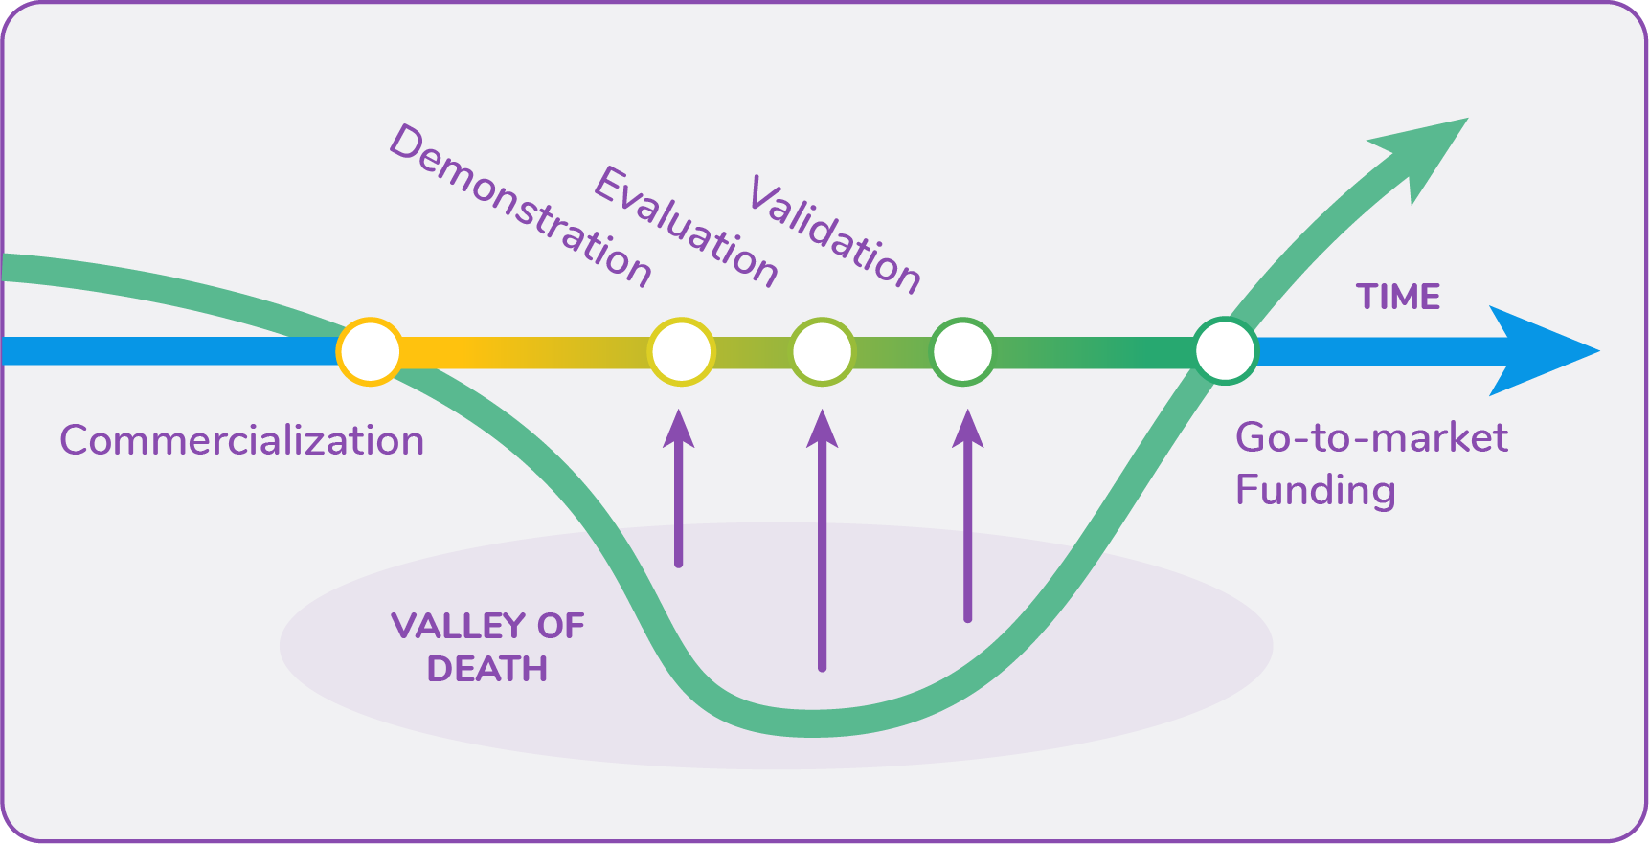

*Figure 1: Valley of Death in the Commercialization Process (Center for Sustainable Energy)*

Among the success stories of programs bridging the commercialization chasm is PG&E’s LED Accelerator Program. An assessment of the program[7] found that the “implementation team have struck a balance between the forward-thinking goals of market development, and the immediate needs of the resource acquisition regulatory environment.” Further, “…early adopter customers understand and value both energy and non-energy benefits (NEB). While these customers are willing to be among the first to adopt a new technology, they are typically not willing to take undue risks and need additional education and technical support to feel comfortable implementing a project with this new technology.”

Consistent with these findings, the TDS program will provide technical support by developing improved information about real-world buildings that have piloted approaches to decarbonization and educating local government staff on decarbonization equipment and strategies for monetizing improvements to secure financing. The program will further address financial needs by testing potential incentives to overcome barriers to decarbonization.

These activities will demonstrate the practicality and effectiveness of new approaches. As part of this effort, BayREN will collect and share real-world data that can be used to inform other programs, including programs serving other sectors.

## Innovation

The TDS program will support innovation in at least two ways. First, the program will support and develop demonstration projects through the Decarbonization Showcase, piloting the use of newer technologies and approaches in real world buildings and documenting the process and results. The resulting data and case studies will help increase the uptake of this equipment by increasing familiarity and decreasing uncertainty. Second, the Education and Financing Services subprogram will test incentive structures with early adopters to encourage technologies that are in the early phases of commercialization.

## 5. Metrics

The program will track the metrics and indicators below:

* Count of completed decarbonization showcases (MS_23_BVM (23a))
* Count of case studies developed from decarbonization showcases (MS_BVM_04)
* Count and % increase/decrease of staff within an LG (and LG consultants) to whom the program provided information on decarbonization technologies and financing options (MS_02_BVM (2c))
* Count of completed projects where LGs plan and implement decarbonization improvements in public buildings (testing program incentives) (MS_23_BVM (23b))
* Annual dollars leveraged from non-ratepayers to support customer-side efficiency programs (MS_BVM_08)
* Estimated electricity energy savings (RA_BVM_01)
* Estimated electricity demand savings (RA_BVM_02)
* Estimated natural gas savings (RA_BVM_03)
* Estimated GHG reductions (RA_BVM_04)

## 6. For Programs Claiming To-Code Savings

Not applicable.

## 7. Pilots

Not applicable.

## 8. Workforce Education and Training

Not applicable.

## 9. Workforce Standards

There are no new workforce standards as part of this program. Projects referred to other programs will comply with the standards of that PA.

## 10. Disadvantaged Worker Plan

There is no direct implementation proposed as part of this program. Projects will comply with the disadvantaged worker plans of the referral PAs.

## 11. Market Access Programs

Not applicable.

## 12. Additional information

Not applicable.

# Supporting Documents

## Program Manuals and Program Rules

The Program Manual will be developed and incorporated into this Implementation Plan as part of the program launch activities. Since this program supports and complements other programs, this timing will allow the Program Manual to be based on the most current information about those programs. Developing the Program Manual at that time will also allow the program staff and consultants who will be managing and involved with the program to develop the Manual.

## Program Theory and Program Logic Model

The logic model for this program is provided below.

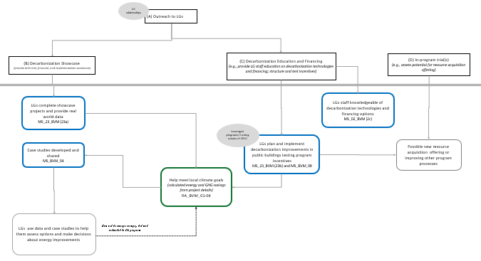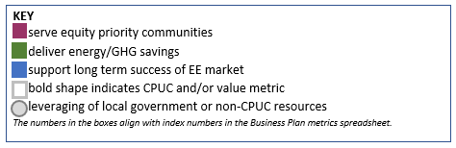

## 

## Process Flow Chart

The following graphic illustrates the process flow for the TDS Program.

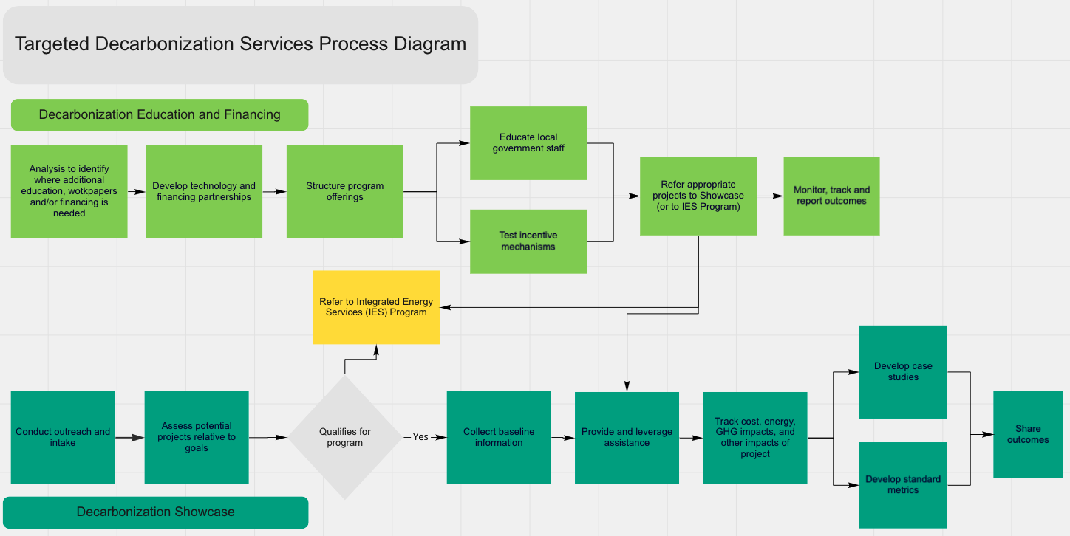

## 4. Incentive Tables, Workpapers, Software Tools

Not applicable. The program does not currently provide incentives for measures that will result in claiming energy savings.

## 5. Quantitative Program Targets

***Table 2. Contracted Metrics, Methodology, and Targets***

|  |  |  |  |  |  |
| --- | --- | --- | --- | --- | --- |
| *Metric* | *Method* | *Targets* | | | |
|  |  | ***2024*** | ***2025*** | ***2026*** | ***2027*** |
| *Decarbonization Showcases Completed* | *Count of completed Decarbonization Showcases* | *0* | *0* | *3* | *7* |
| *LG Staff Engaged in Decarbonization Technologies and Financing* | *Count and % increase/decrease of staff within an LG (and LG consultants) to whom the program provided information on decarbonization technologies and financing options* | *25* | *50* | *75* | *100* |
| *Decarbonization Improvement Projects Implemented* | *Count of completed projects where LGs plan and implement decarbonization improvements in public buildings (testing program incentives)* | *0* | *2* | *4* | *4* |

## 6. Diagram of Program

The diagram below shows linkages among BayREN’s portfolio of programs. Additional linkages to other programs will be explored through BayREN’s existing Joint Cooperation Memorandum and other ongoing coordination processes among the energy efficiency PAs.

## 7. Program Measurement & Verification (M&V)

BayREN will ensure that data collection activities are embedded in the TDS program design to capture the information necessary to meet evaluation requirements and to expand the understanding of local government building decarbonization and best practices. A database within a customer relationship management (CRM) system will be used to track information about the local governments, decarbonization projects and goals, and other details that will help show the impact of the TDS program. Although specific energy savings metrics are not directly tied to this program, the energy savings reported as indicator values and featured in the Decarbonization Showcase will be based on standard engineering calculations of energy savings. All data collected will be available for evaluation upon request by the CPUC.

## 8. Normalized Metered Energy Consumption (NMEC)

Not applicable. If the Decarbonization Education and Finance Service develops an NMEC pathway for participating projects, this Implementation Plan will be amended.

1. Information in *italics* is provided in anticipation of the draft Implementation Plan Template Guidance 3.0 template, which has not been finalized at this time.
2. [California State Controller](https://publicpay.ca.gov/Reports/SpecialDistricts/SpecialDistricts.aspx?year=2020)
3. BayREN will consider technologies and applications such as the following: heat pumps (including air, water, and ground source) for water and space conditioning, variable refrigerant flow (VRF) systems, grid-integration measures, integration of other energy technologies with solar plus storage, microgrids, and islanding/backup power systems. The full list of technologies will be developed as a program launch activity based on equipment available at that time.
4. Stakeholders who work for Santa Clara County jurisdictions expressed a need for case studies that capture operation and maintenance costs on an annual basis to better support the implementation of decarbonization technologies in municipal buildings (Santa Clara County Members and Agencies Working Group meeting, 9/27/21).
5. The incentives and rebates being offered for decarbonization technologies are changing rapidly. One key change was the CPUC’s authorization of fuel substitution in Decision 19-08-009. PG&E’s third-party public program administered by Willdan provides incentives for those decarbonization technologies with current workpapers and is under contract through 2023. That program may or may not be extended into the period covered by this program. Several of the seven CCAs operating in the Bay Area have proposed or are considering incentive programs that would be available to public agencies.
6. [New Horizons for Energy Efficiency: Major Opportunities to Reach Higher Electricity Savings by 2030](https://www.aceee.org/sites/default/files/publications/researchreports/u1507.pdf). Dan York, Steven Nadel, Ethan Rogers, Rachel Cluett, Sameer Kwatra, Harvey Sachs, Jennifer Amann, and Meegan Kelly. September 2015 Report Number U1507. © American Council for an Energy-Efficient Economy.
7. [How Forward-Looking Product Specifications, Strategic Engagement and Competition Drive Adoption of Best-in-Class Technologies.](https://www.aceee.org/files/proceedings/2016/data/papers/7_681.pdf) Brian Barnacle, Terrance Pang, Pamela Molsick, Eng Seng Ng, Energy Solutions Jane Kruse, Charalambos Charalambides, Carmen Bradley-Dioum, Pacific Gas and Electric Company. ACEEE. 2016.