MCE Commercial Efficiency Marketplace
The following information is provided to the CPUC to house on the California Energy Data and Reporting System (CEDARS)⁹, in accordance with CPUC decisions and Staff guidance.

Program Overview
The MCE Commercial Efficiency Marketplace (Commercial Marketplace) will offer a flexible path for commercial aggregators to bridge the gap of customer needs and MCE's energy efficiency resource needs. A price-based population NMEC program design will support delivery of cost-effective savings (and potential decarbonization) to help meet MCE’s goals and optimize energy usage for commercial customers. Performance incentives will push aggregators to deliver beyond the minimum when they deliver optimized load shapes and maximize system benefits.
MCE has further reduced risk and administrative costs by contracting with a single third party, Recurve, as an implementation and administration partner. Recurve is tasked with relationship management and enrollment of aggregators, determining customer eligibility, analytics, determining payments to aggregators, M&V and more.
The program budget is established in this implementation plan, but all payments are tied to the delivery of savings. Aggregators will leverage capital up front to deliver the savings and MCE (ratepayers) will only pay a minimal administration fee based on the expected benefits from the forecasted projects to track and monitor projects as they are brought into the program and for actual savings delivered at the meter.

Program Budget and Savings
- Program and/or Sub-Program Name: Commercial Marketplace
- Program / Sub-Program ID number: MCE02-A
- Program / Sub-program Budget Table:

MCE02-A Budget Category | 2021 Budget
Administration | $63,149
Marketing, Education, and Outreach | $0
Implementation (Direct Implementation Non-Incentives) | $300,000
Measurement and Verification | $7,826
Incentives | $931,750
Total | $1,302,725

- Program / Sub-program Gross Impacts Table:

Sub-Program ID | Net kWh Reduced | Net Therms Reduced
MCE02-A | 2,650,750 | 43,250

- Program / Sub-Program Cost Effectiveness (TRC): 1.08
- Program / Sub-Program Cost Effectiveness (PAC): 1.36
- Type of Program / Sub-Program Implementer (PA-delivered, third party-delivered or Partnership): Third Party Delivered
- Market Sector(s) (i.e., residential, commercial, industrial, agricultural, public): Commercial
- Program / Sub-program Type (i.e., Non-resource, Resource): Resource
- Market channel(s) (i.e., downstream, midstream, and/or upstream) and Intervention Strategies (e.g., direct install, incentive, finance, audit, technical assistance, etc.), campaign goals, and timeline. : Downstream

Implementation Plan Narrative

- Program Description: Describe the program, its rationale and objectives.

The Commercial Marketplace opens up a new opportunity for aggregators to capture savings and decarbonization benefits from a wide array of interventions. Its primary objective is to simplify the path for MCE to translate allocated budgets for energy efficiency into actual results in their service territory in the most cost-effective means available - by creating an aggregator marketplace designed to deliver cost-effective impacts with an upfront price signal, consistent, transparent meter-based quantification of impacts and an auditable performance payment structure.

The rationale for this new model is to overcome the barriers of entry for qualified aggregators, ensure MCE can maintain required cost-effectiveness thresholds, and validate the impacts for both customers and the grid. This will enable a tighter connection of energy efficiency program investments with the grid impacts that drive significant value for MCE in reducing the cost of procuring energy, meeting climate goals, and improving the lives and livelihoods in the communities they serve.

MCE will contract directly with Recurve to facilitate the creation of the commercial marketplace. Recurve will recruit and contract with multiple qualified aggregators at a set price for energy savings and flexibility payments for time-valued components of savings. Recurve will support aggregators directly with targeting analytics to identify and engage the highest value customers based on the aggregators' business model. Aggregators recruit customers, install projects, and Recurve will track the impacts using CalTRACK and the OpenEEmeter in the Recurve Platform. MCE will pay aggregators at the conclusion of each year based on the impacts achieved and the auditable record of performance for the portfolio.

See flow diagram in Attachment Section 3. Process Flow for more detail

Pricing, payments and incentives are included in Attachment Section 4.

- Program Delivery and Customer Services: Describe how the energy efficiency program will deliver offerings (including program strategies/tactics, market channel, and targeted market/customer group); how it will reach customers, including those in CPUC-defined hard-to-reach and/or disadvantaged communities (if applicable), and any services that the program will provide. Describe all services and tools that are provided.

The core strategy of this program is simplification and flexibility. Qualified aggregators will have the flexibility to meet commercial customers where they're at in terms of energy needs, technology fit, and project cost. Rather than a prescriptive set of program offerings, aggregators will develop their offerings around a core set of targeted solutions (HVAC, Lighting, and heat pumps) and optimize the meter-based performance to maximize benefits to the grid and to the customer.

This is a commercial marketplace solution. Aggregators will focus on specific sub-categories of the commercial market that they anticipate will respond to a specific set of core technologies and solutions. The strategies and ideas will come into the market place by way of aggregator's business model descriptions, estimates of savings potential, and synergies with commercial customers in the MCE service territory. This match on aggregator and potential customer pool will be part of the aggregator qualification process.

The range of services, products and tools that are provided by the aggregators is diverse. They will have full flexibility to propose any kind of service, tool, or intervention to customers to encourage adoption, effectuate consumption changes, and manage energy.

Recurve will provide core services and tools to MCE and aggregators in the form of an operational platform to identify, track, and settle the energy efficiency resources delivered through this program.

This program is not designed to address hard-to-reach customer segments, but it is flexible and may be a viable program for doing so. If aggregators have a business model that can target this customer segment cost effectively they will be highly valuable participants in the marketplace.

- Program Design and Best Practices: Describe the program strategies/tactics that will be used to reduce the identified market barriers for the targeted customer group and/or market actor(s). Describe why the program approach constitutes “best practices” and/or “lessons learned.” Include descriptions of key software tools that are significant to program strategy and implementation, including audit tools. Provide references where available.

The key program strategies and tactics to reduce barriers for targeted customers are:
- Reduce technical and administrative barriers associated with traditional deemed, custom, and site specific NMEC project development pathways. These delivery pathways are not only burdensome for aggregators and contractors, but also for customers, who may also bear risk in the traditional incentive application process
- matching customers with aggregators who are best-equipped to meet their needs, and
- tying those needs to grid-optimized solutions (as valued in the avoided costs adopted by the Commission)
- Leveraging a key benefit of population-level NMEC programs - the inclusion of to-code savings opportunities and thereby reducing so-called “stranded” savings opportunities, while simultaneously removing the administrative challenges of excluding to-code impacts
We anticipate that a specific set of technologies will be best suited to maximizing the avoided costs, but their adoption (and appropriate incentive levels) will be a function of the customer needs, financing requirements, and other funding mechanisms available to the aggregator to promote adoption through financing options or shared costs.

MCE is adopting a best practice of focusing on market design rather than program design to draw in the maximum number of solutions from aggregators, setting the price for energy savings to meet minimum cost-effectiveness thresholds and managing risk by only paying for the savings delivered. This strategy protects the rate-payer risk of investing in programs that may not deliver savings and creates the proper incentives for aggregators to mobilize and deliver the maximum benefit possible.

The Recurve platform is critical to the strategy, administration and implementation of the Commercial Marketplace. It provides the necessary analytic tools to bridge the flow of information between MCE, aggregators, and evaluators. The primary elements of Recurve’s platform to be leveraged are:
- The Resource Planning module, used to target and optimize aggregators' customer outreach.
- The Fleet Management module, which provides revenue-grade monitoring and tracking of impacts grounded in the open-source CalTRACK and OpenEEmeter.
- The Flex Ledger module provides a fully auditable record of payment recommendations and transactions within the program and will be the basis of savings claims to the CPUC.
- Innovation (If applicable and for programs designed and implemented by a third party): Describe how the program is innovative and will increase the uptake of cost-effective energy efficiency and minimizes lost opportunities for promoting other demand side energy reduction efforts by advancing a technology, marketing strategy, or delivery approach in a manner different from previous efforts. See Appendix D for the update innovation definition and requirements.

The key innovation in this program is flexibility for MCE, aggregators and customers. By leaving the solution set open-ended but fixing the price to value delivered, and providing consistency in tracking impacts, the range of possible solutions that may come forward are determined by optimizing between these two (price and benefits) rather than prescribing a fixed program solution to a customer. It aligns the incentives for aggregators to fit customers with an appropriate solution that also maximizes their payments and delivers cost effective savings to MCE.

The other key innovation is that this program will drive toward cost-effective savings by tying payment directly to value delivered. The per unit price is set to deliver on the minimally cost effective deemed savings estimates from the CPUC. Payments to aggregators will be based on the full benefits (avoided costs) of the portfolio of projects they deliver net of the participant cost and other administrative costs to maintain the cost-effectiveness threshold. Aggregators will target customers and optimize their budget by reducing delivery costs, increasing savings impacts, and finding the right shared cost point for customers to "say yes" to a project. It is in the hands of the aggregator to maximize their performance payments across their portfolio by getting the greatest benefits (savings and demand impacts) at the lowest cost possible.

By focusing on the cost-effective value delivered (both as presented through analytics and motivated through price), aggregators will have the tools and resources to improve their portfolio over time, manage risk and be paid for the actual value delivered to MCE. Underperformance by an aggregator will likewise signal either modifications to their delivery model or exit from the marketplace with no additional risk to ratepayers to support a marginal program.
- Metrics: Provide metrics that will be used to track program progress. For programs designed and implemented by third parties, include the required performance metric for innovation. Metrics can include non-energy metrics if applicable.

The primary metrics for tracking program progress will be the energy savings (kW, kWh, Therms), time valuation of the savings, and carbon impacts, all of which are included in the reporting requirements. The achieved cost effectiveness of the portfolio and the actual load shapes delivered will be part of the metrics that are monitored. With the exception of inherent demographic information on participants, no non-energy metrics will be used to track program progress.

- For Programs claiming to‐code savings: Describe how the program complies with Applicable Laws and:
  - Identify where to‐code savings potential resides;
  - Specify which equipment types, building types, geographical locations, and/or customer segments promise cost‐effective to‐code savings;
  - Describe the barriers that prevent code‐compliant equipment replacements;
  - Explain why natural turnover is not occurring within certain markets or for certain technologies; and
  - Detail the program interventions that would effectively accelerate equipment turnover.
[from D. 17-11-006 Ordering Paragraph 2]
The MCE Commercial Marketplace is a population NMEC program. All savings will be demonstrated against an existing conditions baseline including to-code savings.
Capturing to-code savings may be part of any given project that is implemented as part of this program, for any number of technologies. SB350 has authorized programs to capture below code savings to limit stranded potential. Meeting customers "where they are at" is how aggregators will be able to identify and accelerate equipment turnover and overall adoption of solutions to achieve energy savings and decarbonization.

- Pilots: Describe if any pilot projects are part of this program and explain the innovative characteristics to these pilots. The inclusion of this description should not replace the Ideation Process requirements currently agreed by CPUC staff and the IOUs. This process is still undergoing refinements and will be further discussed as part of Phase III of this proceeding (R.13-11-005).^{10 [10} The Ideation Process is a set of reporting requirements developed collaboratively to ensure adequate reporting and review of pilots and other similar projects. This process will be further deliberated as part of Phase III. The current set of guidelines can be found here: https://www.cpuc.ca.gov/WorkArea/DownloadAsset.aspx?id=5292]

The MCE Commercial Marketplace is proposed as a commercial sub-program not a pilot.

- Workforce Education and Training:^{11 [11} D.18-05-041, page 20-21 and Ordering Paragraph 7] Describe how the program will support workforce, education, and training to:
- Expand/initiate partnerships with entities that do job training and placement;
- Require placement experience for any new partners in the workforce, education, and training programs and new solicitations;
- Require “first source” hiring from a pool of qualified candidates, before looking more broadly, beginning with self-certification; and
- Facilitate job connections, by working with implementers and contractor partners, and utilizing energy training centers.

The MCE Commercial Marketplace does not have a direct component for workforce education and training, but it indirectly addresses the objectives of growing job opportunities and on-the-job training.

- Workforce Standards:^{12 12 [}D.18-10-008, Ordering Paragraph 1-2 and Attachment B, Section A-B, page B-1.]Identify all relevant workforce standards that the Implementer deems applicable to the Program, including any specific skills certification and/or broader occupational training and experience for the following:
  - HVAC Measures
    - Installation, modification, or maintenance of non-residential HVAC measures with an incentive of $3,000 or more are required to be installed by workers or technicians that meet one of the following criteria:
      - Enrolled in and/or completed an accredited HVAC apprenticeship
      - Completed more than five years of work experience at the journey level per California Department of Industrial Relations definition, passed competency tests, and received specific credentialed training
      - Has a C-20 HVAC contractor license issued by the California
Contractor’s State Licensing Board?
  - Advanced Lighting Control Measures
    - Installation of non-residential lighting control measures with an incentive of $2,000 are required to be installed by installation technicians who have completed the California Advanced Lighting Controls Training Program (CALCTP).

Aggregators that join the Commercial Marketplace will adhere to all requirements for workforce standards established by the Commission. As part of the intake and review process, aggregators will affirm qualifications and licensure to perform the proposed work.

- Disadvantaged Worker Plan:^{13 [13} D.18-10-008, Attachment B, Section D, page B-9.]Describe how the program will provide Disadvantaged Workers with improved access to career opportunities in the energy efficiency industry for programs that directly involve the installation, modification, repair, or maintenance of Energy Efficiency equipment. Also describe the method that will be used for tracking this population in order to satisfy metric reporting requirements.

The MCE Commercial Marketplace does not have a direct component for targeting disadvantaged workers, but it indirectly addresses the objectives of growing job opportunities and on-the-job training.

- Additional information: Include here additional information as required by CPUC decision or ruling, as applicable. Indicate decision or ruling and page numbers.

Supporting Documents
Attach the following documents (in PDF format):

Program Manuals and Program Rules (See below)

The program rules and basic program manual for the MCE Commercial Marketplace are available at: https://mce.demandflexmarket.com; and have been attached to this Implementation plan.

- Program Theory¹⁴ and Program Logic Model¹⁵ : Program Theory and Logic Models should visually explain underlying program theory supporting the sub-program intervention approach, referring as needed to the relevant literature (e.g., past evaluations, best practices documents, journal articles, books, etc.).

¹⁴ Program Theory = The expected causal relationships between program goals and program activities in a way that allows the reader to understand why the proposed program activities are expected to result in the accomplishment of the program goals. A well-developed program theory can (and should) also describe the barriers that will be overcome in order to accomplish the goals and clearly describe how the program activities are expected to overcome those barriers. California Evaluation Framework, June 2004.
¹⁵ Program Logic Model = The graphical representation of the program theory showing the flow between activities, their outputs, and subsequent short-term, intermediate, and long-term outcomes. California Evaluation Framework, June 2004.]

The essence of the program theory for the MCE Commercial Marketplace is price signaling. The primary role of the program administrator is to establish a flexible structure (market design) by which aggregators can offer direct value from energy efficiency investments, and MCE can purchase that value directly.

Unlike a traditional program, MCE is not buying the service, but the commodity - a stream of net benefits - from the aggregator. Historic barriers to program implementation have included rigid program designs with fixed technology incentives and pre-payment for program services which risked non-cost-effective savings delivered. In the Commercial marketplace the program theory holds that the aggregators will act to optimize the value they can deliver, based on the price offered.

Aggregators are typically already familiar with the barriers for their targeted customer groups and have the flexibility to devise solutions to address those barriers for the customer groups that are likely to adopt the similar technologies offered by the aggregators.

MCE gets the benefit of the value delivered at a price aligned with the Commission's established value (in the avoided cost calculator) and with a protection against exceeding cost-effectiveness thresholds by only paying for value delivered and only for value above and beyond the customer and administrative costs.

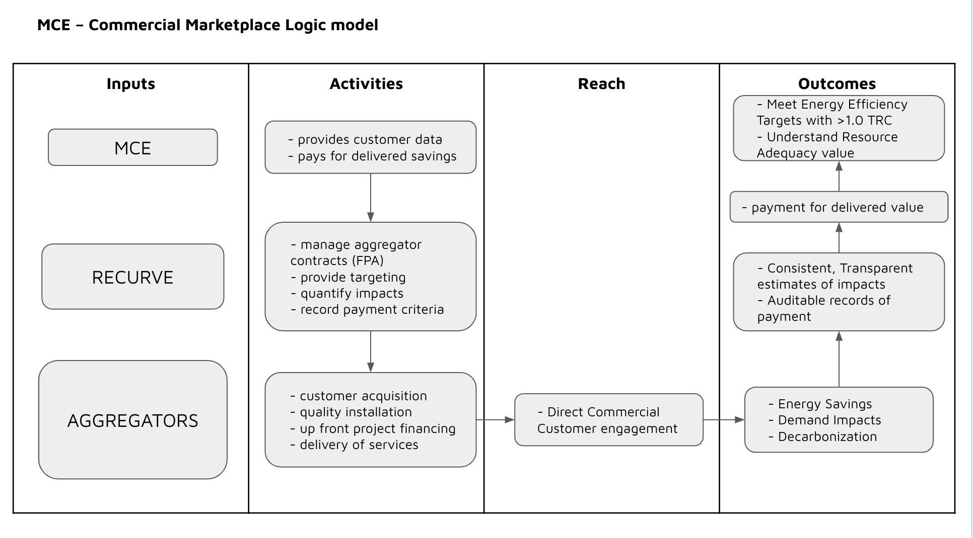
MCE_Program Theory and Logic Model

- Process Flow Chart: Provide a program or, if applicable, a sub-program process flow chart that describes the administrative and procedural components of the sub-program. For example, the flow chart might describe how a customer submits an application, how the implementer screens the application, the application approval/disapproval process, verification of purchase or installation, incentive processing and payment, and any quality control activities.

The following graphic illustrates the process flow for the Commercial Marketplace program for the aggregator, Recurve, and the program administrator.

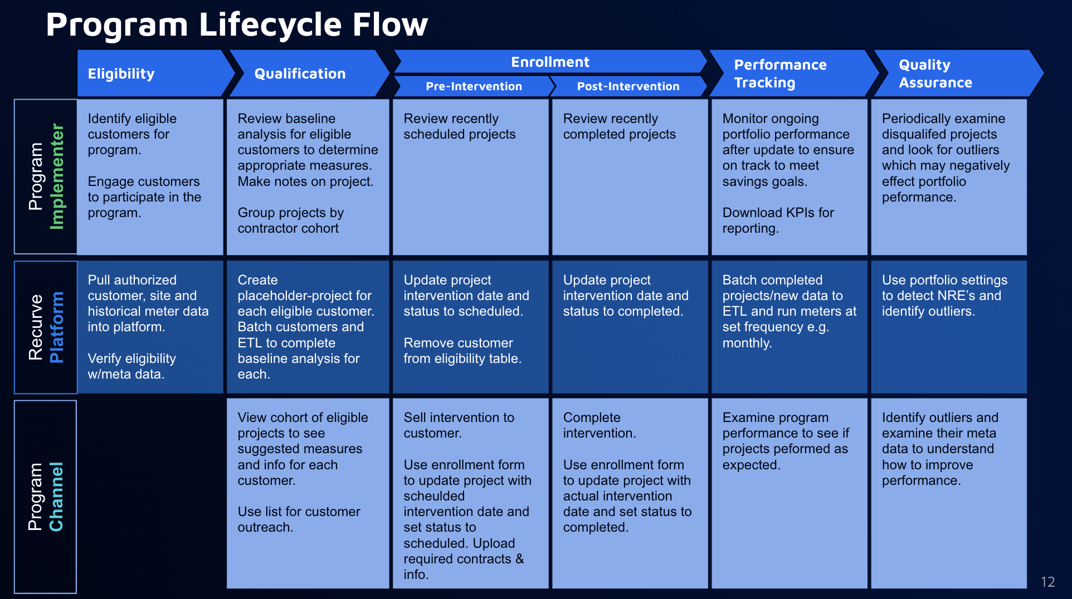
- Incentive Tables, Workpapers, Software Tools: Provide a summary table of measures and incentive levels, along with links to the associated workpapers.

MCE Marketplace is a Population NMEC program and does not have fixed measures or incentives. Workpapers are not part of the program plan. The program-level Population NMEC M&V plan describes the approach and associated software tools for calculating actual payable and claimable savings.

Pre-installation savings estimates will be reviewed and validated by Recurve. Since they are not foundational to the Aggregator payments or cla review is focused on ensuring customers are getting reliable internal estimates of savings potential and that MCE can have confidence in forecasted impacts and manage performance payment budgets.

For payable savings, the base rate per energy unit is based on the primary measures aggregators select for projects in their portfolio. The value per unit for electricity is grounded in the climate zone of the project, the DEER load shape and Effective Useful Life, appropriate for that primary measure (based on historic savings claims).

Incentives and costs presented to the customer are at the discretion of the aggregator. In sum, administrative, aggregator and customer costs must, at a minimum, be equal to or less than the net benefit (avoided cost) value of the portfolio for payment. Energy project costs will be documented and reported to Recurve by the aggregators for each project.

For program claims, actual reported measure costs will be net of non-energy private investment. Measure costs can account for a large portion of the total resource costs. Programs that leverage incentives to encourage a high degree of private investment are often best able to achieve savings goals and policy objectives at the lowest ratepayer cost. Along with utility incentives, customers are often motivated to invest in energy efficiency projects and measures for non-energy reasons.

To encourage participation, aggregators routinely promote non-energy impacts in its program marketing, driving participant investments in non-energy efficiency benefits that are not appropriate to incorporate into total resource costs. In the recently completed process evaluation of On Bill Financing, commercial participants valued the non-energy value of the project on par with the full loan value. Several other evaluations of commercial programs have quantified the relative value of energy in participant projects., These findings support recording customer contributions as net of non-energy private investment.

Aggregators can balance the value proposition with prospective participants to capture co-investment for non-energy purposes in addition to the value of energy savings. This approach reflects the best available information in evaluation literature, and this is consistent with precedent for adjusting for non-energy costs. MCE has taken steps to more accurately estimate energy efficiency measure costs in anticipation of more focused measure cost reporting.

- Quantitative Program Targets: Provide estimated quantitative information on number of projects, companies, non-incentive customer services and/or incentives that program aims to deliver and/or complete annually. Provide references where available.

This program is dependent on the nature of aggregators that qualify and come into the program. Therefore the current program targets are based on rough estimates submitted in the September 2021 Annual Budget Advice Letter. We anticipate this program will deliver savings of 2,650,750 in net kWh and 43,250 in net therms. The estimated incentives for the program are $1.3M; and we project 4-5 aggregators will be active by the end of 2021.

- Diagram of Program: Provide a one-page diagram of the program including sub- programs. This should visually illustrate the program/sub-program linkages to areas such as:
  - Statewide and individual IOU marketing and outreach [N/A]
  - Workforce Education & Training programs [N/A]
  - Emerging Technologies and Codes and Standards [N/A]
  - Integrated efforts across demand-side management programs [N/A]
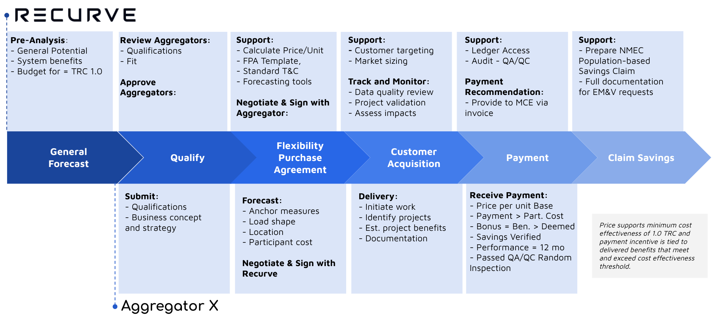

- Evaluation, Measurement & Verification (EM&V): Describe any process evaluation or other evaluation efforts that the program administrator (PA) or program implementer (PI) will undertake to identify the evaluation needs that the must be built into the program, clearly identifying who will be responsible for which evaluation activity. These might include:
  - Data collection strategies embedded in the design of the program or intervention to ensure ease of reporting and near-term feedback, and
  - Internal performance analysis during deployment
  - Performance metrics
  - All PAs should indicate what coordination support and funding, if any, they will provide to support program evaluation.

No process evaluation or other evaluation effort will be undertaken to identify evaluation needs for this program. This program employs a robust embedded M&V strategy (as described in the NMEC Program-Level M&V plan).

- Normalized Metered Energy Consumption (NMEC): If NMEC is applicable please include a detailed Program-level M&V plan, as called for in the most recently updated NMEC Rulebook. The revised Rulebook includes requirements for Program-level M&V plans to be submitted as part of the Implementation Plan:

Population-level NMEC Programs:
The MCE Commercial Marketplace Population-level NMEC M&V Plan is provided with this implementation plan.

- Contractor Eligibility Requirements: List any contractor (and/or developer, manufacturer, retailer or other “participant”) or sub-contractor eligibility requirements (e.g. specific required trainings; specific contractor accreditations; and/or, specific technician certifications required).
To participate in this program, commercial customers in the MCE territory must meet the following criteria:
Participant Criteria:
- Not be a current participant in a PG&E program
- Project site must be located in the MCE service area
- Have 12 months of consecutive consumption data for the same account
- Received electric distribution service from MCE or PG&E and natural gas service from PG&E
- No installed solar at least 12 months prior to intervention
- Model fit needs to be < 1.0 CVRMSE (MCE will conduct analysis at intake)
- Not be a current participant in other MCE or PG&E programs

Aggregators must meet the expectations of the Flexibility Purchase Agreement, including licensure, and workforce standards applicable to the project types they propose implementing. They must attest to their financial solvency.

- Participating Contractors, Manufacturers, Retailers, Distributors, and Partners: For upstream or midstream incentives and/or buy down programs indicate, if applicable.

Not applicable

- Additional Services: Briefly describe any additional sub-program delivery and measure installation and/or marketing & outreach, training and/or other services provided, if not yet described above
Not applicable
- Audits: Indicate whether pre and post audits are required, if there is funding or incentive levels set for audits, eligibility requirements for audit incentives, which demand side resources will be included within the audit’s scope and who will perform the audit.
No pre-or post on site audits are required. MCE will, as part of the quality assurance framework, select a random sample of projects to confirm technologies were installed. Audit of data quality and eligibility of participants will be conducted by Recurve.

- Sub-Program Quality Assurance Provisions: Please list quality assurance, quality control, including accreditations/certification or other credentials
MCE will conduct quality assurance as part of this program via random site visits to confirm installation of technologies.
- Other Program Metrics: List all documentation and data used to calculate Program Metrics. This includes but is not limited to data in support of sector-level and portfolio-level metrics.
MCE will be able to track the key Program Metrics using the Recurve platform and available customer and service territory data available at MCE.

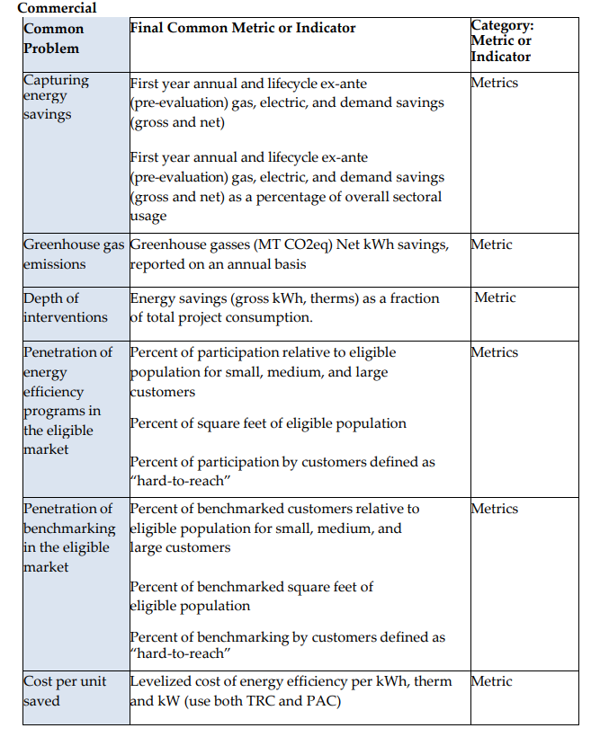
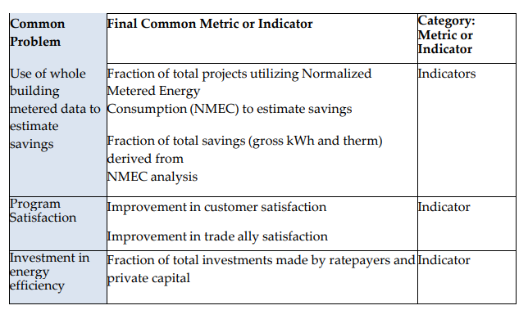

Using open source methods and code that can be verified at a project level.
PG&E Advice Letter 2019 - Advice Letter 4011-G/5375-E - 2019
PY2013-2014 California Statewide Residential and Nonresidential Spillover Study, Opinion Dynamics and Itron, Inc., 2017. CALMAC ID: CPU0186.01
N. Stevens, B. Billing, S. Murakami. The Bottom Line and Energy Efficiency: How Non-Energy Impacts Improve the Bottom Line and Create Targeted Messages Addressing Industry Specific Pain Points, IEPEC, 2019
Evaluation of PG&E’s OnBill Financing - Alternative Pathway PY2018-2019 August 3, 2020
Early EM&V of Pacific Gas and Electric Company’s Commercial LED T8 Incentives, Evergreen Consulting September 18, 2017
The California Energy Efficiency Financing Small Business Market Baseline Study Report from December 11, 2017, identifies multiple value drivers in program participation and Cost-Effectiveness of Energy Efficiency Financing Programs - Methodology & Strategic Issues, December 2016 documents the influence of other value drivers for participating in the financing programs.

