Southern California Regional Energy Network

DRAFT

Implementation Plan

Public Agency NMEC Program

First Filing Date: TBD

- Table of Contents
Program Budget and Savings Information 3
Program Information 3
Program Implementer 3
Implementation Plan Narrative 5
Program Description 5
Program Delivery and Customer Services 6
Program Design and Best Practices 7
Evaluation, Measurement, and Verification (EM&V): 8
Program Performance Metrics 10
Quantitative Program Targets 11
Pilots 11
Program Logic Model 12
Process Flow Chart 13
Diagram of Program 14
Additional information 14
For Market Transformation Programs Only 15
Quantitative Baseline and Market Transformation Information 15
Market Transformation Strategy 15
Appendix: Supporting Information and Documents 15
Program Manuals and Program Rules 15
Incentive Tables, Workpapers, Software Tools 16

Program Budget and Savings Information

Program Information
Program Name | Public Agency NMEC Program
Program ID# | SCR-PUBL-B3

Program Implementer
Program Implementer | Yes
SOCALREN Only
SOCALREN – Statewide Lead
Other PA – Statewide Lead
Third Party | X
Other

- SOCALREN Business Plan Sector
SOCALREN Business Plan Sector | Yes
Residential
Commercial
Industrial
Agricultural
Public | X
Codes & Standards
Workforce Education & Training
Finance
Other

- Program Type
Program Type | Yes | No
Resource | X
Non-Resource |  | X

- Intervention Strategies
Primary Intervention Strategy | Yes | No
Upstream |  | X
Midstream |  | X
Downstream | X
Direct Install |  | X

- Projected Program Budget

Budget data on CEDARS?: | X | Yes |  | No | If No, then show below:

- Savings Impact
Budget data on CEDARS?: | X | Yes |  | No | If No, then show below:

- Program Effectiveness
Budget data on CEDARS?: | X | Yes |  | No | If No, then show below:

Implementation Plan Narrative

Program Description
Describe the program, its rationale, and objectives.

The objective of the Southern California Regional Energy Network’s (SoCalREN) Public Sector is to identify and implement energy efficiency projects that yield electricity and gas savings. Currently, the SoCalREN Project Delivery Program (PDP) focuses on projects that are above code as per the investor-owned utility (IOU) core programs. Developing a Normalized Metered Energy Consumption (NMEC) strategy under the SoCalREN umbrella will allow customers to utilize another pathway to develop projects, primarily by capturing savings that are no longer incentivized by IOU incentives or are considered Industry Standard Practice (ISP). In addition, offering NMEC services will further enable SoCalREN to contribute to California’s SB 350 goals which seek to double energy efficiency savings in electricity and natural gas final end uses by 2030.

The SoCalREN Public Sector’s overarching goal is to support public agencies in the effort to reduce energy and costs in their facilities as well as infrastructure. The Public Agency NMEC Program (NMEC Program) will contribute to this effort by achieving the following objectives:

- Pursue projects that may not be eligible for IOU incentives, but still have a minimum 10% of energy savings potential supporting program and state goals.
- Reduce multi-measure project complexity and improve project completion timelines.
- Develop new program and method expertise in a public agency context, such as normalized usage data and metered savings verification.
- Provide technical expertise and appropriate training to facility personnel so as to ensure the persistence of savings
- Explore performance-based methods in the public sector, enabling the screening of projects that deliver consistent, transparent and reliable savings.

Beginning in 2019, SoCalREN will offer NMEC services that support and motivate public agencies to complete EE projects that are to or above code. The NMEC Program will target facilities and infrastructure with the goal of identifying projects within disadvantaged communities. This NMEC Program will offer technical expertise and project management support from start to finish the same way the SoCalREN Project Delivery Program does for traditional projects that run through the current utility core program incentive process. However, for projects running through the NMEC Program, a different method of calculation will be used to quantify the savings impact upfront. In addition, technical assistance will be provided once the project is completed to ensure savings persist into the future. In addition, this program will work with facility staff to develop a measurement and verification plan, a maintenance plan and a training plan to confirm equipment and projects are performing as expected. By doing so, the NMEC Program will fill in gaps of service for the public sector, gaining access to even more cost and energy savings for public agencies. Typical projects are measures that face elimination from IOU core incentive programs or termination due to ISP determinations. Examples include exterior lighting and whole building retrofits.

The NMEC program will be a resource program; therefore, energy efficiency savings from these projects will contribute to SoCalREN program goals and overall portfolio cost-effectiveness calculations. Initially, no monetary incentives will be offered to the agency based on post-installation energy performance. This is in contrast to the current IOU programs. In lieu of financial incentives, the NMEC Program will offer technical and financial services customized for each agency and project.

The NMEC Program will be available exclusively for public agencies enrolled in the SoCalREN EE Project Delivery Program. This includes cities, counties, tribes, school districts, water districts, sanitation districts and other special districts. There will also be a targeted effort to focus on disadvantaged communities (DACs). Disadvantaged communities are identified within each public agency customer using CalEnviroScreen 3.0 as per the SoCalREN program guidelines. The NMEC Program will initially be offered within Los Angeles County and in the future be offered to all public agencies in the SoCalREN service territory. This includes the counties of Los Angeles, San Bernardino, Riverside, Ventura, Inyo, Imperial, and Mono, as well as portions of the counties of Orange, Kern, Tulare, Santa Barbara, and Kings.

Program Delivery and Customer Services
Describe how the energy efficiency (EE) program will deliver savings (upstream, downstream, direct install, etc.), how it will reach customers, and the services and it will provide. Describe all services and tools that are provided.

The Program plans to deliver savings using a downstream intervention strategy where all services are offered through a third party implementer. Potential projects will be identified through either conducting a new audit or utilizing an existing audit of buildings and facilities. However, the NMEC method does not require an investment grade level audit to confirm the accuracy of measure savings. This element of the program will save customers and the program time and money. Next, an energy baseline analysis will be conducted to identify potential energy savings. Engineering estimates utilizing measured existing condition baselines will be used to forecast cost savings and energy savings for the project life cycle, which will then be verified using NMEC methods.

The NMEC Program will engage current and future participants of the SoCalREN EE PDP. SoCalREN already has over 115 agencies enrolled, all of which could be potential participants for the NMEC Program. In addition, there are over 700 agencies in the SoCalREN territory that may enroll and become new participants due to their interest in the NMEC Program. The goal is for the NMEC Program to leverage new and existing relationships with enrolled agencies to target projects that would be successful. Separate marketing and outreach will be done to educate and communicate the benefits of the NMEC Program and what it means for each customer.

Once an agency agrees to participate in the NMEC Program, it will benefit from a customized approach to technical assistance and project management from the third party implementer. Examples include project scoping, financial analysis, procurement assistance, energy modeling and savings persistence tracking. In addition, customers will have access to financial support services. SoCalREN third party engineers, with experience in ASHRAE energy savings calculation standards and International Performance Measurement and Verification Protocols (IPMVP), will support NMEC projects and help ensure their success. Most importantly, these services will be provided to agencies at no-cost. The NMEC Program will provide support in a way that complements existing programs and resources. These will be within CPUC NMEC Guidelines and will go through the Custom Measure and Project Archive (CMPA) process.

Program Design and Best Practices
Describe how the program overcomes the market barriers in its market sector and/or end use. Describe why the program approach constitutes "best practices" or reflects "lessons learned." Provide references where available.

The NMEC Program has been designed to overcome several market barriers in the public sector. Three key barriers identified and resolved by this program include: (1) limited IOU core program services for savings below code, (2) lengthy project implementation schedules, and (3) lack of available funding and financing.

Barrier 1: Limited IOU core program services for savings below code
As mentioned, the IOU core program design is limited in that it focuses its resources on asset upgrades that are above code or standard practice. The current SoCalREN EE PDP mirrors this design, but also recognizes there are significant energy savings below code that have been left unrealized. The NMEC Program aims to provide the necessary resources to facilitate these projects and get them completed in order to meet and go beyond code or standard practice. Addressing this barrier will remove obstacles agencies face in project delivery and help them realize additional energy and cost savings. Street lighting and exterior lighting owned by public agencies are good examples of projects that would have significant energy savings on a below code/ISP basis. The following best practices have been incorporated into the NMEC Program design to leverage lessons learned throughout the industry.

Best Practices
- Measure meter energy usage before and after installation. Normalize data as needed to support maintenance and monitoring activities managed by facility staff.
- Have a targeted focus on asset and behavioral upgrades including interior lighting, exterior lighting and mechanical systems to capture savings up to and above code.
- Offer customized project management and technical expertise as needed for each project to maximize outcomes and minimize program resources.
- Gather and ensure accuracy of project data including inventory, equipment specifications and maintenance protocols to support ongoing project performance and savings persistence.

Barrier 2: Lengthy project implementation schedules
Typical energy efficiency projects within a public agency can take 18-24 months from identification to completion. This is a major challenge for public agencies because it delays energy and cost savings. Moreover, priorities can change during this time, thus jeopardizing the availability of resources and funding. One key focus for the NMEC Program will be behavioral, retro-commissioning and operational (BRO) measures which can be implemented much faster than a traditional retrofit program, as long as an acceptable NMEC baseline is established. This targeted measure approach overcomes time constraints faced by the customer. Saving time allows these customers to receive financial savings sooner. In addition, saving time removes any potential issues for facility managers who need to ensure the continuous and ongoing operation of their buildings. The following best practices have been incorporated in the program design.

Best Practices
- Support agencies in obtaining funding and stakeholder buy-in to ensure project support remains positive until completion.
- Offer a streamlined approach to BRO upgrades such as building tuning and employee engagement to deliver energy and cost savings as soon as possible to the customer.

Barrier 3: Lack of available funding and financing
Financing of capital upgrades often requires multiple funding strategies. When going through the IOU process, customers need to have construction funds reserved upfront to utilize IOU on-bill financing. In addition, projects may not receive incentives or financing at all from the IOU programs because of their lack of claimable savings. They are then shelved even though agencies have the willingness to do them. This program aims to address both of these barriers through a two-pronged approach. First, the NMEC Program will provide technical assistance to support below-code projects and motivate agencies to take action. Second, the program will leverage available funding sources to support project delivery and cash flow requirements. The NMEC calculation method will support financing products which require a higher level of certainty on project performance, energy and cost savings. The following best practices have been incorporated in the program design.

Best Practices
- Pursue a variety of measure types simultaneously to produce a balanced cost per kilowatt-hour result and as a result increase the likelihood of project approval.
- Support a whole building effort, combining elements of mechanical replacement, retrocommissioning, weatherization and lighting where possible to optimize financials and support project approval.

Evaluation, Measurement, and Verification (EM&V):
Describe any process evaluation or other evaluation efforts that the PA will undertake. Identify the evaluation needs that the PA must build into the program. These might include data collection strategies embedded in the design of the program or intervention to ensure ease of reporting and near term feedback, and/or internal performance analysis during deployment.
EM&V typically includes an ex post evaluation of savings claims; however, with NMEC projects, meter based savings are embedded in project implementation. This program will include meter based savings throughout the measurement and verification (M&V) period according to the specific intervention strategy (24 months for BRO strategies, and 12 months for all others). The NMEC Program implementation will be more closely aligned with evaluation since ex post type analysis occurs in parallel to the ex ante review process. This includes the interaction and feedback loops between project level M&V - through IPMVP Option C and in some cases Option D - and program-level EM&V. For the NMEC Program as a whole, EM&V will be performed to compare the total forecasted savings with the realized savings after the measurement period. This approach will inform impact evaluations specific to buildings and assets in the public sector. The project M&V plan is submitted as a separate document and is catalogued under section “4”, Appendix: Supporting Information and Documents.
Data Collection Strategy for Whole Building Projects
The NMEC Program will need to have an audit for each facility it services including estimated savings and a list of measures. In addition to the information in the audit, the program will collect baseline pre-intervention data from SCE and SCG by requesting meter level consumption data. Green Button 15-minute interval data, actual meteorological year (AMY) weather data and C 2010 weather data will be used when available. Weather normalized energy consumption data will be calculated based on ASHRAE Guideline 14 to calibrate the weather normalization model and create sufficient baselines for the 12 month pre-intervention. Submeters may be used as needed to isolate retrofit impacts. Other data may be collected to align with the final NMEC rulebook, especially to characterize non-routine events.

Data Collection Strategy for Exterior and/or Street Lighting Projects
Projects with meters serving only lighting such as the exterior lighting in a park or street lighting may not need an audit if there is an accurate inventory of equipment. In cases where a model and simulation are not cost effective or necessary, submeters may be used to create baseline data for single-end-use predictable lighting loads. Other data may be collected to align with the final NMEC rulebook as needed.

Data Collection Strategy for Other Project Types
Projects that are dependent on factors other than weather such as production rates may also be considered. For such projects, it is important to identify the independent variables. Production rates, such as the number of meals served in a cafeteria or the water used in irrigation, may be important for the project type that is being explored. However, such projects can mostly be pursued only if there are no other project types (e.g. Whole Building or Exterior/Street Lighting) being considered at that meter. After the independent variable is identified, the quantity of data required would depend on the variability of the data. e.g. if the data does not change from month to month, then a month’s worth of data may be sufficient. The data collection strategy which relates to normalization and identification of non-routine events will mostly follow a path similar to the whole building project type data collection strategy.

Program Performance Metrics
Describe the program performance metrics. (metric, measurement method, frequency, etc)

The NMEC Program is proposing the following key performance metrics to be tracked and reported on periodically throughout the program cycle.

No | Metric | Method | Frequency
1 | Number of Projects Reviewed | Projects reviewed through energy analysis | Quarterly
2 | Number of Projects Identified | Projects submitted to CPUC | Quarterly
3 | Number of Projects Completed | Savings submitted to CPUC | Quarterly
4 | Count and types of facilities (e.g. school, streetlights) for which projects were completed | Count submitted to CPUC | Quarterly
5 | Gross and Net Annual and Lifecycle kWh Savings Claimed | Savings submitted to CPUC | Quarterly
6 | Gross and Net Annual and Lifecycle kW Savings Claimed | Savings submitted to CPUC | Quarterly
7 | Gross and Net Annual and Lifecycle therm Savings Claimed | Savings submitted to CPUC | Quarterly
8 | Average percentage of annual electric and gas savings at the meter | Average percentage submitted to CPUC | Annually

The necessary project information will be gathered through a series of discussions and verification checks with each public agency customer. A database within the existing SoCalREN Customer Relationship Management (CRM) system, will be used to track information about the customer, project, energy savings claimed and other details that will help show the impact of this program. This will be done on a quarterly basis and more frequently as needed. Once the information is gathered, it will be entered in the database and then used to generate reports. Savings will support overall SoCalREN public sector goals.

Quantitative Program Targets
Provide estimated quantitative information on the number of projects, companies, non-incentive customer services and/or incentives that the program aims to deliver and/or complete annually. Provide references where available.
[To be included in the final draft that will be uploaded to EEstats and CEDARs.]

Pilots
Please describe any pilot projects that are part of this program and explain what makes them innovative. The inclusion of this description should not replace the Ideation Process requirements currently agreed upon by the California Public Utilities Commission (CPUC or "Commission") staff and Investor Owned Utilities (IOUs). The Ideation Process is still undergoing refinements and will be further discussed as part of Phase III of this proceeding.

This section is not applicable.

Program Logic Model
Model should visually explain the underlying theory supporting the sub-program intervention approach, referring as needed to the relevant literature.

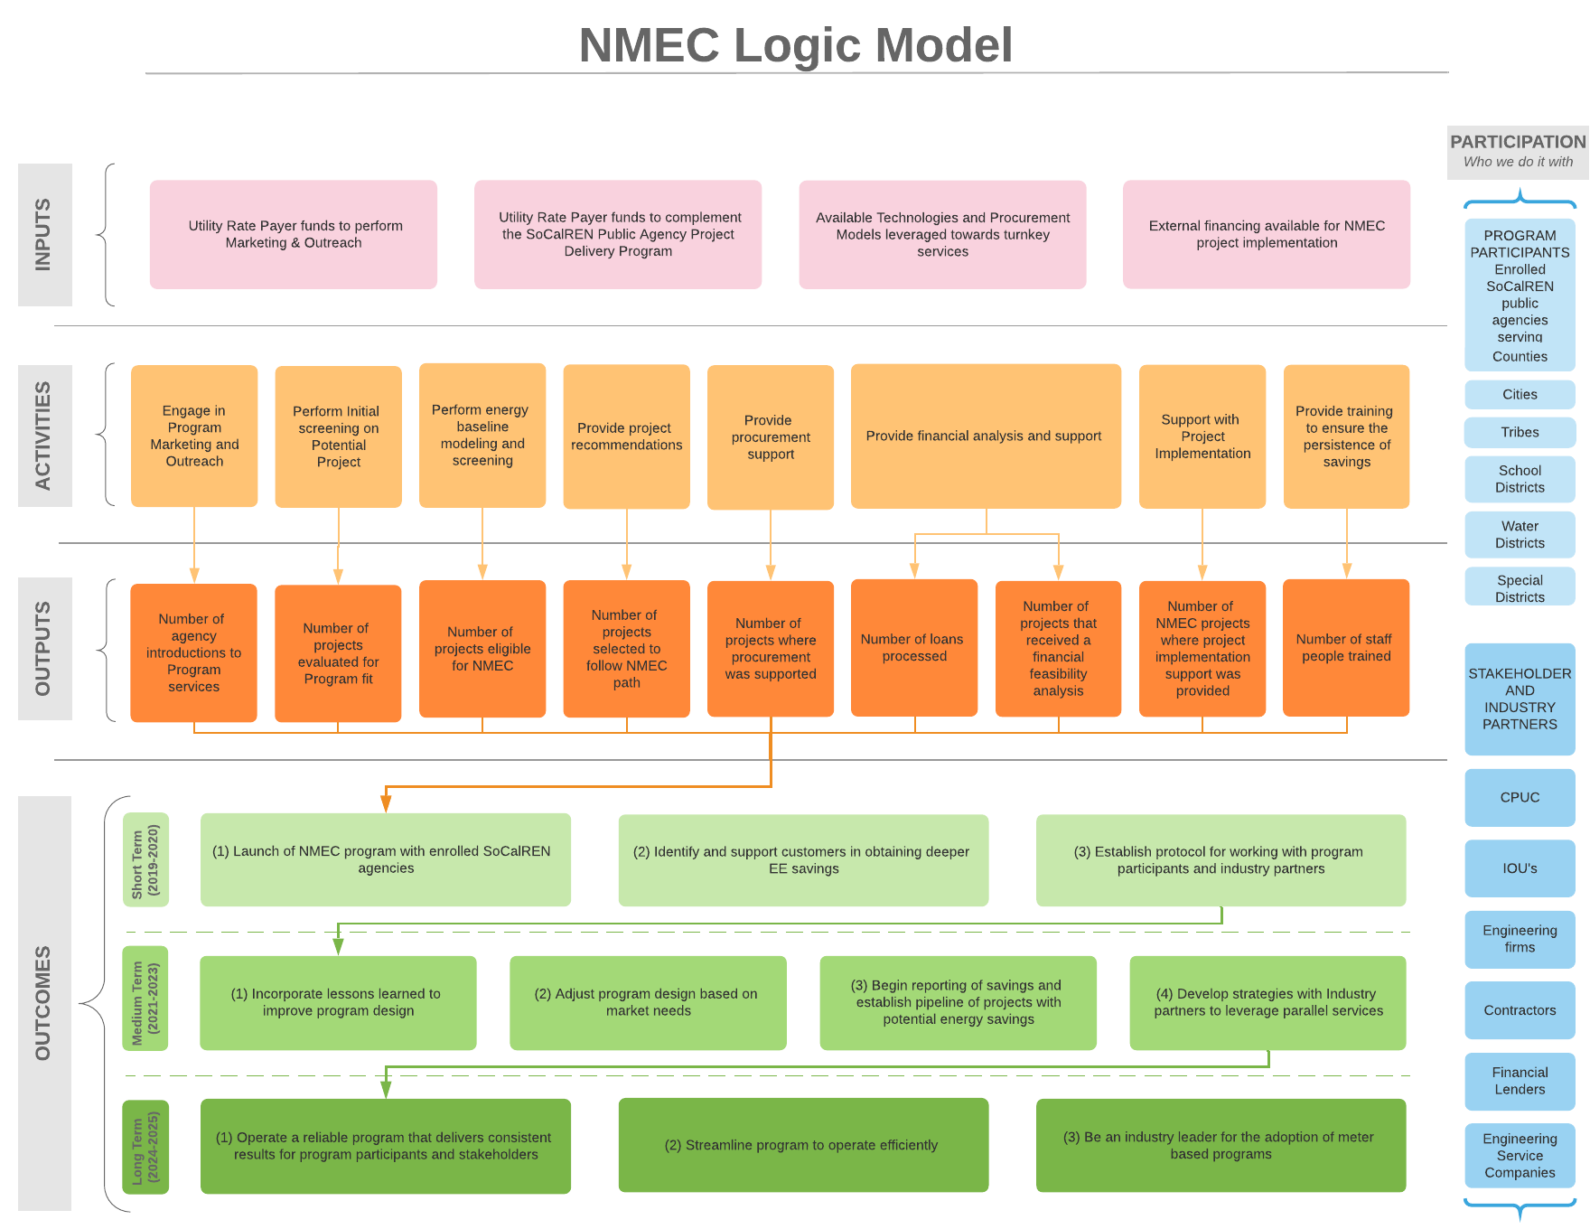

Process Flow Chart
Provide a sub-program process flow chart that describes the administrative and procedural components of the sub-program.
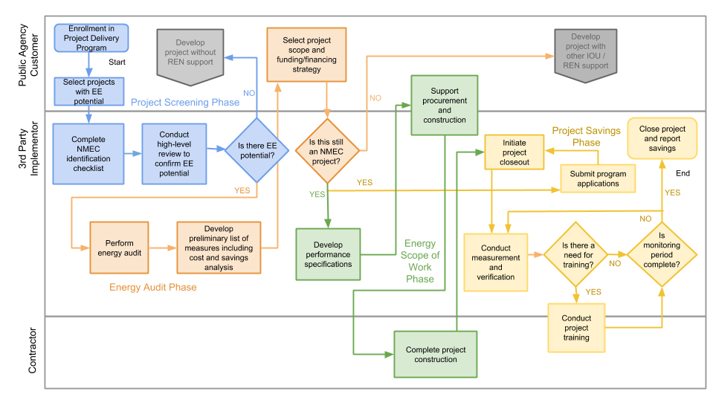

Diagram of Program
Please provide a one page diagram of the program including subprograms. This should visually illustrate the program/sub-program linkages to areas such as:
- Statewide and individual IOU marketing and outreach
- Workforce, Education and Training (WE&T) programs
- Emerging Technologies (ET) and Codes and Standards (C&S)
- Coordinated approaches across IOUs, and
- Integrated efforts across Demand Side Management (DSM) programs.

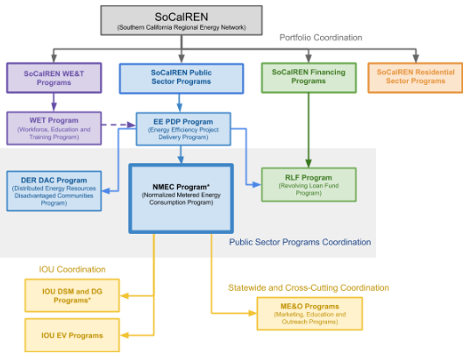
*Resource Program

Additional information
Include additional information as required by Commission decision or ruling. As applicable, indicate the decision or ruling, with page numbers.

This section is not applicable.

For Market Transformation Programs Only

Quantitative Baseline and Market Transformation Information
Provide quantitative information describing the current EE program baseline information (and/or other relevant baseline information) for the market segment and major sub-segments, as available.

This section is not applicable.

Market Transformation Strategy
Provide a market characterization and assessment of the relationships and/or dynamics among market actors, including identification of the key barriers and opportunities to advance DSM technologies and strategies. Describe the proposed intervention(s) and its/their intended results, and specify which barriers the intervention is intended to address.

This section is not applicable.

Appendix: Supporting Information and Documents

Program Manuals and Program Rules
All programs must have manuals (brochures) for implementers and customers to clarify the eligibility requirements and rules of the program. At minimum, manuals should include:
A short description of supporting materials is provided below. Greater detail will be provided in the program manual.
Table 1. Supportive Materials Index
# | Information  Required | Short Description
1 | Eligible Measures or measure eligibility | A list of eligible measures, or measure eligibility requirements  This meter based program is measure agnostic; however all savings will be transparent in their calculations.
2 | Customer Eligibility Requirements | Requirements for program participation  NMEC Program will work with customers that are eligible for the SoCalREN Public Sector Project Delivery Program. This includes cities, counties, school districts, tribes and special districts serviced by SCE and/or SoCalGas.
3 | Contractor Eligibility Requirements | List of any contractor or other participant eligibility requirements.  Program will comply with workforce requirements and targets as they are triggered in D.18-10-008
4 | Participating Contractors, Manufacturers, Retailers, Distributors | Information as to the program or sub-program delivery channel and if it is an incentive and/or buy-down type program.  This is a downstream program with technical assistance and no monetary post-installation incentives
5 | Additional Services | Descriptions of any additional sub-program delivery, measure installation, marketing & outreach, training, and/or other services provided.  Program will offer education and training services to ensure savings persistence. Post-installation performance reports on a monthly basis will also be presented to the customer.
6 | Audits | Information as to whether audits are required and funding or incentive levels have been set. Include eligibility requirements for audit incentives.  Audits, pre and post installation will be conducted in a manner that aligns with the finalized NMEC Rulebook.
7 | Sub-Program Quality Assurance Provisions | List of quality assurance and quality control requirements, including accreditations or other credentials of individuals or organizations performing this work.  Quality assurance checks will be implemented throughout the process at various milestones to maintain accuracy of data and savings and customer satisfaction

Incentive Tables, Workpapers, Software Tools
Provide a summary table of measures and incentive levels, along with links to the associated workpapers.

This program will use the Commission direction in Resolution E-4952 for Database of Energy Efficiency Resources (DEER) 2019 and 2020 updated assumptions, methods and values for savings estimates and 2020 planning, implementation and reporting where applicable. Where public sector buildings have unique operating characteristics that deviate from DEER, the program will follow the NMEC procedures for savings documentation. The program will follow the NMEC procedures for claims.
Software tools below may be used not only for CPUC savings calculations, but also to ensure that market based solutions, including but not limited to financing needs, and data workflows can be compatible with program savings calculations. Listed below is a summary of tools that is under consideration for the Program.

# | Document Name | Short Description | URL link or location name
1 | OpenStudio | Open source Energy Modeling Software supported by DOE | www.openstudio.net/
2 | ECAM | Energy Charting and Metrics tool: ECAM is a Microsoft Excel®-based tool that facilitates the examination of energy information from buildings to complete pre and post energy efficiency project regression analyses of utility interval meter data against outdoor air temperature. | www.cacx.org/PIER/ecam/
3 | ASHRAE Inverse Modeling Toolkit | An industry recognized toolkit for creating multivariate regression models to calculate savings from energy related upgrades. | www.techstreet.com/ashrae/searches/21801900
4 | CalTrack | CalTRACK methods describe a process of arriving at a calculation of avoided energy use. | www.caltrack.org

www.energy.ca.gov/sb350
SoCalREN’s future program optimization strategies may lend themselves to modify this tactic to offer incentives if needed.
Codes & Standards program, Emerging Technologies program, Workforce Education & Training program, etc.

