California Energy Efficiency Coordinating Committee Meeting #23
November 21, 2019 9:30-12:45
SDG&E, Energy Innovation Center, 4760 Clairemont Mesa Blvd, San Diego, CA 92117
Facilitators: Dr. Jonathan Raab, Raab Associates, Ltd. & Meredith Cowart, CONCUR
Final Meeting Summary

On November 21, 2019, a quarterly meeting of the full CAEECC took place at SDG&E’s Energy Innovation Center in San Diego. Seventeen Members or Proxies participated in-person, and six Members or Proxies participated on the phone. Approximately 16 other stakeholders participated in person and 17 other stakeholders registered to participate via webinar. A full list is provided in Appendix A: In-Person and Webinar Participation.

Meeting facilitation was provided by Dr. Jonathan Raab (Raab Associates Ltd) and Meredith Cowart (CONCUR). Meeting materials, including presentations, are provided on the CAEECC website at https://www.caeecc.org/11-21-19-coordinating-committee-mtg

All redline edits captured during the meeting following the presentations are provided in the document below. Any additional key discussion points, clarifying questions or comments are listed below the relevant PowerPoint slide, and responses to questions are noted. Most discussion is captured without attribution; however, in some instances, the affiliation of the speaker is identified, because their affiliation is relevant to the comment. Next Steps, at the end of this document, list all next steps discussed at the meeting.

Session 1: Introductions
J. Raab opened the meeting, and reviewed the agenda (see CAEECC Agenda-11-21-19-draft (11.11.19) at link above).

Session 2: Important Updates & CAEECC Discussion

1) ABAL filings and PG&E/SCE Biz Plan Refilings (P. Franzese, CPUC)

P. Franzese explained that PG&E and SDG&E’s 2019 Annual Budget Advice Letters (ABALs) didn’t meet cost effectiveness threshold. He stated that these ABALs are suspended and that the CPUC will provide guidance to PG&E and SDG&E in a forthcoming Resolution or Disposition.

2) MTWG and RENs proposed decision (C. Torok and N.Strindburg, respectively, CPUC)

C. Torok explained that the ALJ released a Proposed Decision (PD) (Decision Regarding Frameworks for Energy Efficiency Regional Energy Networks and Market Transformation) on October 23, 2019. The PD is scheduled to go before the CPUC on December 5, 2019.

In the PD, the ALJ proposed the adoption of the Market Transformation (MT) framework based largely on work of the CAEECC MT Working Group report, including the recommendation for a single statewide administrator and a lifecycle (rather than year to year) C/E approach (although it did not adopt a C/E threshold for the time being). The ALJ suggested that the MTWG continue to meet to address questions related to how to set goals, how to attribute savings to various efforts under the MT umbrella in each market, as well as duplication/negative overlap with EE portfolios.

Regarding Regional Energy Networks (RENs), the PD states that the RENs have been in pilot phase long enough and that they can now be considered permanent Program Administrators (PAs), though they are still subject to triggers set forth in D-15-10-028. The PD also allows for the formation of new RENs. Potential RENs must file a motion in the ongoing energy efficiency proceeding per the criteria laidout in D.12-11-015, vet their draft Business Plans with the CAEECC, and submit Joint Cooperative Memos (JCMs) with any overlapping PAs. N. Strindberg also pointed out that the CPUC would likely work with (or consult w/the CAEECC facilitation team and Co-Chairs as well as the applicants) to determine the details and timing of the CAEECC vetting of the new PA’s business plan or subsequent budget filing.

3) 3rd Party (3P) Solicitation Processs (A. Besa)
A. Besa provided an update on the roll-out of the 3P solicitation process. The Procurement Review Group is reviewing IOU deliverables in December, starting with PG&E. The PRG Independent Evaluator report will most likely be released in January 2020 , and will be followed by a public workshop in February.

Session 3: Fine-Tuning CAEECC Processes and Procedures
J. Raab reviewed key recommendations from the Facilitation Team’s evaluation of the CAEECC. The full report is available online (see link above, CAEECC Evaluation 5.29.19 (10.31.19)); the full presentation summarizing the key recommendations is also is available online (see link above, Potential Changes to CAEECC (11.15.19)).

Throughout J. Raab’s presentation, he paused following individual recommendations for Member discussion and feedback. He recorded key discussion points via edits to these slides in real time, as captured below in redline. Additional clarifying questions and discussion points are also summarized below. Following discussion, J. Raab held informal straw votes to gauge support for/against several topic selection criteria options. The results of those straw votes are captured in the redline edits to the CAEECC Topic Selection (Criteria) slide below and also summarized beneath that slide.

Decision Rule for CAEECC Groundrule Changes: Current Options
J.Raab explained that when the ground rules were originally written, the facilitation team did not include a decision rule for how updates or changes to the ground rules should be made. He proposed that changes to ground rules be added to the decision rule below on significant process-related issues. The group agreed that changes to ground rules should be considered a significant process related issue and that this is an appropriate way to handle these changes.

- For any significant process-related issues (including the annual selection (or removal) of Co-Chairs, whether or not to launch a CAEECC Working Group or Subcommittee on a particular topic, approval of new Members, and changes to groundrules, etc.) the goal would again be to reach a consensus. However, if a consensus is not achieved in a timely fashion, a decision can be made if two-thirds of the CAEECC Members present (including those participating on the phone) agree.

In addition, Members discussed whether this decision rule (strive for consensus; 2/3 agreement if consensus cannot be achieved in a timely fashion) is appropriate if a significant number of Members (or their proxies) are not present (or on the phone) when a vote is called. Members agreed that a quorum is needed, and this this quorum should considered ¾ of Members/Proxies.

Note: The facilitation team will add an additional rule to the Groundrules stating that when the CAEECC votes on an issue, a quorum (defined as the presence [in person or on the phone] of a Member or Proxy of ¾ of Member organizations) is needed.

CAEECC Topic Selection (Criteria) (Slide 4)

- Non-Discretionary Topics:
  - CPUC has formally directed CAEECC to take on an issue (e.g., through an order);
- Discretionary Topics:
  - CPUC Energy Division has identified an important topic and initiated a starting point (e.g., issued a list of key sub-topics and/or questions, or a white paper on a topic); and diversity of opinions on issue (if not significant diversity of opinion should stay with CPUC); or
  - CAEECC has identified an important topic that it wants to take on, and received feedback from ED on the issue;
  - And for discretionary issues identified either by CPUC or CAEECC where a new Working Group or Workshop is proposed, at least 2/3 of CAEECC Member organizations agree that CAEECC should take on, and at least ½ of CAEECC Member organizations plan to participate.
- For discretionary issues identified either by CPUC or CAEECC where a new Working Group or Workshop is proposed, at least 2/3 (or ¾) of CAEECC Member organizations agree that CAEECC should take on, and for a Working Group at least 1/3 or ½ of CAEECC Member organizations plan to participate (no minimum participation for Ad Hoc Workshops). (This rule does not cover topics taken on by CAEECC subcommittees.)

Discussion/Agreements on CAEECC Topic Selection Criteria:
- Discretionary Topics (Working Group and Workshop): Members agreed that a super-majority of CAEECC Member organizations must agree that the CAEECC should take up the issue in a Working Group or Workshop, but were were split on whether “super-majority” should be defined as 2/3 or ¾.
- Working Group Participation Threshold: Members agreed that (in addition to super-majority CAEECC Member organizations agreeing that the CAEECC should take on an issue), a threshold for participation is also needed, but were split on whether the threshold should be 1/3 or 1/2 of CAEECC Member organizations
- Workshop Participation Threshold: CAEECC Members agreed a threshold for CAEECC Member organization participation is not needed for an Ad Hoc Workshop as long as a super-majority of CAEECC Member organizations agree that CAEECC should take up the issue.
- Note: Reminder that the CAEECC is not a voting/ parliamentary body, so voting should be used sparingly. These are process decision rules that make operations smoother.

Venue and Strategy for Each New Topic (Slide 5):

- For any new major topic undertaken by the CAEECC:
  - Facilitator and Co-Chair (in consultation w/ED) should develop a proposal including:
    - Appropriate venue (Full CAEECC meetings, Working Group, Workshop, or Subcommittee);
    - Goals (i.e., education, structured feedback, or consensus-seeking/recommendations)
    - Timeframe and number of meetings

Discussion/Agreements on Strategy for New Topics
- Overall—Members agreed to the proposed approach and language
- Subcommittees—The CAEECC agreed that although subcommittees have not yet been used recently, they could be in the future and so should be included under venues for consideration.

CAEECC Membership Criteria (Slide7):

- An Existing CAEECC Member organization can be asked to leave removed from the CAEECC
  - If it’s representatives/alternates are not regularly attending (in person or via phone) Full CAEECC meetings (i.e., 2 or more of past 4 meetings) unless there are extenuating circumstances; or
  - If it has an insurmountable conflict of interest arise (as determined by ED); or
  - If its representative is deemed to be unproductive, non-collaborative, or not acting in good faith (by a super-majority of CAEECC Members)
- New Member Selection:
  - [New Requirement] Any new Member nomination must have the sponsorship of at least two existing CAEECC Members
  - [Add to Application] Describe specific prior experience working collaboratively in other stakeholder processes
  - [Guideline to CAEECC] Avoid overly duplicative Membership on the CAEECC (e.g., an umbrella organization plus separately several of its organizational members.)
  - [Guideline to CAEECC] Periodically (i.e., every other year) the CAEECC should consider whether important broad stakeholder clusters are missing from current CAEECC make-up—e.g., an organization specializing in social justice issues

Discussion/Agreements on CAEECC Membership Criteria:
- CAEECC Members agreed to add criteria for removing Members from CAEECC for non-participation and conflicts of interest (with modifications above)
- CAEECC Members, however, didn’t agree to include removal criteria related to a Member being unproductive, non-collaborative, or not acting in good faith in part because these are subjective criteria and in part because the CAEECC is not typically a voting body.
- CAEECC Members agreed to add the proposed changes under New Member Selection.

Session 4: CAEECC 2020 Planning Session
J. Raab explained that the purpose of this Session was to discuss for 2020 a proposed work plan, quarterly Full CAEECC meeting dates, the proposed facilitation budget; and Co-Chairs (see link above, CAEECC Workplan Dates Budget 11-1-19 (11-1-19), slide 4).

He explained that, in the “2020 Workplan” slide copied below, “ND” stands for “non-discretionary” (topics the CPUC directs the CAEECC to take on) and “D” stands for “Discretionary” (topics the CAEECC proposes to take on).

Members suggested several new topics that they think the CAEECC should take on in 2020, including:
- Portfolio progress;
- Definition of underserved; and
- Narrowly focused cost-effectiveness issues

Members suggested refinements to where these new and pre-existing topics should be placed, including a new sub-heading for “Other Potential Topics” that are of interest to multiple CAEECC Members have not been vetted with ED or approved by CAEECC yet. J. Raab captured these points in real time as demonstrated in the redline text to the slides below:

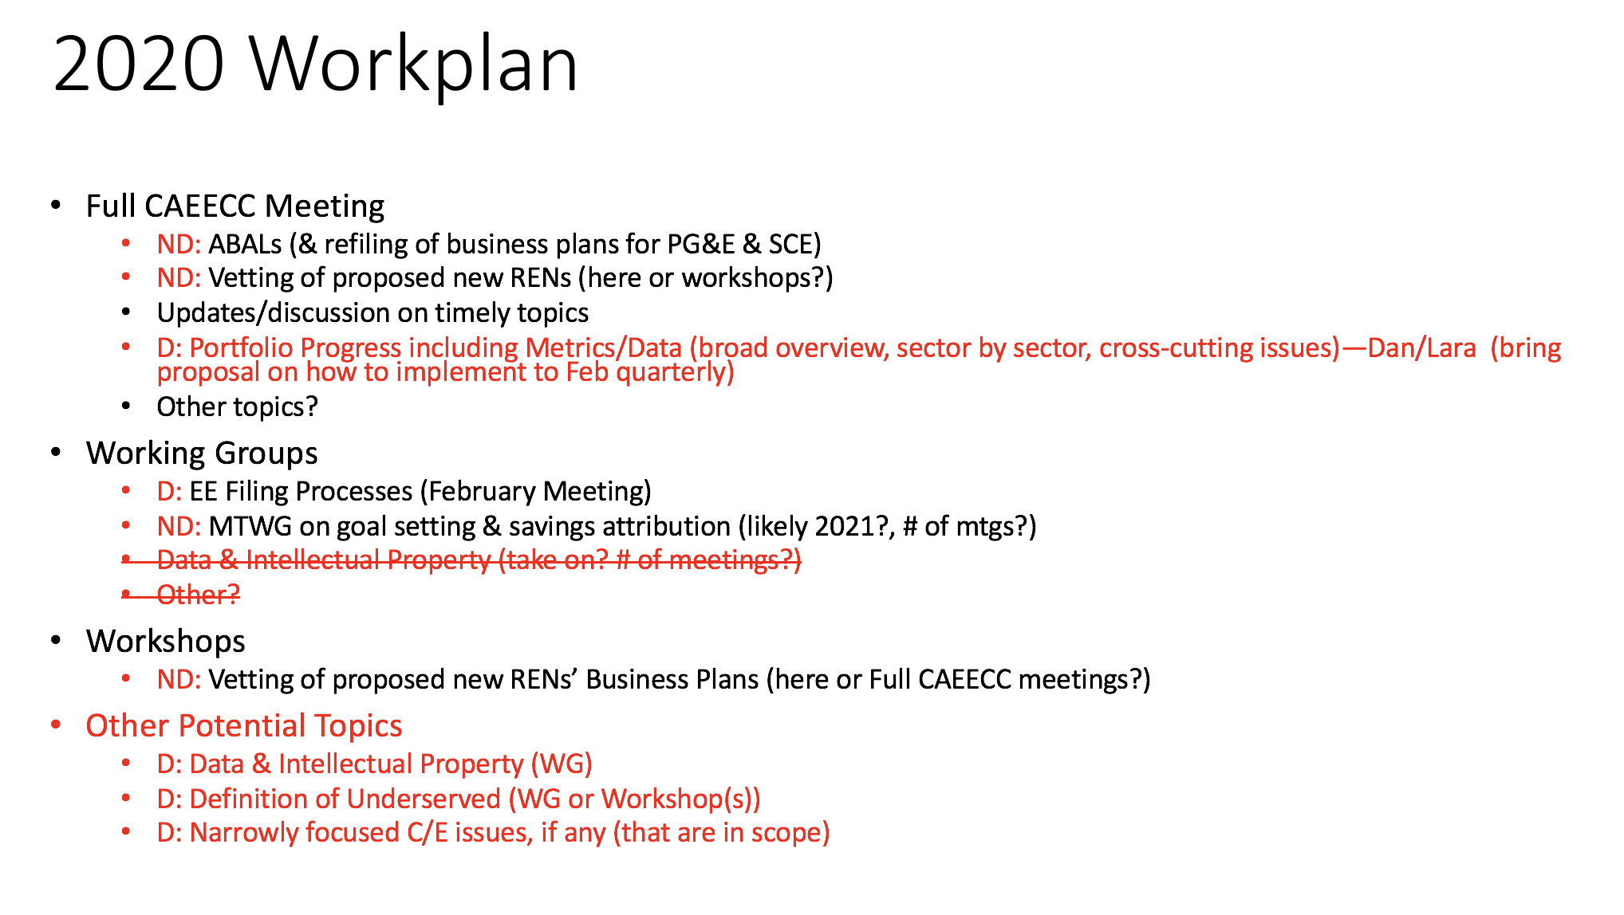
Proposed 2020 Full Quarterly CAEECC Meetings:
J. Raab explained that the Facilitation Team and Co-Chairs propose the following dates for full quarterly CAEECC meetings:

- February 27,2020 (Pacific Energy Center,SF)
- May 14, 2020 (Southern CA)
- August 13, 2020 (Northern CA)
- November 12, 2020 (Southern CA)

Discussion on Proposed Meetings:
- The Members felt that all the dates were fine, with the exception of August 13 meeting date which is too close to ABAL submission deadline. The Members agreed to move this a week earlier to August 6th for the time being. it should be moved to the prior week.
  - Members also discussed whether there may be flexibility on what’s contained in the ABAL filings and how the CAEECC reviews them while still being compliant. (L. Ettenson and D. Buch agreed to investigate this further.)

Placeholder 2020 CAEECC Facilitation/Administration Budget
J. Raab presented a placeholder 2020 CAEECC facilitation budget He explained that the Public Advocates Office had requested this be reviewed at the CAEECC meeting. This will be included in the Advice Letter along w/draft CAEECC 2020 Workplan to be filed in January.

The Public Advocates Office stated that they already reviewed the budget, think it is reasonable, and appreciate that the facilitation team put it together. There were no additional questions or comments

2020 Co-Chair Nominations
J. Berg was nominated to replace E. Brooks as the PA co-chair. L. Ettenson agreed to remain the non-PA co-chair of the CAEECC in 2020. The group had no objections to either Co-Chair.

Next Steps

CAEECC Members:
- Review/comment this meeting summary and revised groundrules
- Participate in upcoming CAEECC meetings (February 27, 2020 -Northern CA; May 14-SoCal, 2020; August 6th 2020-Northern CA; and November 12, 2020- SoCal) [Potentially revisit timing of August 6th - ABAL focused meeting at Feb 27th meeting.]
- L. Ettenson and D. Buch to investigate whether there is a means by which the CAEECC can reduce its review role of the 2020 ABAL filings while maintaining compliance with Commission direction.
- L. Ettenson and L. Schmidt (via the EE Filing Processes Working Group) to develop a proposed approach to adding a regular agenda item for the Full CAEECC on “Portfolio Progress” for discussion at the February CAEECC meeting

Facilitation Team and Co-Chairs:
- Discuss workplan w/ED
- Develop strategy to resolve groundrule on new topic thresholds

Facilitation Team:
- Draft this meeting summary
- Update the groundrules with changes agreed to at the meeting

Appendix A: In-Person and Webinar Participation

Note: The list of CAEECC Member/Proxies attendees joining in person reflect actual participation; the list of other participants attending in person and attendees joining via webinar reflect registration only. If non-CAEECC Members/Proxies seated at the table participated in person or if other individuals participated in the webinar but did not register, or registered but did not participate in the webinar, these last-minute changes are not reflected here.

Participants Attending in Person:

Company | First | Last
CAEECC Member/Proxy - Seated at the Table
BayREN | Jenny | Berg
CALCTP | Douglas | Avery
CEC | Brian | Samuelson
CEDMC | Serj | Berelson
CEE | Bernie | Kotlier
Center for Sustainable Energy | Raghav | Murali
CodeCycle | Dan | Suyeyasu
JCEEP | David | Dias
MCE | Alice | Havenar-Daughton
NRDC | Lara | Ettenson
PG&E | Ryan | Chan
Public Advocates Office | Dan | Buch
SCE | Matt | Evans
SDG&E | Athena | Besa
SoCalGas | Erin | Brooks
The Energy Coalition | Laurel | Rothschild
Other Participants
City of Chula Vista | Coleen | Wisniewski
CLEAResult | Chad | Ihrig
CONCUR, Inc. | Meredith | Cowart
Energy Solutions | John | Jacobs
Franklin Energy | John | Shipman
Jay Luboff Consulting, LLC | Jay | Luboff
Oracle / Opower | David | Siddiqui
Raab Associates | Jonathan | Raab
PG&E | Lucy | Morris
Recurve | Andrew | Terenzio
San Diego Gas & Electric | Eric | Drabb
Silent running | James | Dodenhoff
Strategic Energy Innovations | Liz | Fitzpatrick
TRC Companies | Susan | Davison
Western Riverside Council of Govts | Anthony | Segura
Center for Sustainable Energy | Stephen | Gunther

Participants Attending Remotely:

CAEECC Member/Proxy
3C-REN/County of Ventura | Alejandra | Tellez
SoCalREN | Lujuana | Medina
SJVCEO | Courtney | Kalashian
SBUA | Ted | Howard
SF Department of Environment | Kathleen | Bryan
The Energy Coalition | Marc | Costa
Other Participants:
CPUC | Christina | Torok
CPUC | Nils | Strindberg
CPUC | Peter | Franzese
DA Consulting | Don | Arambula
PG&E | Charles | Ehrlich
SDGE | Jon | Kochik
The Energy Coalition | Christopher | Ford
Franklin Energy | Ken | Williams
ICF | Paul | Kyllo
Mark Wallenrod Consulting | mark | wallenrod
Navigant | Kristin | Landry
Navigant | Craig | McDonald
NEEA | Jeff | Harris
Pacific Power | Nancy | Goddard
PG&E | Ben | Brown
Raab Associates | Susan | Rivo
SANDAG | Anna | Lowe

