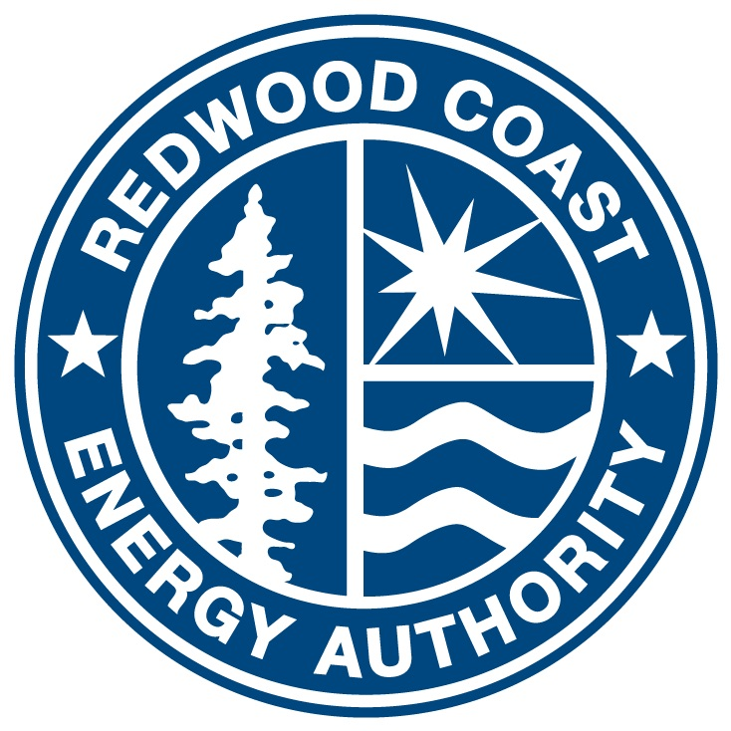

Redwood Coast Energy Authority (RCEA)
Local Government Partnership (LGP) Non-Resource Program
Implementation Plan
For Program Year 2020
August 14, 2020

Table of Contents
Program Overview 1
Program Budget and Savings 1
Implementation Plan Narrative 2
1. Program Description 2
2. Program Delivery and Customer Services 2
3. Program Design and Best Practices 4
4. Innovation 8
5. Metrics 10
6. Programs Claiming to-code Savings 12
7. Pilots 12
8. Workforce Education and Training 12
9. Workforce Standards 12
10. Disadvantaged Worker Plan 13
1. Program Manuals and Program Rules 14
Eligible Measures or Measure Eligibility 14
Customer Eligibility Requirements 14
Contractor Eligibility Requirements 14
Participating Contractors, Manufacturers, Retailers, Distributors, and Partners 14
Additional Services 14
Audits 15
Sub-Program Quality Assurance Provisions 15
Other Program Metrics 15
2. Program Theory and Program Logic Model 16
3. Process Flow Chart 17
4. Incentive Tables, Workpapers, Software Tools 18
5. Quantitative Program Targets 18
6. Diagram of Program 19
7. EM&V 19
8. NMEC 19

Program Overview
The purpose of the Redwood Coast Energy Authority’s (RCEA) Non-Resource program is to overcome the barriers that affect the customers (PG&E Ratepayers) of our region and to lead customers to more comprehensive energy actions. Our primary objective is to support cost-effective resource acquisition program services to the Public sector and Hard-to-Reach (HTR) customers while growing local capacity. RCEA will leverage our unique presence in the community and incorporate non-resource program services seamlessly with the suite of overall demand side management offering to our customers.
The three-year program will use a time and materials payment structure and be evaluated by key performance indicators.

Program Budget and Savings
Program Name: Redwood Coast Energy Watch
Program ID Number:
Program Budget Table:
 | 2020 Budget | 2021 Budget | 2022 Budget | 2023 Budget
Administration | $8,862 | $17,724 | $17,724 | $8,862
Marketing | $6,470 | $14,010 | $14,440 | $6,900
Implementation | $95,470 | $227,812 | $239,898 | $107,555
Incentives | $0 | $0 | $0 | $0
EM&V | $0 | $0 | $0 | $0
Total | $110,802 | $259,546 | $272,062 | $123,317
Net Impacts Table: N/A The Redwood Coast Energy Watch is a non-resource program and has no energy savings goals.
Program Cost-Effectiveness (TRC): N/A
Program Cost-Effectiveness (PAC): N/A
Type of Program Implementer: Local Government Partnership
Market Sector: Public
Program Type: Non-Resource
Intervention Strategies: Non-Resource

Implementation Plan Narrative

Program Description
The Redwood Coast Energy Watch (RCEW) program is intended to overcome the barriers that affect the customers of our region and to lead customers to more comprehensive energy actions. Our primary objective is to support cost-effective resource acquisition program services to the Public and Hard-to-Reach (HTR) sectors while growing local capacity. Using best practices, lessons learned from the successes and challenges of previous program years, and knowledge of the local market, RCEA will simplify service delivery and provide value to resource programs. The program will leverage our presence in the community to target public agencies, non-residential HTR customers, and residential HTR customers of Humboldt County. RCEW will apply innovative approaches to enroll customers and build trusted relationships with an end goal of fostering enduring participants that are motivated to continue pursuing deeper retrofits into the future.
Key objectives of the program include:
- Drive comprehensive public agency energy projects
- Increase cost-effectiveness for resource programs
- Increase opportunities for HTR customers to save energy
- Integrate deep-reaching energy projects
- Build local capacity through education

Program Delivery and Customer Services
The RCEW program will increase the opportunities to save energy in local public buildings and for HTR customers to save energy. RCEW will also maximize the value to resource acquisition programs by reducing administrative and participant costs through the following activities:
- Customer Outreach and Engagement for Public and HTR Customers
  - Data-Driven Customer Outreach. RCEA has 13 years of implementation data, as well as access to CCA customer usage data and will be able to execute highly targeted campaigns. RCEA will work with all applicable resource programs to increase participation by effectively targeting, engaging, and serving HTR customers where opportunity aligns with offered products and services.
  - Prequalification. Our prequalification process will increase project conversion rates leading to reduced implementation costs for resource programs. Prequalification allows our Program Specialist to quickly verify customers’ eligibility for all applicable programs and their level of commitment enabling us to guide them through resource program enrollment. This process will be expanded to include all new third-party resource program offerings while bridging a variety of solutions.
  - Assessments, Reports, and Roadmaps. RCEW staff will assess non-residential facilities through walk-through assessments while residential assessments will be conducted over the phone. Assessments will include interviews with staff and/or building occupants and review of energy usage data including energy consumption, energy load curves, peak demand, and usage during peak hours. Customers will receive a report and or roadmap with specific recommendations outlining incremental steps they can take towards greater energy efficiency, demand response, storage, and self-generation.
  - Energy Advisors. RCEW Energy Advisors will be effective at increasing participation and facilitating project success by providing integrated services to both public sector and HTR customers. Services will include contract coordination and providing a non-biased and trusted opinion on project recommendations.
  - Project Bundling. RCEW staff will bundle two or more project opportunities for resource acquisition programs. The bundling of project opportunities will reduce the transactional costs of serving Humboldt County’s geographically remote public sector and HTR customers.
- Workshops, Training, and Education. RCEW will facilitate and host workshops and trainings to build awareness and knowledge of energy efficiency and demand response for public agency staff and decision makers as well as HTR customers. RCEW will leverage Workforce Education and Training opportunities whenever feasible. Building awareness and understanding of available opportunities and new technologies will increase project adoption. Facilities adopting advanced technologies, such as ADR, will require trained facility staff to program, monitor and operate smart technologies. Well-informed local government officials will help normalize the enforcement of energy codes and set the stage for enacting reach codes.
- Benchmarking and Energy Star Certification for Public Agencies. RCEW will assist public agencies with benchmarking their facilities and training staff to review the data where there is a high propensity to act. We will work with facilities staff and managers to establish goals and methodology for benchmarking, identify desired outcomes and outputs, communicate results to key staff and decision makers, and develop energy goals based on benchmark results. RCEW will then assist public agencies with achieving Energy Star certification for their buildings.
- Public Agency Energy Management:
- Public Agency Project Management. Public sector project management support will be provided to overcome barriers to participation while facilitating streamlined implementation for resource programs. This will result in increased rates of project acceptance, which will lead to greater energy savings and comprehensiveness. Support will also be focused on accelerated project timelines while keeping costs as low as possible and minimizing missed opportunities for integrated energy efficiency/demand response projects.
  - Public Agency Procurement. The RCEW program will implement a variety of strategies to reduce public agency participant costs. Strategies include but will not be limited to:
    - The use of California Government Code (GC) Section 4217 to streamline the procurement process
    - Developing scopes of work and project specifications
    - Facilitating and managing the bid cycle
    - Supporting engagement with the Department of Industrial Relations.
  - Financing Assistance: The program will identify appropriate financing mechanisms and support efforts of public agencies and HTR customers to access a suitable finance product like PG&E’s On-Bill Financing, low- or no-interest loans from the California Energy Commission (CEC), California Hub for Energy Efficiency Financing, and state, federal, or private grants and loans. Financing support is expected to increase participation rates, project comprehensiveness, and savings.
The RCEW program’s core activities are aimed at creating a cohesive customer experience, while remaining nimble to the needs of the participant and available resource programs and services.

Program Design and Best Practices
RCEW presents an integrated energy management approach to services that aligns with the California Public Utilities Commission’s (CPUC’s) directive to advance Integrated Demand Side Management (IDSM) efforts and PG&E’s Business Plan objectives of streamlining program offerings to improve the customer experience. This model puts RCEW at the center of a wheel with spokes leading in from a suite of energy offerings that include PG&E and Third-Party (3P) resource programs, statewide and regional programs, benchmarking, trainings, financing, Demand Response (DR) programs, self-generation, and storage programs. The customer is presented with a roadmap that outlines steps to pursue services, programs, and financing. A central theme of the RCEW program is that the customer should not have to “shop” for solutions that best fit their needs. The program will identify the customer’s interests, evaluate their needs, determine their eligibility for all applicable programs, and present them with an integrated solution that provides the best value for their unique situation. Customer roadmaps will guide customers through a loading order using a stepped approach for the customer to act on opportunities in a way that balances value in the short-term with deeper retrofits in the long-term.
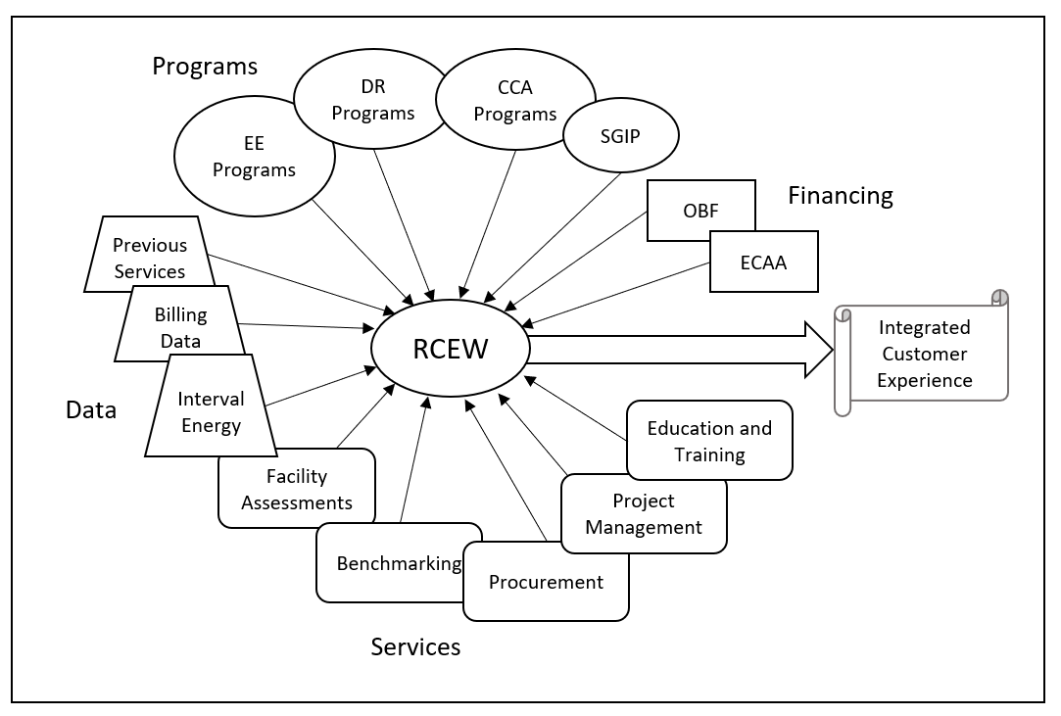
Figure 1 presents how our proposed RCEW program will operate as a hub that integrates and delivers an integrated customer-centric service.
RCEW’s integrated energy management services begin with prequalification screening that addresses the customer’s interests, facility characteristics, and other factors including level of commitment. Public agencies and HTR non-residential customers that are a good fit will receive a comprehensive assessment of their facilities and energy data to identify opportunities that have value both to the customer and resource programs. When appropriate, a consultant or third-party resource program will be brought in to provide a deeper technical analysis. Residential customers will receive phone consultations to identify opportunities that align to resource programs. Customers will receive a report or roadmap that recommends next steps and referrals will be made to the resource programs. This approach will increase project conversion rates and decrease implementation costs for resource programs by providing qualified and committed leads. Additionally, the program will focus on bundling project opportunities to increase cost-effectiveness for out-of-area resource programs.
The program’s involvement does not end with the referral. The RCEW staff will stay engaged throughout the implementation process and will encourage adoption of projects by identifying appropriate financing mechanisms and supporting the program participant’s efforts to access a suitable product. RCEW staff will become a trusted energy advisor to the customer and will encourage customers to continue through their roadmap and foster implementation of next steps.
RCEW will facilitate and host workshops and trainings to build awareness and knowledge of energy-related technologies and opportunities. RCEW will leverage Workforce Education and Training whenever feasible. By building local capacity through energy education we will increase project adoption. As new technologies launch, additional training will be required to optimize and maintain equipment to secure persistent savings. By training local government officials, we will normalize the enforcement of energy codes and set the stage for enacting reach codes. This empowers our local governments to lead by example and make energy efficiency commonplace in our community.
Goals and objectives for the program include:
- Grow our local governments and public agencies into energy efficiency leaders
- Maximize services provided by resource programs
- Increase opportunities for HTR customers to save energy
- Build local energy efficiency capacity

The RCEW program uses a customer-centric approach to attract and retain participants. By determining the energy goals of the customer, the program will produce a roadmap for the customer to achieve their immediate goals as well as describe future opportunities. Along the way, customers are pre-qualified and channeled into the appropriate resource programs. The resource programs receive qualified and committed leads that reduce their marketing and administrative costs and assist them with achieving cost-effective energy savings. The RCEW staff member continues to act as a trusted energy advisor to the customer. The program will inspire a lifetime of energy actions based on changing customer needs and priorities, new technology, new load management strategies, and grid resource requirements.
Many of the public agencies and HTR customers in Humboldt County have previously worked with RCEA on energy projects. RCEW will leverage existing customer relationships to address their future energy needs. When a customer shows interest in installing a solar array on their building, our program will set that as a goal and encourage preliminary steps including energy efficiency or demand response. Their interest in self-generation can be utilized to make them more aware of the time of day when energy is used in their facility and how they can reduce, or shift loads to benefit themselves and the grid. Additionally, deeper energy retrofits will be presented to the customer, showcasing the financial benefits of installing a smaller solar array or storage system after their overall usage is reduced.
The RCEW program will guide public and HTR non-residential customers from prequalification through site assessment and data review to determine the customer’s goals and identify customer needs and interests. Referrals may be made directly from the prequalification, when a more in-depth technical assessment is needed from the resource program or may occur after the full assessment by the RCEW program. The energy advisor will continue to engage with the customer as needed to help provide consistent support throughout implementation of their projects. RCEW will also act as the boots on the ground for resource programs to support collecting data or inspecting completed projects as needed. The resource programs will guide the project through completion.
The program will primarily focus on the downstream program channel by working with customers and resource program implementers. The program will also engage with upstream and mid-stream programs that benefit participants. RCEW will work with distributors on bulk purchasing to lower participant costs. RCEW will develop partnerships and work closely with resource program implementers. We will learn how to prequalify customers for their programs. We will bundle viable referrals to reduce mobilization and material costs. Follow-ups with resource programs on referrals will occur regularly for continuity and reporting purposes. We will invite resource programs to provide our team with training on their services and offerings in-person or through web-based platforms. The preferred method for sending and tracking referrals will be established with each applicable program implementer. Whenever possible, RCEW will prefer to use Energy Insight for sending and tracking referrals.
Direct observable program outputs will follow the success of program activities and will include, but not be limited to:
- Assessments performed
- Reports and roadmaps delivered
- Facilities benchmarked and Energy Star certified
- Customer financing secured
- Workshops and trainings provided
- Referrals made to resource acquisition programs
Program outcomes in the first year will include a pipeline of viable project referrals, services rendered, and projects completed by resource programs as a result of RCEW referrals. Partnerships between RCEW and resource programs will be established. Resource programs will find cost-effective projects in Humboldt County. Customers will have positive experiences with energy projects. Public agency customers will become better informed on how they use energy, establish trust in RCEW energy advisors, and gain confidence engaging in energy projects. Non-residential HTR customers will find opportunities to act on low-cost projects receiving incentives. Customers that are already further along on their roadmap will find financing support for deeper retrofits. Residential HTR customers will receive no-cost services to secure immediate savings and roadmaps to learn of future opportunities. Public agency customers and HTR customers will have access to local educational opportunities. This will all lead to completed projects with reportable energy savings.
In the intermediate term, resource programs will find RCEW a reliable partner. RCEW will continue to deliver a pipeline of viable projects leading to predictable forecasting and completed projects with reportable savings. Partnerships with additional resource programs will be established as untapped opportunities are identified. New customers will have positive experiences with energy projects. Existing customers will act on opportunities identified in their roadmap for deeper retrofits and stage for automated demand response (ADR). As customers experience successive positive experiences with realized financial savings, further trust is established leading to investment in deeper retrofits. Workshops and trainings make knowledge of energy efficiency technologies and demand response concepts more accessible to the community.
In the long term, resource programs will leverage RCEW’s outreach and assessment activities to meet their savings goals. Together, RCEW and resource programs will develop new strategies to further reduce participant costs. HTR customers will have increased access to resources as energy efficiency will be commonplace. As new advanced technologies launch, RCEW will establish partnerships with new resource programs. Existing customers will integrate on-site storage and generation as a distributed energy resource and for resiliency. Wherever possible, public agencies will achieve Energy Star status for their public facilities in alignment with the California Long Term Energy Efficiency Strategic Plan. These public facilities will lead by example and showcase their optimized energy usage to the public. Local governments will have the knowledge and training to enact reach codes leading to long-term energy savings.

Innovation
Innovative elements of the RCEW program include:
- Taking a Customer-Centric Approach. Rather than approaching customers with pre-determined solutions, the customer’s needs will be aligned with available services. During customer prequalification, RCEW will refer to our database for past project information, known opportunities and customer interests to inform our approach. After engagement, the assessment phase for non-residential customers will include a multi-faceted, comprehensive approach to understanding the customer’s facilities, operations, and energy use. This approach establishes RCEW as the customer’s energy advisor and builds a lasting relationship from which to serve future needs.
- Looking for Opportunities across All Resource Programs. The RCEW program will focus on comprehensive energy assessments. RCEW staff will be knowledgeable of all resource program services, eliminating the customer’s need to “shop” across programs.
- Bundling Project Leads. RCEW will bundle leads to resource programs, which will increase the likelihood of serving our geographically HTR region by reducing travel and lodging costs per assessment or installation. Bundling also lowers costs for individual customers, increasing project adoption.
- Creating and Delivering Customer Roadmaps for Energy Projects. Assessments, energy benchmark values, data and utility rate analysis, and third-party and resource program reports are used to create roadmaps to guide customers through project options. The roadmap includes a stepped approach loading order that guides customer action on opportunities to balance short-term value with deeper retrofits in the long term. RCEW technicians and project managers will provide roadmaps to customers and be available to interpret the report and develop next steps, financing plans, and contracting requirements. The customer roadmap will expand the focus beyond energy efficiency and drive future participant opportunities that may include DR, peak shaving, load shifting, and self-generation.
- Leveraging Business and Political Leader Endorsement. RCEW will work with our member agencies, municipalities, county government, local educational agencies, special districts, and non-profits to increase the community’s awareness of energy efficiency programs and options. RCEA will employ co-branded energy efficiency-promoting collateral developed with cities and the county. Outreach and marketing campaigns will use endorsements from business leaders with positive program experiences to increase awareness and adoption of energy efficiency projects in our HTR region. These endorsements will be leveraged to build program trust in the community.
- Providing Public Agency Procurement Support. The RCEW program will provide public agencies with public works procurement and management support including bid document preparation, bid reviews, compliance with prevailing wage and public works labor requirements, and engagement with the Department of State Architects, Division of Industrial Relations, the Office of Planning and Research, the California Energy Commission (CEC) and other state agencies. Another RCEW solution is the use of California Government Code Section 4217 for energy projects, which allows public agencies to utilize a more streamlined procurement process when contracting with energy services companies. RCEA has previously worked with local agencies’ legal counsel to develop a contracting framework that can be deployed broadly with public agencies to help them save time and money by combining design and construction into one contract.
- Providing Technical Administrative Expertise on Public Agency Projects. RCEW will act as a trusted energy advisor to local governments and public agencies interested in energy efficiency options. RCEW project managers and technicians will conduct interviews with decision makers and facility managers and perform site assessments resulting in project identification and leads to appropriate resource programs. The program will provide data analysis, financing support, and rate analysis to public agency staff. RCEW project managers will provide independent technical review and administrative support through the project’s design, implementation and contracting stages as needed.
- Encouraging Public Agencies to Lead by Example with Benchmarked and Energy Star Certified Buildings. RCEW will continue to ensure that public agencies are benchmarked in Energy Star’s Portfolio Manager and will train participant staff on engaging with their benchmarks. As facilities become benchmarked and improve their energy usage, those qualified will be taken through the Energy Star Certification process.
- Leveraging Interest in Solar and Storage to Motivate EE and IDSM Project Adoption. RCEW will leverage interest in self-generation and energy storage to guide customers toward a deeper understanding of their energy use and energy use reduction prior to sizing solar installations and storage systems in accordance with the CPUC’s loading order for comprehensive energy projects. This approach supports the deployment of public agency energy projects in the most cost-effective manner.
- Identifying Future IDSM Opportunities. The RCEW program will provide a comprehensive assessment of customers’ facilities, operations, and energy use beyond energy efficiency measures. Opportunities for automated demand response, peak day energy management, controls, peak shaving, load shifting, vehicle electrification, and integration of energy technologies will be identified and encouraged when they align to the customer’s best interest. Customized roadmaps will guide customers toward fully integrated demand side management solutions.

Metrics
The RCEW program’s progress will be measurable by the number of Key Performance Indicator (KPI) targets achieved compared to the annual target. The Program Performance KPIs are designed to lead to future energy savings as described below.
- Public Project Management Activities: RCEW will support the completion of energy projects by public agencies through no-cost project management activities. Support in these areas will increase project acceptance and completion rates.
- Public Agency Benchmarking and Energy Star Certification: Benchmarking reports provide public agencies the decision-making data they need to pursue energy projects. Energy Star certification of public agency buildings will lead the community by example.
- Leads Delivered to Resource Programs: High quality leads and bundled leads delivered to resource programs will reduce programmatic costs and increase participation rates in the remote Humboldt County region.
- Public and HTR Contacts: RCEW will increase opportunities for Public Sector customers and HTR customers to save energy through marketing and outreach of energy programs and services.
- HTR Assessments: RCEW’s assessments, reports, and customer roadmaps will educate and inform HTR customers of specific and successive actions they can take as their time and budget allows.
- Education: Local trainings and workshops will empower decision makers, facility managers, and building operators in both the Public and HTR sectors to take action.

Table 1. Key Performance Indicators
KPI | KPI category | Key aspects of the KPI and performance attribute being measured.
Public Project Management | Number of projects managed and/or using GRITS | RCEW will support the completion of energy projects by public agencies through no-cost project management activities. Any of the following services will count as one project management activity: enrollment in a resource program, site assessment, rate analysis, data analysis, bid document prep, bid reviews, procurement, prevailing wage, public works requirements, financing, review of third party project proposal, engaging with agencies' Board of Directors/ leadership, engaging Dept of Industrial Relations, engaging Dept of State Architects, engaging the Office of Planning and Research, engaging the CEC, engaging the Building Department, and project closeout. Success will be measured on the number of project management activities completed. This is a lagging indicator as counts occur post service delivery.
Public Benchmarking & Energy Star | Number or percentage of Buildings Benchmarked | RCEW will offer no-cost benchmarking and Energy Star certification for public agency buildings. Benchmarking will be performed using portfolio manager. Buildings that qualify for Energy Star will pursue certification. Success will be measured by the number of benchmarking services performed and the number of buildings receiving Energy Star certification. This is a lagging indicator as counts occur post service delivery.
Leads | Number of Leads | RCEW will deliver viable leads and bundled leads to resource acquisition programs. A project lead will be considered viable when the customer is determined to be eligible for the service and has conveyed a willingness to invest or secure financing when needed. Bundles will consist of two or more projects that can be served by the same resource program. Leads will be made for customers in Public Sector and HTR sectors (non-residential and residential). Success will be measured on the number of viable leads delivered and the number of bundled leads delivered. This is a lagging indicator as counts occur post service delivery.
Public/ HTR Contacts | Number of Contacts | RCEW will qualify customers through our program. A customer will be considered HTR-qualified when they meet the HTR criteria as defined by the CPUC. The number of new contacts to public customers and non-residential/ residential HTR customers will be tracked. Success will be measured on the number of new customer contacts. This is a leading indicator as services have not yet occurred.
HTR Assessments | Number of Audits or Reports prepared and presented | RCEW will perform no-cost assessments for non-residential HTR customers and deliver a report and/or roadmap. Success will be measured by the number of assessments performed and reports/ roadmaps delivered. This is a lagging indicator as counts will occur post service.
Education | Number of Educational Opportunities offered | RCEW will host local training events and workshops that target either public agency staff or HTR customers and cover a range of IDSM topics. Success will be measured by the number of training events and workshops completed. This is a lagging indicator as counts will occur post event.

Table 2. Annual KPI Targets
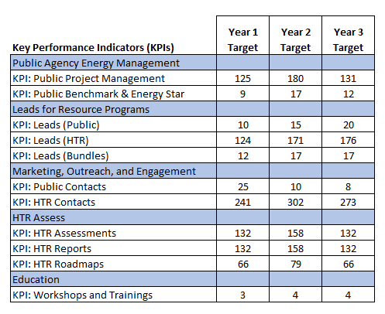

Programs Claiming to-code Savings
N/A

Pilots
N/A

Workforce Education and Training
RCEW will facilitate and host workshops and trainings to build awareness and knowledge of energy efficiency and demand response for public agency staff and decision makers as well as HTR customers. RCEW will leverage the Statewide Workforce Education and Training (Statewide WE&T) opportunities whenever feasible. Building awareness and understanding of available opportunities and new technologies will increase project adoption. Facilities adopting advanced technologies, such as automated demand response (ADR), will require trained facility staff to program, monitor, and operate smart technologies. Well-informed local government officials will help normalize the enforcement of energy codes and set the stage for enacting reach codes.

Workforce Standards
As a non-resource program, RCEW will not directly perform energy efficiency installations. RCEW will provide project management services. For projects receiving support from RCEW, compliance with CPUC mandated Workforce Standards will be verified before project commencement as appropriate.
RCEA understands supporting workforce standards but also recognizes the challenges for meeting those standards in a rural and hard-to-reach community. As part of the capacity building goal of the program, RCEW will assist with bringing training to our community or support local contractors with sending their staff to trainings in order to build the local capacity to support the CPUC Workforce Standards.

Disadvantaged Worker Plan
RCEA is a government entity and the RCEW program does not intent to utilize subcontractors, but to any extent applicable the RCEW program will comply with PG&E’s Supply Chain Responsibility Policy and CPUC Provisions for Disadvantaged Workers as appropriate and allowable by law. RCEA is committed to supporting job access for Disadvantaged Workers. Many of the zip codes in Humboldt County are qualified as high unemployment zones by CalEnviroScreen.

Supporting Documents

Program Manuals and Program Rules

Eligible Measures or Measure Eligibility
Redwood Coast Energy Watch (RCEW) is a Non-Resource program. RCEW will work closely with third party implementers to understand their measure eligibility requirements to effectively seek opportunities and deliver qualified leads to resource programs.

Customer Eligibility Requirements
RCEW will target Public Sector customers and Hard to Reach (HTR) qualified Non-Residential and Residential customers. Customers are required to have an active Pacific Gas & Electric account to be eligible. Customer eligibility for third-party programs will be established by the third-party program implementers. RCEW will work closely with third party implementers to understand their customer eligibility requirements to effectively seek opportunities and deliver qualified leads to resource programs.

Contractor Eligibility Requirements
RCEW is a Non-Resource program and will not have contractors.

Participating Contractors, Manufacturers, Retailers, Distributors, and Partners
RCEW is a Non-Resource program and will not have contractors, manufacturers, retailers, distributors, or partners.

Additional Services
The RCEW Non-Resource program is designed to lead to future energy savings by implementing the following activities:
- Public Project Management Activities: RCEW will support the completion of energy projects by public agencies through no-cost project management activities. Support in these areas will increase project acceptance and completion rates.
- Public Agency Benchmarking and Energy Star Certification: Benchmarking reports provide public agencies the data they need to make decisions to pursue energy projects. Energy Star certification of public agency buildings will lead the community by example.
- Leads Delivered to Resource Programs: High quality leads and bundled leads delivered to resource programs will reduce programmatic costs and increase participation rates in the remote Humboldt County region.
- Public and HTR Contacts: RCEW will increase opportunities for Public Sector customers and HTR customers to save energy through marketing and outreach of energy programs and services.
- HTR Assessments: RCEW’s assessments, reports, and customer roadmaps will educate and inform HTR customers of specific and successive actions they can take as their time and budget allows.
- Education: Local trainings and workshops will empower decision makers, facility managers, and building operators in both the Public and HTR sectors to take action.

Audits
RCEW staff will assess non-residential facilities through walk-through assessments and perform residential assessments over the phone. Assessments are provided at no-cost and will include interviews with staff and/or building occupants as well as a review of the customer’s energy usage data including energy consumption, energy load curves, peak demand, and usage during peak hours. RCEW will self-access energy usage data through PG&E’s Energy Insight and Share My Data tools or work with PG&E’s data team as needed. Customers will receive a report and/or roadmap with specific recommendations outlining incremental steps they can take towards greater energy efficiency, demand response, storage, and self-generation. Post audits will be performed by the third-party implementer. RCEW is available to assist third-party implementers with pre and post audits to reduce travel costs.

Sub-Program Quality Assurance Provisions
RCEW will be implemented by the Redwood Coast Energy Authority staff and will not have subcontractors.

Other Program Metrics
The RCEW program will track services provided to public and HTR customers related to all Key Performance Indicators using internal database and worksheet tools. This data will include but not be limited to: contact information, site information, customer engagement, eligibility criteria, existing technologies, proposed technologies, project milestones, customer reports and roadmaps, training events, workshops, and benchmarking activities.
Monthly reporting through Energy Insight will provide PG&E with program data along with other program results including events, activities, noteworthy achievements, customer complaints/ resolutions, and tracking of all KPI units achieved.

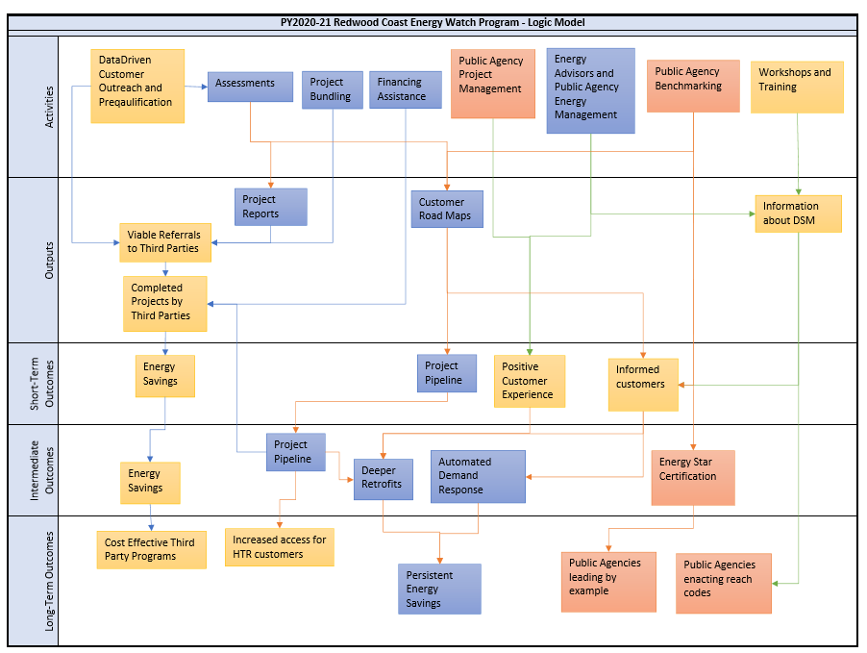
Program Theory and Program Logic Model

Process Flow Chart
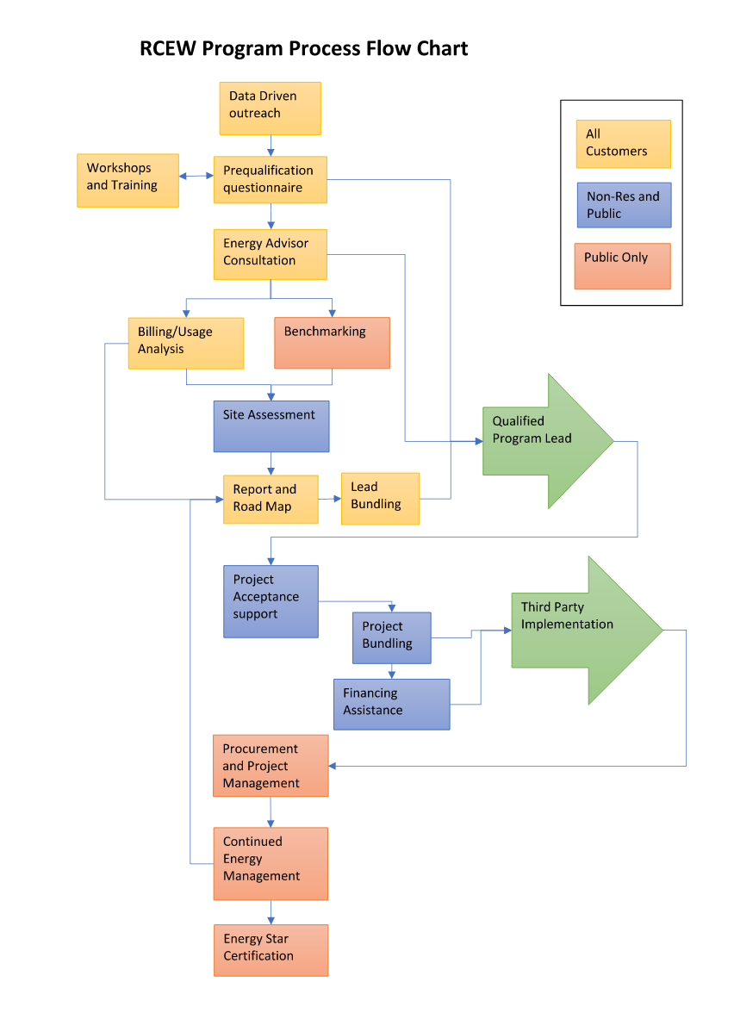

Incentive Tables, Workpapers, Software Tools
N/A The RCEW program is a non-resource program.

Quantitative Program Targets

Diagram of Program

EM&V
N/A RCEW is a non-resource program.

NMEC
N/A

