
Powerful Neighborhoods
Implementation Plan
Prepared by
Seth McKinney, Resource Innovations

Date: 09.11.2024

Table of Contents
Table of Contents 1
1 Program Overview 3
1.1 Program Budget and Savings 3
1.1.1 2024-2027 Program Details 3
1.1.2 2024-2027 Projected Program Budget 3
1.1.3 2024-2027 Projected Program Gross Impacts 3
2 Implementation Plan Narrative 3
2.1 Program Description 3
2.1.1 Brief Summary 3
2.1.2 Program Rationale 3
2.1.3 Program Objectives 4
2.1.4 Program Delivery and Customer Services 5
2.1.5 Market Barriers 11
2.1.6 Key Software Tools 14
2.1.7 Why These Approaches and Tools Constitute Best Practices 14
2.2 Innovation 15
2.3 Program Metrics 17
2.3.1 2024-2027 Program Key Performance Indicators 17
2.3.2 Pilots 19
2.3.3 Workforce Education and Training 20
2.3.4 Workforce Standards 20
2.3.5 Disadvantaged Worker Plan 20
2.3.6 Additional Information 20
2.4 Supporting Documents 20
2.4.1 Program Manual 20
2.4.2 Program Theory and Program Logic Model (DRAFT) 1
2.4.3 Process Flow Chart 2
2.4.4 Incentive Tables, Workpaper, Software Tools 1
2.4.5 Work Papers 13
2.4.6 Software Tools 13
2.4.7 Quantitative Program Targets 18
2.4.8 Diagram of Program 19
2.4.9 Evaluation, Measurement & Verification (EM&V) 20
2.4.10 Third-Party Performance Data Collection Plan 22
2.4.11 Normalized Metered Energy Consumption (NMEC) 24

Program Overview
The Zonal Equity Electrification Pilot (ZEEP), known as Powerful Neighborhoods publicly, is a pilot program designed to electrify specific geographic areas within PG&E's gas distribution system, identified for targeted electrification efforts (a “Zone”). PG&E has assigned these zones gas infrastructure funding and project plans for maintenance, improvements, or repair in the next two years. The Program will establish a process for stacking and interweaving multiple funding sources from federal, state, and local entities (including dedicated gas infrastructure funding) to reduce or eliminate project costs.
The Powerful Neighborhoods Program's primary goal is to maximize zonal building electrification for customers in low-income communities and/or Disadvantaged Communities (DACs). By electrifying these zones, the program aims to decommission sections of the gas system, avoid future gas infrastructure projects, and significantly reduce fossil fuel consumption in these zones. Engagement will use a high-touch, community-focused outreach plan with a Single Point of Contact (SPoC) to evaluate multiple innovative engagement approaches. The program provides EE and electrification education and direct installations to fully electrify premises with a comprehensive measure mix, including service upgrades where necessary. It includes carve-outs to explore engagement approaches, incentives, tools, and technology.

Program Budget and Savings

2024-2027 Program Details
Table 1. Program Details
Program Name | Program ID Number | Overall Program Cost Effectiveness (TRC) | Overall Program Cost Effectiveness (PAC) | Type of Program Implementer
Zonal Equity Electrification Pilot / Powerful Neighborhoods |  | N/A | N/A | Third-Party

Market Sectors | Program Type | Market Channels | Intervention Strategies
Residential/Non-Residential | Local / Equity | Downstream | Direct Install, Incentives, Audit, Electrification and Energy Efficiency Education, Non-energy benefits, residential and business targeting. AMI data analysis, surveys of customers in eligible zones, Community-Based Organization and Program outreach
Program Targets:
- Fully electrify 78 residential premises and 5 non-residential premises within a minimum of 30 zones over three years.
- Achieve an average of $275 in annual bill savings for residential participants and an average of $2,264 in annual bill savings for non-residential participants, totaling $33,270 in estimated annual bill savings to customers in DACs.

Timeline:
The anticipated launch of customer outreach for Powerful Neighborhoods is March 1, 2025. The launch will occur in a phased rollout by county. The program end date is currently scheduled for September 30, 2027. The program will focus its activities across the following Counties:
- Alameda
- Butte
- Fresno
- Kern
- Marin
- San Francisco
- San Mateo
- Santa Clara
- Yolo

2024-2027 Projected Program Budget
Table 2. Program Budget Table
Total Administrative | Marketing & Outreach | Total Direct Implementation: Non-incentive | Total Direct Implementation: Incentive & Rebate | Total NTE EE Budget
$38,365.00 | $525,016.00 | $3,653,124.00 | $1,967,103.00 | $6,183,608.00

2024-2027 Projected Program Gross Impacts
N/A

Implementation Plan Narrative

Program Description

Brief Summary
The Powerful Neighborhoods program addresses growing inequity in energy access by providing no-cost electrification and energy efficiency upgrades to residential customers and commercial buildings in DACs and low-income communities. The program focuses on helping specific Zones transition away from natural gas, improving environmental quality, and enhancing residents' quality of life. It achieves these outcomes by leveraging state, federal, and utility funds, including diverted gas infrastructure dollars, to electrify homes and businesses, reduce energy costs, and help California meet its climate goals. It also aims to develop cost-efficient strategies for scaling building electrification.

Program Rationale
California is committed to reaching carbon neutrality by 2045. As the state’s more affluent homes and buildings electrify, many DACs will be left relying on natural gas infrastructure as natural gas volume decreases, spreading the cost of maintaining and repairing gas infrastructure over fewer users. As a result, natural gas rates are projected to increase faster than electricity rates.
Households and building owners in DACs and low-income communities that rely on natural gas are projected to face higher energy bills and limited options for adopting energy-efficient, electric alternatives from traditional Demand Side Management programs. Without targeted interventions, DAC and low-income community customers will bear the brunt of rising natural gas costs while being excluded from the benefits of California’s clean energy transition.
The Powerful Neighborhoods program aims to alleviate this burden by covering the full cost of electrification. This approach ensures participants experience the benefits of electrification and lower utility bills over the long term while reducing overall energy consumption and GHG production. By integrating energy efficiency measures and, where possible, distributed energy resources (DER), the program will enhance the affordability of clean energy in DACs​. Powerful Neighborhoods addresses these issues by focusing exclusively on customers within DAC communities or those within low-income census tracts. This approach enables these communities to benefit from long-term electrification benefits, where traditional DSM programs would otherwise prioritize energy savings.
While the program targets customer bill savings, its key metric is bill neutrality or savings in the first year, with the expectation that savings will increase over time as rises in gas prices outpace electricity. The pilots will also track other Non-Energy Benefits (NEBs) realized by the customer from program services. However, energy savings claims will also be captured through eligible projects as they occur.
Ultimately, this program will increase activity among underserved customer classes and their communities, facilitating long-term engagement between the DAC, the trade allies and CBOs that support them, and PG&E.

Program Objectives
The Program's main objective is to maximize zonal building electrification in DACs and low-income communities, thereby producing data and learnings that can inform PG&E’s future efforts to scale zonal building electrification. The Program will simultaneously pursue secondary objectives of achieving high customer satisfaction, reducing or maintaining participant energy costs, and minimizing Program costs through non-ratepayer-funded sources.
The Program will:
- Research and screen eligible residential customers and non-residential customers
- Refer to section 2.4.7 for Quantitative Target regarding the number of zones electrified and number of premises electrified.
The Powerful Neighborhoods Program narrative objectives are:
- Accelerate residential electrification and energy efficiency improvements among historically underserved communities, low-income communities, and Disadvantaged Communities (DACs).
- Achieve high customer satisfaction, target participant energy cost reductions or neutrality, and minimize program costs through non-ratepayer-funded sources.
- Test innovative approaches related to emerging technologies, outreach approaches, and community-based organization engagement.
- Produce data and learnings that inform PG&E’s future efforts to scale building electrification.
- Reduce reliance on fossil fuels.
- Improve environmental quality and enhance the quality of life for residents.
- Reduce gas infrastructure costs of maintaining aging equipment.
- Establish a process for leveraging funds from multiple funding sources over the same period.

Program Delivery and Customer Services
Powerful Neighborhoods will provide energy-efficient upgrades and electrification solutions directly to customers in low-income communities and/or DACs. It will achieve its outcomes through a) Targeted Outreach and Education, b) Home and Building Energy Assessments, c) Customized Recommendations, d) Leveraged Programs and Utility Incentives, e) Direct Install Services, and f) Installation Inspection and Follow-up.
Prior to conducting direct customer outreach to solicit participation, the Program will perform research that will enable it to target best-fit customers, develop Program marketing and outreach tactics, and refine Program incentives. The Program will then focus on customer acquisition, project development, installation activities, and Program optimizations. The Program will collect and assess data, report on key activities, and utilize learnings to check and adjust Program approaches. The Program ramp-down will include the closeout of all remaining customer projects and the final program report.
The Program’s research efforts will focus primarily on residential customers and will include:
- performing an AMI-based load analysis to determine target customers’ likelihood of realizing bill savings through energy efficiency (EE) and electrification projects to identify high-priority targets,
- surveying customers for attitudes and preferences related to building electrification,
- testing customer-facing messages and incentive options to inform our marketing and outreach plans, and
- working collaboratively with customers in multi-meter zones to develop specific plans that will gain commitments to electrify their homes.
- The program expects primarily residential customers within the identified zones of the program's assigned counties. Non-residential customers within these zones will also be included. For non-residential customers, the Program will gather information on decision-makers and decision-making processes, gas appliances and operational data, awareness of and interest in building electrification, incentive preferences, and budget availability for capital projects.
The Program will leverage a broad set of incentives to engage customers. Through research and direct outreach efforts, the Program will find an effective message and engagement strategy to gain commitment from each zone and customer.
The customer experience is designed around close, collaborative communication between all stakeholders (e.g., the RI team, PG&E, municipalities, CBOs, neighborhood associations, and customers) and will be carefully choreographed by the Program, which provides trusted customer advisors and concierge-level service throughout the process.
All customers within the targeted zone must agree to electrify their homes before any individual project can proceed. The program will engage with residents, property owners, and businesses using research and data-informed tactics. Marketing will be coordinated with outreach efforts, and program staff will use the Program’s software platform to collect information and file project documentation. Participants will receive status updates on neighborhood commitment levels and opportunities to encourage their neighbors to participate. If a zone does not receive commitments to electrify from all potential participants, those customers who have committed may be referred to other available programs to support their electrification, where available. The program will build relationships and provide technical assistance to residents and property owners. It will require signed letters of intent to participate and coordinate with installation subcontractors to minimize timelines.
Additionally, the program will implement California’s required Split Incentives Program, which requires tenants and property owners to agree to a tenant protection agreement limiting rent increases resulting from home improvements made through the program.

Approach to Reach Target Audiences
- Initial Outreach:
  - Target Identification: Identify target customers through research and data analysis.
  - Marketing Materials: Develop and distribute educational materials to community and neighborhood organizations to inform customers about the program.
- Customized Engagement:
  - High-Touch In-Person Outreach: Implement a high-touch, in-person outreach plan to engage customers directly within the targeted zones.
  - Coordination with Community Organizations: Work with community-based organizations (CBOs), neighborhood associations, and municipalities to gain commitments and support for the program.
  - Community-Based Social Marketing (CBSM): Use CBSM techniques to create effective messages and engagement strategies tailored to the community's specific needs and preferences.
- Phased Approach:
  - Learning and Iteration: Reach zones in a phased manner to learn from early outreach efforts and continuously refine strategies and tactics based on feedback and data collected.

Services Provided
- Outreach and Education: Conduct outreach campaigns and educational workshops to raise awareness about the Program and its benefits, including providing resources to help participants understand and benefit from electrification and energy efficiency.
- Training and Tools for Contractors: Provide contractor training and assessment assistance tools to ensure consistent outcomes and streamline whole-home modeling and recommendations.
- Energy Assessments: Scope energy-saving and equipment electrification opportunities.
- Customized Recommendations: Tailor advice for energy-saving and electrification measures.
- Leveraged Programs: Help with layering and weaving leveraged program funding and completing applications and rebate forms.
- Direct Install Services: Provide no-cost energy-efficient installations and electrified upgrades for eligible customers. Resource Innovations will follow up on installations to ensure functionality and answer participant questions.

Site Assessments.
The Program will perform detailed customer facility assessments for all customers to identify all building electrification and energy efficiency opportunities, document electrification-focused infrastructure (panel, meter, service size), and document all other site conditions that may impact the feasibility of electrifying the facility, such as structural issues and code violations.

Project Installations
The Program will utilize installation subcontractors to provide project installations and leverage and coordinate customer participation in complementary programs. It will also allow non-residential and multifamily building owners to use their preferred non-subcontracted installer for project installations and leverage and coordinate customer participation in complementary programs. The Program will ensure that the installation process is streamlined to avoid circumstances that could nullify the customer’s commitment.
Non-residential and multifamily building owners may select their own installation contractor. In such cases, the Program will provide customers with evaluation, design, and related engineering consulting services for building mechanical and electrical systems. Throughout the scoping and construction process, the Program will remain in close touch with non-residential and multifamily customers and their contractors (either an installation subcontractor or the customer’s non-subcontracted installer) to monitor progress and remove barriers.
The Program installation subcontractor or the Non-residential and multifamily building owner’s non-subcontracted installer will coordinate closely with PG&E’s Service Planning and Design (SP&D) team for projects requiring panel and utility service upgrades. The Program will ensure that all electrification projects undergo a PG&E service application review. The Program will provide project management services to customers and communicate closely with PG&E to shepherd projects through the review process. The Program will mitigate the need for utility service upgrades to the greatest degree possible. Projects that require service upgrades will be carefully planned and coordinated with PG&E’s SP&D, and necessary timelines will be built into the overall project plan. The program timeline is based on the approval date of the Advice Letter on 08/16/2024.

Leveraged Programs and/or Funding Sources:
The Program will leverage resources primarily from ESA, TECH, IRA / Equitable Decarbonization, and PG&E reallocated gas project funding and will secure leveraged funding sources by facilitating customer enrollment in eligible programs (see table below for details).
Name of Resource to be Leveraged | Type of Leveraged Resource | Ratepayer or Non-Ratepayer Funding Source | Purpose of the leveraged resource
ESA/Existing Ratepayer Programs | Installation Program | Ratepayer | Weatherization, lighting, appliances (efficiency), duct sealing, HVAC controls, plug load controls, sector-specific commercial efficiency measures
TECH | Rebate Program | Non-Ratepayer | Heat pumps, heat pump water heaters, panel upgrades, wiring, or plumbing associated w/HP measures
LIWP | Installation Program | Non-Ratepayer | EE, Electrification, solar PV
IRA / Equitable Decarbonization | Installation and Rebate Program | Non-Ratepayer | Home Electrification and Appliance Rebates  - Heat pumps, insulation, wiring, panel upgrades, appliances (electrification)  Home Energy Rebates  - All electrification and efficiency measures where the home exceeds 20% energy savings
PG&E Gas Funding | Other | Ratepayer | Front-of-meter infrastructure upgrades, behind the meter, infrastructure upgrades, solar PV, battery energy storage, non-energy micro-pilots, all measures
SGIP | Rebate Program | Non-Ratepayer | Battery energy storage
The Program will implement the following strategies to coordinate application processes effectively, streamline the customer experience, minimize customer burden and confusion, and expedite the funding procurement timeline.

- Establish a Single Point of Contact. The Program will assign a single point of contact to Program applicants. They will guide customers through the application process for the Program and leveraged resources, provide clarifications, and assist with any questions or concerns.
- Streamline Application Requirements. The Program will coordinate with leveraged programs and stakeholders to harmonize and streamline application requirements, identify common elements across funding sources, and attempt to consolidate them into a unified set of application materials.
- Create a Clear and User-Friendly Application Guide. The Program will develop a comprehensive, user-friendly application guide that provides step-by-step instructions, outlines requirements, and explains eligibility criteria. The Program will use plain language (in multiple languages) and provide examples or templates.
- Develop a Digital Application Platform. The Program will implement a user-friendly, web-based application platform that enables applicants to access, complete, and submit ZEEP applications online. Program staff will facilitate applications in person, providing access to all applicants regardless of computer or internet access.
- Use Pre-Qualification or Eligibility Check: The Program will implement a pre-qualification or eligibility validation process to assess an applicant’s alignment with the eligibility criteria for the leveraged programs. The Program will rely on customer self-attestation for income verification.

Phase | Key Deliverable(s) / Milestone(s) | Dates/Duration [estimated]
Launch Readiness | •Implementation Plan  •Program Management Plan  •Program Materials  •Program Launches | 10/01/2024-2/28/2025  5 months
Program Ramp Up | •Date Program is Available to Customers  •Marketing Plan Implemented  •Pipeline Development | 3/01/2025-4/30/2025  2 months
Program Steady State | •Program Outcomes | 5/01/2025-3/31/2027  23 months
Program Ramp Down / Transition | •Program Ramp-Down Plan  •Date Program Does Not Accept New Customers/Projects | 4/01/2027-9/30/2027  6 months
Program Closeout | •Date Program is No Longer Available to Customers | 10/01/2027-11/01/2027  1 month

Market Barriers
This table organizes the strategies, tactics, and best practices for addressing market barriers to electrification as identified in the Powerful Neighborhoods program design.

Market Barrier | Strategy | Tactic | Why is this a best practice?
Cost and Availability of Electrification Equipment | Utilize the program's incentive model to reduce costs and ensure access to the supply chain. | Provide financial incentives, facilitate access to leveraged program funding sources, and work with suppliers to secure necessary equipment. | Reducing upfront costs makes electrification options more accessible to low-income households.
Installation Subcontractors’ Ability to Promote and Install Electrification Measures | Select subcontractors with proven experience and capabilities in electrification measures. | Partner with experienced ESA contractors and provide additional training. | Ensures high-quality installations and effective promotion of electrification benefits.
Lack of Awareness and Confidence in Electrification Options | Collect input via research activities, develop effective marketing messaging, and conduct high-touch outreach. | Utilize program research to inform marketing strategies and provide personalized outreach through a single point of contact. | Builds trust and confidence in electrification options, addressing misinformation and skepticism.
Lack of Trust and Skepticism for Government and Utility Programs | Employ field staff and trusted community resources like Self-Help Enterprises. | Use trusted local partners and ensure consistent, transparent communication. | Leverages established community trust to increase program acceptance and participation.
Cultural and Lifestyle Preferences for Gas Stoves | Use tailored messaging, outreach, and educational efforts to address cultural preferences. | Highlight the benefits of electrification through community-based social marketing (CBSM) techniques. | Culturally sensitive communication helps shift perceptions and encourages the adoption of electric cooking options.
Tenant Concerns About Property Owner Approval and Rent Increases | Develop owner-oriented value propositions and include rental rate increase prohibitions in program agreements. | Communicate benefits to property owners and enforce agreements preventing rent hikes due to program participation. | Addresses split incentives and tenant concerns, ensuring wider program acceptance.
Inability to Self-Install and Configure Electrification Options | Provide expert subcontractor services and generous incentives. | Offer professional installation and support to participants. | Ensures proper installation and use of electrification measures, maximizing energy savings.
Difficulty Coordinating Multiple Specialists | Use project management and coordination services. | Assign a single point of contact to manage the process for participants. | Simplifies participation and reduces the burden on customers, increasing program uptake.
Limited Understanding of Permitting Requirements | Utilize experienced subcontractors who are experts in permitting. | Handle all permitting processes on behalf of participants. | Removes a significant barrier to participation, making it easier for customers to join the program.
Modifying Aging Infrastructure | Coordinate with the ESA program and allocate funds for remediation and upgrades. | Provide necessary upgrades to accommodate new equipment. | Ensures that all homes and businesses can participate, regardless of the condition of their existing infrastructure.
Customer Fatigue from Navigating Multiple Programs | Ensure strong coordination and communication through customer-facing program personnel. | Use a single point of contact to streamline the process and reduce confusion. | Simplifies participation and maintains customer engagement.
Perceived Reliability Concerns with Electric Appliances | Educate customers about the reliability of electric appliances and offer battery energy storage solutions. | Use CBSM techniques to reinforce community norms and provide backup power options. | Addresses concerns about reliability and resilience, increasing acceptance of electric appliances.
Performance Requirements for Commercial Customers | Use design and installation strategies tailored to commercial needs. | Provide consulting services to ensure electric equipment meets performance requirements. | Ensures that commercial customers can achieve their performance goals with electric equipment.
Ongoing Electric Costs | Use bill impact estimates to screen for negative bill impacts and provide ongoing bill monitoring. | Provide modeling for bill impact reports to estimate impacts during customer engagement and evaluate post-intervention energy bills. | Addresses customer concern for potential bill increases and provides opportunities for corrective interventions.

Key Software Tools
iEnergy Software:
- Enables the following capabilities:
  - Site Assessments: Conduct detailed electrification and energy efficiency-focused site assessments and develop upgrade and replacement measure scopes of work.
  - Project and Program Application: Manage customer applications, build customer project scopes, collect electronic signatures and submit applications, and track and manage project status.
  - Inspection Documentation: Collect and store post-installation project details.
  - Reporting: Generate reports on key project information and milestones.
- Significance: Comprehensive management of assessments, applications, inspections, and reporting streamlines program operations.
EnergyPro and BEOpt:
- Usage: Calculate estimated energy savings to determine bill impact.
- Significance: Provides energy savings estimates to support financial decision-making and program evaluation.

Why These Approaches and Tools Constitute Best Practices
- Customer-Centric Design: The program prioritizes participants' needs, convenience, customer engagement, and satisfaction by offering direct installations, financial incentives, and multilingual support.
- Community Involvement: Partnering with trusted local organizations fosters community trust and leverages established relationships, leading to more effective outreach and higher participation rates.
- Data-driven Decision-making: Utilizing advanced analytics tools ensures that resources are allocated efficiently, targeting areas with the highest potential for bill savings or neutrality, equipment electrification, whole zone commitment, and program impact.
- Continuous Improvement: The program continuously incorporates feedback and lessons learned to refine strategies and tactics, ensuring ongoing effectiveness and relevance.
- Risk Management: Proactive identification and mitigation of risks ensure the program can adapt and respond to challenges effectively.

Innovation
Powerful Neighborhoods incorporates several innovative strategies and approaches to increasing the uptake of cost-effective energy efficiency and electrification options.
Seamless Integration: The program is designed to work seamlessly with existing energy efficiency and renewable energy programs. It offers a comprehensive suite of options covering energy efficiency, renewable generation, energy storage, and electrification by leveraging a mix of ratepayer funding, federal grants, and state incentives. This integrated approach ensures that customers can access a wide range of resources and support to maximize their energy savings and electrification efforts.
Service Upgrades: The program strategically avoids capacity-constrained areas of the grid and targets customers with adequate amperage service levels. By utilizing innovative technologies such as smart panels, low-voltage heat pumps, and HPWHs, the program minimizes the need for extensive service upgrades. This approach reduces the complexity and cost of electrification projects, making them more accessible and appealing to customers.
Micropilots: Resource Innovations will use micropilots to evaluate and refine programmatic tools that can improve project selection, prioritization, and technology deployment. These micropilots align with incentives, rewards, and leveraged funding sources, ensuring they are prioritized and sequenced to maximize value. By continuously testing and optimizing these approaches, the program may improve overall cost-effectiveness and customer bill neutrality, ensuring that projects are impactful and financially viable.
Continuous Improvement: The Program will integrate continuous learning through a “fail fast” approach, documenting and incorporating lessons learned to improve strategies for the next zone. By using survey and demographic data to inform targeted communications, the program can optimize marketing and outreach efforts more cost-effectively than traditional mass marketing or blanket outreach methods. This iterative process ensures the program remains responsive to customer needs and market conditions.
Advanced Electrification Technologies: The Program will promote the adoption of essential electrification technologies such as heat pump systems, energy storage solutions, smart panels, and renewable energy sources. These advanced technologies are selected for their potential to reduce overall energy consumption and eliminate natural gas usage, providing customers with modern, efficient, and sustainable energy solutions.
Bill Neutrality Focus: Bill neutrality is a core aspect of the program's approach. Using data analytics, the program identifies customers and zones most likely to see bill savings from electrification efforts, with a goal of at least a zero increase in customer energy bills. Once a customer is engaged, the program will confirm the potential for bill neutrality and select measure packages that are least likely to increase energy costs. This focus on bill neutrality ensures that customers are not burdened with higher energy bills due to participating in the program. Post-intervention, energy bills will be monitored for 12 months or until the program’s conclusion, whichever comes first. Any post-intervention customer bill exceeding a 6% increase compared to pre-intervention bill amounts will be automatically flagged for a review process that may result in corrective measures.

Program Metrics

2024-2027 Program Key Performance Indicators
Table 3. Program KPI Table
Program Area | Performance Goal | Description | Target | Source
Program Operations | Program Data Quality | Ensures that provided program data is complete, accurate, and timely. Measurement: Data provided at the target frequency, level, and accuracy. | Program reporting requirements will be met within the agreed-upon timeframe 95% of the time. | Program Management Database and Energy Insight
Program Operations | Measure Install Pass Rate (Deemed) | Measures the percentage of deemed measures that pass in regard to the number of deemed measures submitted. Measurement: Measures Passed / Measures Submitted * 100. | Achieve a pass rate of 95% or greater. | Energy Insight
Program Operations | Budget Forecast Accuracy | Measures the variance between forecasted spend (payments + accruals) and actual spend (payments + accruals) for each quarter. Measurement: Average of (ABS [((Actual Payments + Actual Accruals) - (Forecasted Payments + Forecasted Accruals)) / (Forecasted Payments + Forecasted Accruals)] for all quarters of the calendar year. | Achieve an average budget forecast accuracy of +/-10% for 2024-2025 and +/-20% for 2026-2027. | Energy Insight
Program Operations | Electrified Zones Attempted Forecast Accuracy | Measures the variance between forecasted attempts to electrify zones and completed attempts for each quarter. Measurement: Average of ((Actual Zones Attempted to be Electrified) - (Forecasted Zones Attempted to be Electrified)) / (Forecasted Zones Attempted to be Electrified) for all quarters of the calendar year. | Achieve an average forecast accuracy of +/-15%. | Energy Insight
Program Operations | Electrified Zone Forecast Accuracy | Measures the variance between forecasted electrification of zones and completed electrification of zones for each quarter. Measurement: Average of ((Actual Zones Electrified) - (Forecasted Zones Electrified)) / (Forecasted Zones Electrified) for all quarters of the calendar year. | Achieve an average zone forecast accuracy of +/-20% for 2025, and +/-40% for 2026-2027. | Energy Insight
Program Operations | Non-Ratepayer Leveraged Funds | Measures the total amount of funds being leveraged from non-ratepayer sources compared to the total project cost. Measurement: Total % of project funds contributed from non-ratepayer funded sources. | Achieve a minimum of 15% of project costs paid with non-ratepayer leveraged funds. | Program Management Database
Customer Satisfaction | Participant Satisfaction | Measures the total number of customers who provide satisfactory survey responses after installing projects. Measurement: Total score from customers surveyed rating 4 and 5 / Number of survey responses * 100. | Achieve a 90% customer satisfaction rate. | Customer surveys / Program Management Database

Pilots
The Powerful Neighborhoods Program is entirely a Pilot Program. All innovations are described above.

Workforce Education and Training
Formal workforce education and training are not budgeted or included in this program. However, due to its use of local Installation Subcontractors, the Program will increase awareness and training of electrification and energy efficiency benefits, as well as best practices and innovations related to home and building electrification, energy-saving equipment, and use of EE and electrification as a sales tool to contractors that work among DAC and low-income communities. This direct engagement with the workforce will provide an informal contribution to WE&T's desired outcomes.

Workforce Standards
Workforce standards for HVAC and Advanced Lighting Control Measures apply to the Powerful Neighborhoods Program on a project-by-project basis, as dictated in D. 18-10-008. Resource Innovations will provide training on Workforce Standards to participating Installation Subcontractors who may be responsible for installing the covered measures. It is unlikely that a project will trigger these standards due to size and measure type; however, if it does, Resource Innovations will document Installation Subcontractor qualifications and provide them to PG&E upon request.

Disadvantaged Worker Plan
In development.

Additional Information
None.

Supporting Documents

Program Manual
In development

Program Theory and Program Logic Model
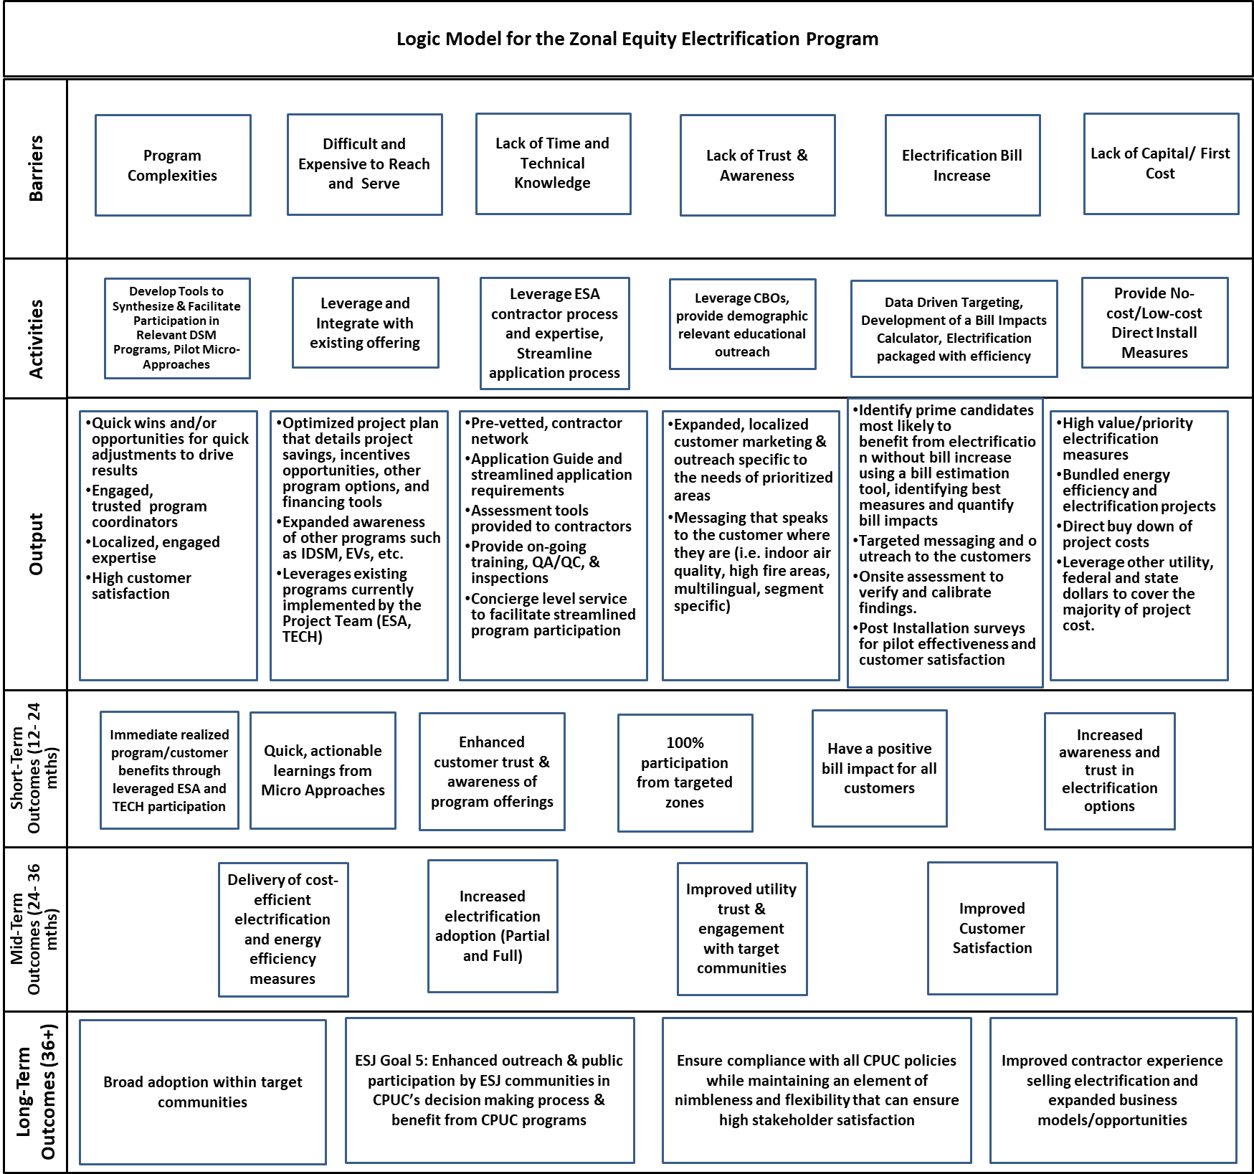

Process Flow Chart
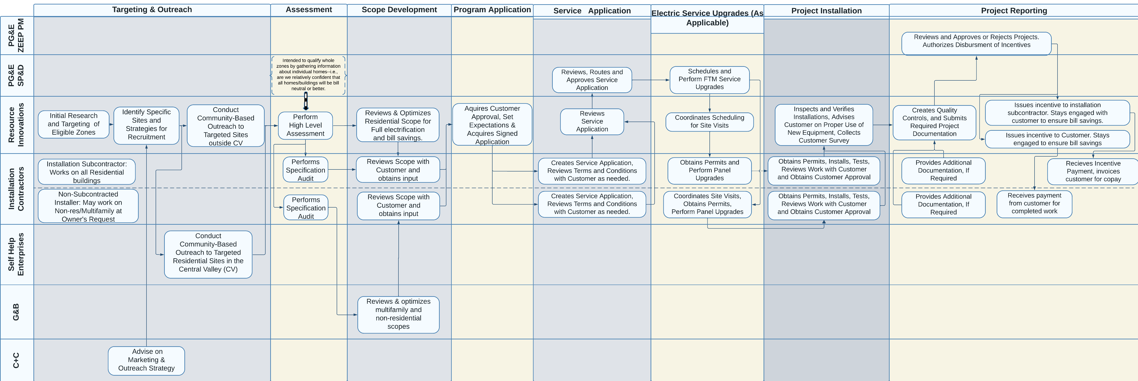

Incentive Tables, Workpaper, Software Tools
Customer incentives, when combined with leveraged resources, will be designed to fully (for residential customers) or mostly (for non-residential and multifamily customers) cover the project costs related to building electrification and additional energy efficiency upgrades needed to maintain bill neutrality or generate bill savings, including necessary FTM service upgrades, BTM electrical upgrades, and minimal remediation. For projects utilizing non-subcontracted installers, the customer is responsible for paying their non-subcontracted installer and the customer will receive Program incentives once their completed project is approved. For projects utilizing installation subcontractors, Program incentives will be paid directly to the installation subcontractors in alignment with installed measures and negotiated prices. Non-residential and multifamily participants will only be obligated to pay out of pocket for project costs not covered by Program incentives and leveraged resources.
Program funding will be supplemented by leveraged resources to minimize direct Program costs and use of ratepayer-funded sources. Leveraged resources will be prioritized as follows:
- Inflation Reduction Act (IRA)/Equitable Decarbonization Programs
  - As eligibility aligns, the federal IRA and California’s Equitable Decarbonization programs will be used for residential projects.
- TECH Clean California
  - To the extent possible, the TECH program will be used to cover behind the meter electric system upgrades and heat pump-based HVAC and domestic hot water electrification costs for residential and multifamily projects.
- Ratepayer Programs
  - To the extent possible, ratepayer programs will be used. For example, the ESA program will be used to address remediation and energy efficiency measure upgrades applicable to the residential premise, if eligible. Commercial incentives and rebates will be used to support measure upgrades applicable to non-residential premises.
- PG&E Reallocated Gas Project Funding
  - Reallocated gas funding available for the targeted zone will be used primarily for infrastructure improvements (FTM, BTM), DERs, and community incentives. If needed, it may also be used for residential and non-residential electrification and energy efficiency costs not covered through the sources listed above.
- Powerful Neighborhoods
  - Any residential project costs directly related to electrification and energy efficiency measures not fully covered by the leveraged programs above will use Powerful Neighborhoods funds to offset remaining measure costs. Neighborhoods funds will cover remaining non-residential measure costs until approximately 80% of the total project cost is paid for by ZEEP and leveraged funding sources.

To the extent additional leveraging opportunities become available, these will be included to minimize costs upon PG&E approval.
Residential incentives will cover 100% of project costs, and non-residential incentives will cover approximately 80% of project costs, minus leveraged program funding the customer is eligible for. For projects only covering 80% of project costs, PG&E will be billed at up to 80% of actual project costs, minus leveraged program funding the customer is eligible for.
Once a project is fully installed, the Implementer will submit the completed Project documentation to PG&E for review, approval, and payment, and the Program will fulfill any remaining obligations under the incentive agreements created with all participants in the fully electrified zone.
If a micropilot is required to incentivize participation, the Program will work with PG&E to design and right-size supplemental zone-specific reward offers beyond measure-level incentives and define each reward package in a way that motivates all customers in a zone to participate in the Program. The Program will work with each micropilot zone to gather input on the reward offers that would be most compelling to them. Program funding will not be utilized for these rewards; the Program will look at external sources first (i.e., Air Resources Board grants, PG&E Corporation Foundation) and may leverage gas infrastructure funding if other external sources cannot be applied. All rewards must be reviewed and approved by PG&E in writing unless approved in the P&P Manual. Rewards will only be funded and issued after all customers in the zone are fully electrified.

Measure List
The following table lists the electrification measures that ZEEP initially intends to offer for residential and non-residential customers and an initial list of energy efficiency measures to support the Program’s efforts to provide bill savings or bill neutrality.
The Program will offer measures based on active or expired deemed measure packages. The Implementer will request written approval from PG&E before offering additional measures not listed in the table. The Program will provide coordination support for additional measures offered through leveraged programs, which will be defined in the PMP along with their corresponding incentives.
MEASURE NAME | MEASURE DESCRIPTION
Ceiling Insulation, Residential | Ceiling - add up to R-60 batts on top of vintage-specific existing insulation R-11, R-19, R-30, R-38, R-44 and R-60 batts
Wall Insulation, Residential | Residential wall blow-in R-0 to R-13 insulation
Window Film, Commercial
Packaged Heat Pump, Commercial, Fuel Substitution | Commercial SEER-rated package heat pump, < 65 kBtu/hr SEER 16 to 18 HSPF 8.5 to 9.7
Packaged Heat Pump, Commercial, Fuel Substitution | Commercial IEER-rated package heat pump, 65 - 134 kBtu/hr IEER 15.0 to 16.0 COP 3.4
Packaged Heat Pump, Commercial, Fuel Substitution | Commercial IEER-rated package heat pump, 135 - 239 kBtu/hr IEER 14.5 to 15.5 COP 3.2
Packaged Heat Pump, Commercial, Fuel Substitution | Commercial IEER-rated package heat pump, 240 - 760 kBtu/hr IEER 13.5 to 14.0 COP 3.2
Unitary Air-Cooled AC or HP  Under 65 kBTU/hr, Commercial | Unitary air-cooled, packaged AC, 18 - 33 kBtu/hr, 15-18 SEER, with no economizer
Unitary Air-Cooled AC or HP  Under 65 kBTU/hr, Commercial | Unitary air-cooled, packaged AC, 33 - 55 kBtu/hr, 15-18 SEER, with economizer
Unitary Air-Cooled AC or HP  Under 65 kBTU/hr, Commercial | Unitary air-cooled, packaged AC, 55 - 65 kBtu/hr, 15-18 SEER, with economizer
Unitary Air-Cooled AC or HP  Under 65 kBTU/hr, Commercial | Unitary air-cooled, packaged HP, 18 - 33 kBtu/hr, 15-18 SEER, with no economizer
Unitary Air-Cooled AC or HP  Under 65 kBTU/hr, Commercial | Unitary air-cooled, packaged HP, 33 - 55 kBtu/hr, 15-18 SEER, with economizer
Unitary Air-Cooled AC or HP  Under 65 kBTU/hr, Commercial | Unitary air-cooled, packaged HP, 55 - 65 kBtu/hr, 15-18 SEER, with economizer
Unitary Air-Cooled AC or HP  Over 65 kBTU/hr, Commercial | Unitary air-cooled, commercial packaged AC, > 760 kBtu/hr, 10.2-12 EER
Unitary Air-Cooled AC or HP  Over 65 kBTU/hr, Commercial | Unitary air-cooled, commercial packaged AC, 135 - 239 kBtu/hr, 11.5-12.5 EER
Unitary Air-Cooled AC or HP  Over 65 kBTU/hr, Commercial | Unitary air-cooled, commercial packaged AC, 240 - 759 kBtu/hr, 10.8-12.5 EER
Unitary Air-Cooled AC or HP  Over 65 kBTU/hr, Commercial | Unitary air-cooled, commercial packaged AC, 65 - 134 kBtu/hr, 11.5-13 EER
Unitary Air-Cooled AC or HP  Over 65 kBTU/hr, Commercial | Unitary air-cooled, commercial packaged HP, 135 - 239 kBtu/hr, 10.8-11.2 EER and 3.48-3.51 COP
Unitary Air-Cooled AC or HP  Over 65 kBTU/hr, Commercial | Unitary air-cooled, commercial packaged HP, 240 - 759 kBtu/hr, 9.7-10 EER and 3.3 COP
Unitary Air-Cooled AC or HP  Over 65 kBTU/hr, Commercial | Unitary air-cooled, commercial packaged HP, 65 - 134 kBtu/hr, 11.5-12 EER and 3.5 COP
LED Lamps: Type B Tubes
LED Lamps: Type C Tubes | 2-lamp Fixture
LED Lamps: Type C Tubes | 3-lamp Fixture
LED Lamps: Type C Tubes | 4-lamp Fixture
LED New Fixture Package - Commercial
HPWH Fuel Substitution - Commercial | 50-gallon HPWH with Uniform Energy Factor (UEF) of 3.75
HPWH Fuel Substitution - Commercial | 65-gallon HPWH with UEF of 3.75
HPWH Fuel Substitution - Commercial | 80-gallon HPWH with UEF of 3.75
HPWH Fuel Substitution - Commercial | 120-gallon HPWH with Coefficient of Performance (COP) of 4.3
HPWH, Electric WH to HPWH - Commercial | 50-gallon HPWH with Uniform Energy Factor (UEF) of 3.75
HPWH, Electric WH to HPWH - Commercial | 65-gallon HPWH with UEF of 3.75
HPWH, Electric WH to HPWH - Commercial | 80-gallon HPWH with UEF of 3.75
HPWH, Electric WH to HPWH - Commercial | 120-gallon HPWH with Coefficient of Performance (COP) of 4.3
Smart Thermostats - Residential | Measure only applicable to primary heating systems gas furnaces and heat pumps  Not applicable for elec resistance or hydronic heating
Smart Fan Controller - Residential | Smart Fan Controller
Smart Fan Controller with Smart Thermostat | Smart Fan Controller with Smart Thermostat
Cooking Appliance, Residential, Fuel Substitution | 84% efficiency Electric Induction cooktop replacing gas cooktop, no oven
Cooking Appliance, Residential, Fuel Substitution | 84% efficiency Electric range with induction cooktop replacing gas range, electric resistance oven
Cooking Appliance, Residential, Fuel Substitution | 74% efficiency Electric Resistance Cooktop replacing gas range, electric resistance oven
Cooking Appliance, Residential, Fuel Substitution | Electric resistance wall oven replacing gas wall oven
Heat Pump Clothes Dryer, Residential, Fuel Substitution  Min Combined Energy Factor (CEF) of 4.50 | Compact size heat pump clothes dryer, 120 volt, vented, dwelling Energy Star qualified clother dryer meeting v1.1 specs
Heat Pump Clothes Dryer, Residential, Fuel Substitution  Min Combined Energy Factor (CEF) of 4.50 | Compact size heat pump clothes dryer, 240 volt, vented, dwelling
Heat Pump Clothes Dryer, Residential, Fuel Substitution  Min Combined Energy Factor (CEF) of 4.50 | Compact size heat pump clothes dryer, 120 volt, ventless, dwelling
Heat Pump Clothes Dryer, Residential, Fuel Substitution  Min Combined Energy Factor (CEF) of 4.50 | Compact size heat pump clothes dryer, 240 volt, ventless, dwelling
Duct Optimization, Residential
Duct Resizing, Residential
Manual J Testing
HVAC Installation - Installation Exception 1, Residential | Crane Fees
HVAC | Permits
HVAC Installation - Installation Exception 2, Residential | Title 24 Testing
LED Lamps: Type A Tubes
LED Lamps: Pin and Screw-base
LED Retrofit Kit: Interior General | Downlight
LED Retrofit Kit: Interior General | Troffer, 1x4,
LED Retrofit Kit: Interior General | Troffer, 2x2,
LED Retrofit Kit: Interior General | Troffer, 2x4,
Faucet Aerators - Commercial | 0.5, 1.0 and 1.5 gpm flow rate aerators with control valves
Faucet Aerators - Residential
Low-Flow Showerhead, Residential | Efficient showerhead with 1.0, 1.25, 1.5, 1.6 and 1.7 gpm flow rates
Low-Flow Showerhead, Commercial
Duct Seal, Residential | Duct sealing to reduce total leakage to a "low" leakage (12% leakage)
Hot Water Pipe Insulation, Nonresidential and Multifamily | 1 inch thickness required for insulation required
Water Heater Pipe Wrap, Residential
LED Exterior Area Lighting | MLC can be used for all Non-Res lighting that do not have an active Measure Package (MP)
LED Exterior Wall mounted lighting | MLC can be used for all Non-Res lighting that do not have an active Measure Package (MP)
BTM Electrical Upgrade - New Circuit Res
BTM Electrical Upgrade - New Panel Res
BTM Electrical Upgrade - New Sub-Panel Res
BTM Electrical Upgrade - New Circuit NonRes
BTM Electrical Upgrade - New Panel NonRes
BTM Electrical Upgrade - New Sub-Panel NonRes
TECH or other leveraged program application submission
Ductless mini split single zone - Residential | Mini-split or multi-split ductless HP, SEER >= 18 and HSPF >= 9.8 (.75 ton)
Ductless mini split single zone - Residential | Mini-split or multi-split ductless HP, SEER >= 18 and HSPF >= 9.8 (1 ton)
Ductless mini split single zone - Residential | Mini-split or multi-split ductless HP, SEER >= 18 and HSPF >= 9.8 (1.5 ton)
Ductless mini split single zone - Residential | Mini-split or multi-split ductless HP, SEER >= 18 and HSPF >= 9.8 (2 ton)
Ductless mini split dual zone - Residential | Mini-split or multi-split ductless HP, SEER >= 18 and HSPF >= 9.8 (1.5 ton)
Ductless mini split dual zone - Residential | Mini-split or multi-split ductless HP, SEER >= 18 and HSPF >= 9.8 (2 ton)
Ductless mini split dual zone - Residential | Mini-split or multi-split ductless HP, SEER >= 18 and HSPF >= 9.8 (2.5 ton)
Ductless mini split dual zone - Residential | Mini-split or multi-split ductless HP, SEER >= 18 and HSPF >= 9.8 (3 ton)
Ductless mini split dual zone - Residential | Mini-split or multi-split ductless HP, SEER >= 18 and HSPF >= 9.8 (3.5 ton)
Ductless mini split dual zone - Residential | Mini-split or multi-split ductless HP, SEER >= 18 and HSPF >= 9.8 (4 ton)
Ductless mini split tri zone - Residential | Mini-split or multi-split ductless HP, SEER >= 18 and HSPF >= 9.8 (2 ton)
Ductless mini split tri zone - Residential | Mini-split or multi-split ductless HP, SEER >= 18 and HSPF >= 9.8 (2.5 ton)
Ductless mini split tri zone - Residential | Mini-split or multi-split ductless HP, SEER >= 18 and HSPF >= 9.8 (3 ton)
Ductless mini split tri zone - Residential | Mini-split or multi-split ductless HP, SEER >= 18 and HSPF >= 9.8 (3.5 ton)
Ductless mini split tri zone - Residential | Mini-split or multi-split ductless HP, SEER >= 18 and HSPF >= 9.8 (4 ton)
Ductless mini split tri zone - Residential | Mini-split or multi-split ductless HP, SEER >= 18 and HSPF >= 9.8 (4.5 ton)
Ductless mini split tri zone - Residential | Mini-split or multi-split ductless HP, SEER >= 18 and HSPF >= 9.8 (5 ton)
Ductless mini split quad zone - Residential | Mini-split or multi-split ductless HP, SEER >= 18 and HSPF >= 9.8 (3 ton)
Ductless mini split quad zone - Residential | Mini-split or multi-split ductless HP, SEER >= 18 and HSPF >= 9.8 (3.5 ton)
Ductless mini split quad zone - Residential | Mini-split or multi-split ductless HP, SEER >= 18 and HSPF >= 9.8 (4 ton)
Ductless mini split quad zone - Residential | Mini-split or multi-split ductless HP, SEER >= 18 and HSPF >= 9.8 (5 ton)
Heat pump package units | Residential legacy-rated split/pkg HP, SEER >= 16 and HSPF >= 9 (2 ton)
Heat pump package units | Residential legacy-rated split/pkg HP, SEER >= 16 and HSPF >= 9 (2.5 ton)
Heat pump package units | Residential legacy-rated split/pkg HP, SEER >= 16 and HSPF >= 9 (3 ton)
Heat pump package units | Residential legacy-rated split/pkg HP, SEER >= 16 and HSPF >= 9 (3.5 ton)
Heat pump package units | Residential legacy-rated split/pkg HP, SEER >= 16 and HSPF >= 9 (4 ton)
Heat pump package units | Residential legacy-rated split/pkg HP, SEER >= 16 and HSPF >= 9 (5 ton)
Heat pump split systems | Residential legacy-rated split/pkg HP, SEER >= 16 and HSPF >= 9 (1.5 ton)
Heat pump split systems | Residential legacy-rated split/pkg HP, SEER >= 16 and HSPF >= 9 (2 ton)
Heat pump split systems | Residential legacy-rated split/pkg HP, SEER >= 16 and HSPF >= 9 (2.5 ton)
Heat pump split systems | Residential legacy-rated split/pkg HP, SEER >= 16 and HSPF >= 9 (3 ton)
Heat pump split systems | Residential legacy-rated split/pkg HP, SEER >= 16 and HSPF >= 9 (3.5 ton)
Heat pump split systems | Residential legacy-rated split/pkg HP, SEER >= 16 and HSPF >= 9 (4 ton)
Heat pump split systems | Residential legacy-rated split/pkg HP, SEER >= 16 and HSPF >= 9 (5 ton)
FTM Service Upgrades - Overhead Res
FTM Service Upgrades - Underground Res
FTM Service Upgrades - Overhead NonRes
FTM Service Upgrades - Underground NonRes
Remediation - HVAC Res
Remediation - HPWH Res
Remediation - Electrical Res
Remediation - Cooking Res
Remediation - Generic Res
Remediation - HVAC NonRes
Remediation - HPWH NonRes
Remediation - Electrical NonRes
Remediation - Cooking NonRes
Remediation - Generic NonRes

Work Papers
TBD

Software Tools
Powerful Neighborhoods will utilize Resource Innovations iEnergy Program Management cloud-based software platform to facilitate streamlined and effective operations of all aspects of the program, including but not limited to customer eligibility screening and enrollment, outreach and engagement, trade ally network coordination and management, tracking project, incentive, assessment and survey data, and real-time insights and reporting.
Simple diagram of iEnergy Program Management platform:
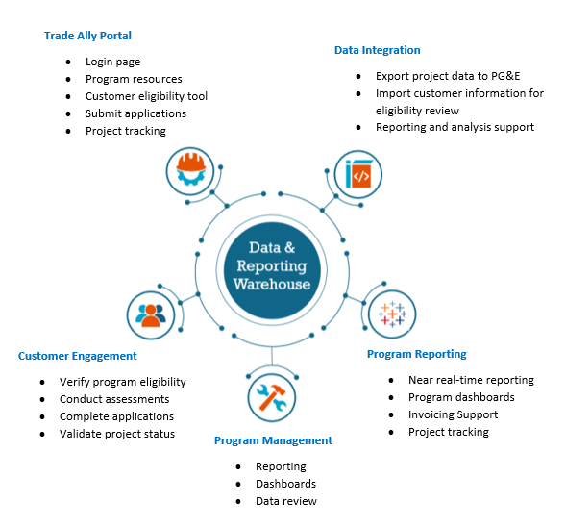
Screenshots of the platform's auditing component, OnSite, will be deployed in support of the Program’s outreach and customer support activities. It is a web-based tool accessible via tablet and smart device, allowing for a simple yet robust collection of customer site information and real-time generation of assessment reports for the customer.

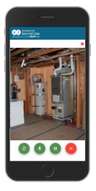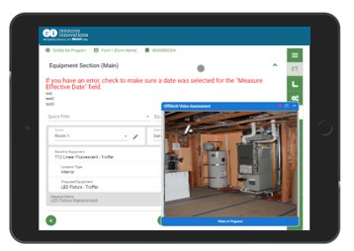
Photo collection for documenting site conditions and post-install verification.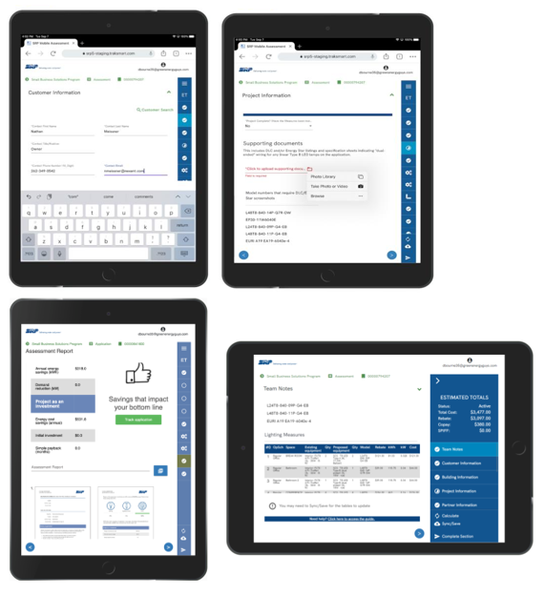
Examples of data collection screen and compilation of measure recommendations, tailored for each customer site visit.

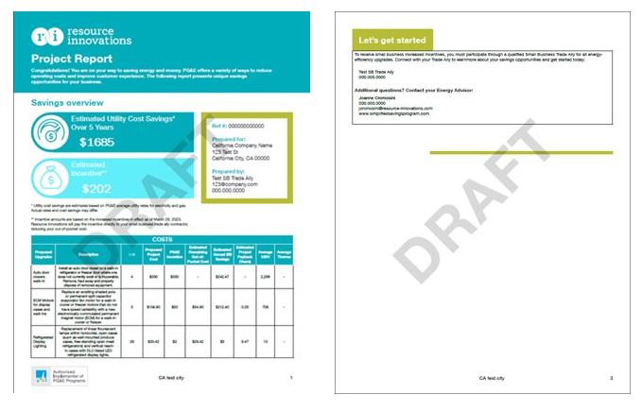
Example of the output produced by the OnSite tool based on findings and information collected during the site visit. This report would be provided to the customer during the site visit and used to encourage adoption of installed measures and continued engagement.

Quantitative Program Targets
See section 1.1.2 for details about the program budget and goals. As a pilot, there are unknown aspects of zone conversion complexity that will improve and decrease conversion rates. The Implementer will work with PG&E to update targets as information emerges from research and ongoing data collection and analysis.
Powerful Neighborhoods will target 78 residential and 5 non-residential participants over three years, all within DACs and low-income communities.
NUMBER OF PREMISES ELECTRIFIED
 | 2024 | 2025 | 2026 | 2027 | Total
Total Number Electrified Residential Premises | - | 14 | 36 | 28 | 78
Total Number of Non-Residential Premises Electrified (NOTE: A minimum of 5 Non-Residential participants req. over the contract duration) | - | - | 2 | 3 | 5
TOTAL NUMBER OF PREMISES | - | 14 | 38 | 31

NUMBER OF ZONES ELECTRIFIED
 | 2024 | 2025 | 2026 | 2027 | Total
Number of electrified zones with 1 meter (No more than 25 single-meter zones may be included without prior PG&E approval) | - | 10 | 10 | 5 | 25
Number of electrified zones with 2-4 meters (no constraints) | - | 1 | 1 | - | 2
Number of electrified zones with 5 OR MORE meters | - | - | 1 | 2 | 3
TOTAL NUMBER OF ZONES | - | 11 | 12 | 7 | 30

AVERAGE EXPECTED BILL IMPACT (ANNUALIZED FIRST-YEAR BILL SAVINGS)
 | 2024 | 2025 | 2026 | 2027 | Avg.
Residential; in dollars | - | $(260) | $(275) | $(290) | $(275)
Non-Residential; in dollars | - | $(2,250) | $(2,362) | $(2,481) | $(2,364)

Diagram of Program

Evaluation, Measurement & Verification (EM&V)

Modeling
The Program will develop whole-building models for interventions that are likely to produce bill savings or neutrality. The process is as follows:
  - Prepare a model of the existing building with existing conditions using utility-reviewed software.
    - Use a combination of customer and modeled data to calibrate/verify the model.
  - Prepare usage summary for both electricity and gas.
    - Hourly or Monthly usage.
    - Hourly load profiles using DEER can be used for hourly summary.
    - Apply normalization in the model where needed, specifically for gas hourly usage.
  - Calibrate the model against utility-provided metering data to be within tolerance limits (+-10% of electricity and +-20% of natural gas)
    - Monthly usage will be calibrated against modeled usage for 12 trailing months.
  - Apply proposed measures to the building.
    - List all assumptions for efficient equipment (i.e., HPWH UEF/COP, HP HSPF, etc.).
    - May use CA T24 2022 or 2025 guidelines for early screening where proposed measure details are not finalized.
  - Prepare electric usage summary after implementing proposed measures
    - Hourly summaries to estimate the impacts accurately
  - If eligible, use PG&E Electric Home rates to prepare bill impact reports for residential customers.
RI will train the model based on the provided historical usage and then use trained models to apply proposed measures and estimate bill impacts.
RI will request at least 18 months of usage data to better understand consumption patterns and train models. However, rental turnover may impact the reliability of models without additional data points that are unlikely to be available, such as move-in/out dates, unoccupied dates, etc.

Monitoring Post-installation Bill Impact
The Implementer will continuously monitor post-intervention energy bills using AMI data, adjusting historical consumption to current rates for accurate comparison. Monitoring will continue for 12 months post-installation or until the Program’s sunset date, whichever occurs first.
The Program will establish an initial tolerance of +6% around the pre-intervention bill amount. This tolerance will account for normal fluctuations in energy consumption while identifying significant deviations that could indicate issues with the EE and/or electrification measures. The Program will flag any participant's bill that exceeds the established tolerance for bill neutrality, triggering a review process.
The review process will investigate, understand, and potentially address the cause with several options, including recommissioning and/or customer training in equipment operation and scheduling. Other corrective interventions may emerge as the Program continuously incorporates lessons from research, installations, and outreach. The Program will continually adjust its strategies to improve effectiveness and customer satisfaction.
Key Assumptions:
- EE and electrification measures will achieve modeled consumption expectations within the tolerances provided above but may require adjustments based on individual site conditions and external energy usage factors.
- Customer energy consumption patterns post-intervention will generally align with projected savings, with allowances made for seasonal and operational variability.

Measure Verification
Measure verification will happen at the project level, with all installers submitting customer information, baseline condition equipment details, and measures installed, including geotagged photographs, copies of invoices, number and cost of units, incentives applied, and installation dates.
RI will capture the information in iEnergy so that it is easily accessible to reviewers and inspectors conducting virtual or in-field inspections.
During the on-site post-inspection process, Implementer will:
- Inspect 100% of projects
- Verify measure eligibility, installation, and quality of commissioning by completing checklists based on established procedures and criteria
- Work with the customer and/or installation subcontractor (or non-subcontracted installer) to resolve any discrepancies, if applicable
Inspectors will finalize, record, and track all quality assurance findings and any necessary project remediations. Participants will be tracked within iEnergy. This will include customer contact information, date of interaction, and any other program outcomes (e.g., if the customer utilized a leveraged program for which they are eligible, referral to another program, referral to another subcontracted installer for additional measures).
The Implementer will provide monthly data-driven reviews with installation subcontractors to evaluate the current scope and depth of data collection and reporting with key stakeholders and determine if any adjustments are needed (e.g., assess the appropriateness/adequacy of metrics, data granularity, report format and frequency, and lead conversions).

Third-Party Performance Data Collection Plan
Resource Innovations will use a data-driven approach to provide effective, comprehensive, end-to-end data collection, analysis, and reporting. This will drive continuous improvement to reduce risk and increase participation, savings, forecast accuracy, and cost efficiencies. The following table summarizes the data types, sources, and frequency of use, which will be considered for internal use only for the Implementer’s program management and reporting purposes and shared only with PG&E.

Table 4. Data Reporting
Outreach and Marketing Reports to track Program operations, increase forecasting accuracy, and analyze the effectiveness of marketing spend and pivot.
Frequency: Monthly  - Data Sources:  - iEnergy OnSite  - Contractor management software  - Salesforce customer relationship manager (CRM) | - Sample Data Points:  - Pipeline: Number/percent of projects by stage and aging  - Website Metrics: Page views, time per page  - Campaign and Reach Metrics: Number of customers engaged, commitment/conversion rates
Customer Data to assess and develop projects, maintain effective customer communications, and track Program operations and customer satisfaction KPIs.
- Frequency: Quarterly  - Data Sources:  - iEnergy Onsite  - Customer Applications  - Salesforce CRM  - Customer satisfaction survey | - Sample Data Points:  - Facility Data: Type, location, size, age  - Systems and Equipment Information  - Satisfaction Ratings  - Contact Information
Program Management to assess overall Program performance vs. goals, review energy/bill savings and Program operations, KPIs, identify underperforming areas and create action plans.
Frequency: Monthly  Data Sources:  - iEnergy Program Management,  - PG&E’s Energy Insights Database | Sample Data Points:  - Program deliverables and milestones  - Budget metrics: Percent spent vs. goal  - Realized vs. Forecasted Energy Savings  - Bill Impact  - Non-Energy Benefits  - Measure and Cost Project Details  - Safety, diversity, and compliance: Incidents, accuracy of incentives processed, diverse business spend
Subcontractor Management to highlight areas for improvement, identify subcontractors for rewards and recognition, forecast and allocate resources, and track and report on customer satisfaction and Program KPIs.
Frequency: Monthly with quarterly and annual roll-up  Data Sources:  - iEnergy OnSite  - Contractor management software  - Salesforce CRM  - Commitments/ Customer/Project Applications | Sample Data Points:  - Pipeline: Number/percent of commitments/projects by stage, aging metrics  - Conversion Rates  - Savings vs. Targets  - Measure Mix  - Referrals  - Installation Subcontractor Satisfaction

Normalized Metered Energy Consumption (NMEC)
Not Applicable

