Implementation Plan

Community Education & Outreach (CEO) Program

Program Implementer: Global Energy Services, Inc.
Portfolio Administrator: SDG&E

Table of Contents

Program Overview……………………………………………………………………… 3

Program Budget and Saving…………………………………………………………….3
- Program Name………………………………………………………………………….3
- Program ID……………………………………………………………………….…….3
- Program Budget Table…………………………………………………………………3
- Program Gross Impacts Table………………………………………………………….3
- Program Cost-Effectiveness……………………………………………………………3
- Program Total System Benefits………………………………………………………..3
- Type of Program Implementer…………………………………………………………3
- Market Sector…………………………………………………………………………..3
- Program Type…………………………………………………………………………..3
- Market Channel and Intervention Strategies…………………………………………...3

Implementation Plan Narrative……………………………………………….……..… .3
- Program Description………………………………………………………….……...…3
- Program Delivery and Customer Services……………………………………….…..…4
- Program Design and Best Practices………………………………………………….....5
- Program Innovation……………………………………………………………….……6
- Metrics……………………………………………………………………….……..…..6
- For Programs Claiming To-Code Savings………………………………………………7
- Pilots…………………………………………………………………………………….7
- Workforce Education and Training………………………………………………….…..8
- Workforce Standards………………………………………………………………….…8
- Disadvantaged Worker Plan………………………………………………………….….8
- Additional Information……………………………………………………………….….8
- DBE Requirement…………………………………………………………………….….8

Supporting Documents……………………………………………………………………10
Attachment 1: Program Manual…………………………………………………...……………..10
Attachment 2: Program Theory & Program Logic Model…………………………...……….….13
Attachment 3: Program Process Flow Chart…………………………………………………….14
Attachment 4: Incentive Table for Measures, Measure Packages……………………………….14
Attachment 5: Quantitative Targets…………………………………..…………………………14
Attachment 6: Diagram of Program…………………………..…………………………………17
Attachment 7: Evaluation, Measurement, & Verification………………………………………17
Attahcment 8: Normalized Metered Energy Consumption (NMEC)……………………………23
Attachment 9: Marketing Plan…………………………….……………………………………..23
Attachment 10: Quality Assurance Plan…………….……………………………………….......27
Attachment 11: Procedures/Training Manual……………………………………………………28
11.1 In-Home Survey Training Manual………………………………………………….33
11.2 Invoicing/Reporting Training Manual……………………………………………...36

Program Overview

The Community Education and Outreach (CEO) Program empowers residential customers in disadvantaged communities (DAC) and hard-to-reach (HTR) within SDG&E’s service territory. Through in-language community booths, seminars, door hangers, and school outreach, CEO enhances participation in SDG&E’s energy efficiency and demand-side management programs.

Program Budget and Savings

- Program and/or Sub-Program Name: Community Education & Outreach (CEO)
- Program / Sub-Program ID number: SDGE4176
- Program / Sub-program Budget Table

Cost Category | 2024 | 2025 | 2026 | 2027 | Total | % of Budget
Administration | $51,000 | $51,000 | $51,000 | $51,000 | $204,000 | 6%
Marketing | 108,250 | 77,250 | 77,250 | 77,250 | 340,000 | 10%
Direct Impl. Non-Incentive | 633,500 | 800,300 | 806,700 | 615,500 | 2,856,000 | 84%
Total Budget | $792,750 | $928,550 | $934,950 | $743,750 | $3,400,000 | 100%

- Program / Sub-program Gross Impacts Table: Not Applicable
- Program / Sub-Program Cost Effectiveness (TRC): Not Applicable
- Program / Sub-Program Cost Effectiveness (PAC): Not Applicable
- Type of Program: Third-Party-Delivered
- Market Sector(s): Residential
- Program / Sub-program Type (i.e., Non-resource, Resource): Non-Resource
- Market channel(s) (i.e., downstream, midstream, and/or upstream) and Intervention Strategies: Downstream. Strategies include information, education, and energy audits.

Implementation Plan Narrative

- Program Description

The CEO is an education and outreach program primarily focusing on residential customers in Disadvantaged Communities (DACs) or classified as Hard-to-Reach (HTR) in the SDG&E service territory. CEO’s comprehensive education and outreach will seek to increase customer participation across SDG&E’s energy efficiency (EE) and other demand-side management programs through in-language community engagement.

Primary objectives of the program include:

- Provide energy efficiency (EE) awareness and education to targeted customers in single-family, multi-family and mobile homes.
- Customers will be presented with the SDG&E program offerings and encouraged to participate in the applicable program.
- Program participants will be referred to other demand-side management (DSM) programs, such as Energy Savings Assistance (ESA) and Demand Response programs where applicable.
- Resource Acquisition programs within the EE portfolio will benefit by increasing energy savings and Total System Benefits through CEO’s referral efforts.

- Program Delivery and Customer Services

The CEO program plans to engage customers using an extensive language-based approach, setting up vibrant booths at community events, workshops, and school outreach. It will collaborate with faith-based groups and local authorities, deploying targeted media advertisements and social media campaigns and maintaining a consistent presence.

GES will undertake the following tasks on behalf of the CEO Program:

The CEO program will offer marketing, education, and outreach (ME&O) services, interacting with customers through booth displays and seminars at community events and targeting marketing efforts with local governments, door hangers, and social media ads. The CEO’s multilingual website will furnish program details and collect customer interests. To ensure cost-effectiveness, the CEO will leverage its community ties and establish communication channels.

Direct Implementation Activities:
- In-Language Seminars: In-person, in-language seminars at community centers. Coordinate, enroll, set up with 3 to 4 staff, present home survey leads, EE program interest, and customer feedback.
- In-Language Community Booths: Coordinate in the DACs for community booths in SDG&E’s service territory. These events include local festivals, farmers’ markets, holiday events, cultural festivals, grocery stores, etc. Booths will have 2 to 3 in-language staff to interact, explain, and enroll customers for in-home surveys, and obtain customer interest in program, along with feedback.
- Green Schools Outreach: Share EE program video and information with parents. The School Outreach initiative will target 5 schools per year in DACs within the SDG&E service territory. We plan to target one school every 2-3 months. The Program will show an engaging and easy-to-understand EE program video in the classroom, designed specifically for students. The video will highlight the benefits of energy efficiency and provide practical tips for saving energy at home. After watching the video, students will receive an informational brochure with detailed SDG&E EE/DR program information to take home and share with their parents.
- Local Governments and Partnership Events: Coordinate with local governments and SDG&E’s local public affairs department to participate in events with booths with 2 to 3 in-language staff to interact, explain, and enroll customers for home surveys and obtain customer interest and feedback.
- Church, Faith-Based Organizations, and Senior Center Outreach: Coordinate and participate in events with booths with 2 to 3 in-language staff to interact, explain, and enroll customers for home surveys and obtain customer interest and feedback.
- Door Hanger in DACs: Door hangers distributed at selected DACs with program information and home survey enrollment. Ride-along and geotagged pictures for records and reporting.
- Multifamily In-Person Visits: In-person visits will be made to multifamily properties to provide direct outreach to multifamily owners, apartment owners and renters on EE program information.
- In-Home Energy Surveys: Multifamily and single-family in-language in-home energy surveys with EE reports, interest cards, and feedback. The Program will provide these energy surveys at the customers’ homes.
- Media Ads (Radio and Newspaper Only): Targeted in-language media ads in popular news media providing program and enrollment information.
- Social Media Ads (Instagram, Google Ads): Targeted DACs with social media ads on Google and Instagram.
- Partner with Midstream Intermediaries: Partner with midstream intermediaries who sell EE equipment to contractors and customers in the DACs. The Implementer will leverage these partnerships to reach out to the ethnic residential contractors serving the DAC/HTR customers.

- Program Design and Best Practices
Market Barriers | Program Strategies
Lack of Awareness: Language Barrier  The lack of awareness of EE initiatives among DACs is largely due to language barriers and the absence of utility EE programs that address those barriers. The two maps of Linguistic Isolation and Disadvantaged Communities in CalEnviroScreen reveal overlap. | - CEO will reach out to the underserved and DAC/HTR customers through a 100% in-language program. CEO will primarily serve the Hispanic, Chinese, Vietnamese, and Korean communities in their languages. CEO’s in-language website is available in multiple languages. The website will be available in Spanish, Chinese, Korean and Vietnamese.  - Each activity is tailored to customer demographics with in-language collaterals, videos, a website, and an in-language helpline available in Spanish, Chinese, Korean and Vietnamese.  - CEO’s in-language home advisors will explain program offerings and enhance participation.
Knowledge Barrier on available EE/Rebate programs.  Gaps in knowledge of EE/Rebate programs stem primarily from the language barriers and the non-existence of in-language utility programs. | - CEO’s in-language staff and home advisors will address the knowledge barrier by educating customers and providing them with EE/Rebate information directly in one-on-one settings. All CEO’s EE activities will create awareness, knowledge, and participation in EE/DR and Electrification programs.
Technical Barrier  The DAC/HTR customer is usually an older population of homeowners and renters who are often not tech-savvy. | - The CEO’s direct interface at events and trained home advisors will answer questions and remove all technical barriers.  - CEO will provide a toll-free, in-language helpline for any technical questions.

The CEO Program seeks to overcome the English as a second language market barrier by targeting hard-to-reach, low- and medium-income customers. The Program strategy is unique because it is 100% in-language. The CEO program will target the Asian, Hispanic, and other ethnicities in the DACs in SDG&E’s service territory.

- Program Innovation

The CEO will offer in-language education and outreach of available EE programs to SDG&E’s targeted customers. CEO will:
- Establish a toll-free phone line to assist customers with technical or participation-related questions.
- Partner with businesses that sell EE equipment to contractors and those contractors who install the equipment in DAC areas to locate qualifying customers.
- Design a Green Schools outreach in DAC/HTR demographics to create awareness and encourage students to enlist their parents in EE programs.
- Partner with midstream intermediaries who sell EE equipment to contractors and customers in the DAC areas. The Implementer will leverage these partnerships to reach out to the ethnic residential contractors serving the DAC/HTR customers.
- Target local DAC/HTR demographics with in-language staffing of booths and table-tops at local grocery stores and various retail outlets to disseminate information and enroll customers.
- Provide business cards to all customers attending the CEO’s outreach events that display program participation information on one side and a QR code on the back. Upon participation, customers can scan the QR code to take them to a landing page on the CEO website.

- Metrics
Table 1 – Key Performance Indicators for 2024-2027
ID | Indicator | Description | Continuous Monitoring Mechanisms
1 | Number of HTR Customers | Total number of HTR customers engaged through outreach and education efforts | Monthly Report  Quarterly Report  Annual Report
2 | Number of DAC Customers | Total number of DAC customers engaged through outreach and education efforts | Monthly Report  Quarterly Report  Annual Report
3 | Number of residential Single family equity targeted customers | Total number of residential single-family equity customers engaged through outreach and education efforts | Monthly Report  Quarterly Report  Annual Report
4 | Number of residential Multifamily equity targeted customers | Total number of residential multifamily (including manufactured homes) equity customers engaged through outreach and education efforts | Monthly Report  Quarterly Report  Annual Report
5 | Number of Community-Based Organizations (CBOs) in Environmental Justice Communities | Number of CBO’s engaged located in Environmental Justice Communities | Monthly Report  Quarterly Report  Annual Report
6 | Advancing Disadvantaged Worker policies | Annual number of supplemental staff residing in SDG&E Disadvantaged Communities | Monthly Report  Quarterly Report  Annual Report
7 | Number of customers referred to an EE/DSM program | Total number of customers referred to an EE/DSM program | Monthly Report  Quarterly Report  Annual Report

- For Programs Claiming To-Code Savings
Not Applicable

- Pilots
Not Applicable

- Workforce Education and Training
Not Applicable

- Workforce Standards
Not Applicable

- Disadvantage Worker Plan

As an implementer of the CEO program, GES is committed to hiring disadvantaged workers from the SDG&E territory. Over 80 percent of GES’ current staff have overcome language barriers, over 30 percent do not have a college degree, and/or reside in lower-income and disadvantaged communities. GES will hire supplemental staff from SDG&E’s Disadvantaged Communities to support CEO community outreach efforts. GES will provide in-house training to these staff members.

GES will collect personal information from individual workers beyond their residential zip code information. GES’ collection of such information will 1) be strictly voluntary for the worker, 2) be recorded anonymously, and 3) not be used as a reason to include or exclude particular workers from assignment to any projects. GES will seek information in a manner such that the workers do not feel compelled to provide any such personal information, particularly related to the marital or parental status, involvement in the criminal justice system, and/or involvement with the foster care system.

GES will provide the following information to SDG&E quarterly and at the completion of the Program on hiring activities as a result of this Program. GES will report:

- Number of new employees hired by Implementer;
- Number of job promotions initiated by Implementer;
- Number of hours worked by employees and subcontractors, and
- Number of hours worked by employees and subcontractors residing in targeted zip codes provided by the Company.

- Additional Information:
- Collecting Customer Information
To manage customer information effectively and engage customers about EE and DR programs without using a traditional CRM system, GES will leverage spreadsheets and Mailchimp alongside physical data collection methods. At events and booths, data can be collected on paper forms, while schools can distribute flyers with QR codes linking to online surveys or signup forms and collect data during informational sessions. Phone interactions can be manually logged into a centralized spreadsheet, and Mailchimp can be used for email campaigns and online signup forms. The collected data, including personal information, demographic details, customer preferences, program interests, and behavioral data, will be securely stored in password-protected spreadsheets and locked physical storage. Spreadsheets will be used to track customer interactions, monitor engagement, and set follow-up schedules, while Mailchimp provides analytics for email campaigns. Regular data integration, cleansing, and reporting ensure the information remains accurate and useful. At the end of each month, securely destroy paper forms that have been digitized to maintain data security. This approach provides a structured and secure method to handle customer data, ensuring compliance with data protection regulations and improving customer engagement.

Supporting Documents

Attachment 1: Program Manuals

Introduction
The Community Education Outreach (CEO) Program, hereinafter referred to as “the program,” is a 100% in-language, non-resource, local, highly-targeted, and residential energy efficiency marketing, outreach, and education that targets hard-to-reach, Asian and Hispanic-speaking residential customers of San Diego Gas and Electric Company (SDG&E).

The CEO Program promotes SDG&E’s energy efficiency (EE) programs through education and training, collaborating with faith-based organizations, schools, and community events. The Program’s marketing efforts spark interest and lead to participation in In-Home surveys, third-party EE programs, and rebate opportunities. Targeting customers in Disadvantaged Communities (DAC) and Hard-to-Reach (HTR) zip codes, the CEO program empowers residential customers in these areas within SDG&E’s service territory. Utilizing in-language community booths, seminars, door hangers, and school outreach, the CEO boosts participation in SDG&E’s EE and demand-side management programs.

Eligible Measures
Not applicable - CEO is a non-resource program.

Customer Eligibility Requirements
The CEO program follows the guidelines of customer eligibility requirements as follows:

- Must be a residential single, multifamily, or mobile home customer of SDG&E.
- Must reside in the DACs and be defined as a HTR or Equity customer within the SDG&E service territory.

Contractor Eligibility Requirements
GES will train Iserv, San Diego, to capture geotagged photographs and send them to GES’s drive for verification, followed by sharing them with our SDG&E Program Advisor in GES’s monthly activity report.

Participating Contractors
Within the CEO initiative, the Program will partner with “Iserv, San Diego” a dedicated door hanger distribution service, to bolster GES’sdoor hanger campaigns.

Additional Services
As an integral component of the CEO program, GES employs a multifaceted approach to effectively engage SDG&E customers. GES’s strategies include:

a. Educational Seminars
- In-language seminars cover energy-saving tips, understanding utility bills, and available SDG&E EE/DR programs.
- Tailored sessions for different community groups, including seniors, low-income families, and non-English speakers.

b. Outreach Events
  - Set up booths at local fairs, farmers markets, and cultural festivals.
  - Provide educational materials, answer questions, and engage with community members.
  - Participate in local community events to disseminate information and resources.

c. Green Schools
- Green Schools outreach will include an energy artist contest. Students will be given drawing sheets with an energy-efficient theme.
- Students will also be given collaterals and a home survey interest card to enroll their parents for a home survey.

d. In-home Energy Advisements
- Offer personalized in-home consultations to help residents identify energy-saving opportunities.
- Provide tailored advice and resources based on individual household needs.

e. Community-Based Organizations
- Collaborate with community-based organizations to expand outreach efforts.
- Leverage existing networks and relationships to reach a broader audience.

f. Door Hangers
- Distribute door hangers in target neighborhoods with information about the CEO program and energy-saving tips.
- Include contact information for residents to learn more or request additional
resources.

g. Multifamily in-person visits
- In-person visits to multifamily properties and provide direct outreach to multifamily owners, apartment owners and renters on EE program information.

h. Social Media/Media
- Utilize social media platforms such as Facebook and Instagram to share information, updates, and event announcements.
- Create engaging content, including videos, infographics, and success stories, to raise awareness and encourage participation.
- Partner with local radio stations to broadcast program information and energy-saving tips.
- Use radio ads to reach non-English speaking communities.

i. Audits
As a non-resource program, audits are not conducted. However, evaluations or assessments may be carried out to measure program effectiveness or participant satisfaction. These evaluations will focus on customer feedback.

Sub-Program Quality Assurance Provisions:
GES ensures quality control through regular ride-along with the door hanger distributor, Iserv, San Diego. Additionally, GES maintain data sheets to track feedback on digital ads, including “likes” and “comments,” as well as monitor radio ad calls on a separate datasheet.

Other Program Metrics
Table 1 – Key Performance Indicators for 2024-2027
ID | Indicator | Description | Continuous Monitoring Mechanisms
1 | Number of HTR Customers | Total number of HTR customers engaged through outreach and education efforts | Monthly Report  Quarterly Report  Annual Report
2 | Number of DAC Customers | Total number of DAC customers engaged through outreach and education efforts | Monthly Report  Quarterly Report  Annual Report
3 | Number of residential Single family equity targeted customers | Total number of residential single-family equity customers engaged through outreach and education efforts | Monthly Report  Quarterly Report  Annual Report
4 | Number of residential Multifamily equity targeted customers | Total number of residential multifamily (including manufactured homes) equity customers engaged through outreach and education efforts | Monthly Report  Quarterly Report  Annual Report
5 | Number of Community-Based Organizations (CBOs) in Environmental Justice Communities | Number of CBO’s engaged located in Environmental Justice Communities | Monthly Report  Quarterly Report  Annual Report
6 | Advancing Disadvantaged Worker policies | Annual number of supplemental staff residing in SDG&E Disadvantaged Communities | Monthly Report  Quarterly Report  Annual Report
7 | Number of customers referred to an EE/DSM program | Total number of customers referred to an EE/DSM program | Monthly Report  Quarterly Report  Annual Report

Attachment 2: Program Logic Model
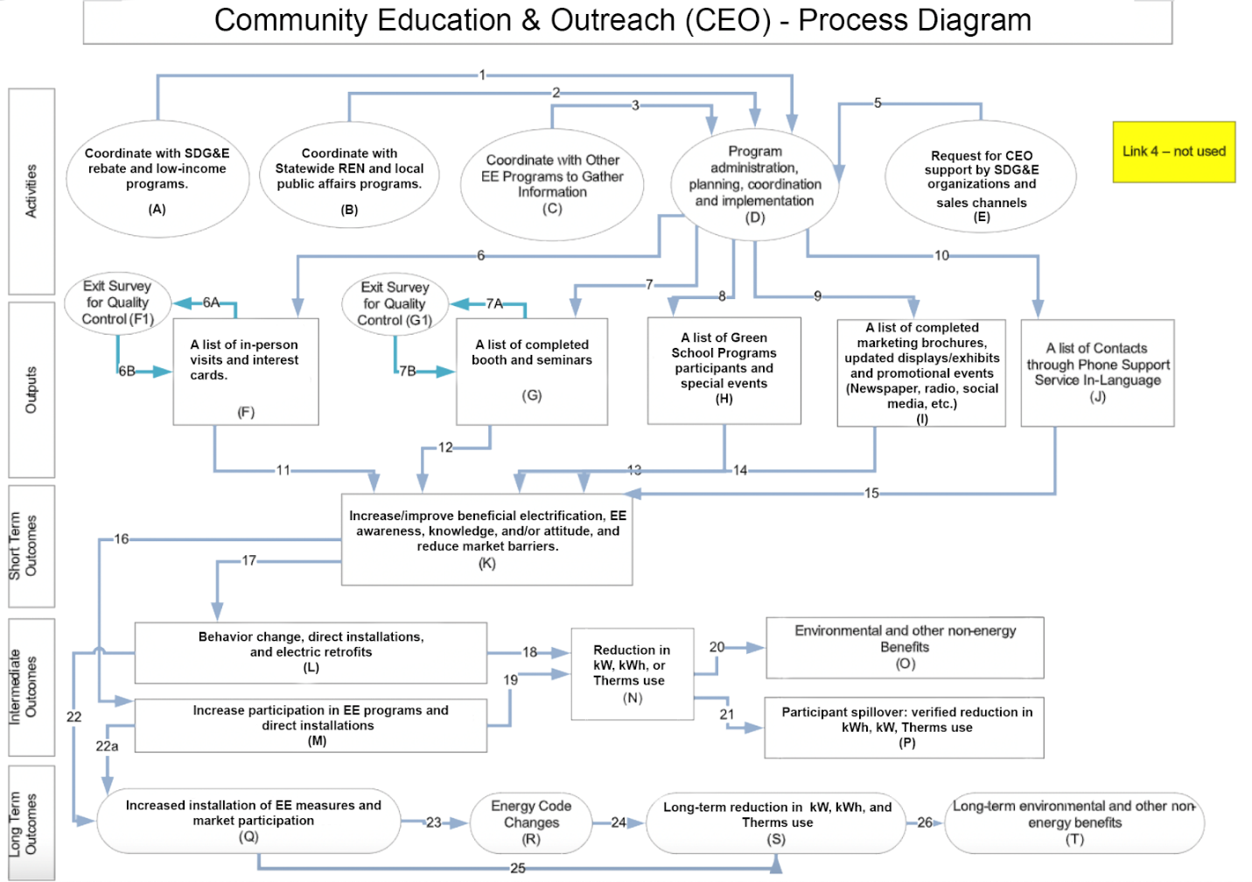

Attachment 3: Process Flow Chart

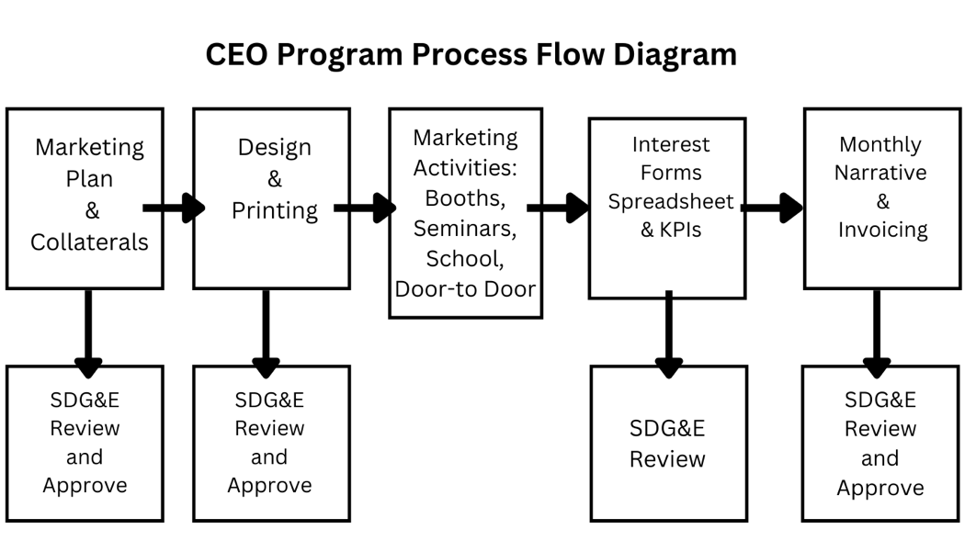

Attachment 4: Incentive Tables, Workpapers, Software Tools

N/A

Attachment 5: Quantitative Program Targets

Target | Description | 2024 | 2025 | 2026 | 2027 | Total  2024-2027
In-Language Seminars | In-person, in-language seminars at community centers. Coordinate, enroll, set up with 3 to 4 staff, present, home survey leads, EE program interest, and customer feedback. | 5 | 5 | 5 | 5 | 20
In-Language  Community booths | Customer with the DACs for community booths. Booths will have 2 to 3 in-language staff to interact, explain, and enroll customers for in-home surveys, and obtain customer interest along with customer feedback | 45 | 65 | 66 | 45 | 221
School Outreach | Share EE program video and information with parents | 4 | 5 | 5 | 4 | 18
Local Governments and partnership events | Coordinate with local governments and SDG&E’s local public affairs to participate in events with booths with 2 to 3 in language staff to interact, explain, and enroll customers for home surveys, and obtain customer interest along with customer feedback | 4 | 4 | 4 | 4 | 16
Church, Faith Based Organizations, and Senior Center Outreach | Coordinate and participate in events with booths with 2 to 3 in-language staff to interact, explain, and enroll customers for home surveys, and obtain customer interest along with customer feedback. | 5 | 5 | 5 | 5 | 20
Door Hangers in DACs | Door hangers at selected DACs with program information and home survey enrollment. Ride-along and geotagged pictures for records. | 10,000 | 16,000 | 16,000 | 10,000 | 52,000
- Multifamily In-person Visits | In-person visits to multifamily properties and provide direct outreach to multifamily owners, apartment owners and renters on EE program information. | 50 | 60 | 60 | 50 | 220
In-home Surveys | Multifamily and Single family -In-language in-home surveys with EE report, interest cards, and feedback. These surveys will be provided in the customer’s home. | 180 | 240 | 240 | 180 | 840
Media Ads (Radio and Newspaper Only) | Targeted in-language media ads in popular news media providing program and enrollment information. | 35 | 37 | 38 | 35 | 145
Social Media Ads (Instagram, Google Ads) | Targeted DACs with social media ads on Google and Instagram. | 60 | 66 | 66 | 60 | 252

Attachment 6: Diagram of Program

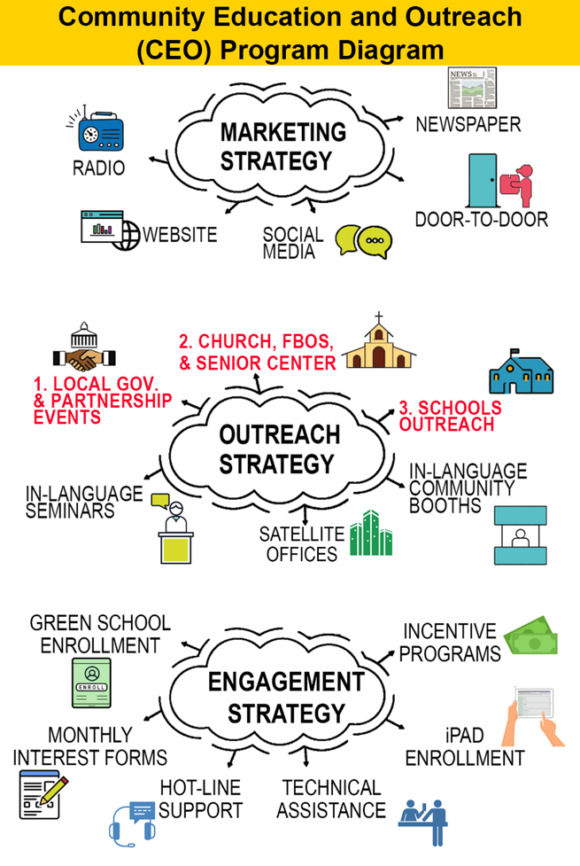

Attachment 7: Evaluation, Measurement, and Verification (EM&V)

Introduction
This Evaluation, Measurement, and Verification (M&V) Plan describes the objectives and approaches used to verify the performance of the Community Education & Outreach Program (CEO), implemented by Global Energy Services (GES). The objective of this Program is to educate and drive Disadvantaged Communities (DAC) and Hard-to-Reach (HTR) residential customers to take energy efficiency (EE) actions that they would not have otherwise. This M&V Plan describes the key performance indicators and metrics that will be measured, and the processes used to measure them. It identifies the schedule for reporting the results and the GES team responsible for carrying them out. GES will use this data to report, assess, manage, and potentially improve program performance.

Program Objectives and Approaches
Per California Public Utilities Commission, in Decision 21-05-031, Equity programs are “programs with a primary purpose of serving hard-to-reach or underserved customers and disadvantaged communities in the advancement of the Commission’s Environmental and Social Justice Action Plan; the objectives of such programs may include increasing customer safety, comfort, resiliency, and/or reducing customers’ energy bills.”

The objectives of the CEO Program are:
- Educating the DAC/HTR and the underserved residential communities in SDG&E’s service area to increase customer awareness and participation across SDG&E’s EE/Demand Response (DR) programs and, as appropriate, the Energy Savings Assistance (ESA) program.
- Coordinate with other Statewide, Regional Energy Networks (REN), Low-income, and other local marketing, education, and outreach (ME&O) programs to add value and avoid overlap.

These objectives are delivered by:
- Conducting meaningful in-language marketing and outreach to the DAC/HTR and the underserved ethnic residential communities in SDG&E’s service area.
- Conducting in-language workshops and booths at community events to educate and enroll customer participation by integrating EE, DR, and electrification measures.
- Conducting in-language door-to-door outreach to ethnic DAC/HTR multifamily customers in housing complexes with fewer than 50 units. This outreach will help customers better understand their electric and gas bills and generate leads for participation in SDG&E’s EE/DR programs and, as appropriate, ESA program.
- Offering a comprehensive website with language options providing EE rebate and DR incentive information and links to direct DAC/HTR customers to SDG&E’s EE/DR programs and, as appropriate, ESA program.
- Creating a social media presence with Facebook, Instagram, and Twitter ads to encourage DAC/HTR customers to sign up for the appropriate EE/DR/ESA programs.
- Publishing EE articles in local city newsletters to educate and provide information on the availability of technical support for residential EE/DR program enrollment information.
- Working closely with the SDG&E’s Program Manager to create a data-secure process that shares data and activity information with other programs and avoids overlap. GES will also work with SDG&E’s Local Public Affairs to coordinate all ME&O.

Table 1: Key Performance Indicators Through Program Reporting
Table 1 – Key Performance Indicators for 2024-2027
ID | Indicator | Description | Continuous Monitoring Mechanisms
1 | Number of HTR Customers | Total number of HTR customers engaged through outreach and education efforts | Monthly Report  Quarterly Report  Annual Report
2 | Number of DAC Customers | Total number of DAC customers engaged through outreach and education efforts | Monthly Report  Quarterly Report  Annual Report
3 | Number of residential Single family equity targeted customers | Total number of residential single-family equity customers engaged through outreach and education efforts | Monthly Report  Quarterly Report  Annual Report
4 | Number of residential Multifamily equity targeted customers | Total number of residential multifamily (including manufactured homes) equity customers engaged through outreach and education efforts | Monthly Report  Quarterly Report  Annual Report
5 | Number of Community-Based Organizations (CBOs) in Environmental Justice Communities | Number of CBO’s engaged located in Environmental Justice Communities | Monthly Report  Quarterly Report  Annual Report
6 | Advancing Disadvantaged Worker policies | Annual number of supplemental staff residing in SDG&E Disadvantaged Communities | Monthly Report  Quarterly Report  Annual Report
7 | Number of customers referred to an EE/DSM program | Total number of customers referred to an EE/DSM program | Monthly Report  Quarterly Report  Annual Report

Table 2 illustrates the monthly KPI tracking template. This template may be modified to meet additional SDG&E and/or CPUC reporting needs.

Table 2: Community Education & Outreach Program Monthly Tracking
Month | Number of HTR Customers | Number of DAC Customers | Number of residential Single family equity targeted customers | Number of residential Multifamily equity targeted customers | Number of Community-Based Organizations (CBOs) in Environmental Justice Communities | Advancing Disadvantaged Worker policies | Number of customers referred to an EE/DSM program
January 2024
February 2024
March 2024
April 2024
May 2024
June 2024
July 2024
August 2024
September 2024
October 2024
November 2024
December 2024
Total | 0 | 0 | 0 | 0 | 0 | 0 | 0
2024 Total Number Rached | 0 | 0 | 0 | 0 | 0 | 0 | 0

GES will develop a simple database to collect and report data from the CEO participants’ customer satisfaction survey (Attachment 1).
Table 3 identifies the data collected from the CEO Program participants’ follow-up surveys. The follow-up surveys will report the number of Program participants that enrolled in SDG&E’s EE/DR programs or ESA program as a result of the CEO.
Table 3: Follow-up Customer Survey Data Tracking
 | Participated in Program Collateral
Customer Name | Booth | Seminar | Door Hanger | Door-to-Door | Social Media | Local Newspaper | Local Radio | Schools | Action Taken? (Yes/No) | What was the action taken?
Customer 1 |  |  |  | X |  |  |  |  | Yes | EE program incentive  (Referral)
Customer 2 |  |  | X |  |  |  |  |  | No

Measurement and Verification Using Monthly and Quarterly Reporting
The plan for the Program includes a thorough process of collecting and reporting data on these KPIs. The Program will collect a large amount of data on the CEO activities and the customers participating. Table 1 identifies KPI data collected for Program reporting. A tracking system will facilitate efficient and accurate entry and validation of workshops, seminars, event booths, newspaper and radio station ads, social media ads, and door-to-door customer engagements. It is simple to define periodic reports that may be generated as needed and automatically report on program operations.

GES will also conduct follow-up customer satisfaction surveys to annually assess CEO’s performance. The customer satisfaction surveys are conducted immediately after a seminar, a booth, or a door-to-door customer interaction. GES will also conduct a participant follow-up survey to assess whether the program’s activities caused the customer to take action, such as inquiring or signing up for an SDG&E EE and/or DR program. Each quarter, after an event of door-to-door customer interaction, GES will reach out to these customers to inquire whether they have taken an EE and/or DR or electrification action. GES is sensitive to customer privacy; GES’s will limit its follow-up contacts to customers to one time per program participant.

Measurement and Verification Activities and Reporting Schedule
During the implementation phase of the Program, monthly reports will be generated, reviewed internally for consistency and accuracy, and uploaded as required to the SDG&E program portal. After review by the SDG&E Program Manager, the GES will respond promptly to questions submitted by the Program Manager. Upon receipt of any data requests from SDG&E, GES will generate custom reports to provide the information that SDG&E requires. The GES program implementation team will conduct these tasks, particularly the sub-team that is responsible for data tracking and reporting. The results will be reviewed and evaluated by the SDG&E Program Manager and the GES Lead.

GES will provide SDG&E, as needed, with documentation to support the accomplishments of the CEO Program activity. GES will collect and provide to SDG&E upon request, for example, the customer signup sheets from seminars and in-home surveys and tracking data of clickable links and online signup to document Program success. For door-to-door customer engagements, customer satisfaction surveys will document customer participation and provide immediate feedback on the Program’s direct customer engagement performance.

In addition to the Program data collection, GES developed Customer Satisfaction Surveys (Attachment 1) to document and collect information on customers’ satisfaction with the Program. GES will use this data to assess the Program’s performance and make improvements as needed. GES will also conduct and document follow-up calls with participating customers to assess if the CEO caused a DAC/HTR customer to participate in an SDG&E EE and/or DR program, and/or installed EE, DR, or electrification measures. GES will report annually to SDG&E the results of the participant customer follow-up surveys.

Risk and Participation Rates Uncertainty
GES does not anticipate any significant risk to the Program’s success during implementation. GES has implemented marketing and outreach programs for the DAC/HTR communities for over five program cycles efficiently and successfully without any risks derailing the Program’s implementation.

The possible risks that could arise are categorized below, but GES trusts none of them will jeopardize the successful implementation of the Program.

- Customers are not willing to participate in door-to-door engagements. GES will be respectful to customers and will leave door-hanger gift bags with those customers to provide EE/DR information materials.
- Low turnouts for community events. GES will ensure that the event’s messaging is clear, concise, and compelling; highlighting the benefits that would interest community members. GES will also engage key stakeholders in the community, such as local organizations, businesses, or influential individuals to seek their support in promoting the event and encourage their participation.
- Technology Challenges. Implementing digital marketing initiatives, such as online platforms or customer engagement tools, may encounter technical issues. This could include website crashes, data breaches, or system failures, impacting the effectiveness of the Program. The CEO will ensure robust testing and continuous monitoring of the technology infrastructure to minimize disruptions.
- Without proper metrics and evaluation mechanisms in place, it can be challenging to determine the Program’s success and make informed decisions. The CEO will establish clear key performance indicators (KPIs) and implement robust monitoring and evaluation processes that will enable GES to assess the Program’s impact and make necessary adjustments.

The risks of collecting M&V data include:
- Customers not willing to sign the sign-in sheet at seminar or booth events,
- Customers not willing to participate in completing the customer satisfaction surveys
- Customers not willing to participate in the follow-up outreach calls

The GES team will do its best to build customer rapport and trust to encourage customer participation.

Details of Who Will Conduct M&V Activities
To minimize the Program’s costs, GES will conduct all the M&V data collection and perform all data analysis.

Process Improvement
Should the results of the monthly reports, customer satisfaction surveys or customer follow-up surveys indicate that the Program is not achieving its objectives, GES will, in collaboration with SDG&E, implement continuous process improvement modifications to the program design and provide adequate documentation of any improvement changes. If necessary, the Program will conduct additional M&V activities to gather more details on why the metrics are not being met.

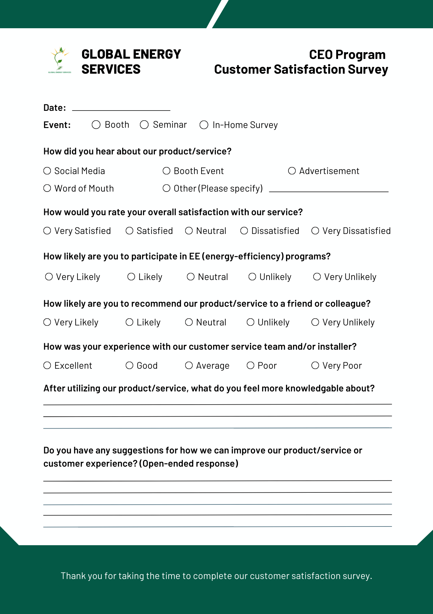

Attachment 8: Normalized Metered Energy Consumption (NMEC):

N/A

Attachment 9: Marketing Plan

OVERVIEW

Introduction
The 2024 Community Education Outreach (CEO) Program, hereinafter referred to as “the program,” is a 100% in-language, non-resource, local, highly-targeted, and residential energy efficiency marketing, outreach, and education that targets hard-to-reach, Asian and Hispanic speaking residential customers of San Diego Gas and Electric Company (SDG&E).

The CEO (Community Education and Outreach) program promotes SDG&E’s energy efficiency (EE) programs through education and training, collaborating with faith-based organizations, schools, and community events. The Program’s marketing efforts spark interest and lead to participation in Energy Advisements, third-party EE programs, and rebate opportunities. Targeting customers in Disadvantaged Communities (DAC) and Hard-to-Reach (HTR) zip codes, the CEO program empowers residential customers in these areas within SDG&E’s service territory. Utilizing in-language community booths, seminars, door hangers, and school outreach, CEO boosts participation in SDG&E’s EE and demand-side management programs.

Purpose
The initiative aims to provide Energy Efficiency (EE) awareness and education to targeted customers in single-family, multifamily, and mobile homes. Customers will be informed about SDG&E program offerings and encouraged to participate in applicable programs. Program participants will be referred to other demand-side management (DSM) programs, such as Energy Savings Assistance (ESA) and Demand Response, when relevant. Resource acquisition programs within the EE portfolio will benefit by increasing energy savings and total system benefits through the CEO’s referral efforts.

Objectives and Goals

The goal of GES’s outreach initiative is to engage and educate disadvantaged communities (DAC) and hard-to-reach (HTR) customers about energy efficiency (EE) programs. This will be achieved through a multifaceted approach that includes in-language seminars and community booths, school outreach, collaborations with local governments and partnership events, outreach through faith-based organizations and senior centers, door hangers, multifamily in-person visits, in-home surveys, and targeted media and social media ads. Each strategy aims to inform and signup DAC/HTR customers for EE programs, ensuring they benefit from available resources and support to enhance energy efficiency in their homes.

Table 1. Goals and Objectives
Goals | Objectives
- In-language Seminars | Educate DAC/HTR customers. Sign-up customers for EE Programs.
- In-language Community Booths | Inform DAC/HTR customers. Sign-up customers for EE Programs.
- School outreach | Educate students and sign-up parents for EE programs.
- Local Governments and Partnership Events. | Inform DAC/HTR customers. Sign-up customers for EE Programs.
- Church, Faith-based Organizations, and Senior Center Outreach. | Inform DAC/HTR customers. Sign-up customers for EE Programs.
- Door Hangers in DACs. | Inform DAC/HTR customers. Sign-up customers for EE Programs.
- Multifamily In-Person Visits. | Educate DAC/HTR customers. Sign-up customers for EE Programs
- In-Home Survey | Educate single-family and multi-family DAC/HTR customers. Sign-up customers for EE Programs
- Media Ads (Radio and Newspaper Only) | Inform, educate, and encourage EE program participation. Hotline calls for technical assistance.
- Social Media Ads (Instagram, Google Ads) | Encourage DAC/HTR customers to sign-up for appropriate EE program.

Target Audience
Contractor will target the following audiences: Residential customers in single-family, multifamily, and mobile homes with the primary focus on hard-to-reach (HTR) customers, disadvantaged communities (DACs), and equity-defined customers
Eligibility criteria include:

- Residential Single, multifamily, and mobile home customers within the SDG&E service territory.
- Must reside in the DACs within the SDG&E service territory.
- Must be a paying SDG&E customer.

Marketing Team
Role | Name
Program Director | Basu Mukherjee
Program Manager | Christopher Rosas
Marketing and Communications Lead | Joscelyn Mendoza
Marketing Designer | Sabrina Kurth
Marketing & Outreach Coordinator | Christopher Rosas
Collateral Coordinator | Christopher Rosas

STRATEGIC MARKETING AND COMMUNICATIONS

Strategies and Tactics

Marketing Strategies | Approach
- Community Partnerships | - Collaborate with Local Organizations: Partner with local community organizations, non-profit.
- Culturally Relevant Messaging | - Language and Cultural Sensitivity: Ensure marketing materials are available in the languages spoken by the community and reflect their cultural norms and values.
- Multi-Channel Approach | - Digital Channels: Use social media and email newsletters to reach tech-savvy residents.  - Traditional Media: Utilize local radio stations and newspapers to reach those less active online.
- Promotions | - Promoting Participation: To stimulate participation such as free energy-saving devices, or raffle entries for those who participate in workshops or events.  - Referral Programs: Encourage word-of-mouth by offering rewards for residents who refer friends and family to the initiative
- Educational Content | - Informative Workshops: Offer educational workshops on energy efficiency, renewable energy options, and strategies to reduce utility bills.

Messaging
TBD

Marketing Materials and Collateral
Need marketing approval from SDG&E.

Trade Ally Engagement Plan
Not applicable

Stakeholder Engagement Plan
TBD

EVALUATION AND MEASUREMENT
Please reference Section 7.

Attachment 10: Quality Assurance Plan

Objective and Scope:

The objective of this Quality Assurance Plan is to ensure that all activities and deliverables within the education and outreach initiative are executed with a high standard of quality. This plan includes all specific activities and deliverables performed by the subcontractor, particularly the door hanger distribution.

Roles and Responsibilities:
- Implementer (Global Energy Services):
  - Overall program management and quality assurance.
  - Conduct regular audits and inspections of subcontractor activities.
  - Provide training and support to subcontractors as needed.
  - Ensure compliance with program objectives and quality standards.
- Subcontractor (Door Hanger Distribution Company):
  - Execute door hanger distribution as per the program requirements.
  - Maintain accurate records of distribution activities.
  - Participate in quality control activities, including inspections and audits.
  - Report any issues or non-conformities to the Implementer immediately.

Quality Control Activities:
- Implementer:
  - Conduct initial and periodic audits of the subcontractor’s distribution process.
  - Perform random inspections of door hanger distribution areas to ensure compliance.
  - Review subcontractor’s records and reports for accuracy and completeness.
  - Conduct peer reviews of the subcontractor’s activities.
- Subcontractor:
  - Perform self-inspections to ensure quality standards are met.
  - Maintain detailed logs of distribution activities, including locations and quantities.
  - Address any identified issues or non-conformities immediately.

Quality Improvement Process:
- Regularly review and update quality standards and procedures.
- Conduct monthly meetings to review quality performance and address any issues.
- Implement corrective and preventive actions for any identified non-conformities.

Communication and Collaboration:
- Establish clear lines of communication between the Implementer and the subcontractor.
- Schedule monthly meetings to discuss progress and address any issues.
- Utilize collaborative problem-solving approaches to address and resolve quality issues.
- Ensure all communications are documented and accessible to relevant parties.

Subcontractor Oversight:
- Conduct regular progress reviews to monitor subcontractor performance.
- Perform inspections and audits of the subcontractor’s activities and records.
- Provide feedback and support to the subcontractor to address any identified issues.
- Ensure that the subcontractor is meeting all defined quality standards.

Risk Management:
- Identify potential risks to quality in the program implementation.
- Assess the likelihood and impact of identified risks.
- Implement measures to mitigate identified risks, such as critical control points and quality control techniques.
- Develop contingency plans to address potential quality issues proactively.

Attachment: 11: Procedural/training Manuals

The primary objective of this training manual is to equip team members with the necessary skills and knowledge to successfully coordinate and execute booths and seminars as part of GES’s education and outreach initiative. This initiative is focused on engaging residential customers in disadvantaged communities (DAC), those classified as hard-to-reach (HTR) promoting equity within the SDG&E service territory.

GES’s goal is to raise energy efficiency (EE) awareness, provide valuable SDG&E information, and foster community engagement through well-organized events. By doing so, GES aims to improve EE, support sustainable practices, and educate customers on EE and Demand Response (DR) programs.

This training manual is designed to be a comprehensive guide that covers all aspects of event coordination and execution. It includes detailed instructions and best practices for:
- Event Coordination: Steps to effectively plan and manage an event, from initial planning to execution.
- Materials Needed: A detailed list of essential items required for setting up booths and conducting seminars.
- Setting Up and Breaking Down: Step-by-step procedures for setting up the booth and breaking it down after the event.
- Geotagged Pictures: Guidelines on the types of geotagged pictures needed and how to capture them.
- Signup Sheets: Templates and instructions for collecting and managing attendee information.
- Best Practices: Tips and strategies for engaging with attendees and ensuring a successful event.
- Health and Safety: Guidelines to ensure the safety and well-being of both team members and attendees.
- Evaluation and Feedback: Methods for evaluating the success of an event and collecting feedback for continuous improvement.

By following this manual, team members will be able to conduct events that are not only informative and engaging but also organized and efficient. The ultimate aim is to create a positive impact on our target communities by providing them with the resources and knowledge they need to make informed decisions about energy use.

- Event Coordination
  - Identifying Location
- Identify locations within Disadvantaged Communities (DAC) territories in SDG&E service territory. Utilize online resources such as the California Environmental Protection Agency’s CalEnviroScreen 4.0 tool (https://experience.arcgis.com/experience/11d2f52282a54ceebcac7428e6184203/page/CalEnviroScreen-4_0/)to pinpoint these areas. Focus on locations that are central and easily accessible for residents, such as public spaces, community centers, schools, and local events where there is a high likelihood of foot traffic.
- Securing the Venue for Seminars: Once a suitable location is identified, contact the venue to check availability, book the space, and confirm any necessary details or requirements.
  - Permits and Permissions
- Application Process: Submit permit applications well in advance of the event. Ensure all necessary documentation and fees are included.
- Compliance: Adhere to all local regulations and requirements related to the event.
  - Logistics: Transportation and Accommodation
- Transport Arrangements: Arrange transportation for all materials and team members to and from the event location. This may include their own vehicles or coordinating carpooling among team members.
  - Defining Roles
- Event Coordinator: The primary person responsible for overall event planning and execution. Tasks include overseeing logistics, managing the budget, and ensuring all team members are on track.
- Setup Crew: Team members responsible for transporting, setting up, and breaking down the booth and equipment.
- Presenter: The individual(s) who will be delivering presentations or leading seminars. Responsible for preparing materials and engaging with attendees.
- Support Staff: Additional team members who assist with registration, managing signup sheets, distributing materials, and answering questions.

- Materials Needed
  - Booth Setup

- Tables: Sturdy tables for displaying materials and interacting with attendees.
- Chairs: Comfortable seating for team members.
- Canopies: For outdoor events, to provide shade and weather protection.
- Banners and Signage: Clear and attractive banners to draw attention and provide information about the initiative. Include branding and messaging.
- Tablecloths: Branded tablecloths to create a professional appearance.

  - Presentation Equipment (seminar)

- Projectors: For displaying slideshows, videos, or other visual materials.
- Screens: Portable screens for projector display.
- Laptops/Tablets: Devices for running presentations and showing digital materials.
- Speakers and Microphones: For ensuring that presenters can be heard clearly by attendees.
- Extension Cords and Power Strips: To ensure all electronic devices can be powered.

  - Promotional Materials

- Brochures and Flyers: Printed materials that provide information about the initiative, energy efficiency tips, and other relevant topics.
- Giveaways: Small branded items such as pens, notepads, reusable bags, or water bottles to attract and engage attendees.
- Business Cards: For team members to distribute to attendees for follow-up contact.

  - Signup Sheets

- Paper Signup Sheets: For collecting attendee information such as names, contact details, and specific interests.
- Clipboards and Pens: To facilitate the use of paper signup sheets.

Create checklists for all materials to ensure nothing is forgotten when preparing for an event. Include a packing checklist for transportation and an on-site checklist for setting up and breaking down. By having all necessary materials prepared and organized, team members can ensure the event runs smoothly and professionally, providing a positive experience for all attendees.

- Geotagged Pictures
  - Geotagged pictures are essential for documenting and reporting the success of GES’s outreach events. These photos help to:

- Validate: Provide evidence that events occur in targeted DACs.
- Market: Showcase successful events on social media, websites, and other promotional materials.
- Evaluate: Assess the setup, engagement, and overall impact of the event for future improvements.
- Pictures need to be on JPG

  - Types of Pictures Needed:

- Booth Setup: Photos of the booth fully assembled, showing banners, tables, materials, and any other setup elements.
- Engagement: Pictures of attendees interacting with team members, signing up, asking questions, and participating in activities.
- Presentations and Seminars: Images of presenters speaking to attendees, showing slides, and engaging with the audience.
  - Geotagging Instructions

Using Smartphones/Tablets
- Enable Location Services: Ensure that location services are enabled on the device. This can usually be done through the device’s settings.
- Camera Settings: Open the camera app and check if location tagging is enabled. This setting might be found in the camera’s settings menu.
- Taking Pictures: Use the camera app to take pictures as usual. The device will automatically embed location data in the photos.

- Signup Sheets
  - Signup sheets are a vital component of GES’s outreach events, serving multiple purposes:
- Follow-Up: Collect contact information for follow-up communication and engagement.
- Reporting: Provide data for reporting attendance and engagement metrics to stakeholders and funding agencies.
- Outreach: Help identify community members interested in specific topics or services for targeted outreach efforts.

  - Essential Information:

- Name: Collect full names for proper identification and follow-up.
- Contact Information: Obtain email addresses and phone numbers for future communication.
- Address: to see if they live in the DAC.
- Interests: Include checkboxes or fields for attendees to indicate their specific areas of interest (e.g., Demand response program, residential energy solutions, ESA).

  - Collecting Information:

- Station Setup: Designate a clear and accessible area at the booth for signup sheets. Ensure it is staffed by a team member to assist attendees.
- Encouragement: Encourage attendees to sign up by highlighting the benefits, such as receiving updates, accessing resources, or participating in future events.

5. Best Practices
a. Engagement Tips:

- Approachability: Ensure booth staff are friendly, approachable, and proactive in engaging with attendees. Smile, make eye contact, and greet attendees warmly.
- Clear Communication: Use clear, concise language when explaining information. Avoid jargon and tailor your message to the audience’s level of understanding.
- Listening: Actively listen to attendees’ questions and concerns. Show empathy and provide thoughtful, relevant responses.
- Follow-Up: Offer attendees materials to take home, such as brochures or flyers, and encourage them to sign up for follow-up communication.

b. Communication Skills:

- Consistency: Ensure all team members deliver consistent messages aligned with the initiative’s goals and values.
- Visual Aids: Use visual aids such as posters, slides, and videos to support verbal communication and make information easier to understand.

6. Evaluation and Feedback

a. Post-Event Review:

- Team Debrief: Hold a debriefing session with all team members immediately after the event to discuss what went well, what did not, and any challenges faced. Document key points.
- Metrics: Evaluate the event’s success using predefined metrics such as the number of attendees, signups, engagement levels, and materials distributed.
- Goals Assessment: Assess whether the event met its goals and objectives. Identify any gaps and areas for improvement.

  - Improvement Plans
- Analyze Feedback: Review and analyze all feedback from attendees and team members. Identify common themes and specific suggestions.
- Action Items: Develop a list of action items based on the feedback. Prioritize them and assign responsibilities for implementation.
- Continuous Improvement: Implement changes and improvements for future events. Document what worked well and what did not to build a knowledge base for continuous improvement.

By following these best practices and incorporating thorough evaluation and feedback processes, GES can ensure our outreach events are effective, engaging, and continuously improving. This will help GES better serve its target communities and achieve its initiative’s goals.

Attachment 11.1 In-Home Survey Training Manual

- Introduction

Welcome to the Home Survey Training Manual. This manual is designed to equip you with the knowledge and skills necessary to conduct effective home surveys. These surveys are crucial for understanding the needs and conditions of households in disadvantaged communities (DACs) and hard-to-reach (HTR) areas.

- Objectives of Home Surveys:

- Assess household energy usage and needs.
- Identify opportunities for energy efficiency improvements.
- Gather data to support program development and resource allocation.
- Build relationships and trust within the community.

- Preparing for the Survey

  - Materials Needed

- Survey forms (printed or digital)
- Clipboard or tablet
- Pens and pencils
- ID badge
- Informational brochures about your Program

  - Pre-Survey Checklist

- Confirm survey appointments with households.
- Charge all electronic devices.
- Review the survey form and any specific instructions.
- Ensure you have sufficient quantities of all materials.

- Conducting the Survey

  - Introduction and Consent

- Introduce yourself and the organization you represent.
- Explain the purpose of the survey and how the information will be used.
- Obtain verbal or written consent to proceed with the survey.

  - Survey Questions

- Start with general questions about the household (e.g., number of occupants, type of dwelling).
- Ask specific questions about energy usage and appliances.
- Include questions about any energy-saving measures already in place.
- Note any observations about the condition of the home related to energy efficiency (e.g., insulation, windows, HVAC systems).

  - Observation and Data Collection

- Take geotagged pictures of key areas (e.g., insulation, windows, HVAC systems).
- Record observations in the survey form.
- Be respectful and minimize disruption to the household.

- Post-Survey Procedures

  - Data Entry and Reporting

- Enter survey data into the designated database or system.
- Review data for accuracy and completeness.
- Submit any required reports or summaries to your supervisor.

  - Follow-Up Actions

- Provide households with any promised informational materials or follow-up actions.
- Schedule any necessary follow-up visits or calls.

- Best Practices

- Maintain a friendly and professional demeanor.
- Be respectful of the household’s time and privacy.
- Ensure clear and concise communication.
- Be thorough but efficient in conducting the survey.

- Safety Considerations
- Be aware of your surroundings and avoid potentially unsafe situations.
- Ensure that someone knows your schedule and location.

- Appendices

Sample Survey Script

“Hello, my name is [Your Name], and I’m with [Organization]. We are conducting a survey to understand household energy usage for SDG&E and identify opportunities for energy efficiency improvements. This survey will take about 30-45 minutes. Your participation is voluntary. May I proceed?”

Sample Survey Form
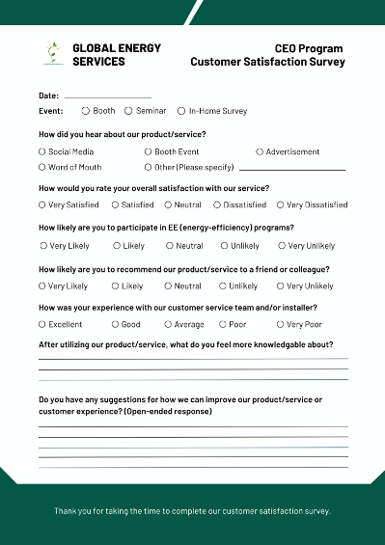

Attachment 11.2: Invoicing/Reporting Training Manual

GES’s staff has been managing and implementing similar programs that mirror the scope of work for the CEO program. As such, they are trained in reporting and invoicing. GES also conducts quarterly training to support staff with any changes or updates.

1. Overview of Invoicing and Reporting
Invoicing and reporting are critical components of GES’s program management. They ensure that financial transactions are documented accurately and that the progress and outcomes of GES’s programs are communicated effectively.

2. Invoicing Procedures

Preparing an Invoice
- Gather Necessary Information: Ensure all required details are acquired, including client information, services provided, dates, and costs.
- Use Standard Template: Fill out the company-approved invoice template to maintain consistency and professionalism.
- Double-Check Details: Verify all entries for accuracy, including calculations and descriptions of services.

Submitting an Invoice
- Review and Approve: Have a supervisor review the invoice for accuracy and completeness.
- Send to Client: Submit the invoice to EECP.

Tracking Invoices
- Log Invoices: Enter invoice details into the tracking system.
- Monitor Payments: Regularly check the status of payments and follow up on overdue invoices.
- Update Records: Keep the tracking system updated with payment statuses and any correspondence with clients.

