Statewide Codes & Standards Advocacy Program

Program Implementers:
2050 Partners
Cohen Ventures LLC, dba. Energy Solutions
Frontier Energy
McHugh Energy Consultants Inc.
TRC Inc.

Lead Program Administrator:
PG&E

June 25, 2024
Version 2.0

Contents
Statewide Codes & Standards Advocacy Program 1
Program Overview 4
Program Budget and Savings 4
1. Subprogram Names 4
2. Subprogram ID Numbers 4
3. Program and Subprogram Budget Table 4
4. Program and Sub-program Gross Impacts Table 4
5. Program Cost Effectiveness (TRC) 5
6. Program Cost Effectiveness (PAC) 5
7. Type of Program / Sub-Program Implementer (PA-delivered, third party-delivered or Partnership) 5
8. Market Sector(s) 5
9. Program / Sub-program Type (i.e., Non-resource, Resource) 5
10. Market Channel(s) 5
Implementation Plan Narrative 5
1. Program Description 5
2. Program Delivery and Customer Services 7
3. Program Design and Best Practices 8
4. Innovation 9
5. Metrics 9
6. For Programs Claiming To‐code Savings 10
7. Pilots: 10
8. Workforce Education and Training 11
9. Workforce Standards 11
10. Disadvantaged Worker Plan 11
11. Additional information: 11
Supporting Documents 11
1. Program Manuals and Program Rules (See below) 11
2. Program Theory9 and Program Logic Model: 11
3. Process Flow Chart 12
4. Incentive Tables, Workpapers, Software Tools 12
5. Quantitative Program Targets: 12
6. Diagram of Program 13
7. Evaluation, Measurement & Verification (EM&V) 14
8. Normalized Metered Energy Consumption (NMEC) 14

Program Overview
The Statewide Codes and Standards (C&S) Program saves energy on behalf of ratepayers by collaborating with regulatory bodies, such as the California Energy Commission (Energy Commission or CEC) and the U.S. Department of Energy (DOE), to strengthen existing clean energy regulations including those for energy efficiency (EE), transportation electrification, and building decarbonization, as well as develop new clean energy regulations.

The State Building Codes Advocacy (SBCA) subprogram supports the California Energy Commission’s triennial update to the Energy Code (Title 24, Part 6) to include new clean energy regulations or to strengthen existing regulations for various technologies or measures, as well as pursue greenhouse gas (GHG) emissions reductions in support of state policy goals. Advocacy activities include the development of Codes and Standards Enhancement (CASE) proposals, research to provide the data needed to advance energy regulations, and participation in the public rulemaking processes. The subprogram also supports the Energy Commission and other state agencies in preparing recommendations to the California Building Standards Commission to update the California Green Buildings Standards (Title 24, Part 11 or CALGreen).

The State Appliance Standards Advocacy (SASA) subprogram targets improvements to Title 20 by the California Energy Commission. Advocacy activities include developing Title 20 code enhancement proposals and participating in the California Energy Commission public rulemaking process. Additionally, the subprogram monitors state and federal legislation and intervenes, as appropriate.

The National Codes & Standards subprogram advocates for national building codes and appliance standards that support California by encouraging adoption of transformative technologies and construction processes. Alignment between national and state codes also helps reduce barriers to compliance by harmonizing the requirements across state borders. Organizations that work across multiple states, including California, can establish business practices that would result in less customization for the California market. Participation in the DOE, Environmental Protection Agency (EPA), Federal Trade Commission (FTC), American Society of Heating, Refrigerating, and Air-Conditioning Engineers (ASHRAE) and International Energy Conservation Code (IECC) codes and standards update proceedings support of increasing requirements is important to minimize gaps, when regionally appropriate, between California’s clean energy and EE regulations and the clean energy and EE regulations that other states adopt.

Program Budget and Savings
The CEDARS platform generates summary views of the following information based on application tables that the Program Administrators (PAs)upload to CEDARS. The information is organized at the program level and, if applicable, sub-program level to enable multiple cross-tabulations and outputs for stakeholders’ review and consideration. Programs with subprograms will be displayed at the subprogram level and will roll up to a program summary page.

Subprogram Names
- Codes & Standards State Building Codes Advocacy Subprogram
- Codes & Standards State Appliance Standards Advocacy Subprogram
- Codes & Standards National Codes & Standards Advocacy Subprogram

Subprogram ID Numbers
- State Building Codes Advocacy Program ID PGESWCS_BLDG
- State Appliance Standards Advocacy Program ID PGESWCS_APP
- National Codes & Standards Advocacy Program ID PGESWCS_NATL

Program and Subprogram Budget Table
Year | Subprogram | PG&E | SCE | SDG&E | SCG | Total
2024 | National Codes & Standards | $ 2,305,748 | $ 1,846,328 | $ 423,806 | $ 511,823 | $ 5,087,704
 | State Appliance Standards | $ 1,926,720 | $ 1,542,822 | $ 354,139 | $ 427,688 | $ 4,251,369
 | State Building Codes | $ 3,692,577 | $ 2,956,832 | $ 678,710 | $ 819,667 | $ 8,147,786
 | Total | $ 7,925,044 | $ 6,345,981 | $ 1,456,655 | $ 1,759,178 | $ 17,486,858
2025 | National Codes & Standards | $ 2,305,748 | $ 1,846,328 | $ 423,806 | $ 511,823 | $ 5,087,704
 | State Appliance Standards | $ 1,267,976 | $ 1,015,332 | $ 233,059 | $ 281,462 | $ 2,797,830
 | State Building Codes | $ 4,349,572 | $ 3,482,920 | $ 799,469 | $ 965,505 | $ 9,597,466
 | Total | $ 7,925,044 | $ 6,345,981 | $ 1,456,655 | $ 1,759,178 | $ 17,486,858
2026 | National Codes & Standards | $ 2,305,748 | $ 1,846,328 | $ 423,806 | $ 511,823 | $ 5,087,704
 | State Appliance Standards | $ 1,064,081 | $ 852,063 | $ 195,582 | $ 236,202 | $ 2,347,929
 | State Building Codes | $ 4,553,467 | $ 3,646,189 | $ 836,945 | $ 1,010,765 | $ 10,047,367
 | Total | $ 7,925,044 | $ 6,345,981 | $ 1,456,655 | $ 1,759,178 | $ 17,486,858
2027 | National Codes & Standards | $ 2,305,748 | $ 1,846,328 | $ 423,806 | $ 511,823 | $ 5,087,704
 | State Appliance Standards | $ 1,811,696 | $ 1,450,716 | $ 332,997 | $ 402,155 | $ 3,997,565
 | State Building Codes | $ 3,805,852 | $ 3,047,537 | $ 699,531 | $ 844,812 | $ 8,397,731
 | Total | $ 7,925,044 | $ 6,345,981 | $ 1,456,655 | $ 1,759,178 | $ 17,486,858
Total | National Codes & Standards | $ 9,222,990 | $ 7,385,312 | $ 1,695,223 | $ 2,047,292 | $ 20,350,817
 | State Appliance Standards | $ 6,070,474 | $ 4,860,934 | $ 1,115,778 | $ 1,347,506 | $ 13,394,692
 | State Building Codes | $ 16,401,466 | $ 13,133,478 | $ 3,014,656 | $ 3,640,749 | $ 36,190,349
 | Total | $ 31,700,176 | $ 25,383,924 | $ 5,826,620 | $ 7,036,712 | $ 69,947,432
Statewide Codes & Standards Advocacy Budget

Advocacy Gross Impacts Table (Goals)

 |  | 2024 | 2025 | 2026 | 2027 | Total
Gwh/Year
 | PG&E | 1,071.19 | 1,008.42 | 987.21 | 909.85 | 3,976.67
 | SCE | 1,071.19 | 1,008.42 | 987.21 | 909.85 | 3,976.67
 | SDG&E | 219.38 | 206.52 | 202.18 | 186.33 | 814.41
Total |  | 2,361.76 | 2,223.36 | 2,176.60 | 2,006.03 | 8,767.75
MW
 | PG&E | 201.85 | 184.68 | 189.99 | 165.88 | 742.40
 | SCE | 186.48 | 172.37 | 168.92 | 154.71 | 682.48
 | SDG&E | 38.19 | 35.87 | 34.87 | 31.90 | 140.83
Total |  | 426.52 | 392.92 | 393.78 | 352.49 | 1,565.71
MMTherms/year
 | PG&E | 22.99 | 22.45 | 14.48 | 14.80 | 74.72
 | SCG | 25.61 | 25.01 | 16.13 | 16.48 | 83.23
 | SDG&E | 2.32 | 2.27 | 1.46 | 1.50 | 7.55
Total |  | 50.92 | 49.73 | 32.07 | 32.78 | 165.50

Program Cost Effectiveness (Total Resource Cost (TRC))
TRC = 2.23

Program Cost Effectiveness (Program Administrator Cost (PAC))
PAC = 33.79

Type of Program / Sub-Program Implementer (PA-delivered, third party-delivered or Partnership)
Third-Party Delivered

Market Sector(s)
Codes & Standards

Program / Sub-program Type (i.e., Non-resource, Resource)
Resource

Market Channel(s)
Upstream

Implementation Plan Narrative

Program Description
The Statewide Codes and Standards (SW C&S) Advocacy Program, which is comprised of the State Building Codes, State Appliance Standards, and National Codes & Standards Advocacy subprograms, reduces building and appliance energy use and associated GHG emissions through the advancement of test procedures, building codes, and appliance standards. These subprograms complement incentive programs and utility information offerings to customers. After incentive programs capture a percentage of the market, a transition to regulatory intervention is essential to maximize portfolio energy savings, minimize the cost to ratepayers, and encourage new technologies that benefit all California residents. For example, the transition from incentive programs to code commoditizes premium efficiency products and services and stimulates the release of new technologies and services by manufacturers and builders, thereby reducing the overall cost of energy efficiency to society.
The SW C&S Advocacy Program reduces energy use on behalf of ratepayers by influencing continuous updates in energy efficiency regulations, improving compliance with existing codes and standards, and working with local governments to develop ordinances that exceed statewide minimum requirements.

The SW C&S Advocacy Program supports activities that improve building and appliance efficiency regulations. The principal audiences for this work are:
  - The California Energy Commission (Energy Commission or CEC) that conducts periodic rulemakings (on a three-year cycle for building regulations) to update building and appliance energy efficiency regulations;
  - The United States Department of Energy (DOE) in setting national regulations for appliance and equipment standards and test procedures that impact California;
  - The United States Environmental Protection Agency (EPA) in establishing national environmental regulations and programs for appliances and equipment that impacts California; and
  - Other significant code-setting bodies publish standards that are highly likely to be adopted by states or local jurisdictions and are expected to affect a significant portion of the built environment (e.g., ASHRAE, International Code Council (ICC)) in those regions.
In some cases, the SW C&S Advocacy Program may also seek to influence the state legislature and other state agencies like the California Air Resources Board (CARB) to influence policy regarding buildings and appliances. SW C&S Advocacy Program leads may explore ways to influence the United States Congress outside the traditional means of negotiating through Federal partners such as the American Council for an Energy Efficient Economy (ACEEE) or the Appliance Standards Awareness Project (ASAP).
SW C&S Advocacy subprograms support California’s rulemaking processes to update its Appliance Efficiency Regulations (otherwise known as Title 20) as well as its Building Energy Efficiency Standards (otherwise known as the Energy Code or Title 24, Part 6) by authoring CASE studies for promising design practices and technologies. Advocacy also includes affirmative expert testimony at public workshops and hearings, participation in stakeholder meetings, ongoing communications with industry, and a variety of other support activities.
SW C&S Advocacy subprograms directly or indirectly support DOE and EPA proceedings and legislative negotiations, leading to federal appliance standards and test procedures passed through to California as a result of federal preemption. In addition, the SW C&S Advocacy Program monitors and/or participates in a wide range of activities or proceedings that have direct or indirect impacts on California regulations including, but not limited to ASHRAE, ICC, the International Association of Plumbing and Mechanical Officials (IAPMO), voluntary standards such as CALGreen building codes, and rating organizations such as the Cool Roof Rating Council (CRRC), National Fenestration Rating Council (NFRC), and the United States Green Building Council (USGBC). Additionally, the program intervenes in ENERGY STAR® proceedings and other voluntary activities, as necessary, to shape future regulations or support coordination with voluntary programs.

Program Delivery and Customer Services
The SW C&S Advocacy Program deliverables and activities include but are not limited to, comment letters and CASE studies and/or roadmap proposals, stakeholder engagement and coalition building, attendance and participation in public meetings, dissemination of compliance tools, coordination with other energy efficiency proponents (such as Natural Resources Defense Council and ASAP), data modeling, lab testing, legal consulting, industry outreach, field metering, building energy modeling, and product testing.

Specific Energy Code advocacy program offerings include:
- Support for the implementation of recently adopted versions of the Energy Code, mainly by submitting suggested revisions to the Energy Commission for the compliance manuals, Alternative Calculation Method (ACM) Reference Manual, code language for the sections not included in CASE reports, forms, and technical support and data for improvements to the compliance software.
- Preparation of CASE reports and other technical support documentation (i.e., comment letters, memorandum, or research results reports) for the next code cycle, in coordination with the Energy Commission. This includes:
  - Conducting building energy use research to advance state policy goals.
  - Supporting coordination of Statewide CASE Team stakeholder meetings, public facing website, and other public communication modalities.
  - Researching and advocating for methods to remove code compliance barriers to the increased use of renewable energy, energy storage systems , transportation electrification, and building decarbonization in support of statewide clean energy and GHG emission reduction goals.
  - Supporting the continuous improvement of the compliance software used to comply with the Energy Code.
- Increasingly, C&S program personnel facilitate discussions between the Energy Commission and other lines of business within utilities regarding the impacts of codes and standards on future gas and electric operations. Topics include the impacts of solar photovoltaic systems, electric vehicles, and batteries on electric distribution systems, reductions in gas infrastructure costs from all-electric buildings, etc.

Specific Title 20 and Federal program offerings include:

- Participation in public rulemaking proceedings for both state and federal standards and test methods.
- Developing Title 20 CASE proposals and Federal comment letters in DOE and EPA proceedings based on research and analysis, and participating in direct negotiations with industry.
- Monitoring state and federal legislation and intervening, as appropriate.

The SW C&S Advocacy subprograms will be administered by PG&E as the lead PA on behalf of Southern California Edison (SCE), San Diego Gas and Electric (SDG&E), and Southern California Gas (SoCalGas). Based upon discussions with CPUC staff and other stakeholders, PG&E expects the other engaged IOUs (SCE and SDG&E) to participate in the advocacy subprograms under the following assumptions:
- The SW C&S Advocacy Program will seek alignment on advocacy objectives by providing draft and final documents for review and comment by SCE and SDG&E codes and standards representatives prior to docketing with the Energy Commission, DOE, or EPA. Advocacy review documents will include Energy Code and Title 20 CASE reports, federal comment letters, and IOU comments to be docketed in response to industry feedback on C&S proposals.,
If the Program leads agree with the proposed edits by SCE and SDG&E, the changes will be included in document to be docketed. If an agreement cannot be achieved, references to other IOUs, including logos, will be removed.
- When requested by PG&E, SCE, and SDG&E will attend Program-scheduled meetings where non-lead IOU input from across service regions is necessary to support Energy Commission (Title 24 and Title 20), DOE, and EPA proceedings.
- SCE and SDG&E will respond to technical data requests or requests for meetings sent by the Implementers to the lead and non-lead IOUs, and support the Program in responding to CPUC data requests by providing IOU-specific information available neither to PG&E nor Implementers.
The statewide coordination is structured to streamline the administration costs while maintaining the needed support for the advocacy subprograms.

Program Design and Best Practices
As involuntary interventions, codes and standards are effective at breaking down market barriers such as split incentives between building owners and tenants that are difficult to overcome through incentive and information programs. Minimum code requirements direct consumers’, builders’ and renovation contractors’ choices of materials and appliances to higher efficiency products and design practices, thereby reducing monthly energy bills to tenants. Regulations also improve equity in benefits from IOU customer investments in energy efficiency through rates. Through codes and standards, positive changes initiated through voluntary programs targeting early adopters are extended to all customers. Hard-to-reach groups that do not participate in voluntary offerings benefit through more ubiquitous codes and standards.
In the development of Federal, Title 20, and Title 24 standards, early and regular industry outreach is essential to ensure that proposed C&S changes are effective, easily implemented, and not unduly burdensome. Industry opposition is the most significant barrier the SW C&S Advocacy Program faces to proposal adoption. Several best practices have been developed to ensure that industry stakeholders are engaged constructively. The SW C&S Advocacy Program team:
- Participates in working groups, committees, negotiations, and workshops where applicable to engage with industry outside of the formal rulemaking process,
- Conducts industry outreach through relevant professional societies or trade organizations to present ideas, hear feedback, and come to consensus on disagreements,
- Coordinates with advocates to align positions and collaborate on research, and
- Collects data through field studies, laboratory testing, customer surveys and any other qualitative or quantitative mechanism necessary to acquire high-quality and reliable data.

Innovation
Continuous improvement and innovation are key success factors in updating existing or proposing new state or federal regulations. In recent years, for example, program personnel have focused on improving outreach processes to solicit feedback from building industry representatives, engaging compliance improvement professionals in the writing of Title 24 Compliance Manuals to improve their accessibility, enhancing data quality and analyses to increase technical rigor in C&S proposals, leveraging data from certified labs (ours and others) to develop data-driven working relationships with manufacturing industry representatives, and expanding our understanding of federal preemption language to improve our responses to industry proposals based on federal legislation. In recent years, there has also been an increased focus on energy equity as the C&S Advocacy Program considers regulatory change, including a focus on both procedural and distributional equity. Tactical innovations include, but are not limited to:

- Coordination and integration of codes and standards with other energy efficiency programs to maximize energy savings;
- Diverse outreach and coalition-building with industry stakeholders;
- Developing and strengthening relationships with individuals and organizations that represent positions of energy and environmental justice communities;
- Modeling of site-energy savings as well as GHG abatement potential for all proposals;
- Field studies and metering;
- Customer surveys, focus groups and other qualitative research methods;
- Web-scraping and other automated data-gathering techniques to identify product information to illustrate market trends; and
- Laboratory testing.

The program has struggled in the past with creating strong industry relationships. As an example of marked improvement, through the Variable Refrigerant Flow (VRF) DOE Appliance and Equipment Standards Program established the Appliance Standards and Rulemaking Federal Advisory Committee (ASRAC) negotiation, more stringent data collection, and partnering with industry significantly improved the outcome. Without the rigorous lab testing and regular communication with both advocates and opposers, the positive result may not have been achieved. The SW C&S Advocacy Program personnel will work to utilize more stringent data collection to improve industry relationships, which are necessary, especially during political administrations, to further improve building codes and appliance standards.

Metrics
The National, State, and Appliance subprograms include the following key performance indicators (KPIs):

Federal Codes & Standards KPIs:

Program Area | Performance Goal | Description | Goal | Source
Program and Advocacy Recommendations | Provide and make recommendations and decisions that are data-driven and based on sound science and strong engineering fundamentals. | Incidents (defined as an outside party – DOE, CEC, IOU engineers – providing feedback about inaccurate data used in the comment letter, unsupported arguments, inaccurate calculations, and data that has since been updated) related to data quality | < 2 incidents per product category (HVAC, water heating, white goods, electronics, commercial appliances) per year on average for all product categories. PG&E to track and document instances when implementer’s recommendations or decisions were based on flawed, incorrect, or insufficient data. Instances can be identified by PG&E directly or by other stakeholders to PG&E. | PG&E
Written Communication | Provide written communication that is clear and articulate without being verbose. Demonstrate strong organizational structure and grammar. Use written communication for effective and appropriate persuasion. | Incidents related to written communication quality in final review draft documents | < 1 incident per product category (HVAC, water heating, white goods, electronics, commercial appliances) per year on average for all product categories. PG&E to track and document instances when implementer’s written materials (e.g., comment letters, reports) lacked effective written communication by either: 1) containing recommendations that were not logical, consistent, or easy to understand; or 2) containing significant spelling or grammatical mistakes. | PG&E
Subject Matter Expertise | High impact or strategically significant product categories will have at least one PG&E-approved subject matter expert, subcontractor, or specialist assigned as a team member within 30 days of prioritizing the topic. | Percentage of high impact or strategically significant product categories that have at least one PG&E-approved assignee, including partnering firms and subcontractors | 100% | PG&E
Budget | Percent of Delta between Monthly Accrual and Invoice | Delta between monthly accrual amount and invoice compared to monthly invoice | <5% Annually | PG&E

State Building Codes Standards KPIs:

Program Area | Performance Goal | Description | Goal | Source
Program and Advocacy Recommendations | Provide and make recommendations and decisions that are data-driven and based on sound science and strong engineering fundamentals. | Incidents (defined as an outside party –CEC, IOU engineers – providing feedback about inaccurate data used in the comment letter, unsupported arguments, inaccurate calculations, and data that has since been updated) related to data quality | < 2 incidents per CASE Report topic per year on average. PG&E to track and document instances when implementer’s recommendations or decisions were based on flawed, incorrect, or insufficient data. Instances can be identified by PG&E directly or by other stakeholders to PG&E. | PG&E
Program and Advocacy Recommendation | Proposals increase energy efficiency of buildings subject to state building codes | Advocacy efforts result in proposals that increase the stringency of enforceable, cost effective building standards. Consideration and adoption of proposals is subject to the approval by the CEC | Advocacy contributes to statewide C&S program meeting or exceeding the energy savings goals in CPUC Decision 21-09-037 | PG&E
Stakeholder Relationships | Relationship Satisfaction | SBCA Coordinator conducted a survey measuring relationship satisfaction with industry contacts | >80% of stakeholder contacts identified by Implementer feel that the information shared in the draft and final CASE reports are reliable and trustworthy, measured by a midcycle and end- of-cycle survey conducted by the SBCA Coordinator. The Statewide Utility Team will be able to review the survey instrument. | PG&E
Stakeholder Relationships | Ahead-of-time  Notification of  Public Events | Number of days before  significant public  stakeholder events that  invitees were notified | Implementer provides a list of  invitees to the SBCA  Coordinator at least four weeks  before the event and reaches  out individually to key  stakeholders at least two  weeks before the event. | PG&E
Stakeholder Relationships | Reasonable Response Rate | Respond to stakeholders who 1) suggest code cycle measure ideas to Implementers, 2) contact the Implementers through title24stakeholders.com, 3) reach out to the CEC and the CEC requests CASE Team follow up, 4) ask questions in public meetings held by the CEC, or in the CEC’s docket, that are associated with the CASE report development process, in a timely manner to acknowledge receipt and indicate a productive dialog | Respond within 5 business days of receiving the measure suggestion or proposal questions from the public via the SBCA Coordinator or the CEC. | PG&E
Stakeholder Relationships | Reasonable Response Time: CEC | Respond to questions and comments from CEC staff in a timely manner to acknowledge receipt and engage in productive dialogue | Respond within 5 business days of receiving communication from CEC staff, or, when more research is necessary, Implementer will contact staff with a timeline for responding to the request. | PG&E
Stakeholder Relationships | Number of Stakeholder Relationships | Document the name, organization, date, and conclusions for all stakeholder interactions. | At least 10 relationships with stakeholders for each major rulemaking | PG&E
Measure Selection | On-Time Delivery of Measure Ideas for CEC Review | Measure selection tool delivered to CEC for review on time, on the date agreed upon by SBCA Coordinator, Implementer, and CEC | + 1 Business Day | PG&E
Written Communication | Provide written communication that is clear and articulate without being verbose. Demonstrate strong organizational structure and grammar. Use written communication for effective and appropriate persuasion. | Incidents related to written communication quality in final review draft documents | < 1 incident per CASE Report topic per year on average. PG&E to track and document instances when implementer’s written materials (e.g., comment letters, reports) lacked effective written communication by either: 1) containing recommendations that were not logical, consistent, or easy to understand; or 2) containing significant spelling or grammatical mistakes. | PG&E
Budget | Percent of Delta between Monthly Accrual and Invoice | Delta between monthly accrual amount and invoice compared to monthly invoice | <5% Annually | PG&E

State Appliance Standards KPIs:
Program Area | Performance Goal | Description | Goal | Source
Program and Advocacy Recommendations | Provide and make recommendations and decisions that are data-driven and based on sound science and strong engineering fundamentals. | Incidents (defined as an outside party - DOE, CEC, IOU engineers - providing feedback about inaccurate data used in the comment letter, unsupported arguments, inaccurate calculations, and data that has since been updated) related to data quality | < 2 incidents per product category (HVAC, water heating, white goods, electronics, commercial appliances) per year on average for all product categories. PG&E to track and document instances when implementer’s recommendations or decisions were based on flawed, incorrect, or insufficient data. Instances can be identified by PG&E directly or by other stakeholders to PG&E. | PG&E
Written Communication | Provide written communication that is clear and articulate without being verbose. Demonstrate strong organizational structure and grammar. Use written communication for effective and appropriate persuasion. | Incidents related to written communication quality in final review draft documents | < 1 incident per product category (HVAC, water heating, white goods, electronics, commercial appliances) per year on average for all product categories. PG&E to track and document instances when implementer’s written materials (e.g., comment letters, reports) lacked effective written communication by either: 1) containing recommendations that were not logical, consistent, or easy to understand; or 2) containing significant spelling or grammatical mistakes. | PG&E
Subject Matter Expertise | High impact or strategically significant product categories will have at least one PG&E-approved subject matter expert, subcontractor, or specialist assigned as a team member within 30 days of prioritizing the topic. | Percentage of high impact or strategically significant product categories that have at least one PG&E-approved assignee, including partnering firms and subcontractors | 100% | PG&E
Budget | Percent of Delta between Monthly Accrual and Invoice | Delta between monthly accrual amount and invoice compared to monthly invoice | <5% Annually | PG&E

Additional KPIs may be included as future Implementers are under contract. The KPIs may also evolve to keep in line with shifting policy objectives.

For Programs Claiming To‐code Savings
Not applicable.

Pilots

Not applicable.

Workforce Education and Training
Not applicable.

Workforce Standards
Not applicable.

Disadvantaged Worker Plan
Not applicable.

Additional information:

Not applicable.

Supporting Documents

Program Manuals and Program Rules (See below)

Not applicable.

Program Theory9 and Program Logic Model:
Codes and Standards: Standards Advocacy Logic Model
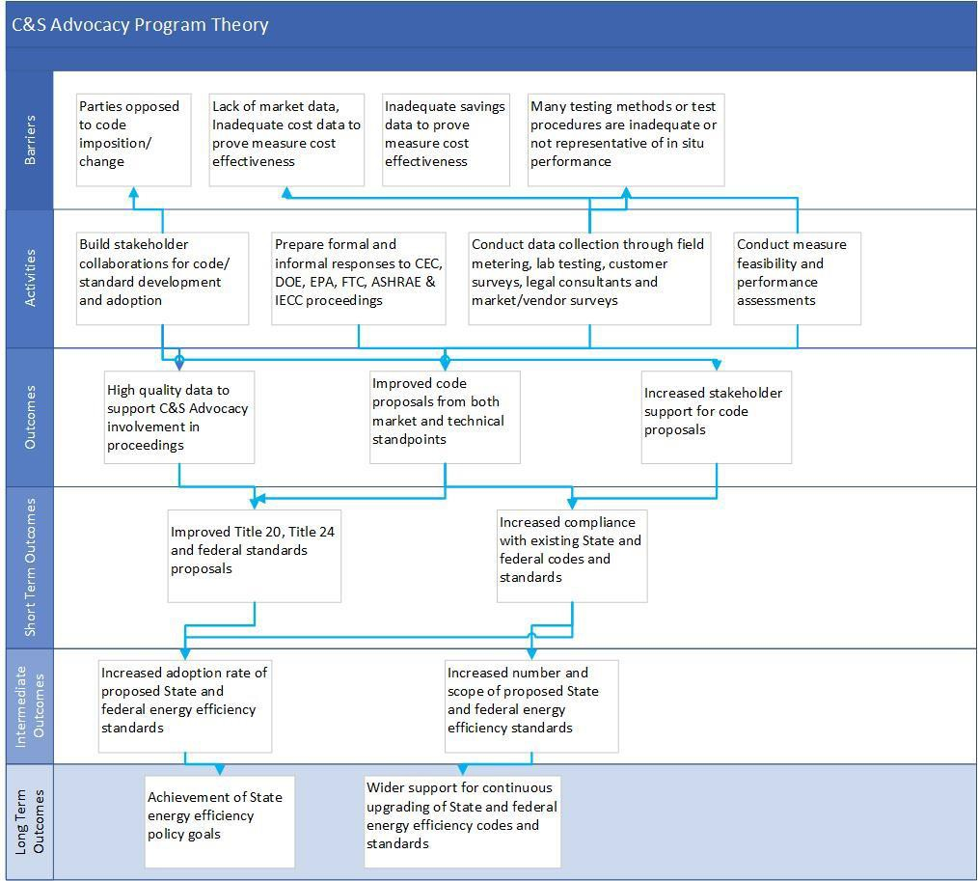

Process Flow Chart

The advocacy process differs by rulemaking. There are several rulemaking types the program supports over the three subprograms. Each rulemaking agency or organization follows a different process, and this may change from iteration to iteration. Example rulemakings that the program supports include the California Appliance Efficiency Regulations (Title 20) and the California Energy Code (Title 24, Part 6).

Incentive Tables, Workpapers, Software Tools
Non-resource program. Not applicable.

Quantitative Program Targets
Each C&S Advocacy rulemaking process informs quantitative program targets. The agency or organization that controls the rulemaking process ultimately determines the volume of work, including the number of measures that the subprograms must address. The number of CASE studies, CASE measures, test procedures, and comment letters is directly connected to the rulemaking agency or organization’s direction. Typically rulemaking agencies do identify the number of rulemakings or measures to be addressed in advance. The effectiveness of the program is not directly tied to the volume of these deliverables, but to whether the proposals are adopted and implemented.

The C&S Advocacy Program team will share quantitative information on the number of CASE studies and comment letters submitted in the annual metrics filing with the CPUC.

Diagram of Program
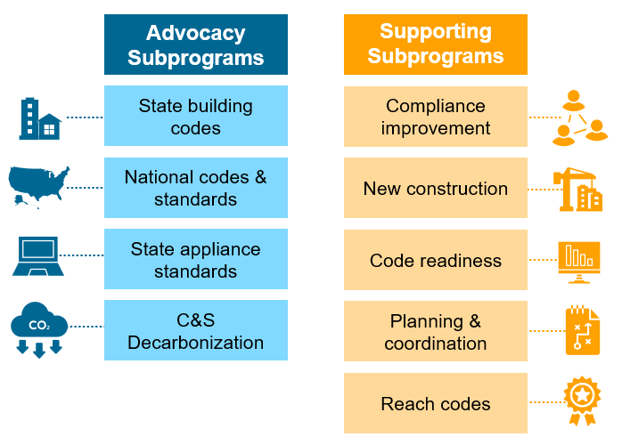

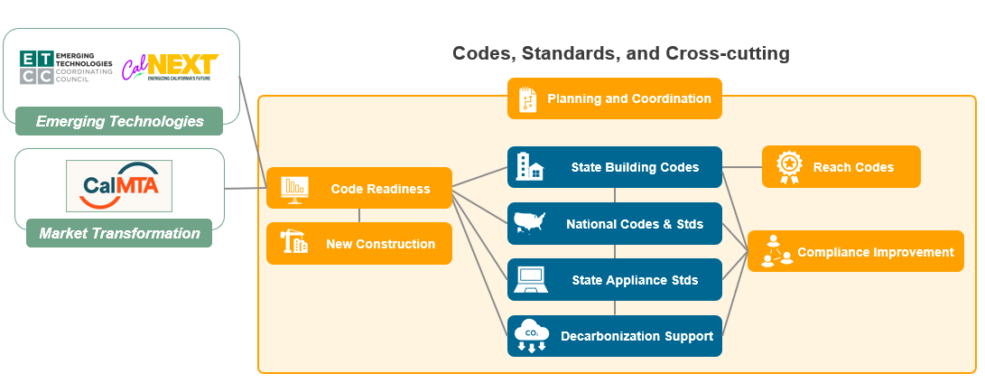

Evaluation, Measurement & Verification (EM&V)
To help ensure quality assurance and effective evaluation, the IOUs will continue ongoing efforts to track and assess the effectiveness of the SW C&S Advocacy Program in advocating for new codes.

The SW C&S Advocacy Program will continue to support the impact evaluation efforts of the CPUC and its contractors by documenting code advocacy efforts. The IOUs coordinate with the CPUC and their impact evaluation contractors to ensure that sufficient data are being collected at the appropriate levels of detail to enable an estimation of energy savings related to codes and standards activities. This includes:

    - Supporting the CPUC in their research effort to establish Title 20 and Title 24 baselines, and track changes in adoption and compliance over time.
    - Providing appropriate program data, as well as encouraging the participation of vendors, contractors, building officials and others, as appropriate, in providing information for establishing baselines and changes in penetration over time.
    - Provide proof of attribution to the CPUC through Code Change Savings Reports.
Additionally, formative research will be conducted to provide insight into emerging issues related to current and pending codes and standards. Specifically, research will be carried out to identify issues and trends appearing along the delivery chain for appliances as well as for building practices.

Normalized Metered Energy Consumption (NMEC)
Not applicable.

CPUC issued D.23-04-035 on April 14, 2023, which expanded the scope of the C&S Advocacy Program to support the state’s broader clean energy goals, including transportation electrification and building decarbonization (Decision 23-04-035, COL 12).
PG&E’s 2024–2027 True-Up Advice Letter in Compliance with Decision 21-05-031, Decision 23-06-055, and Decision 23-08-005
PG&E’s 2024–2027 True-Up Advice Letter in Compliance with Decision 21-05-031, Decision 23-06-055, and Decision 23-08-005
Lab testing will occur at the International Standards Organization (ISO) 17025 certified independent labs or at PG&E Applied Technology Services Lab as determined by the C&S Advocacy Implementors.
These documents will not be shared with SoCalGas.
PG&E will also seek alignment on Code Change Savings Reports prior to submitting to the Energy Division.

