Appendix A: Implementation Plan Template (2.0)
The following information shall be uploaded to the CPUC-maintained website, the California Energy Data and Reporting System (CEDARS), in accordance with CPUC decisions and Staff guidance.

Program Overview

The Small and Medium Commercial EE Program (Program), will provide the following services to small and medium commercial customers in the Riverside and San Bernardino counties.

- Participant eligibility screening
- Marketing and outreach and enrollment
- Customer education
- Facility audits and technical assistance to Customers
- Project scoping and procurement advice
- Financial incentives/rebates
- Inspection and verification of project results
- Promotion of On-Bill Financing (“OBF”)

Program Budget and Savings
- Program and/or Sub-Program Name
Small and Medium Commercial EE Program.
- Program / Sub-Program
ID SCG3845
- Program / Sub-program Budget Table
$4,500,000
- Program / Sub-program Gross Impacts Table
First Year Annualized Deliverable | 2021 | 2022 | 2023
Gross Therm Savings | 303,934 | 349,350 | 331,882
Net Therm Savings | 173,891 | 199,875 | 189,881
Gross kWh Savings | NA | NA | NA
Net kWh Savings | NA | NA | NA
Gross kW Reduction | NA | NA | NA
Net kW Reduction | NA | NA | NA
Gross Gallons Saved | NA | NA | NA
Net Gallons Saved | NA | NA | NA
Non-resource Deliverable(s), if applicable: (e.g., Number of Assessments) | 555 | 638 | 607
Assumed Program Launch Date | 12/1/2020

- Program / Sub-Program Cost Effectiveness (TRC)
1.24
- Program / Sub-Program Cost Effectiveness (PAC)
1.41
- Type of Program / Sub-Program Implementer (PA-delivered, third party-delivered or Partnership)
Third Party delivered
- Market Sector(s)
Commercial
- Program / Sub-program Type
Resource
- Market channel(s) Downstream and Intervention Strategies
Direct install and incentive with financing options campaign goals: 1,048,049 Gross Therms, 599,624 Net Therms over 3 year program.

Implementation Plan Narrative
PAs shall include the following narrative description for each program (and sub-program, if applicable):

- Program Description:
The Small and Medium Commercial EE Program will target small and medium commercial business (“SMB”) customer facilities in San Bernardino and Riverside counties (therm usage up to 50,000 therms per year) with an emphasis on customer segments, such as restaurants, lodging, dry cleaning, retail, office, and others.

The Program will focus on helping businesses in disadvantaged communities, particularly HTR customers, improve competitiveness by saving energy through several program resources, including assessments, kits, and prescribed incentives. The solution includes the following elements:
  - Customer segmentation by business type and usage thresholds to identify geographic hotspots and customer targeting
  - A program website with links to:
    - find a contractor
    - apply for prescriptive rebates
    - order kits, and
    - identify financing options
  - An energy action plan for customers who receive an in-field assessment
  - Regional engagement targeting high propensity customers through awareness campaigns, canvassing and outreach
  - In-field audit with direct install of energy efficient low-cost products and identification of opportunities for contractor installed savings measures.

- Program Delivery and Customer Services:
The Small and Medium Commercial EE Program will target small and medium commercial business (“SMB”) customer groups (therm usage up to 50,000 therms per year) with an emphasis on customer segments, such as restaurants, lodging, dry cleaning, retail, office, and others. The Program will focus on businesses in Riverside and San Bernardino counties during the first 3-year contract and prioritize outreach to HTR customers and customers within DACs. Interventions designed to overcome HTR customers’ unique barriers will include no-cost, mailed energy saving products kits, in-field facility audits with recommendations, access to contractor and financing resources, and actionable EE information. Based on an initial high-level analysis, it is estimated that approximately 50% of the small commercial customers participating in their program will be HTR.

The Program will serve DACs within the SoCalGas service territory. DACs will be prioritized by geotargeting communities for local blitz marketing and outreach. The Program’s Rancho Cucamonga office will be the hub of outreach to the Inland Empire. It is estimated that 70% of the small and medium commercial businesses that are expected to participate in this program will be within DACs.
A measure mix of energy saving products kits, direct installed measures, and rebated customer- and/or contractor-installed measures will be identified and delivered based on program innovations such as a "leave no customer behind" tiered intervention approach and the Program’s unique customer engagement technology.

- Program Design and Best Practices:
Intelligent Customer Targeting, Outreach, and Engagement. The Program will be using multiple data sources to segment the market and target the most effective mix of tactics to each market segment. Research and analysis will identify eligible customers with the highest propensity to participate.

Technical Assistance. The Small and Medium Commercial EE Program provides cost-effective technical assistance to customers on their terms, from a web portal for each participant to on-site energy assessments. The Program also assists customers in moving forward with identified projects by providing them access to a find-a-contractor tool and calculating and verifying projected energy savings.

Customer Incentives. The Program includes no charge on customer kits, direct installed energy measures, and prescriptive rebates.

Direct Install. Contractor will directly install energy savings measures during in-field energy assessments.

Financing. The Small and Medium Commercial EE Program will provide customers with a wide range of EE project financing options, including on-bill financing in collaboration with SoCalGas.

- Innovation:
This program utilizes several combined strategies to deliver an innovative design. The program uses targeted marketing, customer choice, concierge services, and enhanced incentives to achieve the result of greater measure uptake and cost-effective penetration of the SMB market. The targeted marketing will serve appropriate messaging to each customer to create interest in the program. Customers will review the program offer and participate at the depth of service that meets their needs. It’s a common understanding that SMB owners “wear many hats” and often do not have time for energy efficiency projects when running their business so the program’s Energy Advisors will provide concierge services to help move projects forward. And finally, in this economy where small and medium businesses are faced with so much uncertainty, the program will leverage enhanced incentives to reduce upfront costs and create appealing ROIs.

- Metrics:

Metrics used to track program progress will include:
Program marketing:
- Program website site traffic analysis
  - Conversion to signup or kit order
- Email metrics: Open rates, click-through rates
Program Success rates:
- Canvassing success rate Conversion from assessment to project
- Time duration from application approved to rebate paid
Innovation metrics related to program uptake through digital engagement:
- Customer conversion by enrollment channel
- Conversion rate of “major measure” projects

- For Programs claiming to‐code savings:
Not Applicable to this program

- Pilots:
Not applicable to this program

- Workforce Education and Training: The program will be hiring local staff to execute services. The Energy Advisors will live in the communities the program serves and as a result of program training will become skilled SMB auditors and will develop valuable sales skills. The program will also use a diverse supplier to provide additional local support to the program, and this staff will receive the same training benefits.

- Workforce Standards
Not applicable to this program

- Disadvantaged Worker Plan:
The program focuses on San Bernardino and Riverside counties, both of which have a significant portion of their geography designated as disadvantaged communities under CalEnviroScreen. It is expected that this program will create hundreds of energy efficiency projects that will, in-turn, be completed by local contractors employing disadvantaged workers.

- Additional information:
No additional information

Supporting Documents
- Program Manuals and Program Rules
See below
- Program Theory and Program Logic Model:
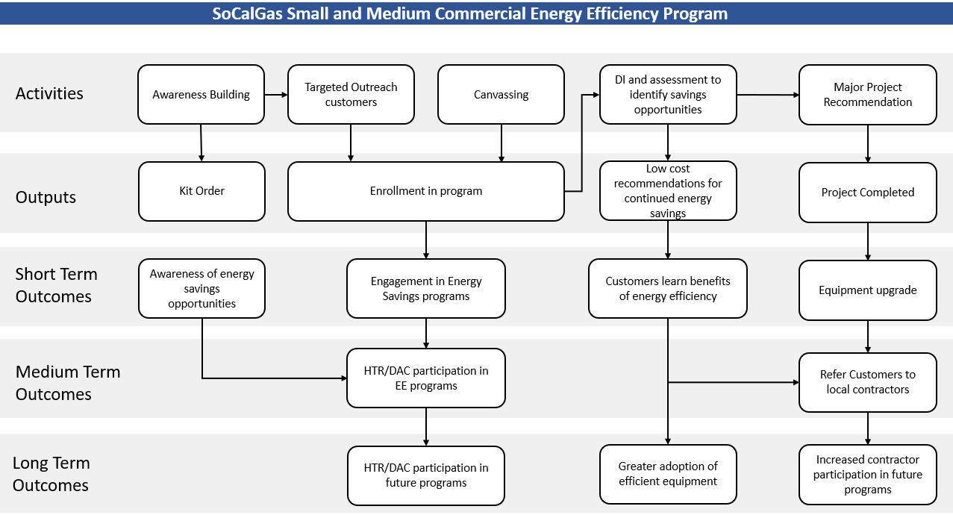

- Process Flow Chart:
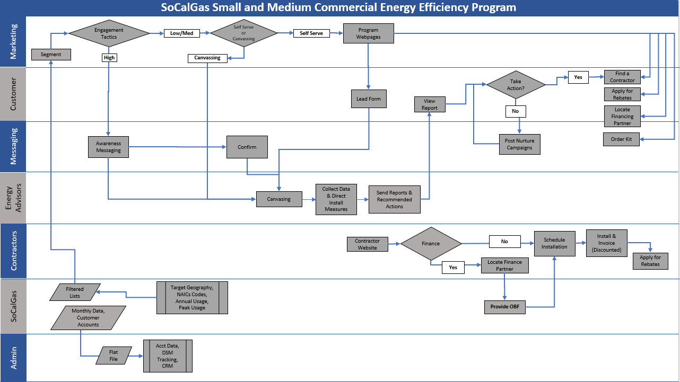

- Incentive Tables, Workpapers, Software Tools:
Measure Description | Workpaper
Laminar Flow Restrictor - 1.0 GPM | SWWH004-01
ProcessBoiler-Steam-(>=83%CE) | SWWH008-01
ProcessBoiler-Water-Tier1(>=85%CE) | SWWH008-01
ProcessBoiler-Water-Tier2(>=90%CE) | SWWH008-01
CommercialBlr-DWH-Large(>200MBtuh)-Tier2(>=90%TE) | SWWH005-01
CommercialBlr-DWH-Large(>200MBtuh)-Tier1(>=84%TE) | SWWH005-01
CommercialBlr-DWH-Small(<=200MBtuh)-Tier2(>=90%EF) | SWWH005-01
CommercialBlr-DWH-Small(<=200MBtuh)-Tier1(>=84%EF) | SWWH005-01
Pipe Insulation 1 Insulation <= 1 pipe Hot Water_Indoor | SWWH017-01
Low-Flow Pre-Rinse Spray Valves <0.75 gpm | SWFS013-01
PROCESS BOILER - DIRECT CONTACT WATER HEATER | SWWH008-01
SpaceHeatingBoilers-Steam-Medium-(>=83%CE) | SWHC004-01
SpaceHeatingBoilers-Water-MediumLarge-Tier2(>=90%CE) | SWHC004-01
SpaceHeatingBoilers-Water-Medium-Tier1(>=85%CE) | SWHC004-01
Steam Traps | SWPR003-01
Commercial Stor. Heaters <=75 kBtu/hr 50G-HD-0.68 UEF | SWWH007-01
TanklessWaterHeaters-Large(>200MBtuh)-Tier2(>=90%TE) | SWWH006-01
TanklessWaterHeaters-Small(<=200MBtuh)-Tier1(>=0.82EF) | SWWH006-01
TanklessWaterHeaters-Small(<=200MBtuh)-Tier2(>=0.90EF) | SWWH006-01
Commercial Combination Oven/Steamer < 15 pan capacity (Gas) | SWFS003-01
Commercial Combination Oven/Steamer 15 to 28 pan capacity (Gas) | SWFS003-01
Commercial Combination Oven/Steamer > 28 pan capacity (Gas) | SWFS003-01
Automatic Conveyor Broilers Belt Width <20 | SWFS017-01
Automatic Conveyor Broilers Belt Width 20-26 | SWFS017-01
Automatic Conveyor Broilers Belt Width > 26 | SWFS017-01
Commercial Fryer (Gas) | SWFS011-02
Comm Griddle | SWFS004-01
Commercial Single Rack Oven - Gas | SWFS014-02
Commercial Double Rack Oven - Gas | SWFS014-02
Commercial Full-Size Convection Oven (Gas) | SWFS001-02
Commercial Conveyor Oven - Gas | SWFS008-01
Modulating Gas Valve for Com Dryers up to 200 lbs cap | SWAP012-01
Commercial Steam Cooker | SWFS005-02
NATURAL GAS POOL HEATER >=84% TE | SWRE003-01
Heat Recovery Roof Top Unit for SHW | SWHC048-01
Process Boilers Feedwater Economizer 81.4 TE | SWPR007-01
Process Boilers Condensing Economizer 87.2 TE | SWPR007-01
Tank Insulation - Low Temperature Applic. (LF) 1 in Indoor | SWWH018-01
Tank Insulation - High Temperature Applic. (LF) 1 in Indoor | SWWH018-01
Tank Insulation - Low Temperature Applic. (LF) 2 in Indoor | SWWH018-01
Tank Insulation - High Temperature Applic. (LF) 2 in Indoor | SWWH018-01
DHW Pump Demand Control Gas Com 150 Units | SWWH015-02
Efficient Commercial Dishwasher High Temp Tier 2 | SWFS002-01
Energy Efficient Commercial Underfired Broiler | SWFS019-01

- Quantitative Program Targets: Provide estimated quantitative information on number of projects, companies, non-incentive customer services and/or incentives that program aims to deliver and/or complete annually. Provide references where available.
TBD

- Diagram of Program: 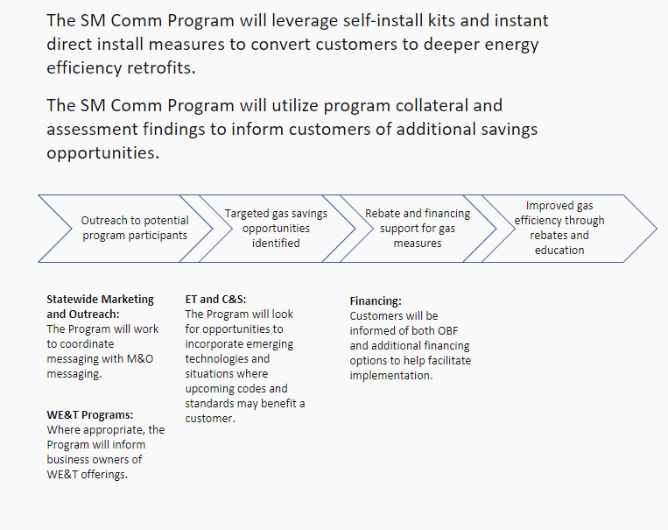
- Evaluation, Measurement & Verification (EM&V):
The Program will work with the PA and evaluators to ensure appropriate data is collected. The Program will collect standard EM&V data that may include; customer contact information, pre and post measure data, or project costs and incentives. This data will be made available to the PA and EM&V consultants at their request in a standardized format agreed to by both parties.

- Normalized Metered Energy Consumption (NMEC):
Not applicable to this program.

Program Manuals
All programs must have manuals uploaded in CEDARS to clarify the eligibility
requirements and rules of the program for implementers and customers. Program rules must comply with CPUC policies and rules. Table templates are available at CEDARS. At minimum, manuals should include:

- Eligible Measures or measure eligibility, if applicable: Provide requirements for measure eligibility or a list of eligible measures.

Measure Description | Size Thresholds | Criteria
Process Heating Steam Boiler | <= 20MMBtuh | >=83%CE
Process Heating Hot Water Boiler | <= 20MMBtuh | >=85%CE, >90%CE
Boiler Stack Economizer | <= 20MMBtuh | Condensing,Feedwater
Commercial Hot Water Boiler | <=200, >200MBtuh | >=84%EF/TE, >=90%EF/TE
Space Heating Hot Water Boilers | 300-2500, >2500 Mbtuh | >=85%TE, >=94%TE
Space Heating Steam Boilers | 300-2500, >2500 Mbtuh | >=80%TE, >=82%TE
Tankless Water Heater | <=200, >200MBtuh | >=82% EF, >=90%TE/EF
Storage Water Heater | >75MBtuh | >=83%, 90%, 96% TE
Pipe/Fitting Insulation | <=1",1-4",>4" | Hot Water, Steam <=15psig
Tank Insulation | 1", 2" | 120-170°F, 170-200°F
Pre-Rinse Spray Valve | <1.07 GPM | Limited Sectors
Laminar Flow Restrictor | <=2.2 GPM | Limited Sectors
Steam Traps | Any | >=12 Hrs./day
Heat Recovery Rooftop unit | >=10 Tons | N/A
Modulating Gas Valve | 30 - 200 lbs | Limited Sectors
Pool Heater | Any | >=84% TE
DHW Pump Demand Control | <150 units | 24 Hrs./day
Combination Oven | <15,15-28,>28 Pans | Steam;>=38%,Oven;>=44%
Conveyor Broiler | 2, 3, 4 Lane | Only Qualified Products
Fryer | Any amt. of vats | >=50%
Griddle | Any amt. of linear feet | >=38%
Rack Oven | Single or Double | >=50%
Convection Oven | Any amt. of Ovens | >=46%
Conveyor Oven | >=25" | >=42%
Steam Cooker | Any amt. of compartments | >=38%
Underfired Broiler | Any amt. of linear feet | Only Qualified Products
Efficient Dishwasher | Single Dishwasher | EnergyStar Tier 2 Product

- Customer Eligibility Requirements:
Under 50,000 Therms required, valid account with SoCalGas and have not participated in a program for the same measures previously and the customer must be in Riverside or San Bernardino counties

- Contractor Eligibility Requirements:
All contractors that work in the service territory and offer the measures eligible are eligible to participate in the program. Customer eligibility will still apply.
- Participating Contractors, Manufacturers, Retailers, Distributors, and Partners:
Open network program.
- Additional Services:
There is no sub-program, does not apply.
- Audits:
This does not apply.
- Sub-Program Quality Assurance Provisions:
Franklin Energy adopts a continuous improvement philosophy based on Lean principles. Employees are provided standard work processes and all tasks are subject to inspection. In addition, we view every missed opportunity as a learning opportunity and use Root Cause Analysis (including the 5 Whys and Fishbone Diagram). Our quality approach emphasizes open and forthright communication. We continuously improve our processes.

Expectations of employees:
All employees of Franklin Energy are expected to:
- Use the processes provided
- If you see something, say something
  - Make others aware when you see something that doesn’t look right
  - Seek a solution
  - Escalate to manager if can’t be resolved or call QCI confidential hotline
- Review your own work and seek peer review
- Seek continuous improvement
- Engage in seeking and implementing best practices
- Learn from others and openly share
Inspections
In order to continuously improve our quality, safety, and customer service standards, we conduct in-process inspections of program staff in field, post-inspections of Trade Ally projects, ride-alongs, customer follow-up calls, and surveys or incoming calls. These inspections provide a way to observe and report on any issues, implement process changes if necessary, provide accountability to our employees and Trade Allies, and provide recognition for exemplary performance to reinforce those behaviors and ensure better performance and positive business results.
Tools and Activities
- AccuTracker – A tool available to everyone within the company, where they can document any quality misses, safety near misses, and suggestions. This is a management tool for accountability to help identify close calls and target efforts for improvement.
- Quality Plan on a Page (QPoP) – Regional management calls that encompasses updates on quality metrics. This includes reporting on all KPIs, Franklin quality standards, discussing program-specific challenges, ideas for improvement and best practices, and operational progress.
- Quality of Operations Review (QOR) – Used as a program scorecard from results of quarterly audits. The review is evaluated in 12 categories that represent the whole span of program operational quality. These results are an important part of Franklin Energy’s strategic improvement goal for quality.

- Other Program Metrics:
Documentation is contained in a central database for both customer contact records and workorders resulting from program operations. The Program will conduct website traffic analysis, evaluate email metrics, and conversion to signup or kit order.
Additional program data will include:
- Open rates, click-through rates
- Canvassing success rate
- Conversion from assessment to project
- Time duration from application approved to rebate paid
- Tracking of rebate processing

California Energy Data and Reporting System (CEDARS), https://cedars.sound-data.com/
kWh and therm values will be estimated using DEER/deemed values; water savings will be estimated.
D.18-05-041, page 20-21 and Ordering Paragraph 7
D.18-10-008, Attachment B, Section D, page B-9.
The expected causal relationships between program goals and program activities in a way that allows the reader to understand why the proposed program activities are expected to result in the accomplishment of the program goals. A well-developed program theory can (and should) also describe the barriers that will be overcome in order to accomplish the goals and clearly describe how the program activities are expected to overcome those barriers. California Evaluation Framework, June 2004.
The graphical representation of the program theory showing the flow between activities, their outputs, and subsequent short-term, intermediate, and long-term outcomes. California Evaluation Framework, June 2004.

