
EmPower My Home
Implementation Plan
Prepared by
Seth McKinney, Resource Innovations
Date: 10.10.2024

Table of Contents
Table of Contents 1
1 Program Overview 3
1.1 Program Budget and Savings 3
1.1.1 2024-2027 Program Details 3
1.1.2 2024-2027 Projected Program Budget 5
1.1.3 2024-2027 Projected Program Gross Impacts 5
2 Implementation Plan Narrative 5
2.1 Program Description 5
2.1.1 Brief Summary 5
2.1.2 Program Rationale 6
2.1.3 Program Objectives 7
2.1.4 Program Delivery and Customer Services 8
2.1.5 Market Barriers 15
2.1.6 Key Software Tools 18
2.1.7 Why These Approaches and Tools Constitute Best Practices 19
2.2 Innovation 19
2.3 Program Metrics 21
2.3.1 2024-2027 Program Key Performance Indicators 21
2.3.2 Pilots 23
2.3.3 Workforce Education and Training 24
2.3.4 Workforce Standards 24
2.3.5 Disadvantaged Worker Plan 24
2.3.6 Additional Information 24
2.4 Supporting Documents 24
2.4.1 Program Manual 24
2.4.2 Program Theory and Program Logic Model 25
2.4.3 Process Flow Chart 26
2.4.4 Incentive Tables, Workpaper, Software Tools 27
2.4.5 Work Papers 34
2.4.6 Software Tools 34
2.4.7 Quantitative Program Targets 39
2.4.8 Diagram of Program 40
2.4.9 Evaluation, Measurement & Verification (EM&V) 41
2.4.10 Third-Party Performance Data Collection Plan 43
2.4.11 Normalized Metered Energy Consumption (NMEC) 45

Program Overview
The EmPower My Home program's primary goal is to maximize residential building electrification for customers classified as Hard-to-Reach (HTR) or low- to moderate-income households located in Disadvantaged Communities (DACs) within the CPUC’s areas of affordability concern and targeted via specific U.S. Census Public Use Microdata Areas (PUMA). By electrifying these homes, the program aims to produce data and learnings to inform PG&E’s future efforts to scale residential building electrification. The Program will simultaneously pursue secondary objectives of achieving high customer satisfaction, ensuring participant energy cost reductions or neutrality, and minimizing Program costs via non-ratepayer-funded sources.
The program provides Energy Efficiency (EE) and building electrification education and direct installations to fully or partially electrify residences with a comprehensive measure mix, including utility service upgrades where necessary.

Program Budget and Savings

2024-2027 Program Details
Table 1. Program Details
Program Name | Program ID Number | Overall Program Cost Effectiveness (TRC) | Overall Program Cost Effectiveness (PAC) | Type of Program Implementer
Residential Equity & Electrification Pilot / EmPower My Home | PGE_RES_005 | N/A | N/A | Third-Party

Market Sectors | Program Type | Market Channels | Intervention Strategies
Residential | Local / Equity | Deemed Downstream | Direct Install, Incentives, Audit, Electrification and Energy Efficiency Education, Non-energy benefits, residential and business targeting. AMI data analysis, surveys of eligible customers in target communities, Community-Based Organization and Program outreach
Program Targets:
- Fully and/or partially electrify 786 residential premises over three years.
- Achieve an average of $209 in first-year bill savings for participants, totaling $164,274 in estimated first-year bill savings to eligible customers.

Timeline:
The anticipated launch of customer outreach for EmPower My Home is March 1, 2025. The program end date is currently scheduled for October 31, 2027. The program will focus its activities on the following areas in a phased rollout:
General Area | PUMA | # of Dual Fuel Customers | Phase
Fresno City | 01903 | 25,600 | 1
Fresno City | 01904 | 42,500 | 1
Fresno City | 01905 | 25,700 | 1
San Jose | To be provided by PG&E | To be provided by PG&E | 2
Oakland | 00104 | 11,600 | 2
Stockton | 07702 | 39,800 | 2
Bakersfield | 02903 | 30,200 | 3
San Francisco | 07503 | 2,600 | 3

2024-2027 Projected Program Budget
Table 2. Program Budget Table
Year | Admin | Marketing & Outreach | Direct Implementation: Non-incentive | Direct Implementation: Incentive & Rebate | Total EE Budget
‘24 | $4,449 | $60,360 | $380,048 | - | $444,875
‘25 | $21,065 | $290,185 | $1,933,195 | $1,049,206 | $3,293,651
‘26 | $14,756 | $108,637 | $1,706,785 | $1,694,899 | $3,525,086
‘27 | $8,863 | $40,188 | $1,030,296 | $640,193 | $1,719,540
Total | $49,142 | $499,370 | $5,050,324 | $3,384,298 | $8,983,134

2024-2027 Projected Program Gross Impacts
N/A

Implementation Plan Narrative

Program Description

Brief Summary
The EmPower My Home program addresses growing inequity in energy access. It accelerates residential electrification and energy efficiency (EE) improvements among historically underserved communities, including those classified as Hard-to-Reach (HTR) or low- to moderate-income households located in Disadvantaged Communities (DACs) within the CPUC’s areas of affordability concern. The Program will directly install energy efficient building electrification and other EE measures for the customer at no or low cost. It will provide end-to-end support, building awareness of efficient electrification options and technologies while facilitating access to utility and non-utility rebates and incentives.
The program focuses on helping customers transition away from natural gas, improving environmental quality, and enhancing residents' quality of life. It achieves these outcomes by leveraging state, federal, and utility funds to partially or fully electrify homes, reduce energy costs, and help California meet its climate goals. It also aims to develop cost-efficient strategies for scaling residential building electrification.

Program Rationale
California is committed to reaching carbon neutrality by 2045. As the state’s more affluent homes and buildings electrify, many low-to-moderate income and HTR communities will be left relying on natural gas infrastructure, spreading the cost of maintaining and repairing gas infrastructure over fewer users. As a result, natural gas rates are projected to increase faster than electricity rates.
Households and building owners in the Program’s target communities that rely on natural gas are projected to face higher energy bills and limited options for adopting energy-efficient, electric alternatives from traditional Demand Side Management (DSM) programs. Without targeted interventions, DAC, HTR, and low-to-moderate-income customers will bear the brunt of rising natural gas costs while being excluded from the benefits of California’s clean energy transition.
The EmPower My Home program aims to alleviate this burden by covering most or all the cost of electrification for eligible customers. This approach ensures participants experience the benefits of electrification and lower utility bills over the long term while reducing overall energy consumption and GHG emissions. By integrating energy efficiency measures and, where possible, distributed energy resources (DER), the program will enhance the affordability of clean energy in DACs​. EmPower My Home addresses these issues by focusing exclusively on HTR or low-to-moderate income customers in DACs within areas of affordability concern. This approach enables these communities to benefit from long-term electrification benefits.
While the program targets customer bill savings, its key metric is bill neutrality or bill savings in the first year, with the expectation that savings will increase over time as rises in gas prices outpace electricity. The program will also track other Non-Energy Benefits (NEBs) realized by the customer from program services. However, energy savings claims will also be captured through eligible measures as they occur.
Ultimately, this program will increase activity among underserved customer classes and their communities, facilitating long-term engagement between these communities, the installation subcontractors, and PG&E.

Program Objectives
The Program’s main objective is to maximize residential electrification of HTR or low-to moderate-income customers in DACs within areas of affordability concern, producing data and learnings to inform PG&E’s future efforts to scale residential building electrification. The Program will simultaneously pursue secondary objectives of achieving high customer satisfaction, ensuring participant energy cost reductions or bill neutrality, and minimizing Program costs via leveraging non-ratepayer-funded sources.
Refer to section 1.1.1 regarding the number of premises electrified.
The EmPower My Homes Program objectives are:
- Accelerate residential electrification and energy efficiency improvements among historically HTR communities, low-income and moderate-income communities, and DACs.
- Achieve high customer satisfaction, target participant energy cost reductions or bill neutrality, and minimize program costs through leveraging non-ratepayer-funded sources.
- Apply innovative approaches utilizing emerging technologies, outreach approaches, and community-based organization engagement.
- Produce data and learnings that inform PG&E’s future efforts to scale building electrification.
- Reduce reliance on fossil fuels.
- Improve environmental quality and enhance the quality of life for residents.
- Establish a process for leveraging funds from multiple funding sources over the same period.

Program Delivery and Customer Services
EmPower My Home (EPMH) will provide energy-efficient upgrades and electrification solutions directly to customers in designated communities. It will achieve its outcomes through a) Targeted Outreach and Education, b) Home and Building Energy Assessments, c) Customized Recommendations, d) Leveraged Programs and Utility Incentives, e) Direct Install Services, and f) Installation Inspection and Follow-up.
Before conducting direct customer outreach to solicit participation, the Program will perform research that will enable it to target customers who will most benefit from EE and electrification based on energy usage, housing stock, and socioeconomic factors. The research will also identify how to support customers from awareness to installation to ongoing energy and electrification engagement. The Program will develop program marketing and outreach tactics during this phase. It will then focus on customer acquisition, project development, installation activities, and program optimizations. This will be an iterative effort in which the Program will collect and assess data, report on key activities, and utilize learnings to check and adjust Program approaches. Program ramp-down will include the closeout of all remaining customer projects, including inspections and final program reporting.
Research and planning efforts will focus on residential customers and will:
- Identify high-priority targets by using AMI data to detect major natural gas end uses and potential all-electric replacements. Then, perform a high-level analysis of estimated bill impacts from electrifying space and water heating loads.
- Grow new and existing community partnerships by establishing relationships with community-based organizations, local contractors, and other stakeholders to improve outreach, implementation, and trust-building.
- Test customer-facing messaging to inform marketing and outreach plans and develop culturally sensitive and accessible marketing materials that resonate with the target communities.
The customer experience is designed to involve close, collaborative communication between all stakeholders. The customers' main contacts will be the Resource Innovations team and the installation subcontractors. The Program will facilitate connections and outreach to customers via programs and activities organized and operated by municipalities, Community-Based Organizations (CBOs), neighborhood associations, etc.
The program will engage with residents using tactics informed by initial and ongoing marketing and outreach testing and market analyses and will iterate the strategies and tactics throughout the pilot. Marketing will be highly coordinated with outreach efforts to maintain the face-to-face, highly customized approach to which these customers and communities will likely respond.
Recruitment will rely on installation subcontractor business development efforts. As a pre-screen, customers located in DACs within areas of affordability concern will be targeted, allowing installation subcontractors to reach low—and moderate-income households.
Enrolled customers will receive technical assistance facilitated by program staff to build customer trust with installation subcontractors conducting home energy assessments and installations. This will ensure that customers feel confident that an expert technician has provided the best recommendations while communicating the options and requirements for proceeding with a particular scope of work.
The Program will collaborate with the customer to optimize one or more bundles of measures to electrify the premise while maximizing bill savings, ensuring that applicable leveraged and EPMH incentives are included in a recommended scope of work to the customer. The scope of work will be optimized to 1) reduce overall energy load with energy efficiency measures applied to the envelope and non-HVAC equipment, 2) size new electric HVAC (Heating, Ventilation, and Air Conditioning) equipment to the home’s new heating and cooling loads, and 3) select appropriate electric equipment for installation, including any potential service upgrades.
The program will require the customer to contact PG&E to stop gas service and remove the gas meter once the project is completed for full home electrification projects.

Approach to Reach Target Audiences
Customer Base and Customer Journey
EPMH will target dual-fuel low-to moderate-income residential customers in DACs and HTR communities within PG&E-authorized U.S. Census Public User Microdata Areas (PUMAs) or the CPUC’s areas of affordability concern. The Program will use screening and recruitment methods to identify and engage low- and moderate-income participants. These methods primarily involve collaboration between the Implementer’s marketing and outreach efforts and the installation subcontractors’ business development efforts within the CPUC’s areas of affordability concern.
Customer Awareness: Initial marketing efforts will focus on ensuring the Program has the materials needed to educate customers along their Program journey. Customers will become aware of the program through community outreach events, flyers, PG&E’s website, installation subcontractor direct outreach, and recommendations from friends or family. The Program will provide the identified community and neighborhood organizations with customer educational materials. Materials will be translated into appropriate languages for each CPUC area of affordability concern. Additionally, because the Program enlists installation subcontractors seeking eligible customers to take part in leveraged programs, they will engage and qualify participant eligibility and ability to participate as part of their normal business development process, including through the channels described above. During these normal business development activities, they will interact with low and moderate-income customers, enabling them to assess their interest in the Program. The Program will also bolster the recruitment of participants between 250%-400% of the Federal Poverty Level through CBO and Program staff targeting and outreach efforts.
Assessment, Scope Development, and Enrollment: The Program will facilitate a targeted walkthrough assessment of the customer’s building, coordinated with other leveraged programs as necessary, to identify eligible electrification and energy efficiency measures. The assessment will document the required remediation work and Front-of-the-Meter (FTM) and Behind-the-Meter (BTM) electrification-readiness measures. The Program will also collaborate with the customer to fully electrify the premise with the contingency to electrify at least one appliance, maximize bill savings, minimize infrastructure upgrades, and ensure that applicable EmPower My Home and leveraged program incentives are included. The customer will sign the agreed-upon project scope and the Program Participation Application Agreement (PPA). The scope will then be sent to the Program review staff for review and approval. The optimized scope will detail each measure's estimated costs, incentives, and benefits—including estimated bill impacts.

Services Provided
Outreach and Education: Conduct outreach campaigns and educational workshops to raise awareness about the Program and its benefits, including providing resources to help participants understand and benefit from electrification and energy efficiency.
Training and Tools for Contractors: Provide contractor training and assessment assistance tools to ensure consistent outcomes and streamline whole-home modeling and recommendations.
Energy Assessments: Scope energy-saving and equipment electrification opportunities.
Customized Recommendations: Tailor advice for energy-saving and electrification measures.
Leveraged Programs: Help with layering and weaving leveraged program funding and completing applications and rebate forms.
Direct Installation Services: Provide no and/or low-cost energy-efficient installations and electrified upgrades for eligible customers.

Site Assessments
The Program will perform detailed customer facility assessments for all customers to identify all building electrification and energy efficiency opportunities, document electrification-focused infrastructure (panel, meter, service size), and document all other site conditions that may impact the feasibility of electrifying the facility, such as structural issues and code violations. The Implementer will coordinate with PG&E’s Service Planning and Design (SP&D) team to ensure projects meet FTM service requirements.

Project Installations
The Program will utilize installation subcontractors to provide project installations and leverage and coordinate customer participation in complementary programs. The Program will ensure that the installation process is streamlined to avoid circumstances that could nullify the customer’s commitment.
The Program installation subcontractor will coordinate closely with PG&E’s Service Planning and Design (SP&D) team for projects requiring panel and utility service upgrades. The Program will ensure that all electrification projects undergo a PG&E service application review. The Program will provide project management services to customers and communicate closely with PG&E to shepherd projects through the review process. The Program will mitigate the need for utility service upgrades to the greatest degree possible. Projects that require service upgrades will be carefully planned and coordinated with PG&E’s SP&D, and necessary timelines will be built into the overall project plan. The program timeline is based on the approval date of the Advice Letter on 09/09/2024.

Leveraged Programs and/or Funding Sources
The Program will leverage resources primarily from Energy Savings Assistance (ESA), TECH (Rebate Program), Inflation Reduction Act (IRA) / Equitable Decarbonization, and secure leveraged funding sources by actively facilitating and coordinating customer enrollment in eligible programs. Where participants must act outside the purview of the Program, it will provide coaching on how to complete applications, follow up to ensure applications are approved, help resolve errors, and make best efforts to remove barriers for the customer until funds are received.
The Program will also coordinate with programs involving distributed energy resources (DER), such as the Self-Generation Incentive Program (SGIP), where those programs will reduce or have a neutral bill impact for the participant.
Name of Resource to be Leveraged | Type of Leveraged Resource | Ratepayer or Non-Ratepayer Funding Source | Purpose of the leveraged resource
ESA/Existing Ratepayer Programs | Installation Program | Ratepayer | Weatherization, lighting, appliances (efficiency), duct sealing, HVAC controls, plug load controls, sector-specific commercial efficiency measures
TECH | Rebate Program | Ratepayer | Heat pumps, heat pump water heaters, panel upgrades, wiring, or plumbing associated w/HP measures
LIWP | Installation Program | Non-Ratepayer | EE, Electrification, solar PV
IRA / Equitable Decarbonization | Installation and Rebate Program | Non-Ratepayer | Home Electrification and Appliance Rebates  Heat pumps, insulation, wiring, panel upgrades, appliances (electrification)  Home Energy Rebates  All electrification and efficiency measures where the home exceeds 20% energy savings
Local and Regional | Various | Non-Ratepayer | Available incentives to reduce project costs
SGIP | Rebate Program | Non-Ratepayer | Battery energy storage
EmPower My Home | Installation | Ratepayer | Any project costs related to electrification and energy efficiency measures not fully covered by the leveraged programs above will use EmPower My Home funds to offset some or all remaining measure costs
The Program will implement the following strategies to coordinate application processes effectively, streamline the customer experience, minimize customer burden and confusion, and expedite the funding procurement timeline.

- Establish a Single Point of Contact. The Program will assign a single point of contact to Program applicants. They will guide customers through the application process for the Program and leveraged resources, provide clarifications, and assist with any questions or concerns.
- Streamline Application Requirements. The Program will coordinate with leveraged programs and stakeholders to harmonize and streamline application requirements, identify common elements across funding sources, and attempt to consolidate them into a unified set of application materials.
- Create a Clear and User-Friendly Application Guide. The Program will develop a comprehensive, user-friendly application guide that provides step-by-step instructions, outlines requirements, and explains eligibility criteria. The Program will use plain language (in multiple languages) and provide examples or templates.
- Develop a Digital Application Platform. The Program will implement a user-friendly, web-based application platform that enables applicants to access, complete, and submit EmPower My Home applications online. Program staff will facilitate applications in person, providing access to all applicants regardless of computer or internet access.
- Use Pre-Qualification or Eligibility Check: The Program will implement a pre-qualification or eligibility validation process to assess an applicant’s alignment with the eligibility criteria for the leveraged programs. The Program will rely on customer self-attestation for income verification.

Phase | Key Deliverable(s) / Milestone(s) | Dates/Duration
Launch Readiness | •Implementation Plan  •Program Management Plan  •Program Materials  •Program Launches | 09/09/2024-2/28/2025  6 months
Program Ramp Up | •Date Program is Available to Customers  •Marketing Plan Implemented  •Pipeline Development | 3/01/2025-4/30/2025  2 months
Program Steady State | •Program Outcomes | 5/01/2025-10/31/2026  18 months
Program Ramp Down / Transition | •Program Ramp-Down Plan  •Program No Longer Accepts New Customers/Projects and Finishes Remaining Work | Projects w/ FTM: 13 months (10/01/26-10/31/27)  Projects w/o FTM: 4 months (7/01/27 - 10/31/27)
Program Closeout | •  • Operational Program Work is Completed  •Program Evaluations are Completed and Impacts are Evaluated | Final program date is 11/01/2027, plus a closeout period of 1-month for program and impact evaluations (11/01/2027-11/30/2027)

Market Barriers
This table organizes the strategies, tactics, and best practices for addressing market barriers to electrification as identified in the EmPower My Home program design.

Market Barrier | Strategy | Tactic | Why is this a best practice?
Cost and Availability of Electrification Equipment | Utilize the program's incentive model to reduce costs and ensure access to the supply chain. | Provide financial incentives, facilitate access to leveraged program funding sources, and work with suppliers to secure necessary equipment. | Reducing upfront costs makes electrification options more accessible to low-income households.
Installation Subcontractors’ Ability to Promote and Install Electrification Measures | Select subcontractors with proven experience and capabilities in electrification measures. | Partner with experienced ESA contractors and provide additional training. | Ensures high-quality installations and effective promotion of electrification benefits.
Lack of Awareness and Confidence in Electrification Options | Collect input via research activities, develop effective marketing messaging, and conduct high-touch outreach. | Utilize program research to inform marketing strategies and provide personalized outreach through a single point of contact. | Builds trust and confidence in electrification options, addressing misinformation and skepticism.
Lack of Trust and Skepticism for Government and Utility Programs | Employ field staff and trusted community resources like Self-Help Enterprises. | Use trusted local partners and ensure consistent, transparent communication. | Leverages established community trust to increase program acceptance and participation.
Cultural and Lifestyle Preferences for Gas Stoves | Use tailored messaging, outreach, and educational efforts to address cultural preferences. | Highlight the benefits of electrification through community-based social marketing (CBSM) techniques. | Culturally sensitive communication helps shift perceptions and encourages the adoption of electric cooking options.
Tenant Concerns About Property Owner Approval and Rent Increases | Develop owner-oriented value propositions and include rental rate increase prohibitions in program agreements. | Communicate benefits to property owners and enforce agreements preventing rent hikes due to program participation. | Addresses split incentives and tenant concerns, ensuring wider program acceptance.
Inability to Self-Install and Configure Electrification Options | Provide expert subcontractor services and generous incentives. | Offer professional installation and support to participants. | Ensures proper installation and use of electrification measures, maximizing energy savings.
Difficulty Coordinating Multiple Specialists | Use project management and coordination services. | Assign a single point of contact to manage the process for participants. | Simplifies participation and reduces the burden on customers, increasing program uptake.
Limited Understanding of Permitting Requirements | Utilize experienced subcontractors who are experts in permitting. | Handle all permitting processes on behalf of participants. | Removes a significant barrier to participation, making it easier for customers to join the program.
Modifying Aging Infrastructure | Coordinate with the ESA program and allocate funds for remediation and upgrades. | Provide necessary upgrades to accommodate new equipment. | Ensures that all homes can participate, regardless of the condition of their existing infrastructure.
Customer Fatigue from Navigating Multiple Programs | Ensure strong coordination and communication through customer-facing program personnel. | Use a single point of contact to streamline the process and reduce confusion. | Simplifies participation and maintains customer engagement.
Perceived Reliability Concerns with Electric Appliances | Educate customers about the reliability of electric appliances and offer battery energy storage solutions. | Use CBSM techniques to reinforce community norms and provide backup power options. | Addresses concerns about reliability and resilience, increasing acceptance of electric appliances.
Ongoing Electric Costs | Use bill impact estimates to screen for negative bill impacts and provide ongoing bill monitoring. | Provide modeling for bill impact reports to estimate impacts during customer engagement and evaluate post-intervention energy bills. | Addresses customer concern for potential bill increases and provides opportunities for corrective interventions.

Key Software Tools
Resource Innovations will leverage its proprietary iEnergy software for the Program. iEnergy will enable the following capabilities:
- Site Assessments: Conduct detailed electrification and energy efficiency-focused site assessments and develop upgrade and replacement measure scopes of work.
- Project and Program Application: Manage customer applications, build customer project scopes, collect electronic signatures and submit applications, and track and manage project status.
- Inspection Documentation: Collect and store post-installation project details.
- Reporting: Generate reports on key project information and milestones.
iEnergy provides comprehensive management of assessments, applications, inspections, and reporting to streamline program operations.
In addition to iEnergy, the Program will use EnergyPro and BEOpt for:
- Usage: Calculate estimated energy savings to determine bill impact.
- Significance: Provides energy savings estimates to support financial decision-making and program evaluation.

Why These Approaches and Tools Constitute Best Practices
- Customer-Centric Design: The program prioritizes participants' needs, convenience, customer engagement, and satisfaction by offering direct installations, financial incentives, and multilingual support.
- Community Involvement: Partnering with trusted local organizations fosters community trust and leverages established relationships, leading to more effective outreach and higher participation rates.
- Data-driven Decision-making: Utilizing advanced analytics tools ensures that resources are allocated efficiently, targeting areas with the highest potential for bill savings or neutrality, equipment electrification, and program impact.
- Continuous Improvement: The program continuously incorporates feedback and lessons learned to refine strategies and tactics, ensuring ongoing effectiveness and relevance.
- Risk Management: Proactive identification and mitigation of risks ensure the program can adapt and respond to challenges effectively.

Innovation
EmPower My Home incorporates several innovative strategies and approaches to increasing the uptake of cost-effective energy efficiency and electrification options.
Seamless Integration: The program is designed to work seamlessly with existing energy efficiency and renewable energy programs. It offers a comprehensive suite of options covering energy efficiency, renewable generation, energy storage, and electrification by leveraging a mix of ratepayer funding, federal grants, and state incentives. This integrated approach ensures that customers can access a wide range of resources and support to maximize their energy savings and electrification efforts.
Service Upgrades: The program strategically avoids capacity-constrained areas of the grid and targets customers with adequate amperage service levels. By utilizing innovative technologies such as smart panels, low-voltage heat pumps, and HPWHs, the program minimizes the need for extensive service upgrades. This approach reduces the complexity and cost of electrification projects, making them more accessible and appealing to customers.
Advanced Electrification Technologies: The Program will promote the adoption of essential electrification technologies such as heat pump systems, energy storage solutions, smart panels, and renewable energy sources. These advanced technologies are selected for their potential to reduce overall energy consumption and eliminate natural gas usage, providing customers with modern, efficient, and sustainable energy solutions.
Bill Neutrality Focus: Bill neutrality is a core aspect of the program's approach. Using data analytics, the program identifies customers most likely to see bill savings from electrification efforts, aiming for at least bill neutrality. Once a customer is engaged, the program will confirm the potential for bill neutrality and select measure packages that are least likely to increase energy costs. This focus on bill neutrality ensures that customers are not burdened with higher energy bills due to participating in the program. Post-intervention, energy bills will be monitored for 12 months or until the program’s conclusion, whichever comes first. Any post-intervention customer bill exceeding a 6% increase compared to the expected bill impact modeled on the customer-accepted scope of work will be automatically flagged for a review process that may result in corrective measures.

Program Metrics

2024-2027 Program Key Performance Indicators
Table 3. Program KPI Table
Program Area | Performance Goal | Description | Target | Source
Program Operations | Measure Install Pass Rate (Deemed) | Measures the percentage of deemed measures that pass in regard to the number of deemed measures submitted. Measurement: Measures Passed / Measures Submitted * 100. | Achieve a pass rate of 95% or greater. | Energy Insight
Program Operations | Budget Forecast Accuracy | Measures the variance between forecasted spend (payments + accruals) and actual spend (payments + accruals) for each quarter. Measurement: Average of (ABS [((Actual Payments + Actual Accruals) - (Forecasted Payments + Forecasted Accruals)) / (Forecasted Payments + Forecasted Accruals)] for all quarters of the calendar year. | Achieve an average budget forecast accuracy of +/-10%. | Energy Insight
Program Operations | Number of Homes Electrified Forecast Accuracy | Measures the variance between forecasted achievements and actual achievements for each quarter. Measurement: Average of (ABS [(Actual Achievements - Forecasted Achievements) / (Forecasted Achievements)] for all quarters of the calendar year | Achieve an average partial- and whole-home electrification forecast accuracy of 10% for 2025-2027. | Energy Insight
Program Operations | Non-Ratepayer Leveraged Funds | Measures the total amount of funds being leveraged from non-ratepayer sources compared to the total project cost. Measurement: Total % of project funds contributed from non-ratepayer funded sources. | Achieve a minimum of 15% of project costs paid with non-ratepayer leveraged funds. | Program Management Database
Moderate Income Customer Participation | Program Operations | Measures the total number of projects completed with moderate income customers compared to the total number of projects completed. | 30% or more of participants at >250% FPG | Energy Insight
Target Percentage of Full Electrifications | Program Operations | Measures the total number of full electrification projects completed compared to the total number of projects completed. | Annual target % of projects that are Full Electrifications:  2024 - N/A  2025 - 11% (Stretch target)  2026 - 11% (Stretch target)  2027 - 11% (Stretch target) | Energy Insight
Customer Satisfaction | Participant Satisfaction | Measures the total number of customers who provide satisfactory survey responses after installing projects. Measurement: Total score from customers surveyed rating 4 and 5 / Number of survey responses * 100. | Achieve a 90% customer satisfaction rate. | Customer surveys / Program Management Database

Pilots
The EmPower My Home Program is a Pilot Program. All innovations are described above.

Workforce Education and Training
Formal workforce education and training are not budgeted or included in this program. However, due to its use of local Installation Subcontractors, the Program will increase awareness and training of electrification and energy efficiency benefits, as well as best practices and innovations related to home and building electrification, energy-saving equipment, and use of EE and electrification as a sales tool to contractors that work among DAC and low-income communities. This direct engagement with the workforce will provide an informal contribution to WE&T's desired outcomes.

Workforce Standards
CPUC mandated Workforce Standards are not applicable as this is a residential program.

Disadvantaged Worker Plan
Small Business Enterprises (SBE’s) and Diverse Business Enterprises (DBEs) with underrepresented workers and those in disadvantaged and hard-to-reach communities will be a criterion used for recruiting and contracting with selected installation subcontractors. Resource Innovations will also prioritize budget allocations to installation subcontractors who can demonstrate that a significant percentage of their workforce meets these requirements while also meeting program quality assurance.
The Program will also provide relevant career development services and training related to electrification programs and measures. Resource Innovations will connect installation subcontractors to local CBO partners offering support services and training organizations and ensure access to workforce education and training, retraining, and upskilling as an aspect of participating in the Program

Additional Information
None.

Supporting Documents

Program Manual
In development – will be submitted with final IP following feedback.

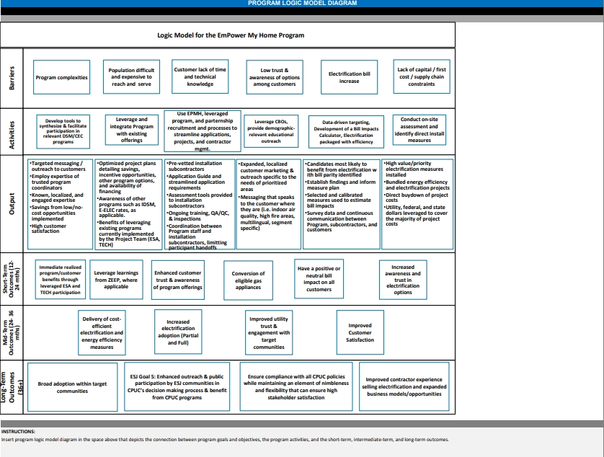
Program Theory and Program Logic Model

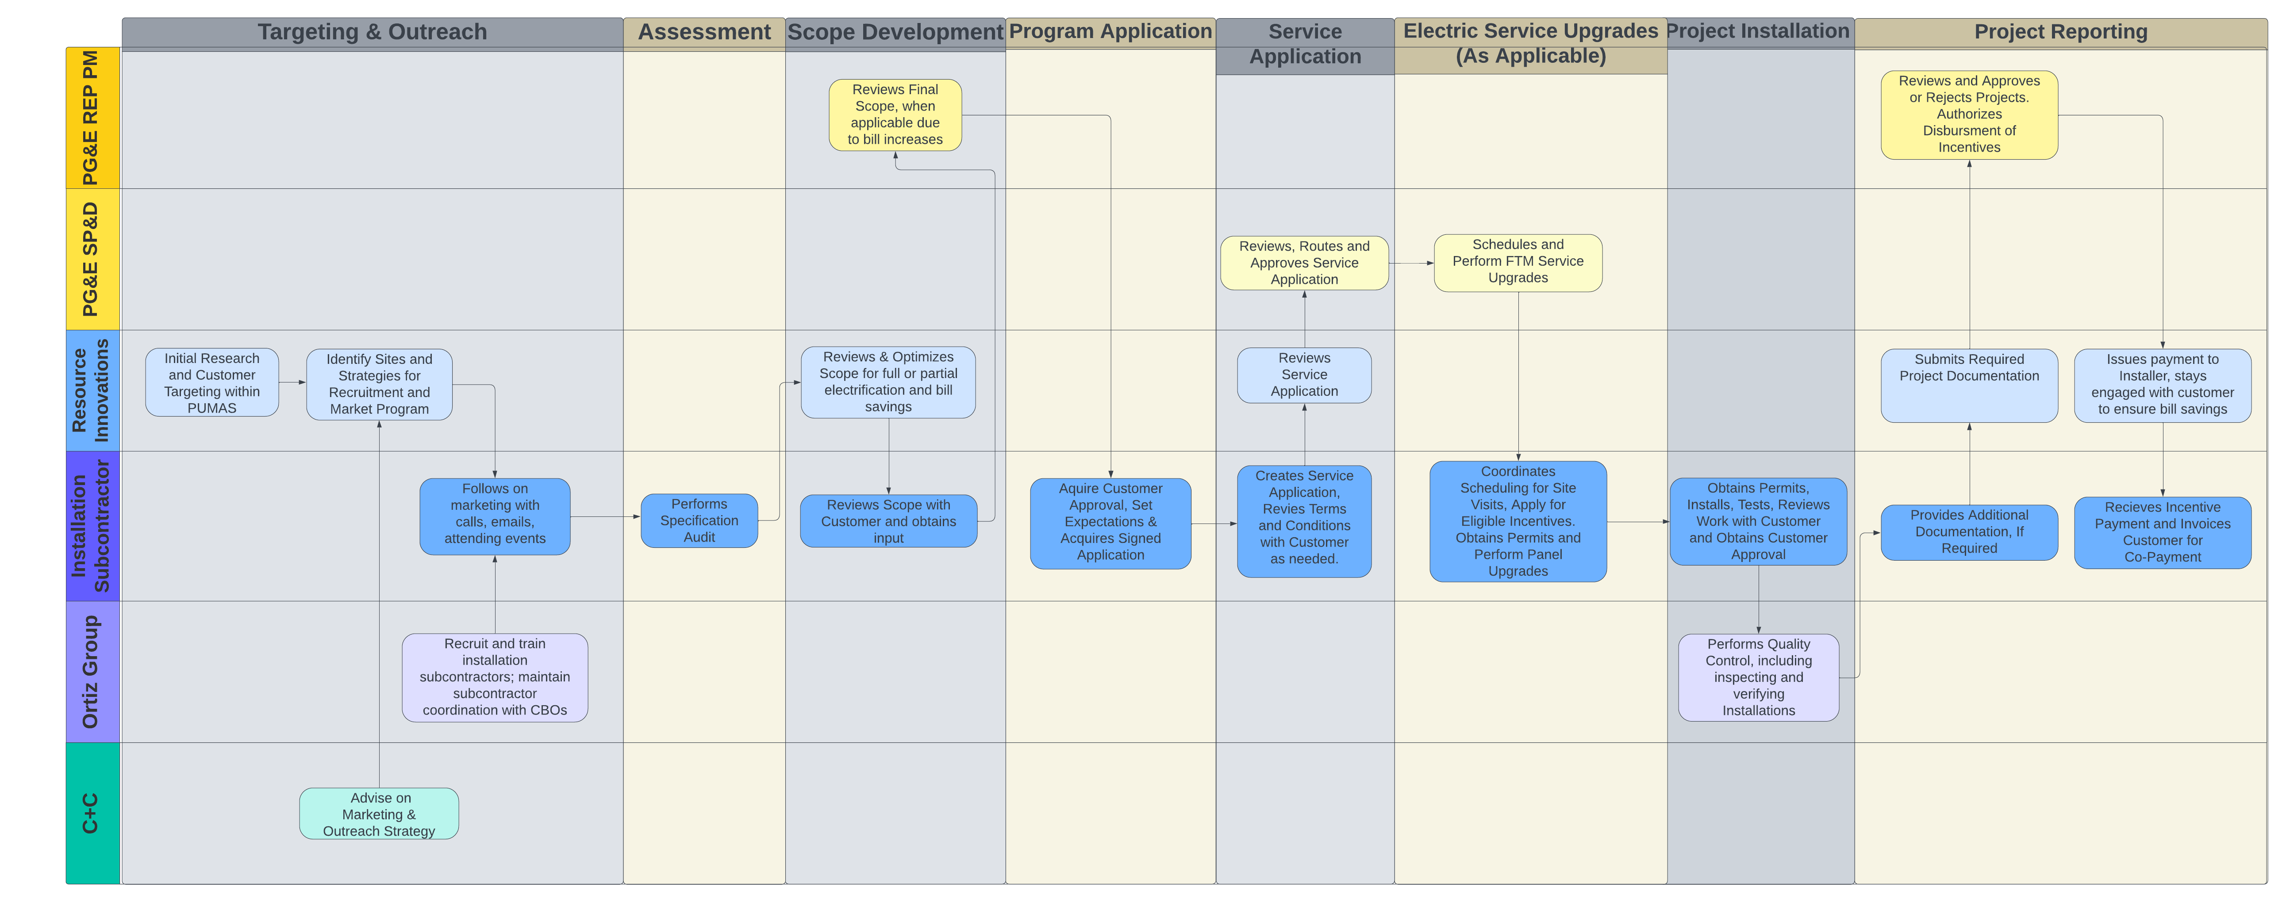
Process Flow Chart

Incentive Tables, Workpaper, Software Tools
Customer incentives, when combined with leveraged resources, will be designed to fully (for household incomes up to 250% federal poverty guidelines [FPG]) or mostly (for household incomes above 250% FPG) cover the project costs related to building electrification and additional energy efficiency upgrades needed to maintain bill neutrality or generate bill savings, including necessary FTM service upgrades, BTM electrical upgrades, and minimal remediation. The incentive structure is designed in a way for moderate-income customers, that rewards progressively higher levels of electrification, motivating them to fully electrify their homes.
Program incentives will be paid directly to the installation subcontractors in alignment with installed measures and negotiated prices. Participants will be obligated to pay out of pocket for project costs not covered by Program incentives and leveraged resources. In the case of a property owner-tenant relationship, the property owner is responsible for the co-pay.
Program funding will be supplemented by leveraged resources to minimize direct Program costs and use of ratepayer-funded sources. Leveraged resources will be prioritized as follows:
Local and Regional Programs
  - Programs that can successfully be layered together will be identified and leveraged to maximize customer benefit.
TECH Clean California
  - The TECH program will, to the extent possible, cover behind-the-meter electric system upgrades, heat pump-based HVAC not covered by local and regional programs, and domestic hot water electrification costs for residential and multifamily projects.
Inflation Reduction Act (IRA)/Equitable Building Decarbonization Programs
  - As eligibility aligns, the federal IRA and California’s Equitable Building Decarbonization programs will be used for residential projects to acquire rebates and tax credits for residents, improving project cost-effectiveness.
Ratepayer Programs
  - Ratepayer programs will be used to the extent possible. For example, where the customer is eligible, the ESA program will address remediation and energy efficiency measure upgrades applicable to the residential premises.
LIWP/LIHEAP
  - These federal and state-sponsored programs to install EE and solar measures will be considered and leveraged to maximize customer benefit in conjunction with programs like ESA.
EmPower My Home
  - Any project costs related to electrification and energy efficiency measures not fully covered by the leveraged programs above will use EmPower My Home funds to offset some or all remaining measure costs.

To the extent additional leveraging opportunities become available, these will be included to minimize costs upon PG&E approval.
Once a project is fully installed, the Implementer will submit the completed Project documentation to PG&E for review, approval, and payment, and the Program will fulfill any remaining obligations under the incentive agreements.

Measure List
The following table lists the electrification measures that EmPower My Home initially intends to offer for customers and an initial list of energy efficiency measures to support the Program’s efforts to provide bill savings or bill neutrality.
The Program will offer measures based on active or expired deemed measure packages. The Implementer will request written approval from PG&E before offering additional measures not listed in the table. The Program will provide coordination support for additional measures offered through leveraged programs, which will be defined in the PMP along with their corresponding incentives.
MEASURE NAME | MEASURE DESCRIPTION
Ceiling Insulation, Residential | Attic - add up to R-60 batts
Ceiling Insulation, Residential | Attic Insulation - Mineral Fiber Loose Fill - R38
Ceiling Insulation, Residential | Remove Existing Attic Insulation (required for new insulation >R38)
Wall Insulation, Residential | Residential wall blow-in R-0 to R-13 insulation
LED Lamps: Type B Tubes | Tubular LED retrofits
LED Lamps: Type C Tubes | 2-lamp Fixture
LED Lamps: Type C Tubes | 3-lamp Fixture
LED Lamps: Type C Tubes | 4-lamp Fixture
HPWH Fuel Substitution - Residential | 50-gallon HPWH with Uniform Energy Factor (UEF) of 3.75
HPWH Fuel Substitution - Residential | 65-gallon HPWH with UEF of 3.75
HPWH Fuel Substitution - Residential | 75-gallon HPWH with UEF of 3.75
HPWH, Electric WH to HPWH - Residential | 50-gallon HPWH with Uniform Energy Factor (UEF) of 3.75
Smart Thermostats - Residential | Measure only applicable to primary heating systems gas furnaces and heat pumps  Not applicable for elec resistance or hydronic heating
Smart Fan Controller - Residential | Smart Fan Controller
Smart Fan Controller with Smart Thermostat | Smart Fan Controller with Smart Thermostat
Cooking Appliance, Residential, Fuel Substitution | 84% efficiency Electric Induction cooktop replacing gas cooktop, no oven
Cooking Appliance, Residential, Fuel Substitution | 84% efficiency Electric range with induction cooktop replacing gas range, electric resistance oven
Cooking Appliance, Residential, Fuel Substitution | Electric resistance wall oven replacing gas wall oven
Induction Cookware, Residential | New pots and pans to work with induction cooktop (5-pan set)
Heat Pump Clothes Dryer, Residential, Fuel Substitution  Min Combined Energy Factor (CEF) of 4.50 | Compact size heat pump clothes dryer, 120 volt, vented, dwelling Energy Star qualified clothes dryer meeting v1.1 specs
Heat Pump Clothes Dryer, Residential, Fuel Substitution  Min Combined Energy Factor (CEF) of 4.51 | Compact size heat pump clothes dryer, 240 volt, vented, dwelling
Heat Pump Clothes Dryer, Residential, Fuel Substitution  Min Combined Energy Factor (CEF) of 4.52 | Compact size heat pump clothes dryer, 120 volt, ventless, dwelling
Heat Pump Clothes Dryer, Residential, Fuel Substitution  Min Combined Energy Factor (CEF) of 4.53 | Compact size heat pump clothes dryer, 240 volt, ventless, dwelling
Heat pump clothes dryer - standard - 120V, vented, Residential, Fuel Substitution | Standard size heat pump clothes dryer, vented, any voltage
Heat pump clothes dryer - standard - 240V, vented, Residential, Fuel Substitution | Standard size heat pump clothes dryer, vented, any volt  CEF of 4.13
Heat pump clothes dryer - standard - 120V, ventless, Residential, Fuel Substitution | Standard size heat pump clothes dryer, ventless, any voltage
Heat pump clothes dryer - standard - 240V, ventless, Residential, Fuel Substitution | Standard size heat pump clothes dryer, ventless, any volt  CEF of 4.13
Duct Repair / Optimization, Residential | Sealing, insulation, reconfiguration, as needed
Manual J Testing | HVAC sizing and design
HVAC Installation - Installation Exception 1, Residential | Crane Fees
Permits | Permits
HVAC Installation - Installation Exception 2, Residential | Title 24 Testing
LED Lamps: Type A Tubes | 4-ft
LED Lamps | A-lamps 400-1200 lumens
LED Lamps | PAR and BR 400-1200 lumens
LED Lamps | Candelabra 400-900 lumens
LED Lamps | MR16 400-650 lumens
Faucet Aerators - Residential | No greater than 2.0 GPM
Low-Flow Showerhead, Residential | Efficient showerhead with 1.0, 1.25, 1.5, 1.6 and 1.7 gpm flow rates
Duct Seal, Residential | Duct sealing to reduce total leakage to a "low" leakage (12% leakage)
Hot Water Pipe Insulation, Multifamily | 1 inch thickness required for insulation required
Water Heater Pipe Wrap, Residential | Minimum R-3
LED Exterior Wall mounted lighting - Residential | Wallpacks and sconces, 400-900 lumens
BTM Electrical Upgrade - New Circuit Res | Non-resource measure
BTM Electrical Upgrade - New Panel Res | Non-resource measure
BTM Electrical Upgrade - New Sub-Panel Res | Non-resource measure
Non-PG&E leveraged program application completed | Non-resource measure
Ductless mini split single - Residential | Mini-split or multi-split ductless HP, SEER >= 18 and HSPF >= 9.8 (.75 ton)
Ductless mini split single - Residential | Mini-split or multi-split ductless HP, SEER >= 18 and HSPF >= 9.8 (1 ton)
Ductless mini split dual - Residential | Mini-split or multi-split ductless HP, SEER >= 18 and HSPF >= 9.8 (1.5 ton)
Ductless mini split dual - Residential | Mini-split or multi-split ductless HP, SEER >= 18 and HSPF >= 9.8 (2 ton)
Ductless mini split dual - Residential | Mini-split or multi-split ductless HP, SEER >= 18 and HSPF >= 9.8 (2.5 ton)
Ductless mini split dual - Residential | Mini-split or multi-split ductless HP, SEER >= 18 and HSPF >= 9.8 (3 ton)
Ductless mini split tri - Residential | Mini-split or multi-split ductless HP, SEER >= 18 and HSPF >= 9.8 (2 ton)
Ductless mini split tri - Residential | Mini-split or multi-split ductless HP, SEER >= 18 and HSPF >= 9.8 (2.5 ton)
Ductless mini split tri - Residential | Mini-split or multi-split ductless HP, SEER >= 18 and HSPF >= 9.8 (3 ton)
Ductless mini split tri - Residential | Mini-split or multi-split ductless HP, SEER >= 18 and HSPF >= 9.8 (3.5 ton)
Ductless mini split tri - Residential | Mini-split or multi-split ductless HP, SEER >= 18 and HSPF >= 9.8 (4 ton)
Ductless mini split tri - Residential | Mini-split or multi-split ductless HP, SEER >= 18 and HSPF >= 9.8 (4.5 ton)
Ductless mini split quad - Residential | Mini-split or multi-split ductless HP, SEER >= 18 and HSPF >= 9.8 (3 ton)
Ductless mini split quad - Residential | Mini-split or multi-split ductless HP, SEER >= 18 and HSPF >= 9.8 (3.5 ton)
Ductless mini split quad - Residential | Mini-split or multi-split ductless HP, SEER >= 18 and HSPF >= 9.8 (4 ton)
Ductless mini split quad - Residential | Mini-split or multi-split ductless HP, SEER >= 18 and HSPF >= 9.8 (5 ton)
Heat pump package units | Residential legacy-rated pkg HP, SEER >= 16 and HSPF >= 9 (2 ton)
Heat pump package units | Residential legacy-rated pkg HP, SEER >= 16 and HSPF >= 9 (2.5 ton)
Heat pump package units | Residential legacy-rated pkg HP, SEER >= 16 and HSPF >= 9 (3 ton)
Heat pump package units | Residential legacy-rated pkg HP, SEER >= 16 and HSPF >= 9 (3.5 ton)
Heat pump package units | Residential legacy-rated pkg HP, SEER >= 16 and HSPF >= 9 (4 ton)
Heat pump package units | Residential legacy-rated pkg HP, SEER >= 16 and HSPF >= 9 (5 ton)
Heat pump split systems | Residential legacy-rated split HP, SEER >= 16 and HSPF >= 9 (2 ton)
Heat pump split systems | Residential legacy-rated split HP, SEER >= 16 and HSPF >= 9 (2.5 ton)
Heat pump split systems | Residential legacy-rated split HP, SEER >= 16 and HSPF >= 9 (3 ton)
Heat pump split systems | Residential legacy-rated split HP, SEER >= 16 and HSPF >= 9 (3.5 ton)
Heat pump split systems | Residential legacy-rated split HP, SEER >= 16 and HSPF >= 9 (4 ton)
Heat pump split systems | Residential legacy-rated split HP, SEER >= 16 and HSPF >= 9 (5 ton)
FTM Service Upgrades - Overhead Res | Non-resource measure
FTM Service Upgrades - Underground Res | Non-resource measure
Remediation - HVAC Res | Non-resource measure
Remediation - HPWH Res | Non-resource measure
Remediation - Electrical Res | Non-resource measure
Remediation - Cooking Res | Non-resource measure
Remediation - Clothes Dryer Res | Non-resource measure
Remediation - Generic Res | Non-resource measure

Work Papers
Not applicable to non-resource programs.

Software Tools
EmPower My Home will utilize Resource Innovations iEnergy Program Management cloud-based software platform to facilitate streamlined and effective operations of all aspects of the program, including but not limited to customer eligibility screening and enrollment, outreach and engagement, trade ally network coordination and management, tracking project, incentive, assessment and survey data, and real-time insights and reporting.
Simple diagram of iEnergy Program Management platform:
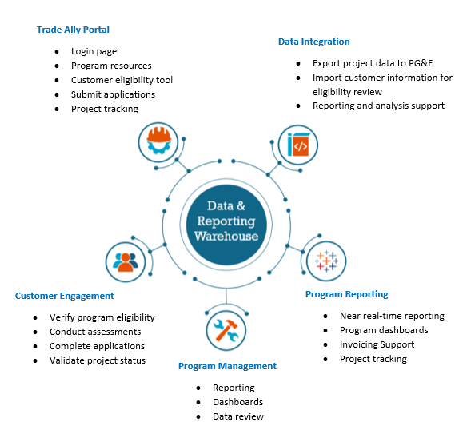
Screenshots of the platform's auditing component, OnSite, will be deployed in support of the Program’s outreach and customer support activities. It is a web-based tool accessible via tablet and smart device, allowing for a simple yet robust collection of customer site information and real-time generation of assessment reports for the customer.

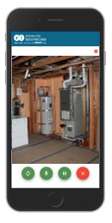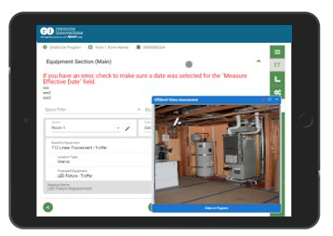
Photo collection for documenting site conditions and post-install verification.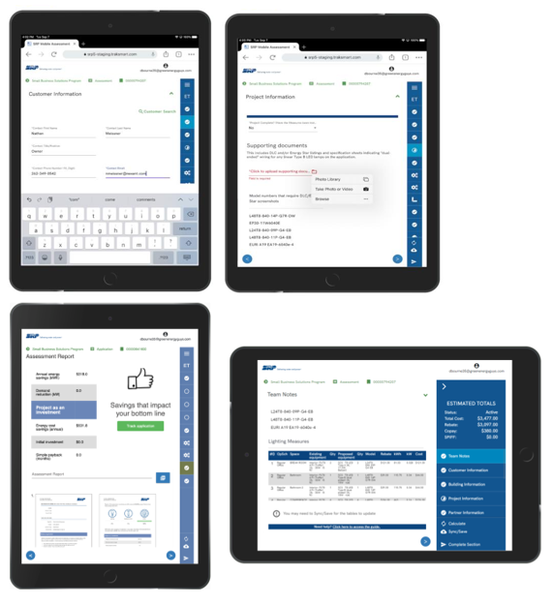
Examples of data collection screen and compilation of measure recommendations, tailored for each customer site visit.

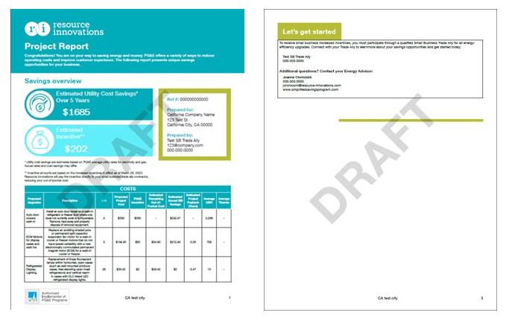
Example of the output produced by the OnSite tool based on findings and information collected during the site visit. This report would be provided to the customer during the site visit and used to encourage adoption of installed measures and continued engagement.

Quantitative Program Targets
See section 1.1.2 for details about the program budget and goals. As a pilot, there are unknown aspects residential building electrification that will improve and decrease conversion rates. The Implementer will work with PG&E to update targets as information emerges from research and ongoing data collection and analysis.
EmPower My Home will target 786 participants over three years, all within DACs in areas of affordability concern.
NUMBER OF PREMISES ELECTRIFIED
 | 2024 | 2025 | 2026 | 2027 | Total
Total Number Electrified Residential Premises | - | 252 | 393 | 141 | 786

AVERAGE EXPECTED BILL IMPACT (ANNUALIZED FIRST-YEAR BILL SAVINGS)
 | 2024 | 2025 | 2026 | 2027 | Avg.
Residential; in dollars | - | $(223) | $(198) | $(215) | $(209)

Diagram of Program

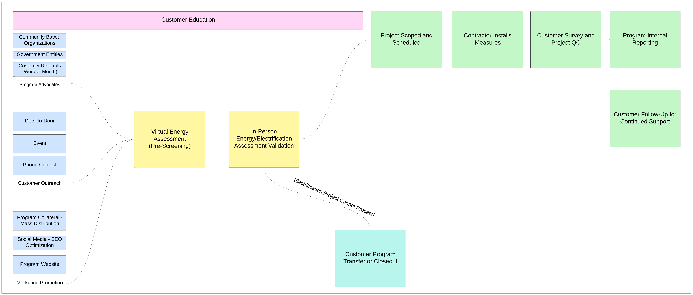

Evaluation, Measurement & Verification (EM&V)

Modeling
The Program will develop whole-building models for interventions that are likely to produce bill savings or bill neutrality. The process is as follows:
  - Prepare a model of the existing building with existing conditions using utility-reviewed software.
    - Use a combination of customer and modeled data to calibrate/verify the model.
  - Prepare usage summary for both electricity and gas.
    - Hourly or Monthly usage.
    - Hourly load profiles using DEER can be used for hourly summary.
    - Apply normalization in the model where needed, specifically for gas hourly usage.
  - Calibrate the model against utility-provided metering data to be within tolerance limits (+-10% of electricity and +-20% of natural gas)
    - Monthly usage will be calibrated against modeled usage for 12 trailing months.
  - Apply proposed measures to the building.
    - List all assumptions for efficient equipment (i.e., HPWH UEF/COP, HP HSPF, etc.).
    - May use CA T24 2022 or 2025 guidelines for early screening where proposed measure details are not finalized.
  - Prepare electric usage summary after implementing proposed measures
    - Hourly summaries to estimate the impacts accurately
  - If eligible, use PG&E Electric Home rates to prepare bill impact reports for residential customers.
RI will train the model based on the provided historical usage and then use trained models to apply proposed measures and estimate bill impacts.
RI will request at least 18 months of usage data to better understand consumption patterns and train models. However, rental turnover may impact the reliability of models without additional data points that are unlikely to be available, such as move-in/out dates, unoccupied dates, etc. The sum of the modeled gas and electric energy savings values of project measures will be used to calculate the estimated bill impacts.

Monitoring Post-installation Bill Impact
The Implementer will continuously monitor post-intervention energy bills using AMI data, adjusting historical consumption to current rates for accurate comparison. Monitoring will continue for 12 months post-installation or until the Program’s sunset date, whichever occurs first.
The Program will establish an initial tolerance of +6% compared to the expected bill impact modeled on the customer-accepted scope of work. This tolerance will account for normal fluctuations in energy consumption while identifying significant deviations that could indicate issues with the EE and/or electrification measures. The Program will flag any participant's bill that exceeds the established tolerance for bill neutrality, triggering a review process.
The review process will investigate, understand, and potentially address the cause with several options, including recommissioning and/or customer training in equipment operation and scheduling. Other corrective interventions may emerge as the Program continuously incorporates lessons from research, installations, and outreach. The Program will continually adjust its strategies to improve effectiveness and customer satisfaction.
Key Assumptions:
- EE and electrification measures will achieve modeled consumption expectations within the tolerances provided above but may require adjustments based on individual site conditions and external energy usage factors.
- Customer energy consumption patterns post-intervention will generally align with projected savings, with allowances made for seasonal and operational variability.

Measure Verification
Measure verification will happen at the project level, with all installers submitting customer information, baseline condition equipment details, and measures installed, including geotagged photographs, copies of invoices, number and cost of units, incentives applied, and installation dates.
Resource Innovations will capture the information in iEnergy so that it is easily accessible to reviewers and inspectors conducting virtual or in-field inspections.
During the on-site post-inspection process, Implementer will:
- Inspect 100% of projects
- Verify measure eligibility, installation, and quality of commissioning by completing checklists based on established procedures and criteria
- Work with the customer and/or installation subcontractor (or non-subcontracted installer) to resolve any discrepancies, if applicable
Inspectors will finalize, record, and track all quality assurance findings and any necessary project remediations. Participants will be tracked within iEnergy. This will include customer contact information, date of interaction, and any other program outcomes (e.g., if the customer utilized a leveraged program for which they are eligible, referral to another program, referral to another subcontracted installer for additional measures).
The Implementer will provide monthly data-driven reviews with installation subcontractors to evaluate the current scope and depth of data collection and reporting with key stakeholders and determine if any adjustments are needed (e.g., assess the appropriateness/adequacy of metrics, data granularity, report format and frequency, and lead conversions).

Third-Party Performance Data Collection Plan
Resource Innovations will use a data-driven approach to provide effective, comprehensive, end-to-end data collection, analysis, and reporting. This will drive continuous improvement to reduce risk and increase participation, savings, forecast accuracy, and cost efficiencies. The following table summarizes the data types, sources, and frequency of use, which will be considered for internal use only for the Implementer’s program management and reporting purposes and shared only with PG&E.

Table 4. Data Reporting
Outreach and Marketing Reports to track Program operations, increase forecasting accuracy, and analyze the effectiveness of marketing spend and pivot.
Frequency: Monthly  - Data Sources:  - iEnergy OnSite  - Contractor management software  - Salesforce customer relationship manager (CRM) | - Sample Data Points:  - Pipeline: Number/percent of projects by stage and aging  - Website Metrics: Page views, time per page  - Campaign and Reach Metrics: Number of customers engaged, commitment/conversion rates
Customer Data to assess and develop projects, maintain effective customer communications, and track Program operations and customer satisfaction KPIs.
- Frequency: Quarterly  - Data Sources:  - iEnergy Onsite  - Customer Applications  - Salesforce CRM  - Customer satisfaction survey | - Sample Data Points:  - Facility Data: Type, location, size, age  - Systems and Equipment Information  - Satisfaction Ratings  - Contact Information
Program Management to assess overall Program performance vs. goals, review energy/bill savings and Program operations, KPIs, identify underperforming areas and create action plans.
Frequency: Monthly  Data Sources:  - iEnergy Program Management,  - PG&E’s Energy Insights Database | Sample Data Points:  - Program deliverables and milestones  - Budget metrics: Percent spent vs. goal  - Realized vs. Forecasted Energy Savings  - Bill Impact  - Non-Energy Benefits  - Measure and Cost Project Details  - Safety, diversity, and compliance: Incidents, accuracy of incentives processed, diverse business spend
Subcontractor Management to highlight areas for improvement, identify subcontractors for rewards and recognition, forecast and allocate resources, and track and report on customer satisfaction and Program KPIs.
Frequency: Monthly with quarterly and annual roll-up  Data Sources:  - iEnergy OnSite  - Contractor management software  - Salesforce CRM  - Commitments/ Customer/Project Applications | Sample Data Points:  - Pipeline: Number/percent of commitments/projects by stage, aging metrics  - Conversion Rates  - Savings vs. Targets  - Measure Mix  - Referrals  - Installation Subcontractor Satisfaction

Normalized Metered Energy Consumption (NMEC)
Not Applicable

Aas, D., Mahone, A., Subin, Z., Mac Kinnon, M., Lane, B., & Price, S. (2020). The challenge of retail gas in California’s low-carbon future: Technology options, customer costs, and public health benefits of reducing natural gas use (CEC-500-2019-055-F). California Energy Commission.
EnergyPro is a comprehensive residential and non-residential building energy analysis software package. The software allows for entry of any type of building and for virtually all types of cooling and heating equipment.
The BEopt™ (Building Energy Optimization Tool) software provides capabilities to evaluate residential building designs and identify cost-optimal efficiency packages at various levels of whole-house energy savings along the path to zero net energy.

