Implementation Plan for
Statewide Midstream Water Heating
SoCalGas®

March 2021

Contents
1 PROGRAM OVERVIEW 1
2 PROGRAM DETAILS 2
3 IMPLEMENTATION PLAN NARRATIVE 3
3.1 Program Description 3
3.2 Program Delivery and Customer Services 3
3.3 Program Design and Best Practices 4
3.3.1 Customer Qualification 4
3.3.2 Market Barriers and Program Tactics 4
3.3.3 Program Incentive Design 5
3.3.4 Innovation 5
3.3.5 Metrics 6
3.3.6 For Program claiming to-code savings 7
3.3.7 Pilots 7
3.3.8 Workforce Education and Training (WE&T) 7
3.3.9 Workforce Standards 7
3.3.10 Disadvantaged Worker Plan 7
3.3.11 Additional Information 7
4 EVALUATION, MEASUREMENT & VERIFICATION (em&v) 8
5 SUPPORTING DOCUMENTS 9

Appendix A - PROGRAM MANUALS AND PROGRAM RULES 10
Appendix B - PROGRAM LOGIC MODEL 11
Appendix C - PROCESS FLOW CHART 12
Appendix D - INCENTIVE TABLES, WORKPAPERS, SOFTWARE TOOLS 13
Appendix E - QUANTITATIVE PROGRAM TARGETS 14

PROGRAM OVERVIEW
The Statewide Midstream Water Heating Program (“Program”), works with midstream market actors to offer point-of-sale (“POS”) rebates to contractors serving California Investor Owned Utility (“IOU”) end-use customers. All customers with a non-residential rate structure served by one of the four IOUs, SoCalGas®, Pacific Gas and Electric Company (PG&E®), Southern California Edison Company (SCE®), and San Diego Gas & Electric Company (SDG&E®), are eligible for POS rebates and the Program will be offered consistently across all IOU territories. The Program offers deemed, POS rebates to contractors serving customers and incentives to midstream market actors for facilitating and influencing sales of natural gas and electric water heating equipment. Additionally, the Program advocates for increased awareness and sales of high-efficiency equipment through a variety of outreach, training, advertising, and engagement activities.

PROGRAM DETAILS
Please refer to the California Energy Data and Reporting System (“CEDARS”) for the following program details:
- Program Budget
- Program Gross Impact Table
- Program Cost Effectiveness (TRC and PAC)
- Type of Sub-Program Implementer
- Market Sector
- Sub-program Type
- Intervention Strategies (Upstream, downstream, midstream, direct install, non-resource, finance, etc.)

IMPLEMENTATION PLAN NARRATIVE

Program Description
The Statewide Midstream Water Heating Program is a deemed midstream incentive program serving Commercial and Multifamily customers. DNV will be the prime contractor for the Statewide Midstream Water Heating Program, and as such, will be responsible for the overall program delivery.
DNV will coordinate with other Program Implementers (Company or Third Parties under Contract with Company), where applicable. Upon program launch, DNV may refer and/or forward customer inquiries pertaining to services provided by other programs.
DNV will perform the following activities on behalf of the Program:
- Develop a broad range of deemed measures and products that are appropriate for a point-of-sale purchase process, including innovative measures.
- Create, build, and foster a solid network of trained, educated, and motivated distributors, across California, including a plan to engage distributors currently enrolled in the Program to limit disruption.
- Develop and implement a market engagement plan to effectively engage distributors, contractors, design firms and customers to drive savings to the measures with the highest savings potential.

Program Delivery and Customer Services
The Statewide Commercial Midstream Water Heating Program is a distributor-centric model design, in which DNV will collaborate with a network of recruited, vetted, trained and managed distributors and manufacturers that specialize in the sale of efficient natural gas and electric water heating measures in the midstream channel through the Program. The primary utility customers for the Program are the commercial sector end users and multifamily master metered buildings.
- Strategy and Planning:
- Integrated market strategy combines manufacturer and distributor engagement and performance targeting with SoCalGas®’ business goals into one comprehensive plan. Using advanced data analytics efficiently targets personalized distributor engagement and helps meet program savings goals cost-effectively across measures.
- Program goals were set to include savings from Disadvantaged Communities (DAC) and Hard-To-Reach (HTR) customers. Analysis was conducted to map the relationship of distributor networks with DACs acknowledging that many DAC customers may overlap with hard-to-reach criteria.
- Identification and Recruitment:
- Begin distributor identification process with an assessment of the distributor’s current customer base and sales volume to determine the level of expected participation, and therefore, how to best allocate program resources going forward.
- Immediately solicit new distributors that have previously participated in other regional programs as well as distributors that have engaged in other DNV midstream programs and are familiar with our processes.
- Use data analytics to identify high-potential, underserved segments, and geographies, then develop strategies with which to engage them.
- Distributor Enrollment:
- Execute a Participation Agreement (PA) with each distributor accepted in the program.
- Implement a vetting process for the newly recruited distributors to ensure they are willing and able to meet program requirements and cost-effectively deliver savings. Enrollment includes completion of a Distributor Reference Form, a comprehensive review of the products they offer. DNV will also review compliance with other requirements, such as:
- A direct relationship with a known and reputable manufacturer(s).
- A California base of operations.
- Staffing ability to comply with all reporting requirements.
- Distributor Engagement:
- Meet regularly with all participating distributors to assess their participation, understanding of the Program and its requirements, and need for additional training and/or marketing and outreach support.
- Survey distributors (either in person or electronically) to determine the level and quality of participation by manufacturers, as well as their own experience with the program.
- Provide program training to each distributor owner and sales staff on how to integrate the sales cycle with the use of incentives, complemented by our marketing support.
- Maintain open and regular contact with the network of participating distributors, including periodic group training and informational events.
- Show managers how incentives should be applied after margins are calculated, so that they are not sacrificing margin dollars by participating in the Program.

Program Design and Best Practices

Customer Qualification
The Statewide Midstream Water Heating Program will be open to all Commercial, and Multifamily customers served by one of the four California IOUs.

Market Barriers and Program Tactics
Midstream barriers | Documentation  of barriers | DNV approaches to barriers
Distributor Recruitment | Distributors are reluctant to participate in a program that has yet to prove itself as being valuable to their business. | We address this challenge by tapping our existing national network of product distributors engaged in other DNV-managed programs. This provides a solid base for the new program and adds legitimacy, providing prospective distributors the assurance that the program is viable and profitable to their own business. We also leverage our existing manufacturer relationships to tap into the distributor network in the proposed territory to ensure that we incorporate all viable distribution partners. DNV will prioritize outreach to the 27 distributors currently enrolled in SoCalGas®’ program to simplify the transition process.
Keeping Product Lists Current and Attractive | Program measures must be kept up-to-date with the needs of an ever-changing marketplace | We address this challenge by maintaining a real-time Qualified Products List (QPL) comprising AHRI and other lists of Energy Efficiency (EE) products. We supplement these lists with products that we qualify, and we respond to distributor and manufacturer requests for product inclusion once a verified vetting process has been complete. This keeps the list current.
Incorporating the Sales Process into distributors’ business models | A distributor will incorporate utility incentives into their point-of-sale process only if it’s easy to manage, easy to explain to customers, and easy to process for reimbursement | DNV provides sales training to integrate the sales cycle with the use of incentives and encourages sales teams to upsell to the EE product by pointing customer focus to the rewards in EE coming in the form of reduction on their utility bill, as well as the discounted price on the invoice of the product. In addition, with our training, the distributor can act as an EE educator, providing one-on-one counsel and advice at the point of purchase.
Ability to Influence Stocking and Selling Practices* | Stocking and selling decisions are typically based on what has sold and what is expected to sell. Changing stock practices often involves risk. | We mitigate the risk by starting with measures that are universally recognized as energy efficient and already popular. This provides a first-entry into EE for many customers, ensuring participation and reducing a distributor’s concern about risk.
Extensive Market Outreach & Engagement* | Unlike downstream programs that typically have a single transaction with a large number of customers, midstream programs have a higher number of transactions with a lower number of market actors. | Core to our midstream program approach is the level of personal, one-on-one support we provide all distributors participating in the programs we manage. Relationships with midstream distributors are more extensive and ongoing and require a deeper understanding of the distributor’s business requirements and perspective. For the Program, we will begin by tapping the experience of participating distributors – as well as distributors participating in other programs we manage – to provide testimonials that will convince potential distributors to join the network. From there, we will provide up-front and on-going training, marketing support and personal visits to ensure we’re meeting their needs, as well as the needs of the program.
Ease of Application Processing* | If the application tracking and submittal processes are too difficult, distributors and vendors refuse to participate. | As explained above, our online Midstream Portal is a simple process for submitting transactions for reimbursement in a timely fashion, often within a week of submission. This has helped promote distributor participation in other programs we manage.
Program Stability for Future Implementation* | Changes to program requirements must be communicated as far in advance as possible. Having (distributors) make stocking and purchasing decisions influenced by the presence of a program that is then abruptly changed or discontinued can permanently damage a relationship. Implementers benefit from the momentum and scale of these programs, but they require time and notice to change. | We will use existing – and where necessary create additional – communications channels to keep distributors abreast of all program development. This not only includes immediate updates on measure and incentive changes, but also advanced notice of impending program changes, such as suspension of operations or even shutdown of the program. In other programs, we produce a monthly electronic newsletter that reports on overall program issues, but we also use blast and individual emails for notifications that fall outside periodic notifications.

Program Incentive Design
The program includes the following incentive design components:
- Incentives are paid at the midstream-level to distributors of water heating equipment based on transactions and sales to contractors.
- Incentives will also be paid at the retail point of sale for large-scale retailers on completion of agreements and integration of DNV’s coupon system with retailer back-office operations. These incentives will only be paid on transactions involving contractors installing at a commercial, or multifamily location .
- Distributors and retail operators will submit details of their sales transactions through the program’s online portal. Pending verification and quality control associated with these transactions, incentives are paid directly to the distributor either by check or by electronic funds transfer (EFT).
- Distributors and retail operators will submit the serial number associated with each qualified product to DNV for subsequent submission to the Company.
- Incentives are modulated for the measure mix within the program to manage program progress to savings goals and cost-effectiveness.
- If properly defined and approved by the CPUC the program expects to coordinate the use of incentives with other programs utilizing non-rate payer funds as appropriate and will not preclude incentive layering or stacking of such incentives.

Innovation
DNV will demonstrate program innovation in the following ways:
- Measure Workpaper Innovation: With our engineering expertise and collaboration with other leading industry professionals, DNV holds an optimum position to draft workpapers with sponsoring from SoCalGas®, to develop new and innovative EE measures with highly credible savings values.
- Enrollment Innovation: DNV understands the demands placed upon distributors and consistently works to find solutions and incentives that will motivate them. An enrollment stipend and an annual performance stipend will act to financially motivate distributor participation. Distributor performance will be based on sales or kWh/therms.
- Market Segment Innovation: Midstream programs have often avoided “big box” store participation (e.g. Home Depot and Lowe’s) because they are not willing to record customer information at the point of sale. We will implement an online coupon tool where mobile-friendly coupons can be generated by approved contractors to allow big box stores to participate in the midstream program without slowing their point of sale process.
- Administrative Process Innovation: DNV’s Midstream Portal provides innovation through a more streamlined implementation process. The portal minimizes the time it takes distributors to enter transactions and receive their payments, minimizes the risk for distributors that transactions will be rejected, and helps distributors connect with their market. The tool achieves these benefits through a design focused on three design principles: responsive process flow, smart data validation and data integration.
- Data Analytics Innovation: Our unique approach to data analytics and data visualization empowers utilities and program managers to interact with data to create an intelligent methodology that deepens engagement with distributors, manufacturers, customers, and utility account managers. With our advanced Program Data Dashboard, the DNV team will present near real-time information to SoCalGas® managers and participating distributors in the field. Our proprietary, secure data backbone provides historical information, as well as performance snapshots, and reliable program forecasting models. Real-time reporting will be available to SoCalGas®’ program managers using the program dashboard. Monthly reports will give detailed descriptions of the Program progress and assess how field work is impacting Program metrics. This will be particularly important as we explore adding layers of products to midstream offerings. Our reporting approach offers the flexibility to best meet IOU needs.

Metrics
The Program will be using first year kWh, kW and therms savings from implementation measures to track program progress. The program will also be evaluated for its cost-effectiveness via CET runs performed annually. The non-energy metric the Program will be tracking are HTR and DAC installations to reach the % program equity goals for the disadvantaged and hard- to-reach customers. The full list of Key Performance Indicators (KPI) is included below.
% | KPI | Description | Continuous Monitoring Mechanisms
10% | Performance: Goal Accomplishment (net therm savings) | Percentage of net annual energy savings achieved vs forecasted | Monthly Reports
10% | Performance: Goal Accomplishment (net kWh savings) | Percentage of net annual energy savings achieved vs forecasted | Monthly Reports
20% | Cost Effectiveness Alignment: TRC Calculation | TRC – Actual vs. forecasted  Difference: Actual Minus Forecasted | Annual Reports
10% | Performance:  Cost Per Unit Saved | Levelized PAC Cost -Actual vs. forecasted  Difference: Actual Minus Forecasted | Annual Reports
8% | Performance: Disadvantaged Communities | Percentage of customers in disadvantaged communities per assignment to DAC by ZIP Code | Monthly Reports
8% | Performance: Hard-to-Reach | Percentage of customers meeting HTR definition | Monthly Reports
5% | Project Pipeline | Projected enrolled distributors targets net energy savings (pipeline) to meet energy savings forecast | Reported Quarterly
5% | Customer Satisfaction – Distributors & Contractors | Satisfaction scores based on surveys of an agreed upon percentage of distributors & contractors | Reported Quarterly
4% | Customer Satisfaction - Responsiveness | Log and report complaints; resolve issues within two weeks | Reported Quarterly
5% | Distributor Enrollment | Number of enrolled and trained water heater distributors within an agreed amount of time from signed contract | Reported Quarterly
5% | Contractor Administrative Performance: Budgets & Expenditures | Percentage of expenditures to overall budget | Monthly Reports
5% | Service Delivery | Program Advisor- rating  - Timely response for out-of-scope requests  - Proactive in continuous program delivery  - On-time invoice and Monthly report  - Quality of Deliverables  - Willingness to partner  - Communication | Monthly Reports
5%* | Supply Chain Responsibility: DBE Spend | Percent DBE spend compared to agreed goal or commitment | Monthly Reports

For Program claiming to-code savings
This section is not applicable to the Program.

Pilots
This section is not applicable to the Program.

Workforce Education and Training (WE&T)
This section is not applicable to the Program.

Workforce Standards
This section is not applicable to the Program.

Disadvantaged Worker Plan
This section is not applicable to the Program.

Additional Information
There is no additional information.

EVALUATION, MEASUREMENT & VERIFICATION (em&v)
The Program will use DEEMED Measure Recording and Verification. The DEEMED measure savings for each approved Program measure are uploaded the SoCalGas® reporting system and reviewed for accuracy. As part of the monthly reporting and invoicing process, the transaction detail report showing customer’s measure installation data will be uploaded to the SoCalGas® reporting system. SoCalGas® may identify a selected percentage of the installed projects from each invoice for Company inspection. If an inspected project fails DNV will coordinate with SoCalGas® to make invoice adjustments.
SoCalGas® EM&V supports the Program to ensure that DEEMED measures are being implemented in the field following the workpaper guidance. SoCalGas® EM&V also notifies the implementer of DEEMED workpaper updates that need to be implemented.
The SoCalGas® program advisor will coordinate with the Program and with SoCalGas® Policy in order to report DEEMED savings for evaluation studies and data requests.

SUPPORTING DOCUMENTS
All supporting documents are in Appendices A-E.

Appendix A - PROGRAM MANUALS AND PROGRAM RULES
This appendix has been attached as a separate document.

Appendix B - PROGRAM LOGIC MODEL
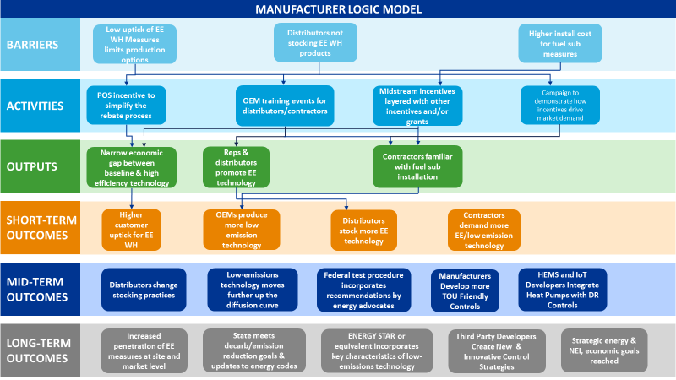
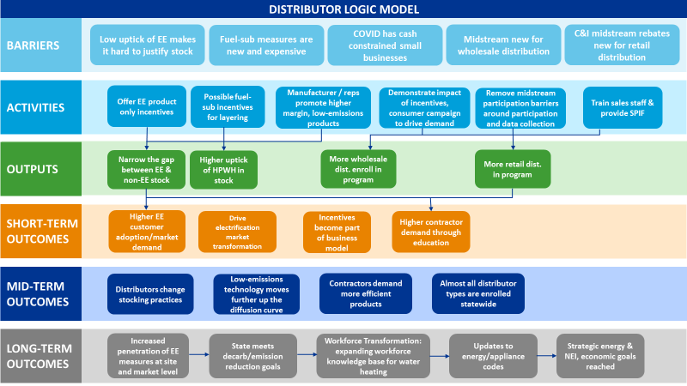

Appendix C - PROCESS FLOW CHART

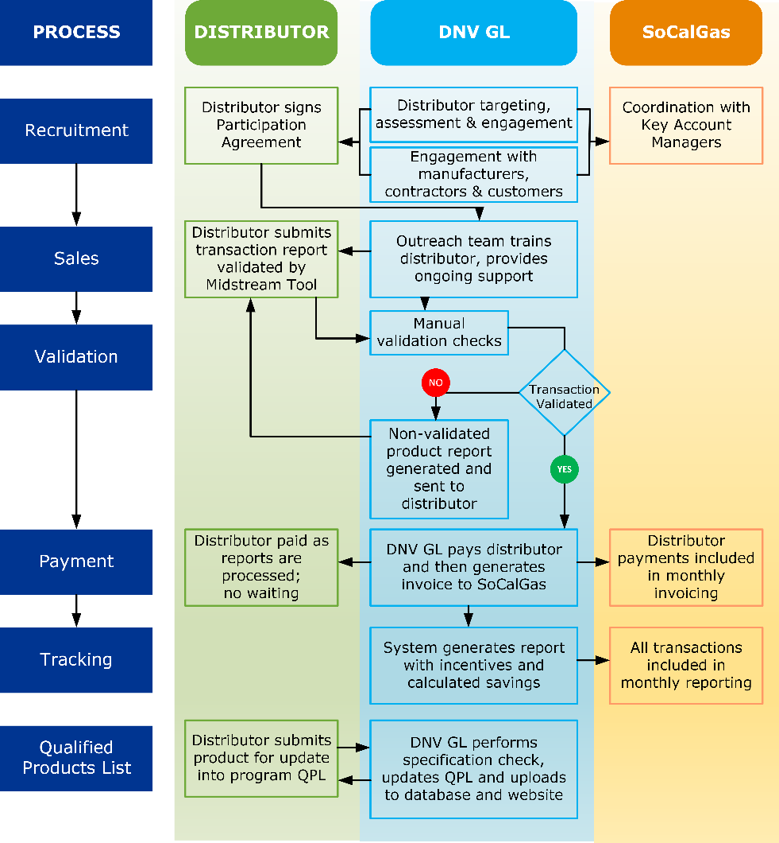

Appendix D - INCENTIVE TABLES, WORKPAPERS, SOFTWARE TOOLS

Category | Measure | $ Incentive/  Incentive Unit | Incentive  Unit
Gas  Storage  WH | NG-WtrHt-SmlStrg-Gas-lte75kBtuh-30G-MD-0p64UEF | 2.00 | CapKBtuh
 | NG-WtrHt-SmlStrg-Gas-lte75kBtuh-40G-MD-0p64UEF | 3.00 | CapKBtuh
 | NG-WtrHt-SmlStrg-Gas-lte75kBtuh-50G-MD-0p64UEF | 2.00 | CapKBtuh
 | NG-WtrHt-SmlStrg-Gas-lte75kBtuh-30G-HI-0p68UEF | 3.00 | CapKBtuh
 | NG-WtrHt-SmlStrg-Gas-lte75kBtuh-40G-HI-0p68UEF | 6.00 | CapKBtuh
 | NG-WtrHt-SmlStrg-Gas-lte75kBtuh-50G-HI-0p68UEF | 5.00 | CapKBtuh
 | NG-WtrHt-LgStrg-Gas-gt75kBtuh-0p83Et | 2.00 | CapKBtuh
 | NG-WtrHt-LgStrg-Gas-gt75kBtuh-0p90Et | 8.00 | CapKBtuh
 | NG-WtrHt-LgStrg-Gas-gt75kBtuh-0p96Et | 8.00 | CapKBtuh
 | NG-WtrHt-SmlInst-Gas-1t200kBtuh-1t2G-MD-0p87UEF-40g | 6.00 | CapKBtuh
 | NG-WtrHt-SmlInst-Gas-1t200kBtuh-1t2G-MD-0p81UEF-40g | 3.20 | CapKBtuh
 | NG-WtrHt-MedInsr-Gas-76to200Btuh-1lt2G-0p90Et | 6.00 | CapKBtuh
 | NG-WtrHt-LgInst-Gas-gte200kBtuh-1t2G-0p80Et | 5.00 | CapKBtuh
 | NG-WtrHt-LgInst-Gas-gte200kBtuh-1t2G-0p90Et | 8.00 | CapKBtuh
 | NG-WtrHt-LgInst-Gas-gte200kBtuh-1t2G-0p96Et | 8.00 | CapKBtuh
Gas  Boilers | Commercial Boilers, HW, <200 kBtu/hr, 84% UEF | 0.5 | CapKBtuh
 | Commercial Boilers, HW, <200 kBtu/hr, 87% UEF | 3.00 | CapKBtuh
 | Commercial Boilers, HW, >=200 kBtu/hr, 96% TE | TBD | CapKBtuh
 | Commercial Boilers, HW, >=200 kBtu/hr, 90% TE | 2.00 | CapKBtuh
 | Commercial Boilers, HW, >=200 kBtu/hr, 84% TE | 0.50 | CapKBtuh
Electric  HPWH | NE-WtrHt-SmlStrg-HP-lte6kW-rep30G-MD-3p09UEF-50g | 57 | CapKBtuh
 | NE-WtrHt-SmlStrg-HP-lte6kW-rep30G-MD-3p31UEF-50g | 48 | CapKBtuh
 | NE-WtrHt-SmlStrg-HP-lte6kW-rep40G-MD-3p09UEF-50g | 51 | CapKBtuh
 | NE-WtrHt-SmlStrg-HP-lte6kW-rep40G-MD-3p31UEF-50g | 42 | CapKBtuh
 | NE-WtrHt-SmlStrg-HP-lte6kW-rep50G-MD-3p09UEF-50g | 44 | CapKBtuh
 | NE-WtrHt-SmlStrg-HP-lte6kW-rep50G-MD-3p31UEF-50g | 50.65 | CapKBtuh
 | NE-WtrHt-SmlStrg-HP-lte6kW-65G-3p33UEF | 6.71 | CapKBtuh
 | NE-WtrHt-SmlStrg-HP-lte6kW-80G-3p42UEF | 13.02 | CapKBtuh
Fuel Sub  HP  Measures | NE-WtrHt-FuelSub-SmlStrg-HP-lte6kW-rep80G-3p42UEF-80g | 40.75 | CapKBtuh
 | NE-WtrHt-FuelSub-LrgStrg-HP-gt6kW-120G-4p20COP | TBD | CapKBtuh
 | NE-WtrHt-FuelSub-SmlStrg-HP-lte6kW-rep30G-MD-3.09UEF-50g | TBD | CapKBtuh
 | NE-WtrHt-FuelSub-SmlStrg-HP-lte6kW-rep30G-MD-3p31UEF-50g | TBD | CapKBtuh
 | NE-WtrHt-FuelSub-SmlStrg-HP-lte6kW-rep40G-MD-3.09UEF-50g | TBD | CapKBtuh
 | NE-WtrHt-FuelSub-SmlStrg-HP-lte6kW-rep40G-MD-3p31UEF-50g | TBD | CapKBtuh
 | NE-WtrHt-FuelSub-SmlStrg-HP-lte6kW-rep40G-HI-3.09UEF-50g | TBD | CapKBtuh
 | NE-WtrHt-FuelSub-SmlStrg-HP-lte6kW-rep40G-HI-3p31UEF-50g | TBD | CapKBtuh
 | NE-WtrHt-FuelSub-SmlStrg-HP-lte6kW-rep50G-MD-3.09UEF-50g | TBD | CapKBtuh
 | NE-WtrHt-FuelSub-SmlStrg-HP-lte6kW-rep50G-MD-3p31UEF-50g | TBD | CapKBtuh
 | NE-WtrHt-FuelSub-SmlStrg-HP-lte6kW-rep50G-HI-3.09UEF-50g | TBD | CapKBtuh
 | NE-WtrHt-FuelSub-SmlStrg-HP-lte6kW-rep50G-HI-3.31UEF-50g | TBD | CapKBtuh
 | NE-WtrHt-FuelSub-SmlStrg-HP-lte6kW-rep60G-HI-3p33UEF-80g | TBD | CapKBtuh
 | NE-WtrHt-FuelSub-SmlStrg-HP-lte6kW-rep75G-HI-3p42UEF-80g | TBD | CapKBtuh
 | NE-WtrHt-FuelSub-SmlInst-HP-lte6kW-replt200kBtuh-LW-3.09UEF | TBD | CapKBtuh
 | NE-WtrHt-FuelSub-SmlInst-HP-lte6kW-replt200kBtuh-LW-3.31UEF | TBD | CapKBtuh
 | NE-WtrHt-FuelSub-SmlInst-HP-lte6kW-replt200kBtuh-MD-3.09UEF | TBD | CapKBtuh
 | NE-WtrHt-FuelSub-SmlInst-HP-lte6kW-replt200kBtuh-MD-3.31UEF
 | NE-WtrHt-FuelSub-SmlInst-HP-lte6kW-replt200kBtuh-HI-3.09UEF | TBD | CapKBtuh
 | NE-WtrHt-FuelSub-SmlInst-HP-lte6kW-replt200kBtuh-HI-3.31UEF | TBD | CapKBtuh
Pump Measures | Recirculation Pump Timer, Commercial (<=1/12 Hp, >1/12 to <=1/3 Hp, >1/3 Hp) | 230 | Each
 | DHW Pump Demand Control, MF & Commercial | 35* | Dwelling Unit/Household
*The incentive and measure cost vary per dwelling unit/household depending on the total number of units the pump would serve. The incentive is the agreed upon % of the measure cost (IMC or FMC in the case of AOE measure). The incentive offered is $10.40-$350.06 per dwelling unit/household, which is based on the costs reported in the current workpapers.

Appendix E - QUANTITATIVE PROGRAM TARGETS

First-year Annualized Deliverable* | 2021 | 2022 | 2023 | Total
Gross Therm Savings | 2,124,703 | 2,552,848 | 3,192,068 | 7,869,618
Gross kWh Savings | 3,052,621 | 4,466,149 | 5,594,047 | 13,112,817
Gross kW Reduction | 3,053 | 4,055 | 5,078 | 12,186
Gross Gallons Saved
Net Therm Savings | 1,274,822 | 1,531,709 | 1,915,241 | 4,721,771
Net kWh Savings | 1,864,367 | 2,873,720 | 3,599,650 | 8,337,737
Net kW Reduction | 1,831 | 2,425 | 3,037 | 7,293
Gallons Saved | NA | NA | NA | NA
Non-resource Deliverable(s), if applicable:  (ASHRAE Level 1 audits and sales consultations) | NA | NA | NA | NA
Assumed Program Launch Date | May 1, 2021
* kWh and therm values will be estimated using DEER/deemed values; water savings will be estimated. Net-to-Gross values based on workpapers and estimated measure counts, as presented in final agreed upon CET.

