MCE: DRAFT Commercial Efficiency Marketplace Program Manual

How the Demand Flex Market Works
Each aggregator enters into a Flexibility Purchase Agreement (FPA) that pays aggregators for all cost-effective value delivered at the meter on performance at the end of the first project year.
The Flex Payment is calculated to provide the maximum market benefits, that are by definition cost-effective per the CPUC Total Resource Cost Test.
The Flex Payment is the difference between the avoided cost value of the project, which is the actual measured hourly resource curve (aka savings load shape) multiplied by the avoided cost value for each hour, minus the total project cost (customer energy-related spend+ admin). The avoided cost value is calculated taking into account the effective useful life (EUL) of the primary measure as defined by the CPUC, to represent the lifecycle value of the project.
An Aggregator's Flex Payment is paid-on-performance at the end of the first 12-months of project operation. This payment represents the maximum available incentive that delivers a project that is definitionally cost-effective per the Total Resource Cost Test.
Aggregators can increase their projects' value by both increasing savings volume and by delivering load shape impacts that are more valuable than the CPUC's deemed average resource curve (savings load shape).
The Efficiency Value will also be calculated for each project using the CPUC Deemed load shape and EUL values for a project's primary measure class, then subtracting customer and admin costs. This value can be thought of as a price floor for aggregators.
Recurve will enroll projects and track savings for every project in an aggregator's portfolio and provide aggregator's near-real-time M&V to all through our Fleet Manager portal, and track payment recommendations through the Flex Ledger.

Understanding Avoided Cost
The CPUC Avoided Cost Calculator provides a set of 8760 marginal hourly values for the California Grid. This data set is used to value demand flexibility in this marketplace and feeds into the Project Value Estimator and the TRC calculation that derives Flex and Efficiency Payments.
Recurve provides aggregators access to the Valuation Explorer tool that will allow detailed analysis of the Avoided Cost price signal to enable analysis of actual project values. The Avoided Cost Calculators can then be downloaded as a CSV and used in conjunction with modeled or actual past hourly resource curves (savings load shapes) to estimate the avoided cost value of project to forecast potential cashflows.

Valuation Explorer
The Flexibility Value Explorer dashboard enables aggregators to explore the avoided cast value that, when combined with your savings load shape and useful life of your primary measure, determine the top line value of your projects.

Not only does this handy dashboard let you visualize the Avoided Cost Value, but will also allow you to download a CSV file that includes the 8760 values. This can be used, in combination with your own resource curve data (savings load shape) either from empirical analysis, or even from models, to determine the value of your projects.

This dashboard requires the basic inputs to calculate the Total Resource Cost test to ascertain for sample project data the available Aggregator Payment value.

Aggregators are paid on the delta between project energy related costs and administration, and the total lifetime avoid cost value, in order to achieve a TRC of 1.0 (aka, pays for itself over the useful life of the measure).

Aggregators can earn more by reducing customers costs, and most importantly, increasing savings and the value of the resource curve (savings load shape) delivered.

These Deemed savings should be viewed as the value floor.

Market Sizing
Recurve will work with aggregators early in the process to survey the MCE marketplace to identify in broad terms the number of potential customers based on NAICS group, level of energy usage, and desired end uses. This initial analysis will inform the early go-no-go decision by aggregators to participate, and be the starting point for specific customer targeting.

Targeting and Optimization to Maximize Value
Aggregators have an incentive to both increase the volume of total savings and maximize the value of the resource curve (savings load shape) they are delivering to maximize project value. The aggregator may also reduce customer cost as a means to increase the available incentive that is cost-effective per the Total Resource Cost test. We would encourage all aggregators to take time using the Project Value Calculator to understand these interactive effects to develop a model that maximizes grid impacts and customer offerings to maximize project value.
One primary tactic provided to aggregators in the Demand Flexibility Marketplace, is that ability to work with Recurve to identify those customers with the highest potential for savings. Aggregators will be encouraged to pursue opportunities with customers whose consumption profiles suggest greater savings potential.

Utilize the targeting tools available through this marketplace to identify those buildings that offer flexibility opportunities during summer evening ramp, which can result in much more valuable avoided cost savings. Recurve will work with aggregators to identify the attributes of high potential customers to identify targeted groups that are the most likely to have cost-effective outcomes for all parties involved.

For example, an aggregator targeting small business Air Conditioner savings will likely find customers most in need of help, who will have dramatically higher bill savings and grid benefits, if one focuses on those customers with the greatest AC usage during the grid peak periods when savings are worth the most.

Aggregators also have the flexibility and incentive to optimize their offerings toward the most beneficial mixes of technologies, innovate on customer engagement strategies or automation, in order to maximize adoption and the load shape impacts that come from these projects. Aggregators will be given maximum flexibility to determine their own business models, and customer value propositions.

Project Performance Tracking with Fleet Manager
Upon enrollment and completion of work, project performance will be tracked using Recurve's Fleet Manager portal.

Aggregators will be able to enroll new customers, unlock meter-level data access, perform QA/QC of recently completed projects, and track ongoing performance with up-to-date meter-level savings calculations for all projects using the Recurve Fleet Manager portal.

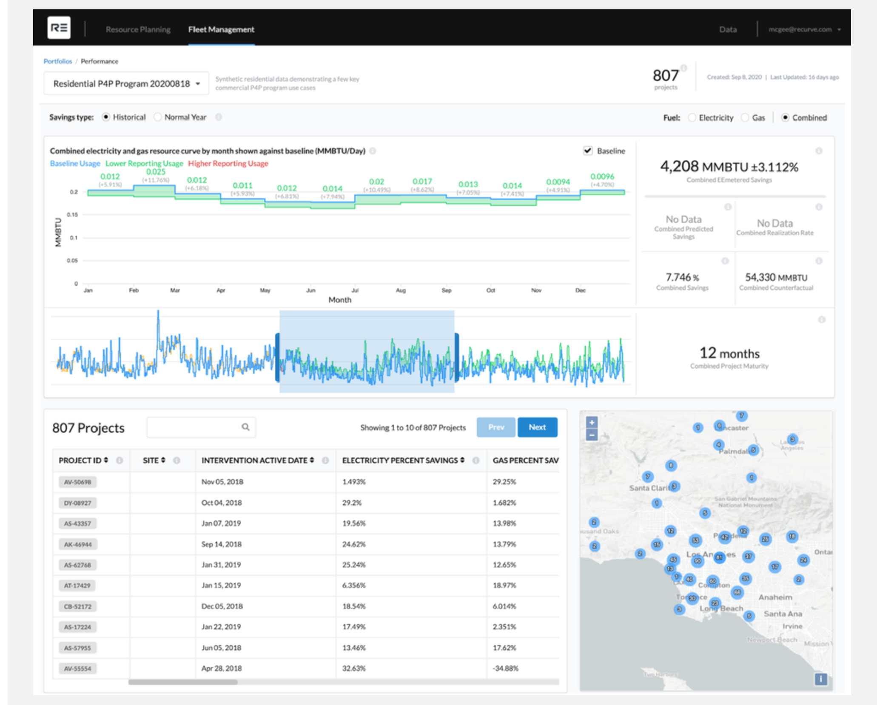

Allocation of Pay for Performance Budgets
Available MCE program budgets will determine performance budgets accessible to aggregators. An initial tranche of funding will be made available to approved aggregators. Once this allocation is exhausted, the aggregator will become eligible to draw from the shared incentive pool until it is depleted.

Project Enrollment Process
1. Check project eligibility by inputting details into the Project Enrollment tab of the Aggregator Portal.
2. Recurve will verify the project is eligible and email confirmation within one business day.
3. Sign contract with customer, provide Recurve with required project documentation.
4. Install measures and track savings using Fleet Manager.
5. After tracking 12 months of savings data, Recurve will calculate aggregator payment values according the the FPA and issue a payment recommendation to MCE.
6. MCE issues payment for value of savings generated.
Project Eligibility
The MCE Demand Flexibility Marketplace is agnostic to measures and business models; however, the expected useful life of the measures being implemented will affect the magnitude of the FPA rate.
Eligibility requirements include:
• Not currently participating in a CPUC-funded downstream program.
• Project site must be located in PG&E and/or MCE service area, and receive electric distribution service from MCE or PG&E and natural gas service from PG&E.
• 12 consecutive months of energy usage data.
• If solar, installation must have been completed at least 12 months prior to intervention.
• Model fit needs to be< 1.0 CVRMSE (Recurve will conduct analysis at intake).

Tracking FPA Value for Payment with Flex Ledger
The Recurve Flex Ledger provides revenue-grade auditable accounting of demand flexibility portfolios to enable Marketplace payments issued to aggregators, as well as savings claims, and procurement reporting.

Similar to an accounting system, the Flex Ledger provides an end-to-end system of record for registering contract requirements, valuing metered savings, creating invoices, managing payments, and reporting savings to regulators, all backed by a fully auditable trail of all transactions and calculations down to the individual meter.

Revenue Grade M&V – CalTRACK and OpenEEmeter
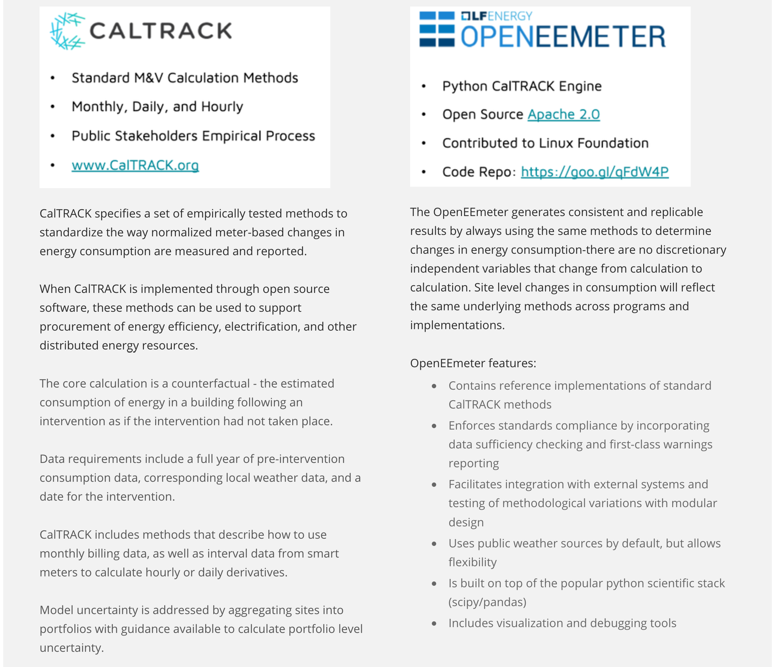

Invoicing and Payment
Recurve's electronic ledger tracks all stages of a NMEC project in a program, including non-routine adjustments. Invoice payment recommendations will be provided to MCE based on CalTRACK payable savings results. MCE will issue payments based on Recurve's payment recommendation.

Aggregator Start Up Process
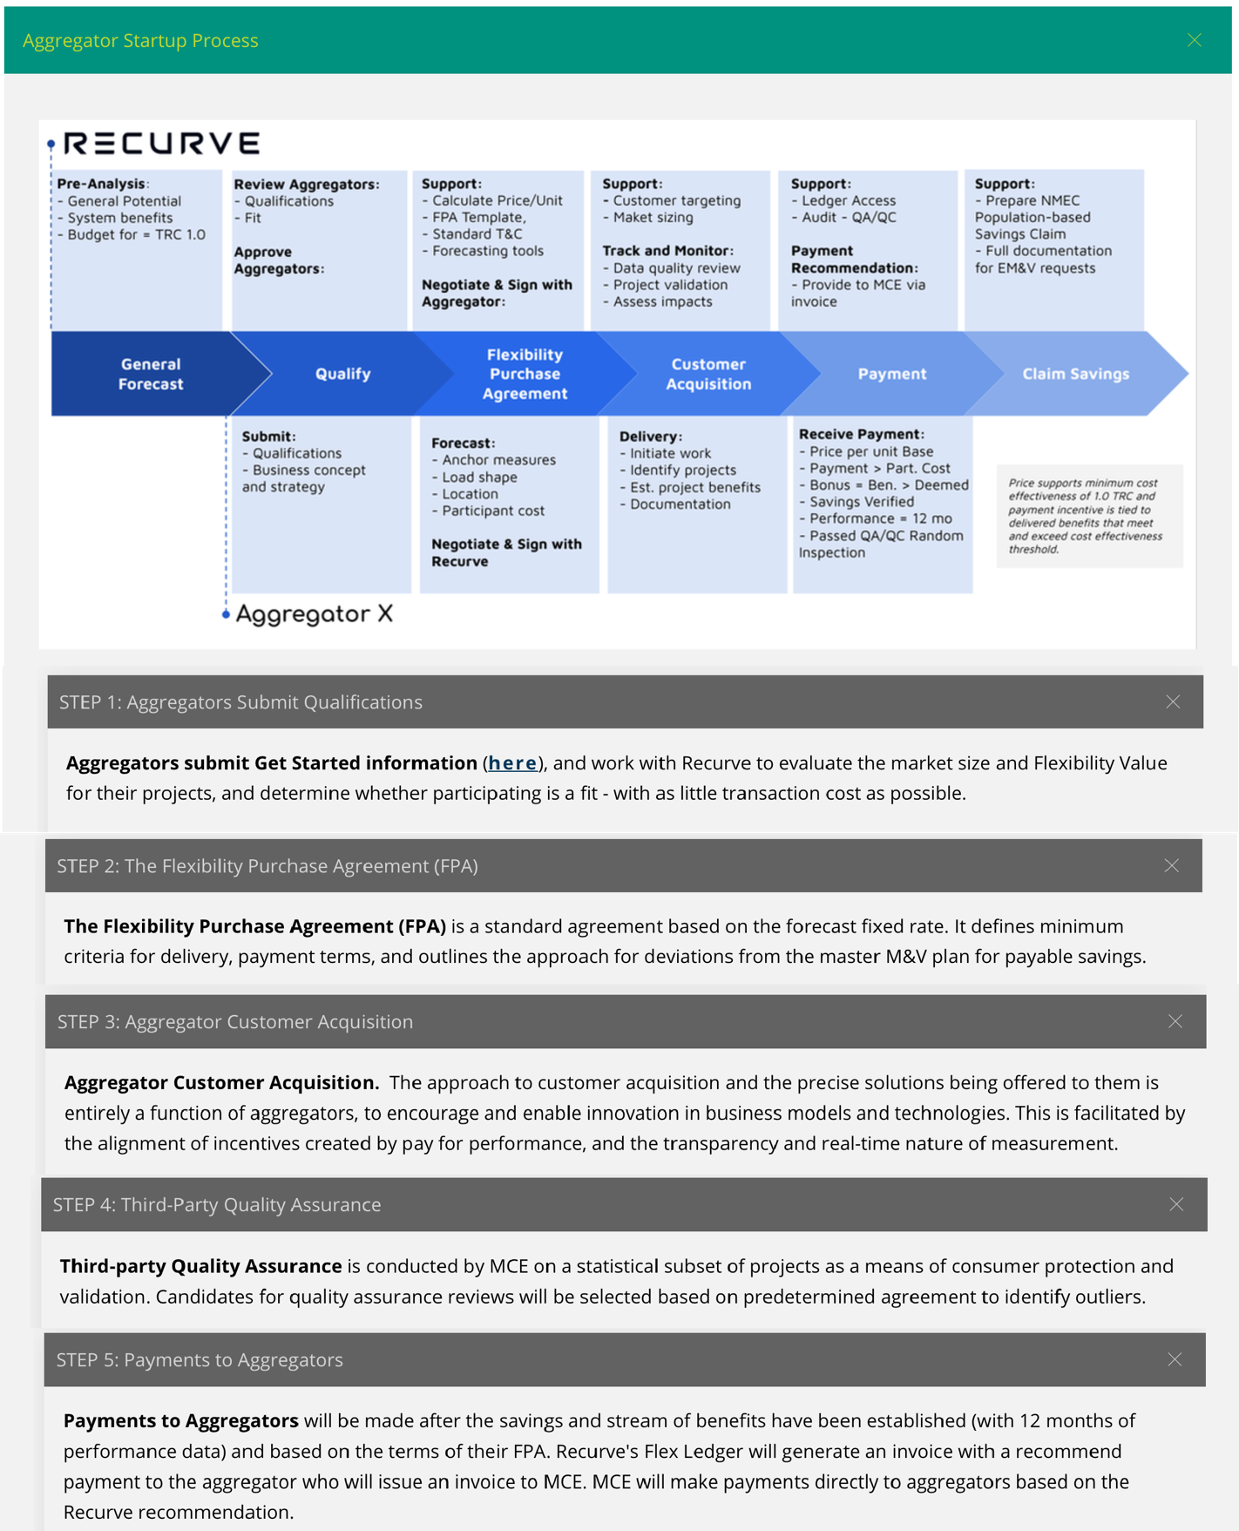
Quality Assurance Plan
MCE maintains the integrity of the MCE Demand Flexibility Marketplace through an independent Standards and Quality Assurance Team who manages the quality assurance system for the Marketplace.

The quality assurance (QA) system has several components, including a review of qualifications and credentials, paperwork audits, the establishment of program standards, and field and photo inspections. QA inspections involve verification of the contracted scope of work, accuracy of site analysis, comparison of installation to submitted designs. RECURVE, MCE, or its representatives may make a reasonable number of visits to the customer site before, during, and/or after installation of efficiency measures to assess overall compliance.

Program Roles and Responsibilities
The program relies on Aggregators to provide complete turnkey services for qualified demand flexibility improvements to customers.

Aggregator Roles and Responsibilities
- Holds the agreement (contract) with the customer
- Responsible for performance, including subcontractors
- Receives incentive payments
- Agrees to terms of the Flexibility Purchase Agreement
- Agrees to terms of the M&V agreement
- Accountable for resolution of customer complaints
- Responsible for warranties and production guarantees
- Responsible for installation and quality of the project
- Responsible for maintaining a credentialed person on staff

Selecting Completed Projects for Inspection
The purpose of the QA inspection is to provide MCE an opportunity to evaluate the accuracy of the site analysis and design documents and verify that building components and equipment are installed according to Program requirements. The QA inspection also includes selected health and safety and performance items.

MCE reserves the right to select any project for inspection. Selections may include consideration of the following criteria:
- Low savings realization rates
- High CVRMSE or CVRMSE change
- High variance

MCE intends to conduct both field and photo inspections based on the following sampling rates:
- 10% photographic
- 2-4% onsite inspection
MCE may select any completed project for inspection based upon customer complaints, warranty related issues, or as part of the review of a contractor under status review or Program disciplinary action.

Field Inspections Process and Scope
The purpose of inspection is to confirm measures are installed per manufacturer instructions and as outlined by the aggregator in the customer agreement, and in the project documentation provided to Recurve. QA field inspections are scheduled at the customer’s convenience. Customers are encouraged to allow the contractor to attend the inspection to answer questions. If the customer agrees, the contractor will be notified by email between 5 to 14 days of the upcoming inspection. Every effort will be made to accommodate the contractor’s schedule, but the customer’s convenience takes precedence.

Customers have the right to request that the contractor not attend the QA field inspection. In these situations, the contractor will not be notified of the scheduled inspection but will receive the report from the QA team within 15 business days of the inspection.

Photo Inspections
The contractor is required to take construction photos for each measure installed, which describe the existing conditions as well as the replacement product or measure. MCE expects contractors to take photos throughout the installation process to ensure that each measure completed is supported with photographic documentation. MCE may request construction photos for purposes of conducting a photo inspection at any time, and failure to provide the requested photos may result in higher inspection rates. Taking multiple pictures of each installed measure will help ensure a smooth photo inspection process.

QA Inspection Report
The QA inspection report will provide a summary of all evaluated elements of the project and list any nonconformances identified during the inspection. The report will provide an overall score (scoring criteria described below) of the project and identify it as a pass or fail.

The report will be provided to the contractor approximately 15 days after the inspection, following an internal review and scoring by the QA Team. The report will be made available to the customer upon a direct request to MCE. The report will contain a score based on the scoring criteria and a list of any nonconformances found during the inspection.

