California Energy Efficiency Coordinating Committee-Hosted Meeting for
Compensation Task Force
Meeting #1 Summary
June 8, 2022 12pm-3pm
See Supporting Documents on Meeting Page
Facilitator: Katie Abrams, SESC

On June 8, 2022, the CAEECC hosted its first meeting for the Compensation Task Force (TF). The meeting was held via Zoom. Fifteen representatives attended from 12 TF Member organizations (including Leads, Alternates and Ex Officio) as well as one member of the public. A full list of meeting attendees is provided in Appendix A.

This meeting summary is a high-level overview of the meeting. It does not capture the discussion of concerns and alternative options for recommendations, as that is captured in the final deliverable, a memo. The memo itself serves as the ultimate record going forward. Next Steps, at the end of this document, list all next steps discussed at the meeting. Within this document, Task Force Member conversations and Facilitator responses are noted with bullets within the appropriate sections. Sub-bullets represent responses to member conversations.

Meeting materials, including the redline changes made during the meeting, are provided on the CAEECC website at: https://www.caeecc.org/compensation-task-force

Housekeeping
Facilitator Katie Abrams provided general reminders, zoom etiquette, and meeting norms. TF Members confirmed that they accept the meeting norms and ground rules.

The Meeting goals were to:
- Get acquainted with fellow Task Force Members
- Review Task Force goals, scope & approach
- Review background & context on compensation
- Brainstorm initial recommendation ideas in breakouts

No Task Force Members had comments on the etiquette, meeting norms, or meeting goals.

Introductions
Facilitator Katie Abrams invited Task Force members to introduce themselves with their Name, Organization, and two values they bring to this working group. Below are each member’s introductions as well as additional meeting participants.
- Task Force Members
  - Alejandra Tellez, 3C REN: local community org outreach; diverse perspectives
  - Jennifer Berg, Association of Bay Area Governments: knowledge/experience with funding limitations
  - Dan Suyeyasu, CodeCycle.org: legal background, creative thinking
  - Lucy Morris, Pacific Gas & Electric: welcome change, welcome more perspectives
  - Christopher Malotte, Southern California Edison: respect, open mindedness
  - Kellvin Anaya, Southern California Edison: diversity, integrity
  - Ted Howard, Small Business Utility Advocates: small is beautiful, strength in diversity
  - Lujuana Medina, Southern California Regional Energy Network: represent small diverse organizations, inclusivity
  - Nicole Milner, American Eco Services: inquisitive collaborator
  - Annette Beitel, Future Energy Enterprises: experience in Community-based Organization (CBO) outreach, commitment
  - James Dodenboff, Silent Running: experienced, commitment
  - Constance Slider Pierre, The Utility Reform Network: curiosity, hunger for learning, inclusion, belonging
  - Stephanie Green, CPUC: collaboration, diversity, engagement
  - Jesus Torres, CPUC: equity, inclusivity
  - Nils Strindberg, CPUC Energy Division: interested in advancing goals and brings openness
  - Kelsey Jones, San Joaquin Valley Clean Energy Organization: not in attendance
  - Sahar Abbaszadeh, ARUP: not in attendance
- Members of the Public
  - Anna Solorio, Community Housing Opportunities Corporation

Goals and Approach
Abrams provided an overview of the goals and approach for the task force. Please review slides for additional details.

Summary of TF Member questions and feedback:
- Can we broaden the scope beyond short term solutions for the Justice-, Equity-, Diversity-, and Inclusion-focused Working Group (JEDI-focused WG) and open the scope to funding opportunities for CAEECC activities more broadly? How hard-set is that charge?
  - Facilitator, Katie Abrams: The driver behind the narrow scope was to ensure that stakeholders who want/need compensation can be compensated as soon as possible for the future Working Group, with funding available for WG members to then have the broader discussion of CAEECC funding. Thus the narrow scope is intended to address the immediate need. It’s not necessarily hard and fast; if the TF has broader funding ideas, we can fold those in..
- Perhaps our brainstorming in this group can consider if it could be applied to CAEECC long term
- This is being looked at as a pilot with the JEDI-focused WG being that pilot group
- Nuance on Question #5: it’s useful to think about the contributions of the compensated member. Is there an obligation to participate in X amount of meetings? What should the organization be required to do as a result of compensation?

Recommendations from CAEECC CDEI Working Group
Jim Dodenhoff and Annette Beitel presented the recommendations they developed as volunteers leading and participating in the mini team on Compensation from the CAEECC Diversity Equity and Inclusion (CDEI) Working Group. Katie Abrams provided a brief overview of the CDEI Working Group. Please review slides for additional details.

Summary of TF Member questions and feedback:
- Evaluation, Measurement, and Valuation are a separate line item in Program Administrator (PA) budgets. Process evaluation is different than impact evaluation as the former does not look at the energy savings
  - Process evaluations are run by the PAs and are for evaluating program implementation improvements.
- Where do the CDEI WG recommendations fit into this TF’s work?
  - A lot of thought went into the CDEI WG recommendations, which is why we’re sharing background, context, and recommendation ideas so that we don’t reinvent the wheel and maybe we spark an idea for this TF. Members of this TF are welcomed and encouraged to share new ideas or build off of the CDEI WG ideas.
- It was identified that the challenges with the Intervenor Compensation Program (I-Comp) are that the timing/process is cumbersome and there are procedural obstacles. Assuming we solve the timing issue and it’s easy to do, would the CAEECC WG be eligible for I-Comp?
  - CPUC, Stephanie Green: Individual members need to qualify, not sure if this would qualify because this isn’t a proceeding.
  - If you flip the question, what if I-COMP was eligible for CAEECC? Could it be a solution? And the answer seems to still be no.
- Stephanie, CPUC: Stephanie, CPUC: The CPUC CBO Pilot for engagement compensation is on hold due to funding issues. Separately, the CBO Case Management Pilot Program will launch soon; its focus is on reducing utility shut offs – we may have some good lessons learned to share with this group in the coming months. That being said, additional funding for the CBO Pilot for engagement compensation may come through the Governor’s Proposed Budget.
- In the Illinois case study presentation, Beital said that “Eventually utilities took over the facilitation contract after 6 years of grants through a utility settlement”. Was that utility passing costs on to ratepayers?
  - Presenter, Annette Beital: This relates to the Energy Efficiency (EE) advisory group in Illinois. The foundation funded it for 6 years. After 6 years, utilities decided they would be willing to fund it through EE funds (not shareholder funds). The money came out of either the administrative pot or evaluation pot. They had latitude to decide from where to pull funding, but it came out of ratepayer funded energy-efficiency portfolio funds. The facilitator ended up being an independent entity from utilities.
- Sounds like there are known objections to the stipend model, what hesitations might be around the stipend model?
  - Presenter, Jim Dodenhoff: Believe there was hesitation from a Program Administrator (PA) and expressed strong concerns around accepting incremental costs. As a result, CAEECC ended up charging us to take another look at Compensation and then to move on to bigger issues.
  - Facilitator, Katie Abrams: when these recommendations were brought forward, there was a PA who was concerned about impacts to rates. When Dodenhoff refers to a stipend model, he’s talking about using EE funds. The objection was complicated due to the broader discussion of who CAEECC will grow up to be.
    - Presenter, Jim Dodenhoff: PA was concerned about any costs. Stipend model is set fees for participation. It seemed like zero-tolerance to anything that would increase funds.
- Concerned about whether the Compensation TF will be an advisory board or something else. How would the JEDI-focused WG work with the CBO Case Management Pilot from the CPUC? What is this group going to do? How much work will follow what it will do. Value follows function, and are worried about the process without the function. We can figure out where there’s money and where authorization is needed, and so this to me isn’t the hard part. Hard part is bringing to the table voices we haven’t heard. Can we expand the facilitator contract to include participation of CBOs?
- CPUC, Nils Strindberg: Echoing the points above. Adding that we are talking about Energy Efficiency (EE) funds. I find the rate argument to be disingenuous. The Energy Division wants folks to treat the EE budget as available and to spend as needed. CAEECC is currently funded through an advice letter.
- The CPUC just articulated another intriguing solution: adding compensation to the CAEECC budget that’s approved by an advice letter. What might recipients be asked to do?
  - Facilitator, Katie Abrams: The charge of the JEDI-focused WG will be defined by the JEDI-focused WG when it convenes
  - The CAEECC budget comes from energy efficiency budgets, which come from Public Purpose Programs Charges on customer bills and is approved by CPUC Energy Division
- We don’t know what we don’t know. We need to talk about some of the possibilities for funding.

Brainstorm
Abrams introduced the breakout session of the meeting and invited Co-facilitator Suhaila Sikand to run through a technological how-to. Participants were randomly assigned to a breakout group and convened on Jamboard (showcased in Appendix B).

Summary of TF Member report outs from breakouts.
- Breakout Group 1: Make sure it’s a simple process; figure out individual/organizational levels and funding; exclude recipients with overlapping funding between I-COMP and this compensation proposal; discuss further the types of organizations eligible; engage recipients for set amount of time to avoid upfront payments; require no upfront payments; include meeting prep time and attendance; conduct research on Solar on Multifamily Affordable Housing (SOMAH); research Energy Savings Assistance (ESA) fund feasibility; consider facilitator IOU relationship; increase CAEECC budget to support CBOs
- Breakout Group 2: focus on simplicity; keep it broad and flexible; consider what meaningful contribution/participation looks like; evaluate if baseline knowledge is necessary; allow self-determination for financial need; consider funding provided by PAs; evaluate the structure for compensation.

Wrap-Up and Next Steps
Abrams closed the meeting with an announcement that the homework would be sent out the following week as well as the summary of the meeting.

Summary of TF Member questions and feedback:
- A TF Member noted they wouldn’t mind putting something on paper for homework.
- Conflating two things: is eligibility to participate in the JEDI-focused WG different than eligibility to participate in the compensation proposal put forth by this TF? What does success at JEDI look like?
  - Facilitator, Kaite Abrams: this topic will be at the June 22 Full CAEECC meeting and we’ll report back at Compensation TF Meeting #2 on anything relevant that was discussed/decided at the Full CAEECC meeting .
- The CDEI WG report (available here) provides specific details on the CDEI WG’s recommendation for the scope, charge, and objectives of the JEDI-focused WG. Don’t think we were given a blank whiteboard, there’s quite a bit of detail in CDEI recommendations.
- Proposal to not start future meetings at 12pm to account for lunch breaks.

Katie Abrams requested feedback on the meeting, noting they can email her; or fill out the anonymous real-time feedback poll (results pasted below). No members reached out to the facilitator with anonymous feedback.

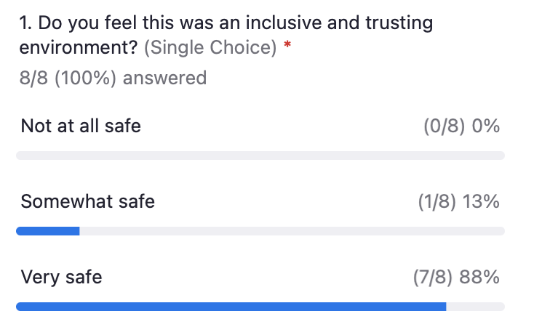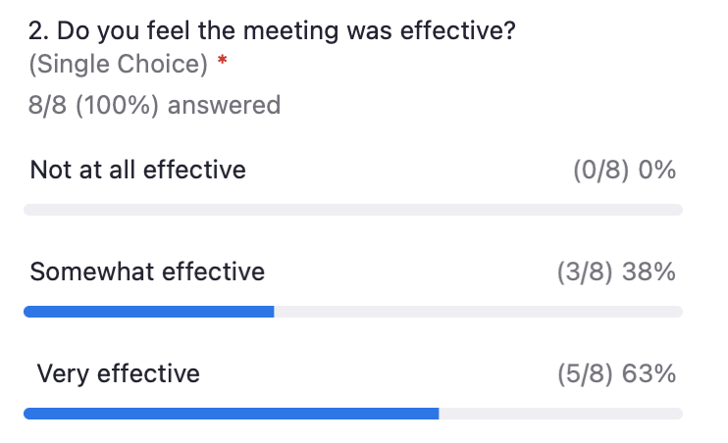

Facilitation Team
- Meeting Summary: draft, post, notice by 6/15/22
- Homework: email forthcoming by 6/17/22

Meeting Participants
- Meeting Summary: Review draft meeting summary, and provide redlines edits - by 6/22/22
Appendix A: Attendance for June 8, 2022, Compensation Task Force Kickoff Meeting

Task Force Representatives & Alternates
Organization | First | Last
3C-REN | Alejandra | Tellez
American Eco Services | Nicole | Milner
Association of Bay Area Governments | Jenny | Berg
Code Cycle | Dan | Suyeyasu
Future Energy Enterprises | Annette | Beitel
PG&E | Lucy | Morris
SCE | Chris | Malotte
SCE (alternate) | Kellvin | Anaya
Silent Running LLC | James | Dodenhoff
Small Business Utility Advocates | Ted | Howard
SoCalREN | Lujuana | Medina
The Utility Reform Network | Constance | Slider Pierre
Ex-Officio
CPUC | Stephanie | Green
CPUC | Nils | Strindberg
CPUC | Jesus | Torres
Members of the Public
Community Housing Opportunities Corporation | Anna | Solorio

Appendix B: Jamboard Breakout Session

