**BEFORE THE**

**OFFICE OF ENERGY EFFICIENCY AND RENEWABLE ENERGY**

**UNITED STATES DEPARTMENT OF ENERGY**

**WASHINGTON, DC**

**Energy Conservation Program )**

**for Consumer Products: ) Docket No. EERE-2014-BT-STD-0031**

**Energy Conservation Standards ) RIN 1905-AD20**

**For Residential Furnaces )**

**SOUTHERN CALIFORNIA GAS (SoCalGas®) COMMENTS:**

In response to the United States Department of Energy’s (DOE) Notice of Proposed Rulemaking (NOPR) regarding non-weatherized gas furnaces (NWGF) and mobile home gas furnaces (MHGF), SoCalGas respectfully submits our comments and analyses on the impact to our customers should this standard advance.

SoCalGas has been delivering clean, safe and reliable natural gas to its customers for more than 140 years. We are the nation’s largest natural gas distribution utility, serving 20.9 million consumers through 5.8 million meters in more than 500 communities. The company’s service territory encompasses approximately 20,000 square miles in diverse terrain throughout Central and Southern California, from Visalia to the Mexican border.

California leads the Nation in energy policy. The state’s Investor Owned Utilities are advancing energy efficiency not only as a way to protect the environment but also to serve our residential, commercial and industrial customers. For decades, SoCalGas has been actively pursuing strategies to promote the efficient use of natural gas and energy efficiency. We have driven advancements in natural gas equipment and low emissions technologies and invested significantly in advanced technologies in renewable natural gas and distributed generation.

Notwithstanding our proven commitment to advancing energy efficiency and our long-standing support of DOE’s efficiency actions, SoCalGas must oppose this rulemaking on behalf of our nearly 21 million customers. Our customers rely on us to assess all actions taken on their behalf and our analyses indicate that most of our customers would suffer a “Net Cost” under this rule rather than a “Net Benefit”. We understand that the DOE does not consider State by State analysis in their rulemakings but the negative impact to Southern California customers is real and burdensome enough to warrant our full opposition to this rule.

SoCalGas, working with Negawatt and Gas Technology Institute (GTI), reviewed the Technical Support Document (TSD) and evaluated the underlying inputs, assumptions and methods of DOE’s life cycle cost (LCC) analysis and also filtered the data by region (California and Southern California). The summary of the findings below demonstrates the negative net impact to our customers. In addition, for more detailed explanation, both reports are attached.

SUMMARY OF FINDINGS BY ISSUE:

Public Policy (Regulation, Environmental, Low Income Consumers)

1. The condensing furnace market has moved substantially toward the proposed 92% AFUE level without it being mandated by the standard.[1] The chart below shows that more than 50 percent of gas furnaces on the national market are already above 90% AFUE, 42 percent of which are above 92% AFUE (U.S. Energy Information Administration, Proposed efficiency standards may eliminate noncondensing gas furnaces, 2015). Simply put, w

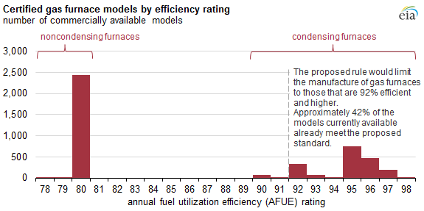

Figure 1: Commented distribution of residential gas furnaces by efficiency

1. The increased costs of moving to a 92% AFUE minimum efficiency gas furnace from the current industry standard of 80% AFUE, particularly in the retrofit market where the switch from non-condensing to condensing furnaces require changing the flue and providing a condensate drain, make fuel-switching (using split-system or mini-split heat

pumps) an attractive alternative to consumers on a cost, rather than performance, basis. A switch from gas to electricity will, however, *increase* source energy consumption due to the inefficiencies of losses in generation, transmission and distribution of electricity.[2] This is particularly true if the heat pumps with lower performance are selected for cost reasons and, on very cold weather days, when heat pumps don’t function well, built-in backup resistance heaters are triggered. The resulting increased source energy use is contrary to the stated goals of the legislation that provides the basis for efficiency standards.

The DOE finds in its analysis that fuel switching will occur but that the rule overall will remain beneficial. This appears to be based on a number of assumptions that are not well documented. For example, the statement “if the payback time of a higher efficiency furnace is 3.5 years or longer, then customers will switch to an electric appliance” is not supported by cited sources. We understand that the AGA attempted to obtain clarification on this threshold, but was not successful. We also understand that other industry organizations have conducted additional research into the fuel switching assumptions (GTI, AGA, AGPA). SoCalGas has concerns that the DOE’s assumptions within the fuel switching analysis are not self-explanatory or transparent, which hinders our attempts to review the DOE’s work.

1. DOE analysis shows that low-income consumers may bear a larger burden than other consumers should this rule advance.[3] This burden is compounded by the fact that low- and fixed-income homeowners typically live in smaller spaces which require less energy to heat, further reducing the potential value of a high-efficiency product to this consumer segment. NOPR participant AGL Resources, Inc. calculated that the overwhelming majority of low- and fixed-income homeowners will receive neutral or negative LCC savings if they install a new condensing furnace. The situation in Southern California would be worse due to the mild climate. Additionally, low- and fixed-income renters will be forced to deal with higher rents when landlords are required to install high-efficiency furnaces and pass on those costs, as they are likely to do.

DOE maintains that these increased costs are necessary and worthwhile given the energy needs of the nation. SoCalGas respectfully disagrees. The US Census Bureau estimates that nearly a quarter of California residents live in poverty. With a total state

population of 38.7 million people[4], approximately 9.7 million residents statewide and over 5.2 million within SoCalGas’ service territory, this rule would constitute an undue burden on a significant number of vulnerable residents who don’t have the economic flexibility to absorb what might seem to be incidental costs.

1. DOE’s calculated simple payback times are greater than 10.8 years for *all* permutations of the DOE’s own provided input parameters (“Summary” tab, “Replacement” case, “Rest of Country” (includes California), “92% efficiency”).[5] Despite this payback resulting in positive lifecycle savings by the DOE’s own calculations, it is important to note that such long payback times would be very problematic for homeowners. The average time of possession, according to the U.S. Census Bureau Geographic Mobility numbers in 2012-2013, is roughly five years. Especially considering that furnace replacement may not be done at move-in, but at a point later during homeownership, it must be concluded that in *most* cases, even if the DOE’s LCC numbers were correct, a high-efficiency retrofit furnace will rarely pay for itself from the homeowner’s perspective.

Findings regarding LCC assumptions, inputs, and method:

1. First Cost: The DOE’s method to determine furnace and installation first cost is very complex and draws on a very large number of input parameters, including a teardown analysis and economic literature.[6] We have several concerns with this approach:
   1. Teardown analysis may not account for innovation;
   2. Advances in manufacturing, and changes driven by yet-unknown future value- or-performance engineering;
   3. Economics is not a “hard” science and has varying degrees of accuracy. Literature and methods will vary depending on the data source.
   4. There likely are regional differences that cannot be properly accounted for, but that could have significant impact on the alleged savings figures.

In addition, it appears that the cost of asbestos removal in retrofitted homes is largely ignored in the DOE analysis. Asbestos abatement services in Southern California typically cost from $250 to $3,000 depending on site conditions. In addition, asbestos abatement causes delays, inconvenience, and safety concerns.

1. Regional Impact: When the DOE NOPR LCC model data is filtered to focus on the Southern California region, the results show negative life cycle costs imposed on Southern California consumers.[7] More Southern California consumers suffer a “Net Cost” than experience a “Net Benefit” under the DOE proposed rule. The 92% furnace proposed in the DOE NOPR as well as any other condensing furnace efficiency levels, would not meet the DOE requirement for economic justification of positive LCC savings and a payback period that is shorter than the equipment expected life in Southern California.
2. LCC Savings Overstated: DOE’s predictive LCC model results combine general assumptions and a limited consumer model that overstate LCC savings compared to a more robust Consumer Economic Decision-making (CED) framework methodology.[8]
3. Equipment Life: DOE likely overestimates the lifespan on the typical gas furnace at 21.5 years in their current LCC analysis.[9] In Canada, when the Energy Efficiency Branch of the British Columbia Ministry of Energy and Mines proposed an AFUE ≥ 92% in January 2014, their modeling assumption included a product lifetime of 15 years, six-and-half years less than DOE uses in its NOPR analysis. LCC significantly increases with shorter product lifetimes.
4. Baseline Furnace Assignment: DOE’s random baseline furnace assignment methodology is technically flawed.[10] Replacing DOE’s methodology with economic decision making criteria changes both the characteristics and fractions of “Net Benefit” and “No Impact” consumers and significantly reduces the financial benefit of the rule, both nationally and regionally.
5. Energy Pricing: DOE uses questionable values for marginal electricity prices in California within their LCC analysis.[11],[12] In 2013 dollars, prices in the LCC range from $0.17/kWh to $0.20/kWh versus the actual $0.25/kWh to $0.29/kWh that were current for tier 3 and tier 4 residential end use at the time (SDG&E, 2013). We were unable to obtain clarification if the DOE values are supposed to constitute *average* marginal electricity costs (which would be lower than true marginal cost), and if so, how the exact figures were devised.
6. Product Pricing: DOE’s product price trend assumptions and calculations are questionable.[13],[14] The product price trend as calculated by DOE uses experience rates derived from producer price indices (PPI) for warm air furnaces, with data from the Bureau of Labor Statistics (BLS), (extrapolated TSD pages 367-372). The rates are a regression on actual furnace data. The method appears to be applied correctly. However, there are some issues, notably:
7. It appears that DOE has not disaggregated the PPI data by condensing and non-condensing furnaces. Non-condensing furnaces are mature and the learning rate should be near 0; the rate should be different for condensing furnaces. Also, the majority of the historical data from 10 years ago or longer is likely made up of non-condensing furnaces. It is not appropriate in our opinion to extrapolate that into the future, where condensing furnaces would be used exclusively if the DOE rule is enacted.
8. DOE appears not to have normalized the data by furnace capacity (in Btu) nor researched the sensitivity of that. We suspect that normalization would change the learning rates because the cost per Btu goes down as furnaces get larger and innovation may progress differently with size. How that impacts the result depends on the mix of homes and that is not known at this time.
9. The DOE conducted the LCC analysis using three different experience rates (0.94 and 0.91) however page 371 in the TSD concludes that the experience rate is 20% plus 2.8% / minus 2.7%, which is very different. It is not clear which experience rates are accurate. In the analysis done by Negawatt, the LCC experience rates were used.

While the scope of our review with Negawatt and GTI did not include an investigation of these trends, SoCalGas has serious concerns that use of invalidated assumptions of product price trends could have contributed to the positive results reported by DOE in the LCC analysis.

1. New Construction Payback: For new construction, DOE contends that payback is immediate due to the first cost for the higher efficiency option being lower.[15] SoCalGas has data for production housing, demonstrating that the installed cost for a 92% furnace over an 82% furnace is higher by $385, $495 and $551 for 40,000, 60,000 and 80,000 Btu/h respectively in California:



Figure 2: Production housing first cost for installed furnaces, SoCalGas territory

DOE results appear to draw from the fact that high-efficiency furnaces can be vented horizontally and, therefore, a vertical build-out with roof penetration is not required. This is not a general construction practice in California, where, in our experience, flues are typically built vertically, no matter the technology, and regardless of whether the furnace is installed in the attic or in an attached space such as a mechanical closet or the garage.

1. Price Forecasts: DOE’s use of price forecasts for energy prices may be outdated.[16], [17] The DOE uses the AEO 2014 (U.S. Energy Information Administration, American Energy Outlook, 2014). In comparison, AEO 2015 (U.S. Energy Information Administration, American Energy Outlook, 2015) anticipates about 4.5% lower natural gas prices than AEO 2014 in real 2013 dollars, by 2040. So the LCC savings that DOE estimated using AEO 2014 would be reduced and payback times for the 92% AFUE condensing furnace would increase accordingly.

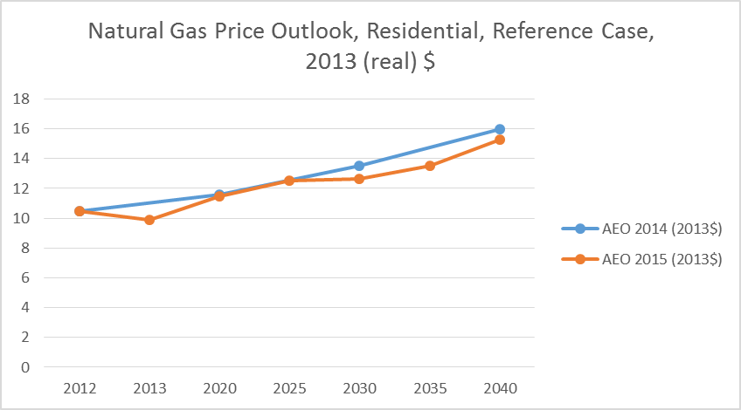

Figure 3: Natural Gas Price Outlook, AEO2014 vs. AEO2015

Using AEO forecasts may not be appropriate for California.[18] The chart below shows that AEO 2015 (U.S. Energy Information Administration, American Energy Outlook, 2015) estimates that prices will *rise* *faster* than what the CEC forecasts for California (California Energy Commission, 2014). Note that the trends from this chart should be interpreted qualitatively at this time (hence the chart label “Draft”). The chart's figures are not normalized at this time, and require conversion from nominal to real dollars, as well as subtraction of transportation cost from the CEC outlook. The fact that AEO predicts a higher rise than CEC should not be affected by these corrections. LCC Savings are reduced and payback times increased if gas prices don’t rise as fast in reality as the DOE assumes.

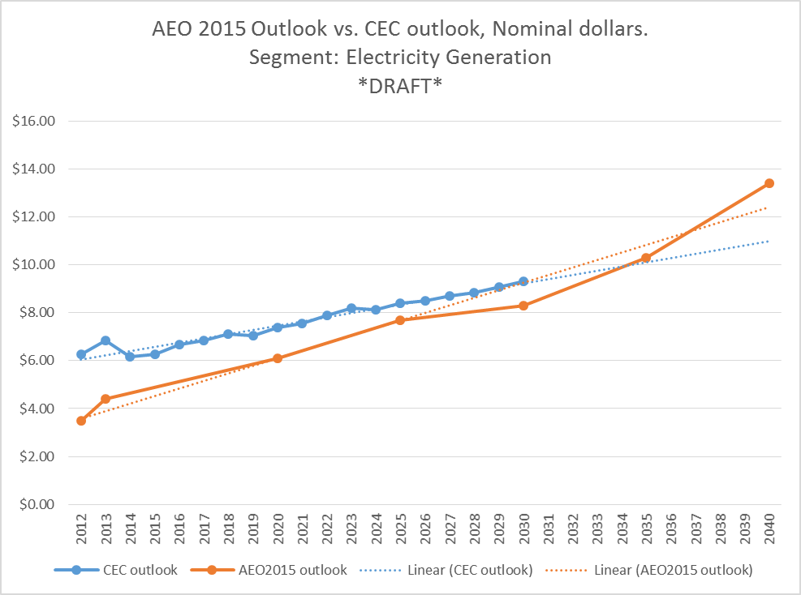

Figure 4: Natural Gas Price Outlook, AEO 2015 vs. CEC 2014 (non-normalized draft)

1. Negative LCC: GTI Integrated Scenario Int-5, based on improved consumer economic decision criteria and modifications to DOE’s input data, shows negative composite average lifecycle cost savings for all four condensing furnace trial standard levels (90%, 92%, 95%, and 98% AFUE) compared to the 80% AFUE baseline furnace in Southern California residences. [19] The 92% furnace proposed in the DOE NOPR as well as any other condensing furnace efficiency levels do not meet the DOE requirement for economic justification of positive LCC savings and a payback period that is shorter than the equipment expected life in Southern California.

Conclusions

SoCalGas has demonstrated our dedication to advancing efficiencies in energy use over decades and our results in that area are substantive. Our efforts have realized savings equivalent to almost 152 million therms over the past five years and over 560 million therms since 1990. Currently, we run 82 energy-efficiency programs, have an annual therm savings goal of over 25 million therms, an annual budget of $89.5 million and employ 186 people to deliver these programs. In addition, our low-income energy efficiency programs have treated over 569,000 low-income households with energy efficiency upgrades at no cost to those households. In 2014 alone, we avoided 170,000 tons of CO2 emissions. Our programs have also helped to create 8,000 jobs in California.

SoCalGas has identified several serious concerns with the rulemaking in general and with the LCC analysis in particular. This rulemaking is not necessary as the combination of market forces and utility efficiency programs are resulting in the adoption of higher efficiency furnaces where it makes economic sense. In addition, if enacted as currently proposed, this rulemaking would have undue impacts on most, if not all, SoCalGas customers as well as to other customers in mild climates because of unfavorable economics. It would have an especially significant impact on low-income and fixed-income seniors. Given their limited disposable income, they would be affected more severely than others. On behalf of our customers, we respectfully ask that you reconsider this rulemaking and pursue adjustments that take into account various climates and customer impacts across the nation. For further detail, please refer to the two reports provided by Gas Technology Institute (GTI) and Negawatt Consulting, attached herein.

1. Negawatt, ”Rulemaking for Residential Furnaces Energy Conservation Standards” for SoCalGas, page 7.
2. Negawatt, page 7.
3. Negawatt, page 8.
4. January 2015 population, California Department of Finance
5. Negawatt, page 8.
6. Negawatt, page 9.
7. GTI, “Furnace NOPR Technical Analysis, page 6.
8. GTI, pages 6-9.
9. Negawatt, page 9.
10. GTI, page 9.
11. Negawatt, page 9.
12. GTI, page 12.
13. Negawatt, page 10.
14. GTI, page 12.
15. Negawatt, page 10.
16. Negawatt, page 11.
17. GTI, page 13.
18. Negawatt, page 11.
19. GTI, page 13.