July 5, 2017
Mr. Daniel Cohen
U.S. Department of Energy
Office of the General Counsel
1000 Independence Avenue, SW.
Washington, DC 20585

ID Number: DOE_FRDOC_0001-3375

Dear Mr. Cohen:

This letter comprises the comments of list participating utilities in response to the Department of Energy’s (DOE’s) Request for Information (RFI) as part of its implementation of Executive Order 13771 (Office of the White House, 2017). These comments focus specifically on DOE’s Appliance and Equipment Standards Program as well as the energy efficiency standard and test procedure regulations developed and implemented by this program.

The signatories of this letter, collectively referred to herein as the Utility Coalition, represent some of the most diverse utility companies in the United States, serving over XX million customers combined. As energy companies, we understand the potential of DOE’s regulations, developed and updated by the Appliance and Equipment Standards Program, to cut costs and reduce energy consumption for our customers while maintaining or increasing the value of covered products and appliances. We have witnessed the implementation of existing appliance standards developed by DOE over the past two decades and seen their effectiveness in significant energy savings from covered products. These standards have been an effective and critical tool in reducing energy use in homes and businesses nationwide, freeing up economic resources for more and for future use.

Utilities in this Utility Coalition have been involved with DOE’s Appliance and Equipment Standards Program since 2005 as stakeholders in DOE’s public rulemaking process and as formal members of the general Appliance Standard and Rulemaking Federal Advisory Committee (ASRAC). We appreciate DOE’s efforts to solicit input from stakeholders on how best to implement Executive Order 13771 to achieve meaningful burden reduction while continuing to meet DOE’s statutory responsibilities in accordance with the Energy Policy and Conservation Act of 1975 (EPCA), as amended (Energy Conservation Standards). The Utility Coalition asks DOE to carefully consider the following comments in response to this RFI.

Energy Efficiency Regulation Impacts: Nationwide
As directed by Executive Order 13777 (Office of the White House, 2017), the regulatory reform task force will identify regulations that, among other things, are “ineffective.” The Utility Coalition believes DOE’s appliance and test procedure regulations are among the most impactful and effective policy tools in reducing energy consumption and driving technology innovation. DOE currently develops, updates, and implements energy efficiency regulations and test procedures for more than 60 appliances. These products represent about 90 percent of home energy use, 60 percent of commercial building energy use, and 30 percent of industrial energy use. Nationally, the cumulative positive impacts of these regulations are massive: by 2020 an estimated $1 trillion saved on consumers’ utility bills and 71 quadrillion British thermal units (quads) of energy saved (U.S. Department of Energy, 2017). DOE efficiency standards have significantly impacted energy demand since the mid-1990s. Figure 1 depicts the cumulative annual energy savings, in quads, from DOE energy efficiency regulations since the first standards took effect.

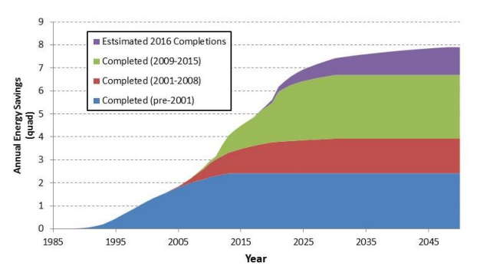
Figure 1: Energy savings as a result of DOE appliance efficiency regulations.
Source: U.S. Department of Energy, 2016.

Energy Efficiency Regulation Impacts: States and Utilities
Many states have compelling needs for advanced appliance efficiency standards, either due to energy costs, state policy goals, regional differences, or other factors. Federal appliance standards can be one of the strongest policy tools for reducing energy use in buildings. For example, in California the California Public Utilities Commission (CPUC) established an aspirational policy goal for zero net energy (ZNE) performance in residential new construction by 2020 and commercial new construction by 2030. Advanced appliance efficiency standards will play a significant part = in achieving these goals.

Utility rebate and other voluntary programs that incentivize efficient products, such as the Environmental Protection Agency’s (EPA’s) ENERGY STAR® Program, are critical to achieving economies of scale and driving cost down for advanced efficiency technologies. These programs rely on energy consumption metrics based on DOE test procedure regulations. Thus, it is critical to periodically review and update test procedures to be periodically reviewed and updated, as prescribed in EPCA, to ensure the energy metrics are representative of new features, technologies, and actual performance.

Energy Efficiency Regulation Impacts: Driving Innovation
DOE energy efficiency regulations advance innovation in energy efficiency technology. Voluntary programs support commercialization of emerging technologies by incentivizing the adoption of promising technologies just out of the research and development phase. Adoption into regulations stimulates the development by appliance manufacturers of new, differentiated products in response to high-margin products becoming the industry standard. This process continues cyclically, as efficiency regulations are adopted and updated periodically, driving towards greater cost-effective efficiency innovations with each cycle (Eilert, Naaf, McHugh, Chase, & Zhang, 2012).

In a retrospective study looking at the effect of DOE efficiency regulations, the study authors found that for each of the ten different products examined, manufacturers introduced and expanded the availability of new features as efficiency regulations took effect (Mauer, deLaski, Nadel, Fryer, & Young, 2013).
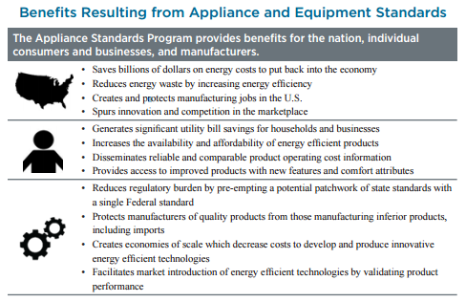
Figure 2: Summary of benefits from appliance standards.
Source: U.S. Department of Energy, 2017.

EPCA Requirements
DOE’s regulatory reform task force is also tasked with identifying regulations that impose costs that exceed benefits. EPCA has safeguards in place to ensure efficiency regulations do not violate this requirement with the following provisions:

(B)(i) In determining whether a standard is economically justified, the Secretary shall, after receiving views and comments furnished with respect to the proposed standard, determine whether the benefits of the standard exceed its burdens by, to the greatest extent practicable, considering—
(I) the economic impact of the standard on the manufacturers and on the consumers of the products subject to such standard;
(II) the savings in operating costs throughout the estimated average life of the covered product in the type (or class) compared to any increase in the price of, or in the initial charges for, or maintenance expenses of, the covered products which are likely to result from the imposition of the standard;
(III) the total projected amount of energy, or as applicable, water, savings likely to result directly from the imposition of the standard (Office of the White House, 2017).

Specifically, the statute requires every energy efficiency standards regulation promulgated by DOE to be “economically justified,” specifically requiring that the cumulative benefits of the regulation exceed the cumulative costs. In information we provide further below, DOE regularly overestimated the actual costs of many regulations, thereby resulting in outcomes that are more economically beneficial than predicted.

As directed by Executive Order 13777, the regulatory reform task force shall also identify regulations that are “outdated.” Yet again, EPCA provides statutory requirements to ensure that efficiency standards and test procedures are reviewed on a periodic basis. Since DOE has expanded the Appliance and Equipment Standards Program to cover a larger share of home, commercial, and industrial energy use, it is increasing important for DOE to maintain its ability to update current energy efficiency standard and test procedure regulations on a periodic basis to ensure standards remain relevant.

Below are the Utility Coalition responses to some of the specific questions listed in the RFI.

Question 1: How can DOE best promote meaningful regulatory cost reduction while achieving its regulatory objectives, and how can it best identify those rules that might be modified, streamlined, or repealed?
- Regarding streamlining regulations, the Utility Coalition strongly supports the efforts of the Appliance Standards and Rulemaking Federal Advisory Committee (ASRAC) established by DOE to improve the process of establishing and updating certain energy efficiency regulations by facilitating stakeholder engagement, data collection, and consensus-building among impacted stakeholders. Members of the Utility Coalition have been/are members of the ASRAC.

The ASRAC working group process streamlines certain efficiency regulations – reducing the overall time a rulemaking takes to finalize as compared to a typical “notice and comment” rulemaking. For example, the commercial package air conditioners and warm air furnaces final rule, which was negotiated through an ASRAC working group, was finalized in eight months from the establishment of the ASRAC working group to a DOE direct final rule. The process would have taken significantly more time, likely several years, had it gone through a non-negotiated rulemaking. This process implemented by DOE should continue to be used for other products, where it makes sense, as a way to shorten rulemaking timelines, thereby reducing overall regulatory costs for both stakeholders and DOE.

- As another way to streamline rulemakings and reduce costs associated with regulations, DOE should consider the use of multi-tier standards more frequently in rulemaking activities. Multi-tier (or multi-phase) standards can enhance the efficiency and cost-effectiveness of rulemaking activities by having one analysis that leads to two standard updates at future dates. In addition to the reduced costs associated with the regulatory process, another major advantage of the multi-tier approach is that it provides manufacturers with regulatory certainty over a longer period of time, enabling them to invest and plan for multiple rounds of standards. DOE instituted this multi-tier approach for the commercial package air conditioners and warm air furnaces final rule, updating standard levels with a compliance date of January 1, 2018 for the first tier and January 1, 2023 for the second tier (Energy Efficiency and Renewable Energy Office, Department of Energy, 2016). This approach was strongly supported by industry, efficiency advocates, consumer groups, and utilities.

The main risk of a multi-tier approach is that the second-tier standard becomes irrelevant due to major technological innovation unaccounted for in the original analysis. DOE can mitigate this risk by a brief review closer to the compliance date of the second-tier standard and subsequently re-open the rulemaking, if the future standard levels are irrelevant.

Question 2: What factors should DOE consider in selecting and prioritizing rules and reporting requirements for reform?
- DOE should prioritize promulgating efficiency regulations with different regional impacts. In 2011, DOE finalized regional regulations for residential central air conditioners and heat pumps and residential gas furnaces, the first standards promulgated by DOE that differed due to varying efficiency needs for this equipment in different regions of the United States. Based on levels agreed to by a coalition of stakeholders, the standards set efficiency levels for three regions based on the number of heating degree days and climate zone. DOE should consider prioritizing the promulgation of regional energy and water efficiency regulations for products where there is an opportunity to address the unique needs of a location, such as severe drought conditions or increasingly severe winter storms.

In promulgating new or updated efficiency regulations, DOE should leverage existing voluntary standards, such as EPA’s ENERGY STAR Program, and relevant information associated with the voluntary standards (e.g., shipment data, technology adoption, etc.) to help form the basis of new or updated mandatory standards. Leveraging existing data could potentially reduce the costs of undergoing certain efficiency regulations.

- DOE should prioritize rules based on the specific development cycles of each unique appliance industry. DOE prescribes a five-year gap between the publication of the final rule and the compliance date for standards for newly-covered products. In prioritizing establishment of new energy efficiency regulations for currently uncovered products, the Utility Coalition believes DOE should reform the five-year delay for products where five years may be too long and for which the market is rapidly changing, such as lighting products and electronic equipment.

One study suggests that consumer product development cycles typically take just under 2.5 years for new-to-the-world products (i.e., highly innovated products). Figure 3 is a graphical representation of the study results. For products and product lines with major revisions, (i.e., those potentially affected by a DOE standard), the average product development cycle is approximately 15 months. According to this study, on average, industrial firms have been taking 2.25 years to develop their more innovative projects.

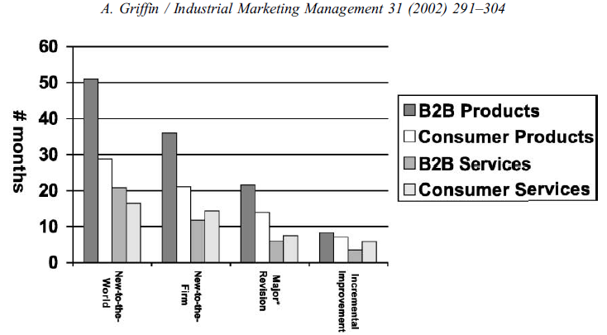
Figure 3: Average product development cycles by product type.
Source: Griffin, 2002.

With this compelling evidence that product development cycles are significantly shorter than five years, we urge DOE to consider a shorter time period between the final rule and compliance dates on a case-by-case basis for each rulemaking with stakeholder input. Additionally, this would ensure that standards are applicable to products on the market at the time of compliance.

Question 3: How can DOE best obtain and consider accurate, objective information and data about the costs, burdens, and benefits of existing regulations? Are there existing sources of data DOE can use to evaluate the post-promulgation effects of regulations over time? We invite interested parties to provide data that may be in their possession that documents the costs, burdens, and benefits of existing requirements?
- There are a number of retrospective studies that have reviewed the impacts of DOE efficiency regulations, which are cited below. Energy efficiency regulations have provided significant economic benefits for consumers through saving energy and freeing up cash for other use, which culminates in broader macroeconomic benefits to both the local and national economy.

One study examined the impacts of energy efficiency standards on ten residential, commercial, and lighting products. The study concluded that as efficiency regulations take effect, performance of the products improves and products become more feature-rich (Mauer, deLaski, Nadel, Fryer, & Young, 2013). Figure 4 provides a graphical representation of price declines for residential clothes washers paired with capacity increases and increased energy efficiency as each new standards update takes effect.

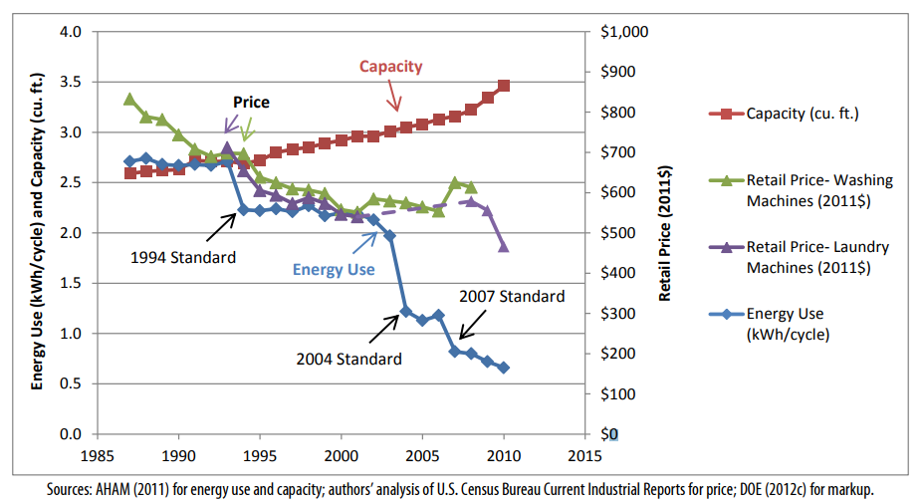
Figure 4: Clothes washer energy use, volume, and retail price from 1987-2010.
Source: Mauer, deLaski, Nadel, Fryer, & Young, 2013.

Another report examines the job increases directly due to current and prospective energy efficiency standards through 2030. Based on the report’s analysis, an average of 318,000 jobs are created annually for historic standards with an expected additional 47,000 jobs created annually for prospective standards (Gold, Nadel, Laitner, & deLaski, 2011). A paper published in the Energy Policy Journal estimates 0.38 job-years are created for every GWh of electricity saved due to energy efficiency measures (Wei, Patadia, & Kammen, 2010). One of the goals of DOE’s regulatory reform task force is to identify regulations that “eliminate jobs, or inhibit job gains as well, and recent research shows that these may have been underestimated in the past. creation.” Based on multiple studies, efficiency regulations have a positive impact on jobs.

There is evidence that DOE has overestimated price increases for appliances after standard implementations. Based on one study, on average, price changes were 108 percent less than DOE estimates (Nadel & deLaski, 2013). Another report further supported this concept by citing that “the positive economic impacts of MEPS [Minimum Efficiency Performance Standards] on consumers may have been underestimated” (Taylor, Spurlock, & Yang, 2015). These results mean that job creation and consumer savings will likely be greater than predicted by DOE in the future, making them even more critical for the future macroeconomic health of the nation.

Question 4: Are there regulations that simply make no sense or have become unnecessary, ineffective, or ill-advised and if so what are they? Are there rules that can simply be repealed without impairing DOE’s statutory obligations and, if so, what are they?
- In regards to regulations that can be repealed, the Utility Coalition points to the anti-backsliding provision in EPCA, which prevents DOE from updating existing regulations that result in either increases in the maximum allowable energy use or decreases the minimum required energy efficiency of a covered product (Energy Conservation Standards). Therefore, statutory requirements prohibit any existing efficiency standards and test procedures from being repealed by DOE.

Question 5: Are there rules or reporting requirements that have become outdated and, if so, how can they be modernized to better accomplish their objective?
- This question is beyond the scope of the Utility Coalition’s comments.

Question 6: Are there rules that are still necessary, but have not operated as well as expected such that a modified, or slightly different approach at lower cost is justified?
- Associated with our comments on Question 1 regarding ASRAC, the Utility Coalition believes that the stakeholder negotiation approach should be considered for other rulemakings where appropriate. The streamlined process of ASRAC reduces the regulatory costs for both stakeholders and DOE in the long-term. Additionally, ASRAC could be used to help address test procedures and standards that may need to be updated based on technological innovations outside of the scheduled review cycle to ensure the regulations are still relevant. Having a nimbler process to update regulations would be helpful for utility incentive programs, which are based on the test procedures and standard regulations developed by DOE.

Question 7: Are there rules of the Department that unnecessarily obstruct, delay, curtail, or otherwise impose significant costs on the siting, permitting, production, utilization, transmission, or delivery of energy resources?
- This question is beyond the scope of the Utility Coalition’s comments.

Question 8: Does DOE currently collect information that it does not need or use effectively?
- The Utility Coalition strongly supports DOE’s extensive efforts to collect information and work with stakeholders, such as trade organization and others, in support of establishing and updating efficiency regulations. DOE’s efforts to collect and effectively use the information ensures rulemakings are data-driven processes. In terms of compliance and enforcement, the information DOE collects ensures the proper implementation of the efficiency regulations promulgated by DOE and the realization of the massive associated consumer benefits previous cited in response to Question 3.

DOE should be more transparent about its own planned data collection activities in support of future standards and test procedures rulemakings. If stakeholders had a better understanding of DOE’s future plans for data collection for rulemakings, they would be better able to effectively contribute to the process, while simultaneously strengthening DOE’s analyses and reducing DOE’s regulatory costs. Examples of product data that could be provided to DOE by stakeholders include: energy performance data; market shipment data; testing data on product prototypes; data on retail, installation, and maintenance costs; and energy consumption data of installed equipment.

Question 9: Are there regulations, reporting requirements, or regulatory processes that are unnecessarily complicated or could be streamlined to achieve statutory obligations in more efficient ways?
- DOE should consider staging test procedure and standard rulemaking updates for a given product category so that the test procedure regulations are completed and implemented before the standards rulemaking. Staging the rulemakings in this way would be sensible to ensure standards regulations are based on updated metrics and data from a new or modified test procedure.
- DOE should work closely with other agencies such as the EPA, the California Energy Commission (CEC), and the European Commission, to share, where feasible, reported product data. Agency collaboration could reduce duplicative reporting burden for manufacturers. Each of the agencies noted manages public-facing product databases displaying information on product efficiency, among other attributes. Given the overlap of reported data required by these agencies, a standardized test template and single product submission to one entity, such as the CEC’s Modernized Appliance Efficiency Database System (MAEDBS), that would be shared with other applicable databases would reduce costs for manufacturers.
- DOE should also consider updating its current compliance certification database to allow stakeholders to more easily search for information on complying products and access test reports. Since utility incentive programs, aimed at increasing adoption of efficient products, establish program requirements based on certified product data, having better access to DOE’s database could potentially reduce additional manufacturer reporting burden for products eligible for incentive programs.

Question 10: Are there rules or reporting requirements that have been overtaken by technological developments? Can new technologies be leveraged to modify, streamline, or do away with existing regulatory or reporting requirements?
- As mentioned previously in comments to Question 9, DOE should work closely with other agencies that manage product databases to reduce duplicative reporting burden for manufacturers by sharing product data when applicable. This would reduce costs for manufacturers and could potentially reduce administration costs for DOE. In addition, the reported product data would be clearer and more consistent for consumers and other stakeholders, such as utilities, that use the product databases.

Question 11: Does the methodology and data used in analyses supporting DOE’s regulations meet the requirements of the Information Quality Act?
- This question is beyond the scope of our comments.

The Utility Coalition thanks DOE for the opportunity to be involved in this process and encourage DOE to carefully consider the recommendations outlined in this letter.

Sincerely,

References
Eilert, P., Naaf, D., McHugh, J., Chase, A., & Zhang, Y. (2012). Code Driven Portfolios. ACEEE Summer Study on Energy Efficiency in Buildings .
Energy Conservation Standards. (n.d.). 42 U.S.C. § 6295.
Energy Efficiency and Renewable Energy Office, Department of Energy. (2016). Energy Conservation Program for Certain Industrial Equipment: Energy Conservation Standards for Small, Large, and Very Large Air-Cooled Commercial Package Air Conditioning and Heating Equipment and Commercial Warm Air Furnaces; Direct final rule. EERE-2013-BT-STD-0007-0113.
Gold, R., Nadel, S., Laitner, J. A., & deLaski, A. (2011). Appliance and Equipment Efficiency Standards: A Money Maker and Job Creator. ACEEE & ASAP.
Griffin, A. (2002, January). Product development cycle time for business-to-business products. Industrial Marketing Management, 291-304.
J.D. Power. (2014). Company Impact Report: Energy Efficiency Programs and Awareness. J.D. Power and Associates, McGraw Hill Financial.
Mauer, J., deLaski, A., Nadel, S., Fryer, A., & Young, R. (2013). Better Appliances: An Analysis of Performance, Features, And Price as Efficiecy Has Improved. AEEE & ASAP.
Nadel, S., & deLaski, A. (2013). Appliance Standards: Comparing Predicted and Observed Prices. ACEEE & ASAP.
Office of the White House. (2017, January 30). Executive Order 13771. Reducing Regulation and Controlling Regulatory Costs.
Office of the White House. (2017, February 24). Presidential Executive Order 13777: ENFORCING THE REGULATORY REFORM AGENDA.
Pacific Gas & Electric. (2017). PG&E's Energy Efficiency Business plan 2018-2025.
Taylor, M., Spurlock, C. A., & Yang, H.-C. (2015). Confronting Regulatory Cost and Quality Expectations: An Exploration of Technical Change in Minimum Efficiency Performance Standards. Berkeley: Lawrence Berkeley National Lanoratory.
U.S. Department of Energy. (2016, February). Building Technologies Office Multi-year Program Plan.
U.S. Department of Energy. (2017, January). Saving Energy and Money with Appliance and Equipment Standards in the United States.
US Department of Energy. (2017, May 20). Reducing Regulation and Controlling Regulatory Costs: Request for Information (RFI). Federal Register, pp. 24582-24583.
VanBuskirk, R. D., Kantner, C. L., Gerke, B. F., & Chu, S. (2014). A retrospective investigation of energy efficiency standards: policies may have accelerated long term declines in appliance costs. Environmental Research Letters, 9(11).
Wei, M., Patadia, S., & Kammen, D. M. (2010). Putting renewables and energy efficiency to work: How many jobs can the clean energy industry generate in the US? Energy Policy.

DOE published the intent to establish the working group was published in April 2015, the working group finalized a term sheet in June 2015, and DOE published a direct final rule in December 2015.

