**MEMORANDUM**

**TO: Sue Kristjansson and A.Y. Ahmed, Southern California SoCalGas**

**FROM: Rob Hammon, Ph.D., President, BIRAenergy; Marc Esser, President, Negawatt Consulting; and George Burmeister, President, Colorado Energy Group, Inc.**

**IN RE: U.S. Department of Energy Proposed Increase in Efficiency Standards for Gas Furnaces**

**DATE: April 6, 2014, Version C**

Southern California Gas Company (SoCalGas) tasked, BIRAenergy and Negawatt Consulting to research and evaluate the potential impacts to the SoCalGas of current U.S. Department of Energy (DOE) proceedings regarding [Energy Conservation Standards for Residential Furnaces](http://www.regulations.gov/#!documentDetail;D=EERE-2014-BT-STD-0031-0032)  (Notice of Proposed Rulemaking [NOPR] for non-weatherized [indoor installations] and mobile home gas furnaces) that could impact minimum efficiency requirements for California and nationwide. Based on experience working inside the DOE, their understanding of national policies and processes for policy development, as well as their experience working in California on residential energy efficiency programs, both development and implementation, Colorado Energy Group, Inc. was instructed by BIRAenergy to perform in-depth research and evaluation of the on-going NOPR. This memo summarizes the NOPR, key elements on its history that have resulted in the current status of the NOPR; we also suggest potential strategies for the SoCalGas, should they decide to alter the course of the NOPR.

This NOPR, dated March 11, 2015, the latest in a series that have circulated through the DOE rulemaking process for a number of years, is to set a new nationwide minimum energy efficiency standard for these residential gas furnaces at an Annual Fuel Utilization Efficiency (AFUE) of 92%. The current national minimum standard is 78% AFUE and the market standard is 80% AFUE. Our team was tasked with providing a history of the processes and events leading to this NOPR and its proposed standard, to identify some of the major issues that warrant the SoCalGas’s attention regarding this NOPR, to execute an analysis of the DOE’s life cycle cost (LCC) analysis, and to evaluate some of the potential retrofit and new construction costs impacts associated with moving to this new standard. This new information was requested to supplement DOE-provided information and to help the SoCalGas establish a formal position on the standard. Our team contends that the potential impact of the standard upon gas and product sales, and the SoCalGas’s energy efficiency program portfolio is significant.

This is an *interim, internal memo* designed to give the SoCalGas quick, general guidance while other ongoing technical tasks related to this NOPR are completed in the near future. In addition to the historical and process review of this NOPR contained within, the SoCalGas was also interested in an exhaustive review of the Crystal Ball software used by the DOE as part of the analysis behind their NOPR. An expert at the Gas Technology Institute (GTI) familiar with the Crystal Ball software was contacted by this team and suggested to SoCalGas officials to forgo analysis of Crystal Ball because such analysis would take three months or more, and anything less than that could expose the SoCalGas due to incorrect results from incomplete or incorrect data and assumptions. Thus, the short-term scope of this effort was limited to focus on an analysis of the process and its immediate implications to the SoCalGas, which are contained within this memorandum. The SoCalGas may wish to follow this memorandum with a more detailed regional (California-specific) review and analysis of the Crystal Ball software—which DOE has not done to date.

**This memorandum is organized across four primary areas:**

1. **Executive Summary**
2. **Important History and Background Information of the NOPR**
3. **Life Cycle Cost (LCC) Summary Comments**
4. **Summary Thoughts and Recommendations**

**Additional detail is provided in attached appendices:**

**A) Life Cycle Cost (LCC) Analysis and Comments**

**B) Major SoCalGas Issues in 2011 and 2015**

**C) Stakeholder Involvement in 2011 and 2015**

**D) DOE Criticism in 2011 and 2015**

**E) Additional DOE Documents of Interest**

**F) References**

**I. Executive Summary**

As evidenced in the timeline on page 8 the U.S. Department of Energy (DOE) NOPR has been underway since 2007, roughly eight years. Comments on the most recent proposed standard are due to DOE from interested parties, potentially including the SoCalGas, by June 10, 2015.

Summarizing the status of the NOPR today after eight years of negotiations: The DOE points to their analyses, spreadsheets and models saying that the national benefits of increasing the efficiency standard outweigh the costs overall, acknowledging a few will be hurt economically; many in the gas and furnace industries say DOE has not been transparent during the process (as required in a recent settlement agreement), suggesting also that DOE is over-estimating the benefits of the proposed standard and underestimating the costs, while using a complicated, unwieldy “black box” model (the Crystal Ball software) *with a brand new methodology* and relying on, and not sharing, costly proprietary data developed by the electric industry and others.

One exasperated industry representative (Mark Krebs, The Laclede Group) was heard to comment during a day-long hearing on the subject on March 27, 2015, “Why can’t you (DOE) use a simple pay-back method on the standard instead of issuing a confusing 1,000 page NOPR which includes a new life cycle costing methodology that very few can understand. You’ve added complexity to what should be easier to understand. This process is anything but transparent.”

The purpose of this short memorandum, and the work upon which it is based, is to provide objective analysis of the process and data, and to identify areas where the SoCalGas and/or California consumers would be impacted negatively by the current proposal from DOE. Based on our research, we can report that the DOE has done an admirable job at involving stakeholders in this process. During this multiyear furnace standards process DOE has worked with industry leaders including the SoCalGas, the California Energy Commission (CEC), the American Gas Association, the American Heating and Refrigeration Institute (AHRI), the Air Conditioning Contractors of America (ACCA), the Gas Technology Institute (GTI), the American Public Gas Association (APGA), manufacturers including Rheem, Lennox, Trane, and many others, along with energy efficiency advocacy organizations, notably the American Council for Energy Efficient Economy (ACEEE), and environmental groups, notably the Natural Resources Defense Council (NRDC). DOE’s stakeholder involvement to date has been satisfactory *(a relatively comprehensive list is attached in Appendix C.)* However, the data obscured or not shared with many of these stakeholders during the process has been a major issue—especially recently. For example, the APGA told us that to be more fully informed of the data, analyses and results relied upon by DOE, they were forced to purchase two proprietary reports for $15,000 simply to be able to interpret some of the DOE Crystal Ball analyses. In addition, the proprietary nature of the reports precludes them from sharing with other interested parties, who otherwise could benefit the process, including the SoCalGas and its customers.

The DOE was criticized for a number of other things during this process, which added to the delay in the DOE process, largely based on legal filings from industry members in 2011. Recently, during a day-long hearing on March 27, 2015, the DOE was criticized for overestimating product lifetimes (AGL Resources and AGA), overestimating the size of the affected market (effectively making the cost-benefit analysis look more “rosy”; AGL Resources, AGA, APGA, and The Laclede Group), using unexplained and inconsistent installation costs and payback periods in its Life Cycle Cost (LCC) analysis (AGA and APGA), low estimates of the amount of fuel switching (AGL Resources, AGA, APGA and The Laclede Group), and for not considering the performance characteristics of (higher efficiency) non-condensing furnaces (AGL Resources, AGA, and APGA) which indicate that they should be considered as a separate product category from condensing furnaces (see list of issues in Appendix D) .

***Highlight of SoCalGas-related Issues….***

In addition to the issues highlighted above there are numerous noteworthy SoCalGas-related policy and technology-related issues that we believe that the DOE process or analysis may be vulnerable and where SoCalGas resources could best be spent analyzing data and analytical procedures. Recommendations are provided here in the Executive Summary, and again later in Section IV. Summary Thoughts and Recommendations:

1. The market has moved substantially toward the proposed 92% AFUE level without it being mandated by the standard. Our analysis shows that more than 50-percent of gas furnaces on the national market are already above 90% AFUE, 42-percent of which are above 92% AFUE (US EIA; Appendix E). These data can support the position that the standard is not needed: the market is already working as evidenced in the products available to consumers and their uptake, making government intervention both unnecessary and potentially disruptive at this time.
2. A lack of product differentiation and consumer choice occurs as the range of efficiency improvements narrow above 90% AFUE. A case can be made that the proposed standard is limiting the furnace products offered to U.S. consumers and in fact, while well-intentioned the DOE may be inadvertently picking winners and losers. This issue was a major concern to industry when Canada raised their minimum standard from 78% AFUE to 90% AFUE effective 2012. Canadian industry was worried then that the product itself would start to become a commodity to the consumer and as a result, many small- and medium-sized furnace manufacturers would go out of business. Despite the climatic difference, it could be fruitful for the SoCalGas to research the actual effects on the Canadian market since the standards bloomed into full debate in 2010. This information could inform the parallel process underway in this DOE NOPR.
3. Increased costs of minimum efficiency gas furnaces, particularly in the retrofit market where the switch from non-condensing to condensing furnaces require changing the flue, make fuel-switching a potentially attractive alternative to consumers on a cost, rather than performance basis. The fuel-switching issue is a potentially huge issue for California, despite DOE comments and analyses to the contrary. The fact is that some fuel switching will occur, and this *fuel switching from gas to electricity will result in an increase in emissions as opposed to the decrease expected from an increase in the standard.* A switch from gas to electricity increases emissions due to the losses in generation, transmission and distribution of electricity. An increase in emissions is contrary to the stated goals of the legislation that provides the basis for efficiency standards and is contrary to the goals of the current Administration.
4. The DOE uses extremely low values for marginal electricity prices in California within their Life Cycle Cost (LCC) analysis; they include a range of $.17/kWh to $.20/kWh vs. the $.25/kwh to $.29/kwh that were current in 2013, the LCC reference point for this data (see http://www.sdge.com/tm2/pdf/ELEC_ELEC-SCHEDS_DR_2013.pdf). However, we are not certain if the DOE values constitute *average* marginal electricity costs; this will be answered in the April 13 continuation of a public hearing that started on March 27, 2015.
5. With respect to retrofits, we contend that the actual costs are substantially higher than those used by the DOE. This needs to be confirmed in the SoCalGas’s service territory. National averages provided by DOE for the purchase and installation of a new 92% AFUE furnace in 2021 (the first year that the standards would take effect; in 2013 $) are estimated to cost consumers $2,712.31, which is $493.96 more than an 80% AFUE furnace. This is both contrary to market experience that necessarily includes substantial costs for changing the flue, and DOE’s own estimates of the incremental costs of installing a 92% AFUE furnace in new homes: $ 2,848.31 and $2,249 to upgrade an existing furnace.
6. Low-income customers in the SoCalGas’s territory and other parts of the U.S. will bear an unusually heavy burden of the standards; DOE analysis shows that low-income consumers will be hit hard, and they maintain that these costs are necessary and worth it given the energy needs of the nation. However, low and fixed income homeowners are less likely to purchase a new home, and are thus forced to endure potentially costly retrofit installations. Additionally, low and fixed income homeowners typically live in smaller spaces which require less energy to heat, reducing or eliminating potental value of a high efficiency product. NOPR participant AGLR calculated that the overwhelming majority of low and fixed income homeowners will receive neutral or negative paybacks when they install a new condensing furnace. Additionally, low and fixed income renters will be forced to deal with higher rents when landlords are required to install high efficiency furnaces. The SoCalGas is advised to examine exactly which customer classes will be impacted due to this proposed standard, in particular which low-income customers, as soon as possible.
7. The DOE likely overestimates the lifespan on the typical gas furnace at 21.5 years in their current LCC analysis. This is arguable, as is the condition of many of the homes retrofitted with such an old system (with potentially higher costs due to the poorer condition of the homes and their equipment). In Canada, when the Energy Efficiency Branch of the British Columbia Ministry of Energy and Mines proposed an Annual Fuel Utilization Efficiency (AFUE) ≥ 92% in January 2014, their modeling assumption included a product lifetime of 15 years, six-and-half years less than the DOE uses in its NOPR analysis. Given that the payback period is crucial for the economic justification of the new standard our team believes that this is potentially a major issue.
8. The cost of asbestos removal in retrofitted homes is largely ignored in the DOE analysis. BIRAenergy estimates that asbestos removal, despite low volumes of asbestos on each job, can add as much as 40%[1] to the cost of a furnace retrofit job in the SoCalGas’s service territory.
9. Despite some potentially low cost estimates input into their analyses, the DOE Life Cycle Cost (LCC) analysis has a payback time of 11.2, 10.6 and 12.5 years for replacing an 80% efficient furnace with a 92% efficient model for the country “Overall”, the “North”, and the “Rest of country”, respectively. To the typical homeowner, this can be a long time, and subject to considerable scrutiny given the DOE’s use of national averages. Of particular concern is that the payback time is longer than the average time of possession for many U.S. homeowners, which according to the U.S. Census Bureau Geographic Mobility numbers in 2012-2013 is roughly five years.
10. The impact of this standard on the SoCalGas’s long term portfolio of energy efficiency programs—an important source of revenue—may be substantial. The standards will go into effect five years from the date of the Final Rule, at the earliest 2021. Our team does not have access to SoCalGas energy efficiency program-related information at this time. A careful analysis of furnace-related programs, rebate scenarios and expected market share is recommended to quantify this impact.

There are many other issues that came to light in our analysis such as waivers for those who cannot afford the cost of a new 92% AFUE furnace, and reviving the short-lived regional energy standards that are discussed in the pages to follow. While the DOE considered California in their analysis, more California-specific analyses are needed in the short term. SoCalGas officials are considering a short contract with the Gas Technology Institute (GTI) to perform some of these analyses; we believe that this is a worthwhile endeavor, given GTI’s history with this proposed standard.

As the SoCalGas formulates a position and formal written comments on this NOPR, our team urges the SoCalGas to solidify its relationships with trade association partners involved in this NOPR, such as the American Gas Association (AGA), and the American Public Gas Association (APGA), and other gas utilities with similar profiles.

Finally, due to the very complicated methodology used by the DOE and the extensive labor required to understand it, the SoCalGas and others are probably justified in asking for another 90-days to review the DOE analysis. Granted, this is a short-term solution but it will allow the SoCalGas to examine more data. Moving the DOE deadline for comments due from June 2015 to September 2015 seems prudent.

**II. Important History and Background Information of the NOPR**

DOE is directed to review gas furnace efficiency standards every six years following various procedural requirements established principally by Energy Policy Conservation Act (EPCA) as well as the National Appliance Energy Conservation Act of 1978 (NAECA) and Administrative Procedures Act (APA).

While it can be an administratively complex rule-making process that typically takes years, it essentially involves three sequential phases—a Pre-Rule phase, a Notice of Proposed Rulemaking (NOPR) phase, and a Final Rule. In the Pre-Rule phase DOE can approach stakeholders (or be approached by them) concerning the setting of a standard, hold informal meetings and begin gathering data and supporting information. As demonstrated in this particular rule-making, DOE can also be directed to implement a rulemaking process as a result of legal action. In the Notice of Proposed Rulemaking (NOPR) phase, DOE publishes a NOPR (including the proposed standard, an extensive summary of the issues submitted by stakeholders, requests for more information, and details about how it arrived at its conclusion) and publishes a technical support document (TSD), gathers comments from stakeholders and conducts public meetings of the process and addresses key issues raised by stakeholders.

During this NOPR phase, DOE is directed to determine whether a higher standard would met the criteria of being technologically feasible, economically justified, and would save a significant amount of energy. This NOPR phase historically includes extensive debate and concern over the data, methodologies, findings and impacts on consumers, the industry, the economy and the environment. If the rulemaking process ultimately finds that a higher standard meets these criteria and regulatory proceedings requirements, it moves into the last Final Rule phase. When DOE publishes a Final Rule setting the minimum standard, it includes a detailed overview of the history of the rulemaking process and sets effective dates for compliance with the new standard.

The current national minimum residential gas furnace efficiency requirement of 78% AFUE became effective January 1, 1992. 80% AFUE is the *de facto* market minimum efficiency. In this NOPR DOE utilizes an 80% AFUE furnace as its baseline for analysis against higher efficiency furnaces (since it already the market standard). The current rulemaking has a long history that is graphically shown in the timeline and summary below.

In 2007 DOE published a Final Rule that set the minimum residential non-weatherized gas furnace (NWGF, or indoor installations) standard at 80% AFUE, to become effective in November 2015. That Final Rule was immediately and successfully challenged in court on the grounds that the 80% AFUE standard was not stringent enough and a higher standard would be both technically feasible and economically justified. The district court’s decision in April 2008 vacated the standards for the residential furnaces in question, and DOE agreed to revisit its analyses and findings in its 2011 rulemaking.

On a somewhat parallel path, in 2009 the California Energy Commission joined a number of efficiency advocates and industry stakeholders in a “Consensus Agreement” that encouraged DOE to establish regional standards for furnaces, central air conditioners, and heat pumps. This alternate approach was taken following Congress’s 2007 amendment to EPCA authorizing DOE to consider and accept proposals submitted by a significant number of relevant stakeholders in order to expedite the rulemaking process. Under this scenario, DOE could publish a Direct Final Rule (DFR) – which is essentially an abbreviated version of the normal process. After determining it still met EPCA’s requirements, held public meetings and considered additional comments.

Unique to the Consensus Agreement was the establishment of regional efficiency standards for central air conditioners and heat pumps in three regions of the country – North, South, and Southwest (CA, NV, AZ, and NM). For gas furnace efficiency standards, the states were split into only two regions based on population-weighted heating degree days (HDDs). States with less than 5,000 HDDs fell into the southern region and those with 5,000 HDDs or above fell into the northern region as shown in the Figure below). Through this Consensus Agreement, the minimum furnace efficiency standards for northern states were set at 90%, and 80% for southern states (including California). Based on California Climate Zone data, only Climate Zone 16 (Mt. Shasta) is likely to exceed 5,000 HDDs (See Appendix B); thus grouping all of California with southern states would be appropriate.

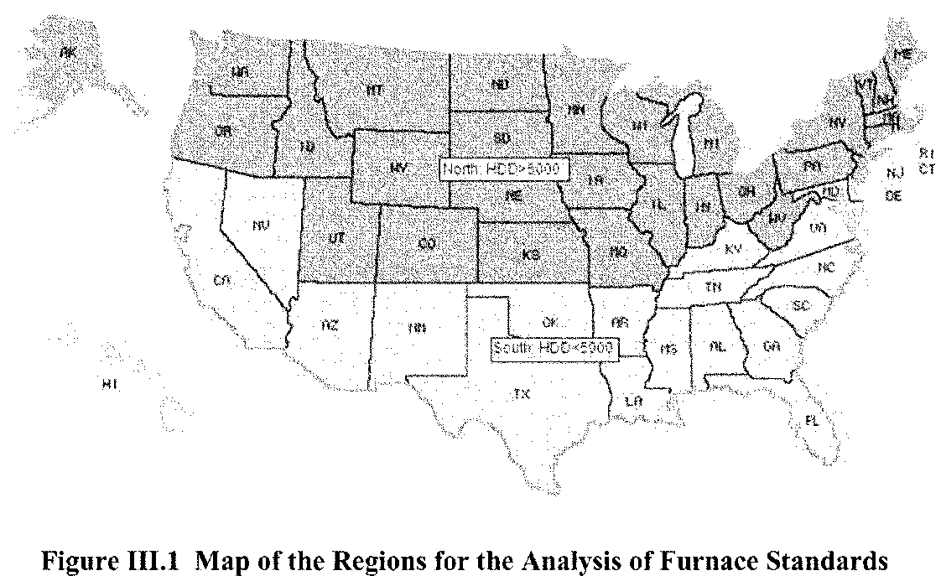

Source: March 12, 2015 NOPR for residential NWGF and MHGF

However, in 2012 before these proposed standards went into effect, the American Public Gas Association (APGA) filed a lawsuit objecting to the process used to adopt the standards. On April 24, 2014, after a two-year delay, the U.S. Court of Appeals for the D.C. Circuit approved a settlement between the DOE and the APGA. Importantly, the settlement abandoned the regional standards for residential gas furnaces (while regional standards set in the NOPR for air conditioners remained) and remanded the gas furnace efficiency standards back to DOE (thereby keeping the current national standard at 78% AFU). DOE was further required to complete a new rulemaking within two years and publish a final rule by April 2016. As noted earlier, this NOPR is meant to satisfy that requirement and proposes one national 92% AFUE efficiency standard. As part of the 2014 agreement a minimum national AFUE standard of 80% (already considered the market standard) becomes effective on November 19, 2015.

Generally speaking, the higher efficiency standards are thought to be more cost-effective in colder climates. EPA Energy Star furnace efficiency requirements are 90% AFUE in states in the southern half of the country (including all of California) and 95% AFUE in northern states. However, the current NOPR would set a minimum 92 % AFUE nationwide which, in addition to having a higher than average up-front cost, are in a class of condensing furnaces (90% AFUE and above) that require a different venting technology than the less-efficient (non-condensing) furnace.

**III. Life Cycle Cost (LCC) Analysis and Comments**

As part of the LCC review, we reviewed more than one-dozen related documents. The majority of our team’s Life Cycle Cost (LCC) analysis was performed by Negawatt Consulting, and is included in Appendix A. The information contained in this section is provided only as a brief summary of some of the major issues identified.

The DOE LCC methodology appears sound and thorough, but it is not transparent. We agree with recent stakeholder criticism about the degree of difficulty involved in understanding the data that DOE provides. It is impractical to assume that anyone unfamiliar with the Crystal Ball software can easily step into the issue and understand DOE’s new methodology without dozens of hours of training and analysis. We tried running the simulation on three different computers, using different operating systems and MS Excel configurations. Despite our best efforts, at this time, we are unable to consistently and repeatedly perform simulation runs without errors or crashes. We are cautiously optimistic that we can minimize these issues in the near future by working with Oracle technical support.

Apart from the practical issues, what appears to be missing is in the DOE LCC materials is a sensitivity analysis for most key variables, and justification as to why they were chosen as they were. This applies both to meta data, such as all the parameters that are shown in the “user interface”, and to actual data. Lastly, some of input data appears incorrect or outdated. Please refer to Appendix A for a more detailed summary of the LCC analysis and for recommendations specific to the LLC analysis (in the Outlook section of Appendix A).

**IV. Summary Thoughts and Recommendations**

We identified 10 issues of concern to the SoCalGas in the Executive Summary. This section is intended to bolster and underpin those issues, while also providing some guidance to the SoCalGas in dealing with this NOPR.

We believe that the SoCalGas should immediately work to develop competency with the Crystal Ball software, and attempt to run California-specific numbers with this software, while simultaneously working with industry partners, especially in the southern U.S., to compare analysis results.

Again, due to the complicated methodology used by the DOE, the lack of transparency in the process and data used, and the extensive labor required to understand and critique, the DOE work, the SoCalGas and others should be justified in asking for a 90-day extension to review and provide comments on the DOE analysis and its results. This is a short-term strategy, but it allows the SoCalGas to perform a much deeper analysis than that they and their contractors have had the opportunity to do at this juncture. Moving the deadline for comments to the DOE on this NOPR from June 2015 to September 2015 seems not only prudent, but well-advised.

There is national concern that moving to these higher efficiency furnaces will drive consumers and builders away from gas and toward increased use of electric appliances. Including heat pumps – fuel switching. While there is legitimate concern over this issue in many parts of the country, we do not see this as likely in California primarily due to consumer preference for gas, higher than national average electricity costs. Regardless, it is an historically-important and –recognized issue – thus, the SoCalGas should be concerned regarding the impact of this standard on SoCalGas customers, in both the new and retrofit markets. Further, we believe that at any significant change in DOE rules that can impact appliances and therefore markets for both gas and electric appliances, fuel switching in the SoCalGas’s service territory is always an issue that needs to be examined closely by the SoCalGas.

We believe that nobody knows better than SoCalGas executives the pressure on traditional energy efficiency program offerings that will result from this proposed higher efficiency standard. Simply stated, with an increase in minimum efficiency from the current market-determined minimum efficiency of 80% AFUE to a new standard minimum of 92% AFUE, the opportunities for more, sizable energy-efficiency gains from above-code programs become substantially limited. With each ratchet-up on the standard, pressure intensifies on the SoCalGas to find new ways to design and deliver profitable, effective energy efficiency programs. We believe that the proposed increase in furnace standard efficiency would likely result in a substantial curtailment in Gas-Company sponsored energy-efficiency program offerings. Energy-efficiency program opportunities and resultant income streams to the SoCalGas as a result of consumer energy-efficiency programs need to be examining different scenarios based on the standard becoming a reality in 2016, and furnaces required five years later in 2021.

To be certain, this is a complex and contentious standard, characterized by many intense DOE-organized stakeholder meetings, numerous legal delays, *ex parte* decisions, unmet industry requests for data, and a formal settlement between DOE and stakeholders that kept the standard process alive after negotiations stalled. The process has been anything but smooth for all parties. One can expect more legal delays based on input at the March 27, 2015 public hearing (which was extended to April 13, 2015 following eight hours of comments and after less than half of the published agenda was covered).

A common concern expressed by those opposed to the move to the higher efficiency standard is the negative economic impact on consumers nationwide. This is not only because of the higher initial cost of a 92% AFUE furnace, but particularly from an increase in installation costs when replacing an 80% AFUE. This is because these “condensing” furnaces achieve a high efficiency by extracting additional heat from exhaust gases, cooling them below the condensing temperature for some exhaust gases, resulting in corrosive condensate in the flue that must be removed and requiring PVC piping for a condensate line (to a drain) and a PVC flue (a standard metal flue would be damaged by the corrosive condensate). The DOE estimates that the cost difference between an 80% AFUE and 92% AFUR furnace ranges from $ 179.18 to $ 1,392.79, potentially low costs, requiring verification. Furthermore, the DOE estimates the total national average installation costs to upgrade the furnace in an existing home is $598.48 more than installation in a new home. Given the potential impact on SoCalGas customers from this ratcheting up of the standard, especially on low to moderate income customers, this issue warrants close attention.

There are important implications for the SoCalGas to consider based on whether and which region California might ultimately be grouped into for the Final Rule. In addition, despite the relatively late notice the SoCalGas may want to suggest more specific, smaller regions for the standard, closer to what was envisioned in the 2011 agreement. Past DOE rulemakings have grouped California into either a large southern (with half of the country, more or less) for natural gas furnaces, or a smaller southwestern group of only four states (CA, AZ, NV and NM) for analyses related to central air conditioners and heat pumps. (“Consensus Agreement” of efficiency advocates, including the California Energy Commission, 2009; Direct Final Rule, November 2007; and Notice of Proposed Rule Making, 2015). Given climatic differences between northern and southern California, an easy argument can be made for two different zones within California, with half of the state in the south, and half of the state in the north. How the California Public Utilities Commission (CPUC) and the State later interpret the zones can ultimately have revenue impacts on the SoCalGas (for example, the northern zone may be ruled eligible for higher allowed rebates through the rate making process). In addition, federal funding for utility energy programs may be tied to the region that the SoCalGas finds itself ultimately within—so, the issue may be important.

One of the most vulnerable areas we identified in our review of the proposed gas furnace efficiency rule is the analysis related to future electricity costs. The DOE relies on Annual Energy Outlook (AEO) analysis, rather than more accurate industry data and analysis. The DOE is quick to respond to criticism by pointing that the AEO is what they always use, and it is essentially the best info that they have access to in their analysis. Regardless of how the SoCalGas views the AEO, a careful analysis of gas prices in the out-years may help the DOE assemble more realistic costs and benefits.

LCC and Market-related considerations:

1. What if the results hold and the PBP is well above 6 years – what does this mean to consumers?
2. Is this likely to, and what if it does drive consumers to fuel-switching? If fuel-switching occurs, how does the primary-fuel savings compare between the more efficient gas furnace and the switched-to HP? Consider both fuel and emissions…

**V. Appendices**

**Appendix A. Life Cycle Cost (LCC) Analysis and Comments**

**LCC Analysis and Comments for SoCal Gas, DOE furnace efficiency rulemaking**

1. **Summary of the LCC**

The DOE has developed a calculation spreadsheet to determine Life-Cycle Cost (LCC) and Simple Payback Period (PBP) for high efficiency furnaces as compared to an 80% AFUE base case. As part of its calculation, the spreadsheet creates 10,000 randomized furnace upgrade scenarios across the nation, and calculates LCC and PBP for each. Results are shown as nationwide averages in the “Summary” tab. These nationwide averages are broken down by NWGF and MHGF (non-weatherized gas furnaces, and mobile home gas furnaces, respectively), and by levels of efficiency as follows:



These results are then disaggregated further by region (“North”, “Rest of Country”), and building type (“Residential” vs. “Commercial”), and by construction scenario (“New” vs. “Replacement”).

In addition, LCC and PBP calculations are provided for four different types of power supply technologies. We are ignoring these calculations in our discussion, as the LCC is insignificant at 1-2% of the furnace LCC.

The DOE’s calculation spreadsheet was shared with the general public in 2014, and has been corrected twice since its original publication due to errors found by independent reviewers. This analysis is based on the latest version available in the docket, dated February 6, 2015. We have also considered several other documents in our review, notably: RF_NOPR Presentation_2015-03-26_for_printing.pptx (presentation provided by DOE during public NOPR meeting on March 27, 2015 in Washington, DC), and EERE-2014-BT-STD-0031-0016.pdf (presentation provided by DOE on November 7, 2014 in Washington, DC), several comment letters by AGA/APGA, and fuel switching materials by GTI. All documents used are available to the public via the DOE docket for this rulemaking.

1. **Summary of calculation inputs**

The calculation inputs considered and the general flow of the calculation are shown below:

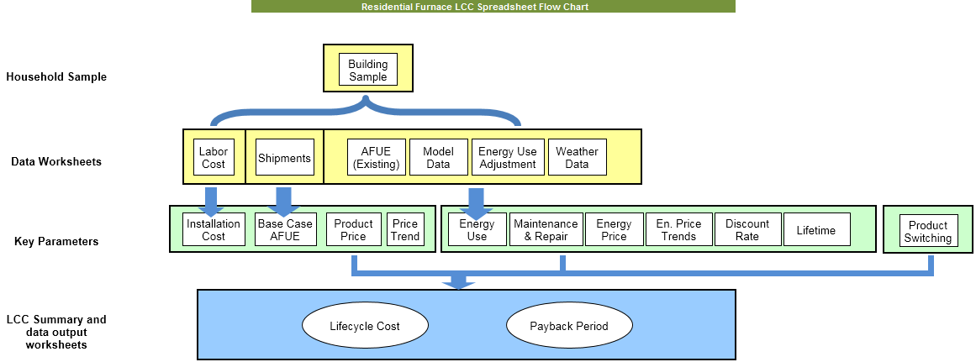

Most raw input data is derived from various public and private sources, for example RECS 2009, CBECS 2003, RS Means 2013, AEO 2014, sales data gleaned from vendors by means of surveys, and so on. Please refer to section “References” for details about the sources cited. Some input parameters were determined by “deliberative process” at the DOE and are not further justified.

Most input data is broken down by region. Input data that were not broken down by region “out of the box”, but where regional differences can be expected, are pre-processed accordingly as part of the calculation. For example, parts and labor cost from the RS Means database is weighed by region.

Some cost figures that are part of the raw input data are being adjusted to 2013-$ by the calculation. It is not clear if this was done consistently, because the associated year is not obvious for all cost figures.

It is important to note that many input data are specified as a *probability distribution* rather than as single values. This is made possible by using a 3rd party MS Excel plug-in, “Oracle Crystal Ball”. For example, where a LCC calculation might traditionally assume the life of a furnace as 21.5 years, this LCC features the life of a furnace as a distribution with a *means* of 21.5 years. The figures below show an example distribution (furnace lifetime), as well as all the input categories in which the feature is used:

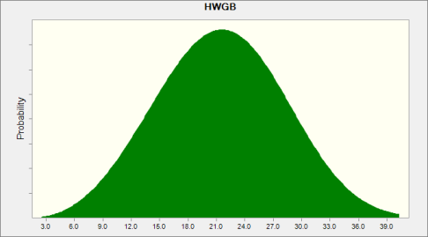 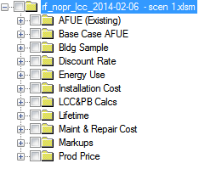

1. **Summary of calculation methodology**

The spreadsheet uses a so-called “Monte Carlo simulation”, as follows:

1. devise 10,000 concrete sets of input parameters from the raw data and probability distributions,
2. calculate 10,000 matching sets of LCC and PBP for each set of concrete inputs,
3. aggregate the results into nationwide averages.

The spreadsheet has a rudimentary “user interface” that allows others to re-run the simulation with changes to certain meta-data parameters. The parameters that can be modified in this manner are:

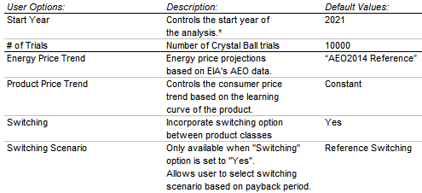

Other data than those accessible via the spreadsheet’s user interface can technically also be modified, although there are some practical difficulties. The data present is very complex and voluminous, and each simulation run takes about 30 minutes, making quick “trial and error” modifications impossible. As progress is made to minimize these issues, it will become possible to do a more thorough sensitivity analysis for all the input data. We also anticipate being able to modify the calculation so that it can be limited to California-only scenarios.

1. **Critique of the LCC**

The methodology appears sound and thorough, but is hard to retrace in detail, and the accuracy and appropriateness for the purpose are therefore hard to confirm. Also, redoing calculations with variations to the input parameters is difficult due to technical hurdles. We have tried running the simulation on three different computers, using different operating systems and MS Excel configurations. Despite our best efforts, at this time, we are not able to consistently and repeatedly perform simulation runs without MS Excel or Crystal Ball errors or crashes. We are cautiously optimistic that we can minimize these issues in the near future by working with Oracle technical support.

Apart from the practical issues, what appears to be missing is in the DOE materials is a ***sensitivity analysis*** for most key variables, and ***justification*** as to why they were chosen as they were[2]. This applies both to meta data, such as all the parameters that are shown in the above “user interface”, and to actual data. Lastly, some of input data appears incorrect or outdated. Discussion of specific examples:

1. It would seem counterintuitive that product prices should not go down over time (default assumption “Constant”, in the user interface), especially considering that if a higher efficiency is mandated, there should be significant economies of scale for the manufacturers
2. Fuel switching: As is, the DOE contends that if the payback time of a higher efficiency furnace is 3.5 years or longer, customers will switch to an electric appliance. AGA asked for justification of this number, to which DOE essentially responded “deliberative process” (i.e. we use our judgment, take it or leave it). See also further discussion of fuel switching in the next-to following section “Outlook”.
3. Similarly, a number of other input parameters, even such that appear to originate from a reputable secondary source, are modified or adjusted using probability distributions. While that appears to be sensible conceptually, setting up the actual distribution leaves room for judgment. Should it be Weibull, triangular, or discrete, ... ? Should it be symmetrical or asymmetrical… ? How wide is the range of values? Technically, each and every such distribution needs to be justified. As is, it appears the researchers who built the spreadsheet often used their professional judgment (aka “deliberative process”). How good their judgment is, and the impact of poor judgment, if any, is speculative at this time. We have not had a chance to finalize sensitivity analysis due to technical difficulties with Crystal Ball.
4. As previously noted, the marginal electricity cost for residential customers in California is stated to vary between 17 and 20c/kWh in 2013-$; in 2013, the marginal rate was between 25 and 30c/kWh[3].
5. The calculation includes considerations for commercial customers, and commercial LCC and PBP are shown disaggregated from the national totals in the summary tab. However, this rulemaking is about *residential* furnaces. It is not clear why commercial data is comingled, and whether the commercial or averaged results are used in any downstream processes.
6. As previously noted, the installation costs do not appear to factor in that older homes may have asbestos issues that need to be addressed during a retrofit to condensing furnaces
7. There does not seem to be a mention anywhere of the also in-progress test procedure rulemaking, and what the impact of an updated test procedure could have on this rulemaking. Depending on whether the updated test procedure results in *higher* or *lower* efficiencies compared to the old test procedure (for otherwise identical equipment), the first cost and savings figures in this analysis may have to be adjusted accordingly.
8. **To Do with respect to LCC**
9. Reach out to contractors and builders to answer Q2-5 from AGA survey by April 9th (anecdotally! - representative numbers are not possible without significant effort & money)
10. Get Crystal Ball to work,
11. Run LCC for California only, if possible
12. Review TSD for further sensitivity analysis and justification on the part of DOE
13. Look for source of seemingly incorrect marginal electricity cost data, and how it matters
14. Review delta CBECS 2003 vs. CBECS 2015 and check what difference it may make.
15. Review other data sources for appropriateness w/r/t California
16. Perform sensitivity analysis for any key parameters and distributions as needed
17. **Outlook**
18. In the opinion of the author, it would behoove the team to consider *what if* the LCC is as good as it gets and the results are sensible. What would it mean to SoCal Gas if the PBP for high efficiency furnaces is indeed well above 6 years for the average residential customer.
19. What if there *is* fuel switching as the DOE assesses? ***Does the extra gas needed to generate the extra electricity offset the gas savings by the better furnaces?*** DOE estimated fuel switching ratios are shown below.

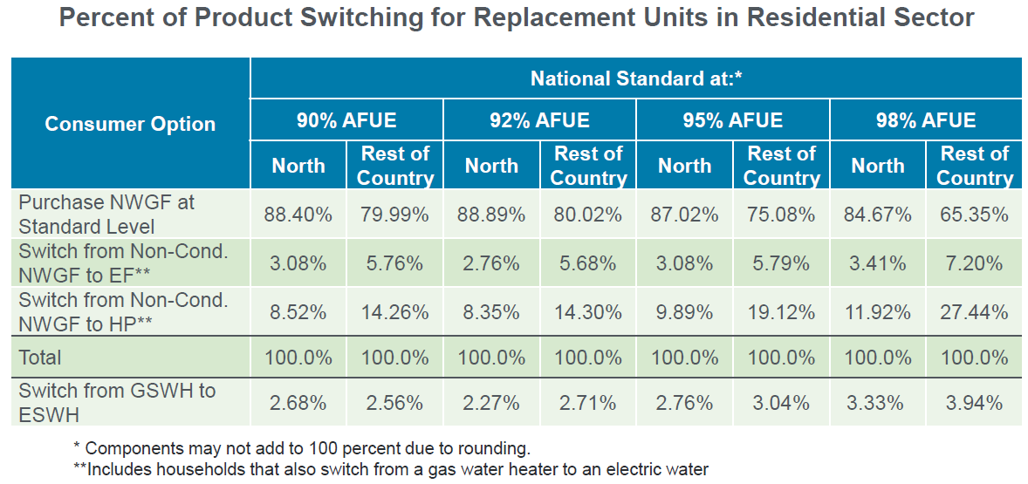

AGA and GTI have conducted their own switching study that the DOE discussed in their 3/27 meeting (slides 81 and 82). The DOE’s position appears plausible at first sight. Switching analysis summary and key differences shown below.

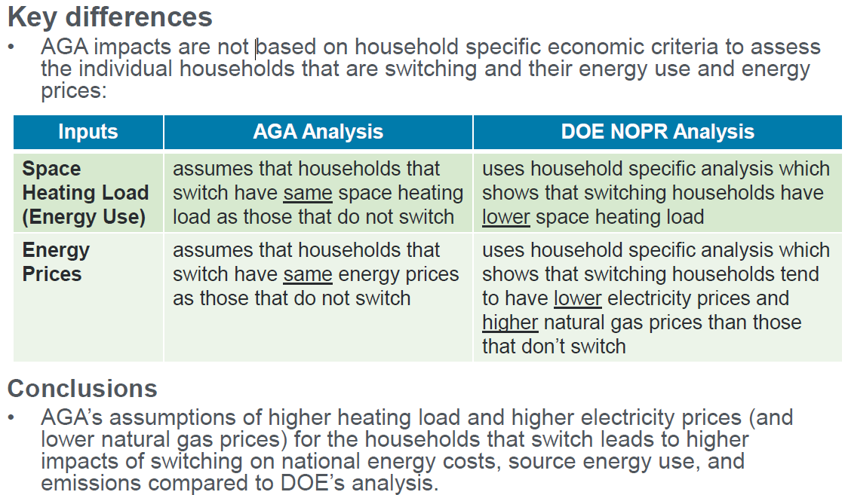

1. Finally, in the author’s opinion, the proposed rule should be investigated on the account of the market, business, and utility consequences… (as opposed to limitations of the LCC calculation). The TSD document and docket have significant additional materials available that should be reviewed in this regard, namely the “Utility impact analysis”, the “National Impact Analysis” and the “Manufacturer Impact Analysis”. Related materials are also shown in the 3/27 slide deck beginning with slide 93. It us our understanding that most of these slides were not covered during the meeting due to lack of time, and that a subsequent meeting on April 13 will cover these items.

**Appendix B Major SoCalGas Issues in 2011 and 2015**

There are numerous issues that have arisen during this rule-making process that warrant the SoCalGas’s close attention. Many of these are in the public record, and some are not. A consistent issue raised by gas industry stakeholders from the beginning has been the rule-making process itself, specifically how Federal rulemaking legislation and regulations are to be interpreted, which information is proprietary and which is not, and how accurate that information is, and what methodologies are used to arrive at conclusions. There is a very clear perception that the DOE and their contractors are analyzing the impact on the gas industry with data that is either difficult to obtain through proprietary sources or available data that may not be accurate or appropriate for the analysis. For example, the DOE uses the Annual Energy Outlook (AEO) projections for the future price of electricity versus a different, more accurate industry source that also considers the marginal costs of electricity-which are not considered in the AEO. The gas industry has been vocal about this issue. Below is a summary of the major concerns expressed by stakeholders during the 2011 and 2015 gas furnace efficiency standards process. 2011 issues are listed on the left-hand column, and 2015 issues on the right column. We also provide extensive lists of stakeholders that participated during this process in each column, which serve as potential future partners and resources for the SoCalGas.

|  |  |
| --- | --- |
| ***2011 Stakeholder Comments*** | ***2015 Stakeholder Comments*** |
| **The Fuel-Switching Issue** | |
| Many gas industry stakeholders believe that the Final Rule will promote fuel-switching to electric furnaces, resulting in higher carbon emissions than the least efficient gas furnaces available today, unintended reductions in energy efficiency, higher operating costs, and increased GHG emissions. | A Gas Technology Institute (GTI) Cost-Switching Survey of builders and contractors determined that respondents believe there will be increases in overall energy costs, source energy usage, and CO2 emissions with the new standards. |
|  | Fuel switching is expected to occur in both heating and water heating systems. |
|  | DOE’s own analysis already acknowledges that fully 60-percent of the energy savings from reduced natural gas consumption will be offset by increased electricity usage due to fuel switching. |
| **Consumer Impacts** | |
| Average increases of 25% to 40% in the cost to replace an 80 AFUE with a 90 AFUE were suggested because of furnace and venting costs retrofits, leaving consumers to choose between electric furnaces and maintaining current inefficient furnaces. The proposed rule was expected to have a disproportionate impact on lower-income consumers and renters. | DOE’s economic analysis underestimates the standards’ costs to consumers and has other adverse impacts. Furthermore, its own analysis shows that 20-percent of households nationwide will see a net life cycle cost increase; 31-percent of consumers in the Southern region will experience net life cycle cost increases, and low-income consumers will be disproportionately affected – 39-percent of low-income consumers in the South will bear net life-cycle costs increases. |
| The American Gas Association (AGA) estimated the installation costs of condensing furnaces would range from $1,500 to $2,200 at the time. | DOE’s NOPR provides a national average total installation cost ($1,342.61 average purchase price and $1,369.70 average installation cost) of $2,712.31.  As least one utility (PG&E) brought up asbestos costs and concerns at the March 27, 2015 public hearing. According to BIRAenergy research done in the Los Angeles area in 2014, despite relatively small quantities of asbestos requiring mitigation, this mitigation can increase installation costs by as much as 40-percent. |
| **Gas Utilities Impacts** | |
| Utility rebate programs designed to encourage conservation and increased energy efficiency will likely be eliminated and/or reduced. State-approved incentive programs and associated rebates would be jeopardized. | Fuel switching conflicts with the gas utility industry’s commitment to help customers save money and reduce emissions, while improving the efficiency of how we use energy. |
| Utility rebates were suggested as an option to cover the costs of converting to a higher efficiency furnace, and it might be worth doing, but that would increase rates and program expenses substantially. | The proposed rule will effectively outlaw non-condensing furnaces and in consideration of the significant adverse consequences under a national (condensing) rule, the final rule should be structured to minimize the likelihood of fuel switching (away from natural gas). |
|  | Without the substantial financial intervention provided by a DSM program, equipment will not be broadly installed in places where the old housing stock and customer socio-economic status create barriers. |
| **The Separate Product Classes Issue** | |
| This was not a major issue in 2011. | If DOE proposes a new furnace efficiency rule that adopts a condensing standard as a minimum, then it must, in the view of some in the gas industry, also provide that non-condensing furnaces are a completely separate product class if the DOE wishes to avoid wholesale fuel switching and to promote overall fuel efficiency. |
|  | Establishing separate product classes (condensing, and non-condensing classes) will largely eliminate pressure on consumers to switch from natural gas to electric space and water heating equipment when condensing natural gas furnace options are not viable alternatives. |
|  | DOE has the legal authority and an extensive precedent to establish separate product classes for condensing and non-condensing furnaces. |
|  | See APGA/AGA White Paper on  Separate Product Classes |

**Appendix C Stakeholder Involvement in 2011 and 2015**

|  |  |
| --- | --- |
| Key Supporters and Opponents of the 2011 Direct Final Rule | |
| The “Joint Petitioners”   * **California Energy Commission (CEC)** * American Heating and Refrigeration Institute (AHRI) * American Council for an Energy-Efficient Economy (ACEEE) * Alliance to Save Energy (ASE) * Natural Resources Defense Council (NRDC) * Appliance Standard Awareness Project (ASAP) * Northeast Energy Efficiency Partnerships (NEEP) * Northwest Power and Conservation Council (NPCC) * Bard Manufacturing Company Inc. * Carrier Residential and Light Commercial Systems * Goodman Global Inc. * Lennox Residential * Mitsubishi Electric & Electronics USA * National Comfort Products * Rheem Manufacturing Company * Trane Residential   Additional Supporters   * Bonneville Power Administration * Consumer Federation of America, National Consumer Law Center * Earthjustice * Northwest Energy Efficiency * NationalGrid * Environment America | Key Opponents   * American Gas Association * American Public Gas Association * Air Conditioning Contractors Association * National Propane Gas Association   Other Opponents   * Alabama Gas Corporation * AGL Resources (Atlanta Gas Light, Chattanooga Gas, Elizabethtown Gas, Elkton Gas, Florida City Gas, Virginia Natural Gas) * Atmos Energy (Dallas, TX) * CenterPoint Energy (Minneapolis, MN) * CGKoch Institute (Arlington, VA) * City Utilities of Springfield, MO * City of Chanute, KS * Consolidated Edison of New York * Heating, Airconditioning, and Refrigeration Distributors International (HARDI) * Laclede Group (Missouri) * Metropolitan Utilities District (Omaha, NE) * National Fuel Gas Distribution Corporation (western NY and NW Pennsylvania) * Nicor Gas (Atlanta, GA) * NW Natural Gas (Portland, OR) * Philadelphia Gas Works * Piedmont Natural SoCalGas (Dallas, TX) * Questar Gas (Utah, SW Wyoming, and SE Idaho) * UGI Distribution Companies (Gas Division, UGI Penn Natural Gas, UGI Central Penn Gas)   U.S. Senators Chambliss and Landreiu (Senate Natural Gas Caucus Co-Chairs) |
| Key Supporters and Opponents of the 2015 92% AFUE National Standard | |
| Key Supporters   * American Heating and Refrigeration Institute (AHRI) * American Council for an Energy-Efficient Economy (ACEEE) * Alliance to Save Energy (ASE) * Natural Resources Defense Council (NRDC) * Appliance Standard Awareness Project (ASAP) | Key Opponents   * American Gas Association * American Public Gas Association * Laclede Group (Missouri)   Philadelphia Gas Works |
|  |  |

**Appendix D DOE Criticism in 2011 and 2015**

|  |  |
| --- | --- |
| **The Department of Energy Rulemaking Process** | |
| Stakeholder comments concerning DOE:   * DOE did not define the enforcement roles and responsibilities under the Direct Final Rule, nor did it analyze the economic burden imposed by the enforcement of regional standards. * DOE data fields were unrealistically high in some cases and unrealistically low in others. * DOE erred by using the Direct Final Rule (DFR)—essentially a procedural shortcut process—to promulgate a final rule. DOE knew that the joint statement upon which it based the DFR was not a consensus-based document of all (or even most) relevant sectors of the industry. * DOE was criticized for having significant flaws in its approach, methodology and analyses. | Recent (2015) stakeholder comments concerning DOE:   * DOE underestimates the adverse impacts of fuel switching. * DOE overestimates product lifetime (21.5 years, instead of closer to 16 years). * DOE overestimates the size of the affected market, this making the cost-benefit analysis look for “rosy.” * DOE uses unexplained and inconsistent installation costs in its Life Cycle Costs (LCC) analysis. * DOE uses unexplained and inconsistent payback criteria in its Life Cycle Cost analysis. * DOE errs in not considering the performance characteristics of (lower efficiency) non-condensing furnaces. |

**Appendix E. Makeup of Residential Furnace Market**

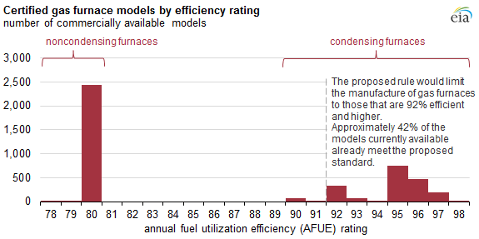

US EIA – Energy Information Administration

“Proposed efficiency standards may eliminate noncondensing gas furnaces”, U.S. Energy Information Administration, February 17, 2015 (<http://www.eia.gov/todayinenergy/detail.cfm?id=20011>)

**APPENDIX F**

**California Climate Zone Descriptions**

The table below lists the representative cities that climate zone data are generally based upon. The table also lists winter and summer design temperatures and heating and cooling degree-days for the representative cities. A map of California climate zones is provided on the following page.

|  |  |  |  |  |  |  |
| --- | --- | --- | --- | --- | --- | --- |
| **Climate Zone** | **City** | **Description** | **Winter Design** | **Summer**  **Design** | **Heating Deg. Days** | **Cooling Deg. Days** |
| 1 | Arcata (Eureka) | North coastal | 35 | 69 | 4679 | 0 |
| 2 | Santa Rosa | Northern coastal valley | 27 | 96 | 3065 | 315 |
| 3 | Oakland | San Francisco bay area | 33 | 84 | 2909 | 128 |
| 4 | Sunnyvale (San Jose) | Central coastal valley | 34 | 88 | 2416 | 444 |
| 5 | Santa Maria | Central coastal | 31 | 83 | 3053 | 84 |
| 6 | Long Beach | South coastal – Los Angeles | 38 | 90 | 1606 | 905 |
| 7 | San Diego | South coastal – San Diego | 42 | 83 | 1507 | 722 |
| 8 | El Toro (Santa Ana) | Southern coastal valley-south | 38 | 89 | 1675 | 972 |
| 9 | Burbank | Southern coastal valley-north | 34 | 96 | 1701 | 1179 |
| 10 | Riverside | Southern inland valley | 32 | 100 | 1919 | 1324 |
| 11 | Red Bluff | Northern inland valley – hot | 29 | 104 | 2688 | 1904 |
| 12 | Sacramento | Northern inland valley – moderate | 31 | 100 | 2843 | 1159 |
| 13 | Fresno | Central inland valley | 28 | 101 | 2650 | 1671 |
| 14 | China Lake (Barstow) | Southern high desert | 22 | 108 | 2547 | 2272 |
| 15 | El Centro | Southern inland valley | 35 | 111 | 1216 | 3794 |
| 16 | Mt. Shasta (Alturas) | Mountain | -4 | 96 | 5890 | 195 |

Note: Design temperature and degree-day data are for the city listed in parentheses, and are 0.2% winter and 0.5% summer values. All data are from *Climatic Data for Region X, Arizona, California, Hawaii and Nevada* published by ASHRAE; except cooling degree-day data are from *Monthly Normals of Temperature, Precipitation, and Heating and Cooling Degree Days (California), 1941-1970* published by the National Oceanic and Atmospheric Administration.

**Appendix G Additional DOE Documents of Interest**

The following four DOE documents are part of this gas furnace standards making process that are relevant to the SoCalGas:

1. **Framework Document:**  The Framework Document outlines the scope of the rulemaking and explains the relevant analyses that DOE anticipates conducting to determine whether to amend the standards, as well as for the development of any amended standards. The Framework Document essentially casts a broad net over the many issues which the rulemaking might encompass and asks for feedback from stakeholders.
2. **Preliminary Technical Support Document (PTSD)** – In this document the DOE discusses methodologies and results of the preliminary technical analyses and indicates the scope and type of rule it might propose, holds hearings and requests comments. The preliminary analyses include an analysis of the costs to achieve higher efficiency levels; an analysis of the life-cycle cost savings and payback period of higher efficiency levels from the perspective of an individual consumer or business; and a national impact analysis of the potential national energy savings and net present value (NPV) of higher efficiency levels.
3. **Notice of Proposed Rulemaking (NOPR)** – Within the NOPR document DOE proposes the standards levels for the product(s) and publishes the technical support document (TSD). The latter contains the analyses which support the proposed levels. The TSD includes a manufacturer impact analysis, a utility impact analysis, an employment impact analysis, and an environmental assessment, among other detailed analyses. DOE holds public hearings and request public comments once the NOPR is published.
4. **Final Rule** - After considering public comments, DOE revises its analysis and publishes the final rule. Usually, manufacturers must comply with the standard three to five years after the new standard is published.  In this case, the earliest the standards may take effect would be five years from 2016, or 2021.

**Appendix H References**

Energy Policy Conservation Act (EPCA)

National Appliance Energy Conservation Act of 1975 (NAECA) as amended.

American Procedures Act (APA), as amended

“How Often and Why Do Americans Move?” February 21, 2014, <http://www.mymovingreviews.com/move/how-often-and-why-americans-move>.Energy Independence and Security Act of 2007 (EISA) as amended

*State of New York, et al.* v. *Department of Energy, et al.,* Nos. 08-0311-ag(L); 08-0312-ag(con) (2d Cir. filed Jan. 17, 2008).

“The Regional Standards Agreement for Residential Furnaces, Air Conditioners, and Heat Pumps: Process, Results, and Implications” Karim Amrane (AHRI) and Howard Sachs and Steven Nadel (ACEEE) <http://aceee.org/files/proceedings/2010/data/papers/1923.pdf>

*American Public Gas Association, et al.* v.*Department of Energy, et al.,* No. 11-1485 (D.C. Cir. filed Dec. 23, 2011).

*Monthly Normals of Temperature, Precipitation, and Heating and Cooling Degree Days (California), 1941-1970* published by the National Oceanic and Atmospheric Administration.

**NATURAL GAS-FIRED FURNACES** REGULATORY PROPOSAL; ENERGY EFFICIENCY BRANCH, BC MINISTRY OF ENERGY AND MINES.

HTTP://WWW.EMPR.GOV.BC.CA/EEC/STRATEGY/EEA/PAGES/DEFAULT.ASPX

“In the Upcoming Rulemaking on Amendments to the Minimum Efficiency Standards for Non-Weatherized Residential Gas Furnaces, DOE Should Employ Separate Product Classes for Condensing and Noncondensing Furnaces”, American Gas Association and American Public Gas Association, October 22, 2014.

RECS 2009: Residential Energy Consumption Survey by US Energy Information Administration, [http://www.eia.gov/consumption/residential/data/2009/#sf?src=‹ Consumption Residential Energy Consumption Survey (RECS)-b1](http://www.eia.gov/consumption/residential/data/2009/#sf?src=‹ Consumption      Residential Energy Consumption Survey (RECS)-b1)

CBECS 2003: Commercial Buildings Energy Consumption Survey by US Energy Information Administration, <http://www.eia.gov/consumption/commercial/data/2003/>

RS Means 2013: Construction Cost Data by The Gordian Group, <http://www.rsmeans.com>

AEO 2014: Annual Energy Outlook by US Energy Information Administration, <http://www.eia.gov/forecasts/AEO/> and <http://www.eia.gov/forecasts/AEO/pdf/0383(2014).pdf>

1. Based on actual bids from PIER project ZNE Retrofits in Low-Income MF Projects.
2. Some of this information may be buried in the 957-page TSD document, “furnaces_nopr_tsd_2015-02-13.pdf”; we are continuing our investigation in this respect.
3. It is possible, although not clear, that the number used by DOE is the *average* marginal rate, under consideration of the fact that not all customers consume enough electricity to be in the highest tier. We are still investigating.