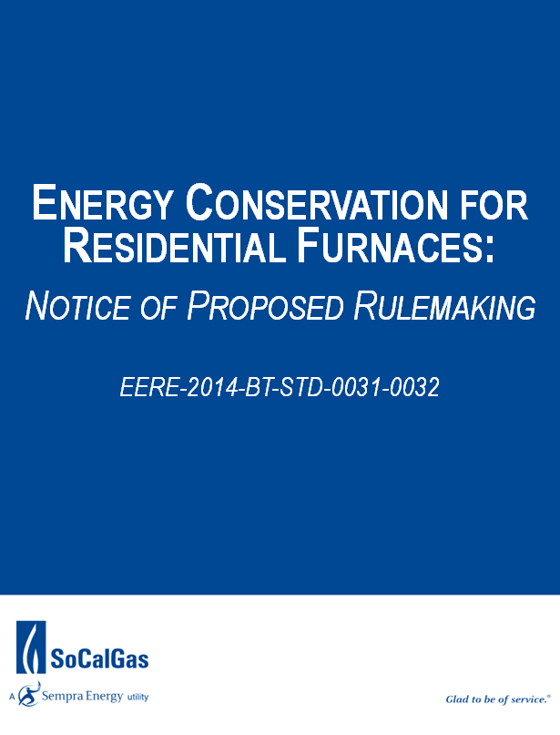
Table of Contents:

- UPDATE – AGA Board Meeting (October 12, 2015)………….……………………. 3
Legislative Update
Results from Comments to NOPR
Notice of Data Availability
SoCalGas’ Planned Action on the NODA

- AGA Board Meeting Issues …………………………………………………………………………………. 8

- SoCalGas Responses to AGA & AHRI Options ……………………..………….…………………. 10

- Intent of Furnace NOPR ………………………………………………………………………………..… 15

- Background, History & Impact ………………………………………………………………………….. 16

- Timeline of Events …………………………………………………………………………………………… 19

- External Stakeholders ………………………………………………………………………………………. 20
American Gas Association (AGA)
American Public Gas Association (APGA)
Gas Technology Institute (GTI)
Leclede Natural Gas (Leclede)
Atlanta Gas Light (AGL)

- Internal Actions ……………………………………………………………………………….……………… 21
Role of SoCalGas
SoCalGas Response to AGA Request
Engagement with SDG&E

- Appendix ………………………………………………………………………………………………………… 22

I. UPDATE – AGA Board Meeting (October 12, 2015)

Since filing comments to the Notice of Proposed Rulemaking, the following actions have taken place:

Legislative Update
The American Gas Association (AGA) and the SRE Washington office are pursuing a legislative fix to the Department of Energy’s (DOE) furnace rulemaking. The House Energy & Commerce Committee recently passed out of committee a bill that prohibits the DOE from issuing a final rule until July 2016. It is expected that the bill will come to the floor of the House of Representatives sometime in the next few weeks and it should have the votes to pass in the Republican majority House.
The Senate Energy and Natural Resource Committee has also passed a bill out of committee that prohibits DOE from moving forward with the rule without a stakeholder conference to evaluate if the furnace rule is economically justifiable. Although the Senate bill passed out of committee with bipartisan support, it is unclear when or if the bill will be brought to the floor of the Senate this year. Therefore, despite success in addressing the furnace rule in both houses of Congress, the uncertainty of final passage by both houses and a reconciliation of any differences before December is unlikely. We expect the DOE to issue a final rule in December prior to the President’s trip to Paris for climate talks.

Results from Comments to NOPR (copy of AGA document attached)
This Notice of Proposed Rulemaking generated a significant amount of attention and the predominant responses were in opposition to the action. Below is an excerpt from a summary of the responses received as prepared by AGA:

Those in favor of the NOPR were generally environmental and energy efficiency-focused groups, including the American Council for an Energy Efficient Economy (ACEEE), the Alliance to Save Energy, California Energy Commission, Consumer Federation of America, Natural Resource Defense Council (NRDC), Northeast Energy Efficiency Partnerships, and Pacific Gas & Electric (PG&E). These groups were extremely supportive of raising the AFUE to 92 percent as proposed, arguing that DOE has demonstrated in their analysis that this standard has already been found to be technologically feasible and cost-effective. While achieving the maximum level of energy efficiency is the prominent aim, supporters, such as Northeast Energy Efficiency Partnerships, also argued that the NOPR will assist low income consumers by reducing monthly utility bills. California-based groups, such as the California Energy Commission and PG&E noted that states were not able to institute their own appliance standards on efficiency and NOx emissions, and needed DOE to act to meet their state’s statutory requirements.

Many critical submissions focused on the negative impact the rule would have on ratepayers, especially low-income consumers. The negative consequence to consumers associated with fuel switching prompted by a condensing standard was another concern shared by almost all natural gas stakeholders, such as Washington Gas and Light, New Jersey Natural Gas and SoCalGas. SoCalGas’ analysis reflected that all customers in SoCalGas’ service territory would suffer a “net cost” rather than a “net benefit” with the proposed rule. This is particularly concerning considering that nearly 33% of California residents fall below the poverty line. These lower income consumers will bear a higher burden than the remaining consumers should this rule be enacted. Additionally, due to the warm climate in California, the simple payback on installation of the equipment proposed in this rulemaking would exceed the stated 21.5 year life of the equipment. SoCalGas’ analysis also contends that government intervention is unnecessary because the condensing furnace market has moved substantially toward the proposed 92% AFUE level in the appropriate markets without it being mandated by the standard. Many groups, such as the American Energy Alliance, discussed the environmental impacts of fuel switching, arguing that the increased use of electric heating systems would cause an increase in greenhouse gas emissions. Advocates of multifamily structures, such as the National Multifamily Housing Council, raised concerns regarding the high cost involved in retrofitting multifamily homes and row houses with condensing furnaces.

Manufacturers and contractors, such as the Air Conditioning Contractors of America, raised concerns over the more technical aspects of the rule, including flaws found in methodology, the failure to accurately estimate costs of installation, updated ventilation, the finalization of test procedures, and the life expectancy of the furnaces.

Noteworthy was the fact that comments were submitted by a consortium of United States House of Representatives -123 Congressional Members joined to submit their opposition to this rulemaking:

United States House of Representatives Congressman Brooks et al.: Brooks et al. raised concerns regarding the ability of low- or fixed-income households to pay for the installation of more efficient natural gas heating systems. The inability to pay for installation, according to Brooks, would result in the use of less efficient electric heating systems, increasing greenhouse gas emissions. Brooks et al. stated that the proposed rule would force citizens to pay thousands for new installations or abandon natural gas use altogether. Brooks et al. recommended that DOE establish separate product classes with respective efficiency standards for condensing and non-condensing furnaces to remove the financial burden from low-income citizens.

Notice of Data Availability Summary
On September 14, 2015, the Department of Energy (DOE) published a Notice of Data Availability (NODA), 80 Fed. Reg. 55038, and released two spreadsheets, one on consumer impacts (life-cycle costs/payback periods) and one on national impacts (national energy savings and net present value of national benefits).
The key aspect of this analysis is that only large furnaces would need to use condensing technology to meet the standard. Therefore residential buildings installing a small furnace would not need to incur the costs associated with installing a condensing furnace.
Table II.1—Potential Standard Level Combinations Analyzed for Large and Small Furnaces
Furnace size | Annual fuel utilization efficiency (%)
Large | 90 | 92 | 95 | 98
Small | 80 | 80 | 80 | 80

This NODA analysis used the same sample of residential furnace consumers as the March 2015 NOPR. Each sample household was assigned a furnace size (in terms of input capacity) based on a number of features. The share of households that would install a small furnace depends on how “small furnace” is defined in terms of input capacity. For this analysis, DOE considered the following small furnace definitions: ≤45 kBtu/hour, ≤50 kBtu/hour, ≤55 kBtu/hour, ≤60 kBtu/hour, and ≤65 kBtu/hour. In each case, large furnaces would be defined as all sizes above the given thresholds. The share of households that would install a furnace meeting a small furnace standard rises as the size cutoff in the small furnace definition increases.

Table II.2—Share of Sample Households by Furnace Size
Furnace size | Small furnace definition | ≤45 kBtu/hour | ≤50 kBtu/hour | ≤55 kBtu/hour | ≤60 kBtu/hour | ≤65 kBtu/hour
Large | 92 | 86 | 85 | 68 | 62
Small | 8 | 14 | 15 | 32 | 38
Total | 100 | 100 | 100 | 100 | 100

Comments have been requested to improve the analysis, as the simulation inputs were not changed to adequately address issues provided by many stakeholders.

SoCalGas’ Planned Action on the NODA
The AGA will be asking the BOD whether they should attempt to find a compromise on minimum threshold for the small furnace size with the key stakeholders to the rule (ACEEE, NRDC, Alliance to Save Energy, etc.). SoCalGas should encourage the AGA to seek that compromise however all information would indicate that a compromise is likely not to be achieved because of the significant divide in opinions on what that size should be. Nonetheless, SoCalGas believes an attempt should be made on behalf of our customers.

Because SoCalGas took a firm position and filed detailed comments to the issuance of the NOPR, it was decided that the company should also file equally firm comments regarding the NODA.

SoCalGas’ position is that although we applaud the DOE’s attempt to find a compromise option, our original concerns have not been addressed. This NODA proposes an option that seeks to address the economic impact to our customer and to some extent it achieves that. However, the DOE has not yet addressed the methodology flaws in the following areas:
- Method DOE used to determine the homes that would be impacted by the proposed rule
- Method DOE used in its fuel switching analysis
- Inaccuracies in various key input variables used in the DOE NOPR Life-Cycle Cost (LCC) Analysis
Regarding the intent of the NODA, which is to gain information on what size threshold would be acceptable for the smaller furnace size, SoCalGas would require a minimum of 65 KBtu/h as that minimum threshold in order to mitigate the negative impact to our customer.

THIS PAGE IS INTENTIONALLY LEFT BLANK

ALL CONTENT BELOW PROVIDES BACKGROUND INFORMATION

II. AGA Board Meeting Issues (May 15/16, 2015)

Issue #1:
Item E on the AGA board agenda addresses the DOE’s Residential Furnace Notice of Proposed Rulemaking (NOPR). AGA staff has presented three potential legislative fixes to this rule. These options are listed below with SoCalGas’ position on each. This represents the high level position – a more detailed explanation can be found beginning on page 5 of this document.

Option 1: Would AGA support a rule that changed the threshold dividing the northern and southern regions from an HDD (Heating Degree Days) level of 5000 to 5500?

- SoCalGas supports a regional standard as outlined in the proposal provided that the language is not altered in any way and that the boundaries of the map are maintained to include California in the Southern Region and subject to the 80% AFUE standard.

Option 2: Would AGA support a regional standard in combination with distinct product classes for new construction and retrofit applications?

- SoCalGas is neutral on this option based on the passage of the regional standard as outlined in Option #1, keeping California in the Southern Region with an 80% AFUE.

Option 3: Would AGA support a regional standard in combination with a new product class for small furnaces that allowed the continued availability of noncondensing furnaces suited to multifamily dwellings?

- SoCalGas is neutral on this option based on the passage of the regional standard as outlined in Option #1, keeping California in the Southern Region with an 80% AFUE.

Issue #2:
AGA released the May 16th BOD meeting agenda on Friday, May 8, 2015. That same day AGA staff attended a meeting of key stakeholders to the furnace rule where AHRI presented three furnace fix options that are acceptable and achievable to the manufacturers. This represents the high level position – a more detailed explanation can be found beginning on page 7 of this document.

AHRI Option A:
- Establish an 80 percent AFUE national minimum for all furnaces.
- Install furnace fans in the 80 percent AFUE furnaces that exceed the minimum standards established in the 2014 furnace fan final rule.
- Accelerate implementation of minimum standards for furnace fans. The new fan energy rating (FER) is currently scheduled to apply to all products manufactured after July 2019. AHRI proposes moving up the effective date of the new fan standard to 2017, but also negotiating a lower FER for non-condensing furnaces.
- Establish a 90 percent AFUE minimum baseline standard for furnaces in the federal performance-based building codes with a “trade-off” provisions for installing 80 percent AFUE. For new construction, builders would have the option of installing a condensing furnace, or, installing a noncondensing furnace with other higher energy efficiency choices elsewhere in the structure to make up the energy consumption difference between a 90 percent and 80 percent furnace.

  - SoCalGas supports this option with the exception of the fourth bullet.

AHRI Option B:
- Establish regional standards as proposed in the Direct Final Rule, with an 80 percent AFUE standard in the southern region and a 90 percent AFUE standard for furnaces with an input rating greater than 75,000 Btu/h in the northern region.
- Establish a separate product class for smaller furnaces, with an input rating of 75,000 Btu/h or less, with a minimum efficiency standard of 80 percent AFUE.

  - SoCalGas supports this option provided the boundaries within the regional map keep California in the Southern Region.

AHRI Option C.
- “Rely on economic and shipment data to advocate for a continued growth of condensing shipment through utility incentives with no change to the national standard.”

  - SoCalGas does not support this option.

III. SoCalGas Responses to AGA & AHRI Options

AGA Options:

Residential furnaces are currently divided into several product classes. Furnaces are separated into product classes based on their fuel source (gas, oil, or electricity), which is required by statute. For this rulemaking, the U.S. Department of Energy (DOE) is analyzing only two product classes for residential furnaces: (1) Non-weatherized gas-fired furnaces (NWGFs) and (2) mobile home gas-fired furnaces (MHGFs). DOE does not additionally separate NWGFs and MHGFs into condensing and noncondensing product classes because they provide the same utility to the consumer (i.e., both are vented appliances that provide heat to a consumer). DOE has tentatively concluded that the methods by which a furnace is vented do not provide any separate performance-related impacts, and, therefore, DOE has no statutory basis for defining a separate class based on venting and drainage characteristics.

The 2015 Notice of Proposed Rulemaking (NOPR), if promulgated by DOE, will amend the national standards increasing the minimum efficiency of residential natural gas furnaces from 78% Annual Fuel Utilization Efficiency (AFUE) to 92%. The AGA team has been working with key stakeholders on both sides of the argument to determine the best course of action and is proposing three potential “legislative fixes” to the rule. Below is a description of each option and SoCalGas’ position related to each:

Option 1: Would AGA support a rule that changed the threshold dividing the northern and southern regions from an HDD (Heating Degree Days) level of 5000 to 5500?

- SoCalGas supports a regional standard as outlined in the proposal provided that the language is not altered in any way and that the boundaries of the map are maintained to include California in the Southern Region and subject to the 80% AFUE standard.
- There is precedence in setting different energy standards geographically, for instance, in California, the Building Energy Efficiency Standards (Title-24) for new construction requires different building efficiencies for each of the 16 climate zones the state is divided into.
- The climate in California indicates that a 92% AFUE furnace is not cost effective because of the lower number of HDD. Therefore, the 80% AFUE for California is reasonable and realistic.
- Non-condensing furnaces (referred to as mid-efficiency) are typically between 78% and 82% AFUE.
- There is a gap in the market for furnaces between 84% and 88% AFUE (which is the low end of the condensing furnace market), leaving an opportunity for manufacturers to increase the efficiency of non-condensing furnaces for future standards increases.
- Maintaining an 80% AFUE would allow SoCalGas to continue to provide rebates and incentives on furnaces of a higher AFUE, helping consumers adopt the higher efficiency technologies and transforming the market.

Option 2: Would AGA support a regional standard in combination with distinct product classes for new construction and retrofit applications?

- SoCalGas is neutral on this option based on the passage of the regional standard as outlined in Option #1, keeping California in the Southern Region with an 80% AFUE.

- IMPORTANT NOTE: Should California become subject to distinct product classes for new construction and retrofit, SoCalGas would oppose this option for the following reasons:
  - Setting different appliance standard for existing and new buildings could have some negative consequences such as effort required in verifying installations and enforcing the code.
  - A study conducted by the Gas Technology Institute (GTI) on behalf of AGA and APGA indicates a potential for fuel switching in the residential new construction market in California of up to 40%; if this percentage truly did opt for an alternate energy source it would be crippling to SoCalGas’ future revenue.
  - A 40% fuel switching potential in residential new construction introduces an additional threat of builders opting out of natural gas altogether. Allowances calculated for new construction projects may not be enough (without the space heating allowance) to keep the cost benefit to builders to run natural gas lines.
  - This same study also indicates a potential for fuel switching in the residential retrofit market of 23%; The increased cost to replace a non-condensing natural gas furnace with a condensing natural gas furnace and all of the infrastructure improvements could sway customers to opt for electric space heating instead.

Option 3: Would AGA support a regional standard in combination with a new product class for small furnaces that allowed the continued availability of noncondensing furnaces suited to multifamily dwellings?

- SoCalGas is neutral on this option based on the passage of the regional standard as outlined in Option #1, keeping California in the Southern Region with an 80% AFUE.

AHRI Options:

Background: AGA released the May 16th BOD meeting agenda on Friday, May 8, 2015. That same day AGA staff attended a meeting of key stakeholders to the furnace rule where AHRI presented three furnace fix options that are acceptable and achievable to the manufacturers. Below is a synopsis of those options that includes AGA’s assessment as well as SoCalGas’ position to each recommendation.

Note: These are discussion items only and are considered in the spirit of attempting to achieve some compromise amendable to all stakeholders that will allow non-condensing furnaces to remain on the market for the foreseeable future. These options are not being presented as fully considered but as addendum options to the three options presented by AGA staff in the BOD meeting agenda. The intent of the discussion around the AHRI recommendations was not to determine which options we support for legislative action; it was to give input to AGA staff, through the BOD, on what elements the membership feels is worth pursuing with the stakeholder community. The SoCalGas positions in this document are reflective of that intent and not in support of any action.

During a conference call of the AGA Sustainability Committee on Thursday, May 14th these options were discussed and natural gas utilities from across the Country voiced their opinions and concerns. The SoCalGas positions below reflect input from this discussion as well as California specific information.

As per AGA staff, this will be discussed at the BOD meeting but not in-depth, the AGA recommended options are the main topic for consideration.

AHRI Option A:

- Establish an 80 percent AFUE national minimum for all furnaces.
- Install furnace fans in the 80 percent AFUE furnaces that exceed the minimum standards established in the 2014 furnace fan final rule.
- Accelerate implementation of minimum standards for furnace fans. The new fan energy rating (FER) is currently scheduled to apply to all products manufactured after July 2019. AHRI proposes moving up the effective date of the new fan standard to 2017, but also negotiating a lower FER for non-condensing furnaces.
- Establish a 90 percent AFUE minimum baseline standard for furnaces in the federal performance-based building codes with a “trade-off” provisions for installing 80 percent AFUE. For new construction, builders would have the option of installing a condensing furnace, or, installing a noncondensing furnace with other higher energy efficiency choices elsewhere in the structure to make up the energy consumption difference between a 90 percent and 80 percent furnace.

SoCalGas supports this option with the exception of the fourth bullet. The recommendation to include a highly efficiency furnace fan and accelerate the 2014 standard to 2017 implementation shows a good faith effort to the efficiency community while continuing to allow some level of consumer choice. The “trade-off” provision will be difficult to implement and in California in particular the building standards are stringent enough that finding an appropriate trade-off would likely cause enough of a challenge as to move builders to alternative sources of energy.

AGA initial assessment: The concept is consistent with our arguments that the DOE should move towards a “systems view” of energy efficiency standards. However, this approach would require legislation.

A large effort involving a broad range of stakeholders is currently underway to “marry up” competing legislative provisions relating to building codes and energy efficiency: Portman-Shaheen, and Blackburn-Schroeder. A major meeting to negotiate a blended outcome is scheduled for May 21st. It will be difficult to approach stakeholders and bill sponsors with a major new proposal altering building codes after this date.

Further, due to the “trade-off” mechanism that would be established for performance based codes, many other stakeholders, such as the window, insulation, HVAC, and other industries and the code-making organizations would be brought into the process, which would likely slow down development of the legislation.

AHRI Option B:

- Establish regional standards as proposed in the Direct Final Rule, with an 80 percent AFUE standard in the southern region and a 90 percent AFUE standard for furnaces with an input rating greater than 75,000 Btu/h in the northern region.
- Establish a separate product class for smaller furnaces, with an input rating of 75,000 Btu/h or less, with a minimum efficiency standard of 80 percent AFUE.

SoCalGas supports this option provided the boundaries within the regional map keep California in the Southern Region. The second bullet in this option is relevant only to the Northern Region and does not affect SoCalGas customers.

AGA initial assessment. Favorable. This is similar to one of the approaches we had already planned to present to the Board of Directors. An important difference is that AHRI is proposing a return to a 90 percent standard in the north. We believe it will be difficult to retreat from the 92 percent standard in the proposed rule.

AHRI Option C.

- “Rely on economic and shipment data to advocate for a continued growth of condensing shipment through utility incentives with no change to the national standard.”

SoCalGas does not support this option. California’s energy-efficiency standards and programs are far in excess of the rest of the Country leaving this option to be considered “status quo”. This is indicative of the differences in efficiency levels throughout the Country. The efficiency stakeholders will very likely oppose this option.

AGA initial assessment. This option – included above verbatim from the AHRI presentation – is the least defined of the three. It reflects a desire on the part of the manufacturers for natural gas utilities to also have some skin in the game. We pointed out that, to demonstrate continued growth in the condensing market share, AHRI would need to provide data to the Department. They are not certain they are willing to do that on an on-going basis.

We also stated that, to achieve acceptance of this type of approach by DOE and by the advocacy community, there would likely need to be a pre-negotiated rulemaking that would go into effect if some “trigger” point was reached. For example, if the annual growth in condensing market share dropped below 1.4 percent (its average level over the last ten years), a previously agreed to— and unwelcome— standard would go into effect.

IV. Intent of Furnace NOPR
The Energy Policy and Conservation Act of 1975 (EPCA), as amended, prescribes energy conservation standards for various consumer products and certain commercial and industrial equipment, including residential furnaces. EPCA also requires the DOE to periodically determine whether more-stringent, amended standards would be technologically feasible and economically justified, and would save a significant amount of energy. In this rulemaking, DOE proposes amended energy conservation standards for residential non-weatherized gas furnaces (NWGFs) and mobile home gas furnaces (MHGFs), in partial fulfillment of a court-ordered remand of DOE’s 2011 rulemaking for these products. Note: MHGFs represent only 5% of the California furnace market.

In accordance with these and other statutory provisions discussed in the rulemaking, DOE proposes amended energy conservation standards for NWGFs and MHGFs. The current AFUE standard for these furnaces is 78%. The proposed standards for minimum AFUE are significantly higher and are shown below.

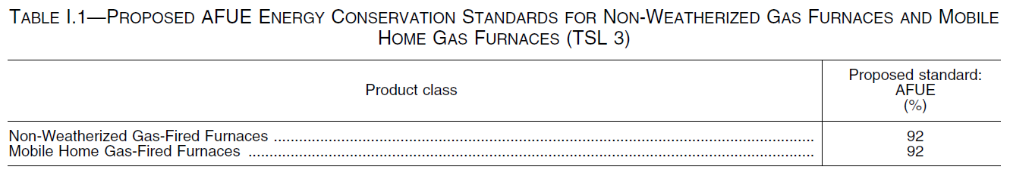

V. Background, History and Impact

EPCA established the energy conservation standards that apply to most residential furnaces currently being manufactured. The original standards, which are still in place for a number of product classes (including all product classes except for non-weatherized oil-fired furnaces), consisted of a minimum AFUE of 75% for mobile home furnaces and a minimum AFUE of 78% for all other furnaces, except ‘‘small’’ gas furnaces (those having an input rate of less than 45,000 Btu per hour), for which DOE was directed to prescribe a separate standard. The standard for mobile home furnaces has applied to products manufactured for sale in the United States, or imported into the United States, since September 1, 1990, and the standard for most other furnaces has applied to products manufactured or imported since January 1, 1992. On November 17, 1989, DOE published a final rule in the Federal Register adopting the current standard for ‘‘small’’ gas furnaces, which consists of a minimum AFUE of 78% that has applied to products manufactured or imported since January 1, 1992.

EPCA also required DOE to conduct two rounds of rulemaking to consider amended standards for residential furnaces a requirement subsequently expanded to encompass a six-year look back review of all covered products . In a final rule published on November 19, 2007 (November 2007 final rule), DOE prescribed amended energy conservation standards for residential furnaces manufactured on or after November 19, 2015. The November 2007 final rule revised the energy conservation standards for non-weatherized gas furnaces to 80% AFUE, weatherized gas furnaces to 81% AFUE, mobile home gas furnaces to 80% AFUE, and nonweatherized oil-fired furnaces to 82% AFUE. Subsequently, on October 31, 2011, DOE published a notice of effective date and compliance dates to confirm amended energy conservation standards and compliance dates contained in a June 27, 2011 direct final rule for residential central air conditioners and residential furnaces. These two rulemakings represented the first and the second, respectively, of the two rulemakings required to consider amending the standards for furnaces.

The June 2011 direct final rule and October 2011 notice of effective date and compliance dates amended, the energy conservation standards and compliance dates for three product classes of residential furnaces (non-weatherized gas furnaces, mobile home gas furnaces, and non-weatherized oil furnaces). The existing standards were left in place for three classes of residential furnaces weatherized oil-fired furnaces, mobile home oil-fired furnaces, and electric furnaces. Compliance with the energy conservation standards promulgated in the June 2011 direct final rule was to be required on May 1, 2013 for nonweatherized furnaces and on January 1, 2015, for weatherized furnaces.

After publication of the October 2011 notice, the American Public Gas Association (APGA) sued DOE invalidate the rule as it pertained to non-weatherized gas furnaces. The parties to the litigation engaged in settlement negotiations which ultimately led to filing of an unopposed motion on March 11, 2014, seeking to vacate DOE’s rule in part and to remand to the agency for further rulemaking. On April 24, 2014, the Court granted the motion and ordered that the standards established for non-weatherized gas furnaces and mobile home gas furnaces be vacated and remanded to DOE for further rulemaking.

Impacts of the Rulemaking
The rulemaking has been a long time in the making and, as such, the DOE has been able to develop an extremely comprehensive cost effectiveness analysis on the impacts of increasing the standards to 92% AFUE. The DOE’s findings reflect a positive benefit to the consumer in most of the population and show a payback of up to 7 years (see chart below). The analysis that they conducted consisted of 10,000 “random” calculation models of different States, climate zones and economic areas. The life-span attributed to the condensing furnace is 21.5 years. Although the DOE acknowledges that there is a somewhat substantial percentage of consumers that will be negatively impacted, they maintain that this rule is in the best interest of all involved.
The logistics of moving from a non-condensing furnace to a condensing furnace are significant in that the infrastructure to accommodate the more sophisticated technology is more costly and the structure in which they are installed must be able to accommodate a specific type of venting system. In the new construction market, this will cause up to 40% fuel switching due to the increased cost of installation of a natural gas condensing furnace. It will become more economical and easier to install electric space heating instead. In the retrofit market, homeowners needing to replace their furnaces will have to absorb a higher cost to move to a condensing furnace, retrofit the infrastructure for the more sophisticated venting and oftentimes this effort will result in an orphaned water heater.
The impact to SoCalGas could be significant. The Gas Technology Institute (GTI) conducted a survey to determine the level of potential for fuel switching and the California results are significant:
- up to 40% fuel switching potential in the residential new construction market
- up to 23% fuel switching potential in the residential retrofit market (includes low income)
And finally, this amendment will eliminate a product class by disallowing non-condensing furnaces in the market after the year 2021.
This rulemaking attempts to address benefits and costs to consumers, impact on manufacturers and national benefits, including energy conservation and emissions reductions however, the DOE’s own analysis admits an overall negative societal benefit to up to 23% of the national population.
Stakeholders have concerns that these costs, benefits and impacts are not accurately portrayed and that a 92% AFUE standard will have unintended and significant consequences. Lack of transparency on assumptions, data and methodologies are also in question
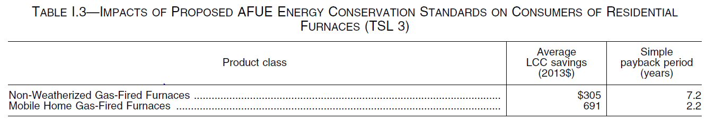

National Benefits
DOE’s analysis of national benefits of the proposed 92% AFUE standard for furnaces finds significant energy savings and emissions reductions. The assumptions and methodologies used to reach the conclusions in the chart below are in question and being challenged.
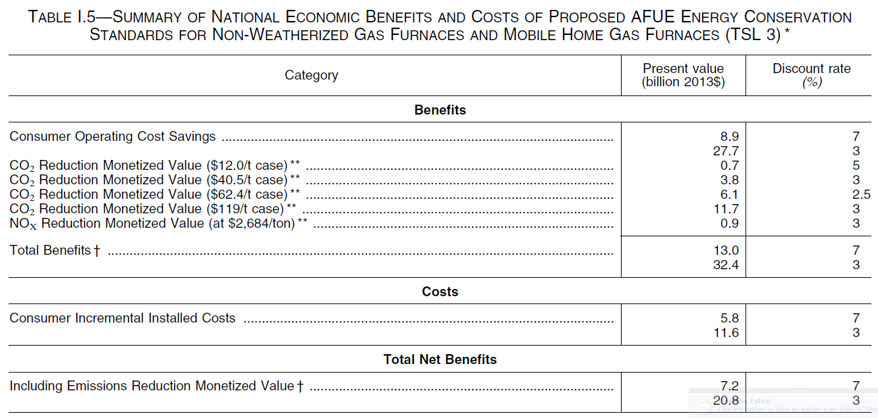

VI. Timeline of Events

September 14, 2015 – DOE issues provisional analysis of potential economic impacts and energy savings that could result from two product classes defined by input capacity.
VII. External Stakeholders:

Considering the length of time for this rulemaking to evolve and come to fruition it is somewhat remarkable that the same market actors have remained involved. The following stakeholders have played some significant role in this action over the years:

American Gas Association:
- Recognized threat to natural gas industry with direct final rule in 2011
- Initiated negotiations to “fix” the rule to minimize the impact on the gas industry as well as the consumer, who may be negatively impacted by the rule
- Responded to 2015 NOPR by enlisting the help of the Gas Technology Institute to conduct a thorough review of the DOE’s cost effectiveness analysis including methodologies, inputs and assumptions
- Initiated coalition building among their members and like-minded stakeholders
- Developed teams to address legislative action and began lobbying to fix the rule within the legislative process
- Preparing for future litigation

American Public Gas Association:
- Successfully sued DOE in 2011 based on DOE procedural errors
- Combined efforts with AGA in proposing legislation to permanently fix furnace action

Air Conditioning, Heating and Refrigeration Institute (AHRI):
- Trade organization to the furnace manufacturers
- Actively opposing furnace rule (providing comments and attending meetings)
- Opposing some options put forth by the AGA/APGA staffs
- Advocating specifically for their manufacturers

Alabama Gas Light (AGL):
- Member of coalition of support
- Providing comments to docket
- Testified in Congress against the furnace rule

Leclede Gas Company
- Member of coalition of support
- Providing comments to docket
- Conducted independent analysis of DOE’s claims
- Sharing finding with coalition members

Gas Technology Institute (GTI):
- Hired by AGA and APGA to conduct all analyses of DOE’s assessment
- Will release first draft report on Monday, May 18th
VIII. Internal Actions:

In response to the DOE’s release of the Furnace NOPR, SoCalGas decided to conduct a preliminary analysis of the cost effectiveness calculations specific to SoCalGas customers/service territory. That cursory assessment resulted in SoCalGas consultant’s identifying enough inconsistencies in the data to warrant a more in-depth assessment. Some indicators of the need to proceed included:
- Significant differential in the installed cost of condensing furnaces
- Potential for fuel switching in California
- Estimates of energy costs inconsistent with historical and factual costs in California

SoCalGas has undertaken the following actions to date:
- Hired an independent consultant to:
  - replicate the DOE analysis using California only data
  - Run sensitivity analysis of the DOE’s data
  - Examine the methodology used by DOE in their analysis
  - Examine the inputs used by DOE for validity
  - Expected completion of independent analysis in mid-June.
- Submitted an official request for extension of comment period*
  - DOE granted a 30 day extension as of May 12, 2015
- Met with SoCalGas’ congressional members staffs to educate them on concerns with DOE’s proposed rule.

IX. Appendix

Based on the final conclusions SoCalGas will either support the DOE’s recommendation or prepare official comments indicating opposition to the action and request that it be rescinded.

Note: Below is a summary of the preliminary findings of the SoCalGas specific analysis. This analysis is in the early stages of development and as such, the data is subject to change with further iterations.

The initial report from the SoCalGas consultant was received on Tuesday, May 12th and preliminary findings are:

- DOE assumes that incremental cost of a 92% condensing furnace is zero or negative. This results in immediate payback for the high efficiency furnace. Nothing is further from the truth. Our own survey indicates that high efficiency condensing furnaces can cost from $385 higher for smaller furnace sizes to up to $550 higher for larger furnaces.

- DOE assumes that the retrofit market is approximately 75% on average across USA. This may not be a good assumption. In Southern California, assuming SoCalGas has 4 million residential meters, with an average life of 20 years, the replacement market is 200,000 units whereas residential housing starts are running well below 30,000 units/year. Thus, the replacement market is 85% in California.

- Three major sets of assumptions are being checked for appropriateness. They are Energy Price Index, Product Price Trend, and Fuel Switching Assumption. Additional investigations are planned on these assumptions.
For instance is the Annual Energy Outlook (AEO) forecast the only forecast of nationwide average rates of gas and electricity? There could be more optimistic or pessimistic forecasts available from other sources. Also, the forecasts for California could be much higher because of higher utilization of nuclear, low availability of hydro, use of peaking plants and other costs of fuel and emissions. This could change the results.
DOE assumes a decreasing price trend of high efficiency furnaces. The trend needs to be studied. If the rule is implemented, initially due to retooling and increased demand, prices could actually rise for high efficiency furnaces until manufacturers figure out economies of scale.
DOE’s assumptions of reference fuel switching should be investigated. With the availability of tax credits for solar PV, and the rapid price drop of PV systems and the introduction of residential battery by Tesla, the fuel switching could be accelerated in new construction homes and in existing homes.
- DOE ‘s analysis indicates an average Simple Pay Back (SPB) of 12.9 years for the high efficiency furnace. SoCalGas’ own analysis indicates that depending on the economic assumption scenarios, the SPB for high efficiency furnaces could be higher than 20 years, exceeding the average life of a furnace. When these assumptions are applied, the Life Cycle Cost could be very high.
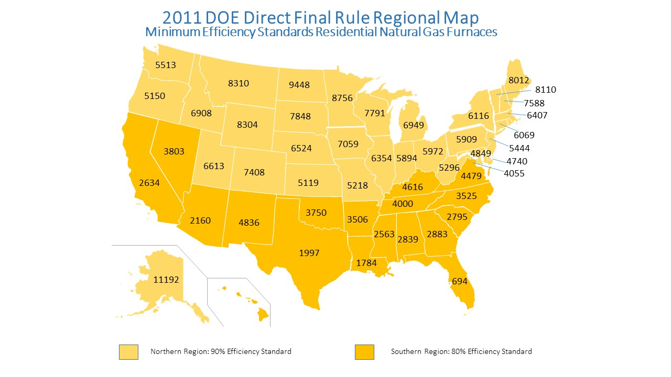

California Fuel Switching Analysis
SoCalGas Request for Extension
Notice of Data Availability | http://www.regulations.gov/#!documentDetail;D=EERE-2014-BT-STD-0031-0166

Please see map in Appendix
See Attachment in Appendix
Orphaned Water Heater - If an old “atmospherically-vented” gas water heater is not replaced with a high-efficiency “direct-vented” unit when the furnace/boiler is upgraded, the water heater venting can become “orphaned” and lead to a potentially dangerous carbon monoxide hazard.
See Attachment in Appendix

