6-26-2015

“Rulemaking for Residential Furnaces Energy Conservation Standards” Comments by SoCalGas

ReseaRCH rEPORT Prepared by The Southern CAlifornia Gas Company

Table of Contents

Acknowledgements 3

1.0 Executive Summary 4

2.0 Introduction 5

3.0 Objectives 5

4.0 Approach 6

5.0 General Observations 7

6.0 Findings regarding LCC assumptions, inputs, & method 9

7.0 Findings regarding regional impact 12

8.0 Conclusions 20

References 21

Table of Figures

Figure 1: Commented distribution of residential gas furnaces by efficiency 7

Figure 2: Production housing first cost for installed furnaces, SoCalGas territory 10

Figure 3: Natural Gas Price Outlook, AEO2014 vs. AEO2015 11

Figure 4: Natural Gas Price Outlook, AEO 2015 vs. CEC 2014 (non-normalized draft) 12

Figure 5: Simple payback comparison for NWGF 92%, retrofit case. Please see text for additional explanation. 14

Figure 6: LCC Savings comparison for NWGF **90%**, retrofit case. Please see text for additional explanation. 16

Figure 7: LCC Savings comparison for NWGF **92%**, retrofit case. Please see text for additional explanation. 17

Figure 8: LCC Savings comparison for NWGF **95%**, retrofit case. Please see text for additional explanation. 18

Figure 9: LCC Savings comparison for NWGF 98%, retrofit case. Please see text for additional explanation. 19

# Acknowledgements

We would like to thank NegaWatt Consulting, Bira Energy, the Colorado Energy Group, and the Gas Technology Institute for sharing their insights into the subject matter.

# 1.0 Executive Summary

Southern California Gas Company (SoCalGas) has evaluated some of the potential impacts of current U.S. Department of Energy (DOE) Notice of Proposed Rulemaking (NOPR) proceedings regarding Energy Conservation Standards for Residential Furnaces. SoCalGas’ research contends that the potential impact to SoCalGas’ customer base in Southern California is significant and that the rule would be a major burden to many.

SoCalGas has a number of general observations about the rule, as follows:

1. The market is already moving on its own towards higher efficiency furnaces, therefore this rulemaking may not be necessary.
2. The standard would be limiting free market forces and pick winners and losers.
3. Some switching to heat pumps and resulting energy use increase is likely.
4. Senior and low income homeowners will be unduly hurt by the proposed rule.
5. Simple payback is greater than twice the average time of home ownership
6. Utility programs subsidizing higher efficiency furnaces would have to be sunset

Additional focus was placed on critiquing the DOE’s life cycle cost (LCC) analysis. The LCC was checked for inputs, assumptions and method, was rerun using permutations of the input values, and was filtered by region for California and Southern California.

There are major concerns with the (overly complex) LCC analysis as a whole:

1. 100+ inputs are probability distributions, many of which have not been fully reviewed and vetted by key stakeholders.
2. First cost method draws on biased inputs and downplays regional differences.
3. The lifespan of a typical gas furnace appears overestimated at 21.5 years.
4. The DOE’s use of r marginal electricity price forecast may not be accurate .
5. The product price trend calculation, among other issues, comingles technologies
6. DOE’s new construction first cost contradicts SoCalGas experience for California
7. AEO 2014 is outdated and predicts 4.5% higher gas prices than AEO 2015 for 2040
8. AEO may not be appropriate for California: CEC predicts slower rising gas cost

Notwithstanding these (compounding!) concerns, recalculating simple payback and LCC Savings for California and Southern California *without any other changes* to the DOE LCC further illustrates the major detrimental impact this rule would have to SoCalGas customers:

* For *all* scenarios in Southern California, and for the *majority* of scenarios in California, payback times are *greater than* furnace lifetime of 21.5 years.
* Similarly, *all* scenarios in Southern California, and the *majority* of scenarios in California have *negative* LCC Savings.

# 2.0 Introduction

Southern California Gas Company (SoCalGas) has researched and evaluated some of the potential impacts to SoCalGas of current U.S. Department of Energy (DOE) Notice of Proposed Rulemaking (NOPR) proceedings regarding Energy Conservation Standards for Residential Furnaces (Department of Energy, Rulemaking for Residential Furnaces Energy Conservation Standards, 2015).

This rule could impact minimum efficiency requirements for California and nationwide, and is the latest in a series that have circulated through the DOE rulemaking process for a number of years. The goal is to set a new nationwide minimum energy efficiency standard for these residential gas furnaces at an Annual Fuel Utilization Efficiency (AFUE) of 92%. The current national minimum standard is 78% AFUE; the market standard is 80%.

The DOE points to their analyses, spreadsheets and models stating that the national benefits of increasing the efficiency standard outweigh the costs overall, acknowledging a few will be hurt economically. Many in the gas and furnace industries say DOE has not been transparent during the process (as required in a recent settlement agreement), and have suggested that DOE is over-estimating the benefits of the proposed standard and underestimating the costs. The methodology used to derive costs and benefits has been criticized for being an overly complex probability-distribution based model that, to make matters worse, in part relies on proprietary data.

Our research contends that the potential impact of the standard to SoCalGas’ customer base (Southern California) is significant and that the rule is not beneficial and would burden many.

# 3.0 Objectives

The focus of our research was on critiquing the DOE’s life cycle cost (LCC) analysis (Department of Energy, rf_nopr_lcc_2014-02-06.xlsm, 2014), and to evaluate its inputs and results with particular emphasis on California and Southern California. This included developing the capability to re-run the DOE’s LCC spreadsheet, with and without modifications. To the extent possible given available time and resources, we also reviewed the proposed rule in more general terms, beyond the life cycle cost component, and are sharing our observations in this report.

# 4.0 Approach

This analysis is based on the latest LCC version available in the NOPR docket (Department of Energy, rf_nopr_lcc_2014-02-06.xlsm, 2014). We have also considered several other DOE documents from the docket in our review, notably: RF_NOPR Presentation_2015-03-26_for_printing.pptx (presentation provided by DOE during public NOPR meeting on March 27, 2015 in Washington, DC), EERE-2014-BT-STD-0031-0016.pdf (presentation provided by DOE on November 7, 2014 in Washington, DC), various comment letters by AGA/APGA (also from the docket), fuel switching materials by GTI (also from the docket), and last but not least the 957-page Technical Support Document [TSD], (Department of Energy, Technical Support Document, 2015).

As part of this analysis we obtained a license to use “Crystal Ball” from Oracle, which is required to re-run the Monte-Carlo simulation based LCC spreadsheet.

We then reviewed a list of the major assumptions and inputs into the LCC, and individually researched those that appeared to have the most impact or to be the most questionable from a Southern California perspective. The number of inputs and assumptions into this calculation being very large, we did not have the time to review *all* assumptions and inputs.

Finally, we filtered the building sample database contained in the LCC in two steps, first for California only, and second for Southern California. This was done so that we could rerun the analysis calculations with a regional focus. The region selection was made by filtering for weather station in the building sample. The California calculations only consider buildings that use the following weather stations: BFL, BLH, EKA, FAT, LAX, MHS, PRB, RBL, RDD, SAC, SAN, SCK, SFO[1]. The Southern California calculations only consider buildings that use the following weather stations: LAX (Los Angeles), SAN (San Diego).

Calculations were performed for all permutations of energy price, product price, and fuel switching, that are existing, selectable inputs to the spreadsheet. DOE contends that different trends are possible in these respects, depending on economic and other developments. We made no changes to the DOE spreadsheet other than narrow it down by region, and used only the available dropdowns to devise the permutations. The results reported are for the residential retrofit case, for non-weatherized gas furnaces [NWGF]. The commercial, new construction and mobile home gas furnaces [MHGF] markets are comparatively very small. We opted against reporting a combined market figures as is done in one section of the original LCC analysis. This is because we wanted to show the significant issues for the NWGF retrofit case without them being “watered down” by new construction figures or MHGF that can be somewhat more positive. Commercial figures incidentally become eliminated by the regional filters. The NWGF retrofit case is *by far* the largest market segment impacted by this rulemaking, with a share of 70% according to the DOE’s own figures (75% retrofit minus 5% MHGF).

# 5.0 General Observations

**One.** The market appears to have moved substantially toward the proposed 92% AFUE level without it being mandated by the standard. The chart below shows that more than 50% of gas furnaces on the national market are already above 90% AFUE, 42-percent of which are above 92% AFUE (U.S. Energy Information Administration, Proposed efficiency standards may eliminate noncondensing gas furnaces, 2015):

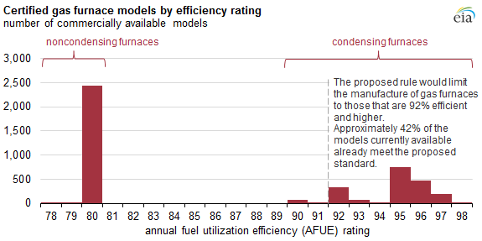

Figure 1: Commented distribution of residential gas furnaces by efficiency

These data can support the position that the standard is not needed, because where the higher efficiencies make economic sense, they are already being adopted by consumers. Government intervention would therefore appear unnecessary.

**Two.** A lack of product differentiation and consumer choice occurs as the range of efficiency improvements narrow above 90% AFUE. A case can be made that the proposed standard is limiting the furnace products offered to U.S. consumers and in fact, while well-intentioned, the DOE may be inadvertently picking winners and losers. This issue was a major concern to industry when Canada raised their minimum standard from 78% AFUE to 90% AFUE effective 2012. Canadian industry was worried then that the product itself would start to become a commodity to the consumer and as a result, many small- and medium-sized furnace manufacturers would go out of business. Also this ruling could negatively impact small businesses owners and installers that deal exclusively in non-condensing furnaces, which would be replaced in the market by condensing furnaces and heat pumps.

**Three.** Increased costs of minimum efficiency gas furnaces, particularly in the retrofit market where the switch from non-condensing to condensing furnaces require changing the flue and providing a condensate drain, make fuel-switching (using split-system or mini-split heat pumps) an attractive alternative to consumers on a cost, rather than performance basis. A switch from gas to electricity may however *increase* emissions and source energy consumption due to the losses in generation, transmission and distribution of electricity. This is particularly true if the heat pumps of lower performance are selected for cost reasons, and on very cold weather days, where heat pumps don’t function well, and built-in backup resistance heaters are triggered. The resulting increased emissions and source energy use are contrary to the stated goals of the legislation that provides the basis for efficiency standards.

The DOE contends in its analysis that some fuel switching will occur, but that the rule overall will remain beneficial. This appears to be based on a number of assumptions that are not well documented, for example, “if the payback time of a higher efficiency furnace is 3.5 years or longer, then customers will switch to an electric appliance”. We understand that AGA attempted to obtain clarification on this threshold, but were not successful. Due to resource constraints and the complexity of this topic, it was not in the scope of this report to analyze fuel switching quantitatively. We understand other industry organization have conducted additional research (GTI, AGA, AGPA).

**Four.** DOE analysis shows that low-income consumers may bear a larger burden than other consumers. This is compounded by the fact that low and fixed income homeowners typically live in smaller spaces which require less energy to heat, further reducing potential value of a high efficiency product. NOPR participant AGLR calculated that the overwhelming majority of low and fixed income homeowners will receive neutral or negative LCC savings when they install a new condensing furnace. The situation in California is likely worse due to the mild climate. Additionally, low and fixed income renters will be forced to deal with higher rents when landlords are required to install high efficiency furnaces. DOE maintains that these costs are necessary and worth it given the energy needs of the nation, however, SoCalGas disagrees..

**Five.** DOE calculated simple payback times are greater than 10.8 years for *all* permutations of the DOE’s own provided input parameters (“Summary” tab, “Replacement” case, “Rest of Country” (includes California), “92% efficiency”). Despite this payback resulting in positive lifecycle savings by the DOE’s own calculations, it is important to note that such long payback times would be very problematic for home owners. The average time of possession according to the U.S. Census Bureau Geographic Mobility numbers in 2012-2013 is roughly five years. Especially considering that furnace replacement may not be done at move-in, but at some point down the road, It must be concluded that in *most* cases, even if the DOE’s LCC numbers were correct, a high efficiency retrofit furnace will not pay for itself *at all* from the homeowner’s perspective.

**Six.** The impact of this standard on SoCalGas’ and other utilities’ long term portfolio of energy efficiency programs—an important activity that subsidizes and thereby rewards homeowners for the installation of higher efficiency appliances—may be substantial. With high efficiency furnaces becoming the law, many of the existing programs may have to be sunset. It is largely due to the utilities’ energy efficiency programs that saturation levels of high efficiency condensing furnaces have been rising. Therefore it is important to allow the market forces of such utility programs to continue to support and subsidize customers to install high efficiency furnaces.

# 6.0 Findings regarding LCC assumptions, inputs, & method

**One.** Over one hundred input parameters to the spreadsheet are modified or adjusted using probability distributions. The researchers who built the spreadsheet often used their professional judgement in determining the actual distribution and did not justify the “shape” of the distribution with a source or survey. The DOE allows this based on their (questionable) right to “deliberative process”. While we did not have the resources to attempt to refute every single assumption, we identified several that were particularly questionable, and are addressing them below. We left others out, for example when we couldn't find a good data source to disprove the DOE’s contention, or when an assumption does not influence the result significantly. The latter applies for example to the new construction vs. retrofit percentage... DOE uses 25/75, whereas the case can be made for California to have a ratio closer to 15/85. But, the difference in simple payback turns out to be only a few months out of several decades (the exact number depending on the case).

**Two.** The DOE’s method to determine furnace and installation first cost is very complex and draws on a very large number of input parameters, including a teardown analysis, manufacturer input, and economic literature. There are any number of general issues with this approach – teardown analysis may not account for innovation, advances in manufacturing, and changes driven by yet-unknown future value- or-performance engineering; manufacturer input may be biased; economics not being a “hard” science, literature and methods will vary depending on the source. In addition, there likely are regional differences that cannot be properly accounted for, but that could have significant impact on the alleged savings figures.

In addition, it appears that the cost of asbestos removal in retrofitted homes is largely ignored in the DOE analysis. We conducted an informal survey of asbestos abatement contractors, and learned that the added cost can range approximately from $250-$1,000 depending on site conditions. In addition, asbestos abatement causes delays, inconvenience, and safety concerns, which likely results in additional fuel switching.

**Three.** The DOE likely overestimates the lifespan on the typical gas furnace at 21.5 years in their current LCC analysis. In Canada, when the Energy Efficiency Branch of the British Columbia Ministry of Energy and Mines proposed an Annual Fuel Utilization Efficiency (AFUE) ≥ 92% in January 2014, their modeling assumption included a product lifetime of 15 years, six-and-half years less than the DOE uses in its NOPR analysis. Life Cycle Cost significantly increases with shorter product lifetimes.

**Four.** The DOE uses questionable values for marginal electricity prices in California within their Life Cycle Cost (LCC) analysis. In 2013-$, prices in the LCC range from $0.17/kWh to $0.20/kWh vs. the actual $0.25/kWh to $0.29/kWh that were current for tier 3 and tier 4 residential end use at the time (SDG&E, 2013). We were unable to obtain clarification if the DOE values are supposed to constitute *average* marginal electricity costs (which would be lower than true marginal cost), and if so, how the exact figures were devised.

**Five.** DOE’s product price trend assumptions and calculations are very questionable. The product price trend as calculated by the DOE uses experience rates derived from producer price indices (PPI) for warm air furnaces, with data from the BLS, that was then extrapolated (TSD pages 367-372). The rates are a regression on actual furnace data. The method appears to be applied correctly. However, there are some issues, notably

1. It appears that the DOE has not disaggregated the PPI data by condensing and non-condensing furnaces. Non-condensing furnaces are mature and the learning rate should be near 0; the rate should be different for condensing furnaces. Also, the majority of the historical data from 10 years or longer ago is likely made up of non-condensing furnaces. It is not appropriate in our opinion to extrapolate that into the future, where condensing furnaces would be used exclusively if the DOE rule is enacted.
2. DOE appears not to have normalized the data by furnace capacity (in Btu), nor researched the sensitivity of that. We suspect that normalization would change the learning rates, because the cost per Btu goes down as furnaces get larger, and innovation may progress differently with size. How that impacts the result depends on the mix of homes and is not known at this time.
3. The LCC uses 1, 0.94 and 0.91 as the experience rate choices for the analysis (“Summary” tab), but the TSD on Page 371 concludes that the experience rate is 20% plus 2.8% / minus 2.7%. That doesn't add up.

Please note, we did not have the time and resources to download the BLS database and positively retrace the DOE calculations to confirm these findings.

**Six.** For new construction, the DOE contends that payback is immediate, due to the first cost for the higher efficiency option being lower. This contradicts SoCalGas figures for production housing, where the installed cost for a 92% furnace over an 82% furnace is higher by $385, $495 and $551 for 40k, 60k and 80k Btu/h respectively in California:



Figure 2: Production housing first cost for installed furnaces, SoCalGas territory

The DOE results appear to draw from the fact that high efficiency furnaces can be vented horizontally, and therefore a vertical buildout with roof penetration is not required. It appears that this does not apply in California, where according to our experience flues are usually built vertically, no matter the technology, and regardless of whether the furnace is installed in the attic or in an attached space such as a mechanical closet or the garage.

**Seven.** DOE uses outdated price forecasts for energy prices. The DOE uses the AEO 2014 (U.S. Energy Information Administration, American Energy Outlook, 2014). In comparison, AEO 2015 (U.S. Energy Information Administration, American Energy Outlook, 2015) anticipates about 4.5% lower natural gas prices than AEO 2014 in real 2013 dollars, by 2040. So the LCC savings that DOE estimated using AEO 2014 would be reduced and payback times would increase accordingly.

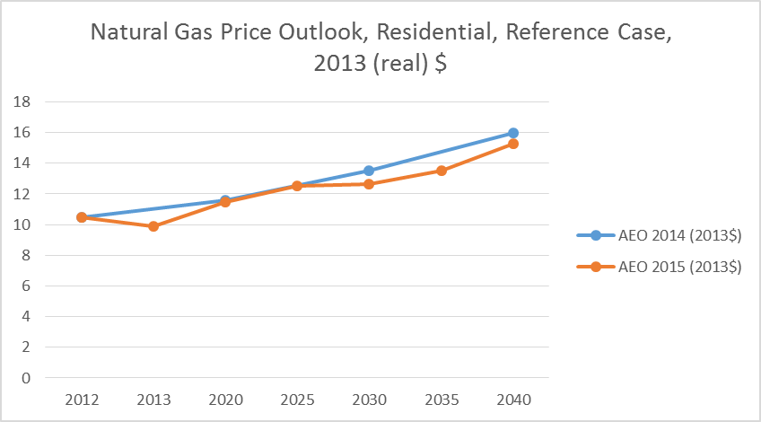

Figure 3: Natural Gas Price Outlook, AEO2014 vs. AEO2015

**Eight.** Using AEO forecasts may not be appropriate for California. The chart below shows that AEO 2015 (U.S. Energy Information Administration, American Energy Outlook, 2015) estimates that prices will *rise* *faster* than what the CEC predicts in (California Energy Commission, 2014). Note that the trends from this chart should be interpreted qualitatively at this time (hence he chart label “Draft”). The chart's figures are not normalized at this time, and require conversion from nominal to real $, as well as subtraction of transportation cost from the CEC outlook. The fact that AEO predicts a higher rise than CEC should not be affected by these corrections. LCC Savings are reduced and payback times increased if gas prices don’t rise as fast in reality as the DOE assumes.

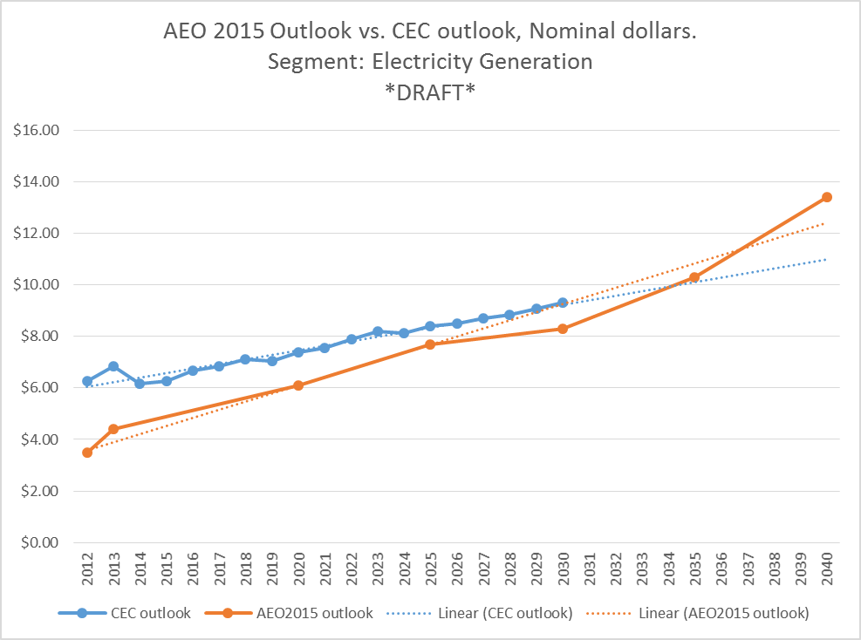

Figure 4: Natural Gas Price Outlook, AEO 2015 vs. CEC 2014 (non-normalized draft)

# 7.0 Findings regarding regional impact

Notwithstanding all our other concerns, we have taken the DOE spreadsheet as is and narrowed the results down to California, and then Southern California, to assess the regional impact. This is described further in section “Approach” near the beginning of this report. The filtering method was peer reviewed by GTI for appropriateness. The first step in this process was “calibration”, i.e. rerun the spreadsheet “as is” and confirm that we obtain the same result than the DOE, which we did. That number is shown in the upper left in the following results (blue column and row highlight).

The results of the regional impact study are shown in the tables on the following pages. Numerical results are limited to the residential retrofit scenario for NWGF, which is the majority of the market that this rulemaking applies to. MHGF are only 5% of the market. The new construction market share varies from 15-25% depending on the source. Considering the issues with the new construction case described earlier, we felt that limiting this research to residential would make for a cleaner, more defensible result.

The region selection was made by filtering for weather station in the Building Sample (RECS database). The California calculations only consider buildings that use the following weather stations (by IATA 3-letter airport code): BFL, BLH, EKA, FAT, LAX, MHS, PRB, RBL, RDD, SAC, SAN, SCK, SFO. The Southern California calculations only consider buildings that use the following weather stations: LAX (Los Angeles), SAN (San Diego). Note that the DOE LCC spreadsheet also contains edge case results for commercial buildings that use residential furnaces. However, this does not apply to California. The regional filter coincidentally eliminates all the commercial edge cases.

The permutations were selected based on DOE’s own selectable inputs, namely

* Energy Price Index
  + AEO Reference Case
  + AEO High Economic Case
  + AEO Low Economic Case
* Product Price Trend
  + Decreasing
  + No Learning (Constant)
  + High Decreasing
* Fuel Switching Assumption
  + No Switching[2]
  + Reference Switching
  + High Switching
  + Low Switching

The first result table on the following page shows simple payback time for the 92% efficiency case. Simple payback time nicely illustrates how much of a stretch this rule would be for average homeowners. On average, homes are owned by the same party for approximately five years, yet, *all* of the payback times, even by the DOE’s own calculations, are *greater than* 10 years, or twice the average home ownership. To make matters worse, for *all* scenarios in Southern California, and for *many* scenarios in California, the payback times are greater than the DOE’s contended furnace lifetime of 21.5 years – the furnaces would not pay for themselves before needing replacement. Recall we further contend that the DOE’s average furnace lifetime estimate of 21.5 years is too long, as discussed earlier. With a furnace lifetime baseline of about 15 years, as was done in Canada, *all* scenarios for California and Southern California have a simple payback that is longer than the furnace lifetime. The results in the table are color coded. Simple payback times greater than the DOE’s contended furnace lifetime of 21.5 years are shown in red, otherwise in green. The darker the colors the larger the absolute numerical values.

[Over, please].



Figure 5: Simple payback comparison for NWGF 92%, retrofit case. Please see text for additional explanation.

The tables above show simple payback results (in years) for all permutations of the three LCC calculation input parameters (except “No Switching”, see text above), and then for all three regional cases that we have considered:

1. the leftmost results for “Rest of Country” are from the DOE analysis baseline,
2. the center results for “California” are from our modified baseline with California only homes,
3. the rightmost results for “So. California” are from our modified baseline with Southern California only homes

The calculation has three input parameters with three possible values each, which makes for 3x3x3 or 27 combinations for each region. The result for the “default” case is shown in the upper left cell of each region, i.e. 12.5, 20.7 and 40.4 years.

The tables on the following four pages are grouped the same way, but instead show Lifecycle Cost Savings for the four efficiency cases of 90%, 92%, 95% and 98% respectively. The results are again color coded. Positive life cycle savings are shown in green, and negative (i.e. a bottom line *cost* to the homeowner) in red. The darker the colors the larger the absolute numerical values. Keeping in mind that the DOE must legally show positive life cycle savings, the results are disconcerting: *All* Southern California scenarios have negative (i.e. no) life cycle cost savings, and so do the majority ofCalifornia scenarios.

[Over, please]



Figure 6: LCC Savings comparison for NWGF **90%**, retrofit case. Please see text for additional explanation.

The tables above show LCC Savings results (in real $) for all permutations of the three LCC calculation input parameters (except “No Switching”, see text above), and then for all three regional cases that we have considered:

1. the leftmost results for “Rest of Country” are from the DOE analysis baseline,
2. the center results for “California” are from our modified baseline with California only homes,
3. the rightmost results for “So. California” are from our modified baseline with Southern California only homes

The calculation has three input parameters with three possible values each, which makes for 3x3x3 or 27 combinations for each region. The result for the “default” case is shown in the upper left cell of each region, i.e. $120, -$66 and -$246.



Figure 7: LCC Savings comparison for NWGF **92%**, retrofit case. Please see text for additional explanation.

The tables above show LCC Savings results (in real $) for all permutations of the three LCC calculation input parameters (except “No Switching”, see text above), and then for all three regional cases that we have considered:

1. the leftmost results for “Rest of Country” are from the DOE analysis baseline,
2. the center results for “California” are from our modified baseline with California only homes,
3. the rightmost results for “So. California” are from our modified baseline with Southern California only homes

The calculation has three input parameters with three possible values each, which makes for 3x3x3 or 27 combinations for each region. The result for the “default” case is shown in the upper left cell of each region, i.e. $188, $1 and -$208.



Figure 8: LCC Savings comparison for NWGF **95%**, retrofit case. Please see text for additional explanation.

The tables above show LCC Savings results (in real $) for all permutations of the three LCC calculation input parameters (except “No Switching”, see text above), and then for all three regional cases that we have considered:

1. the leftmost results for “Rest of Country” are from the DOE analysis baseline,
2. the center results for “California” are from our modified baseline with California only homes,
3. the rightmost results for “So. California” are from our modified baseline with Southern California only homes

The calculation has three input parameters with three possible values each, which makes for 3x3x3 or 27 combinations for each region. The result for the “default” case is shown in the upper left cell of each region, i.e. $268, $55 and -$218.



Figure 9: LCC Savings comparison for NWGF 98%, retrofit case. Please see text for additional explanation.

The tables above show LCC Savings results (in real $) for all permutations of the three LCC calculation input parameters (except “No Switching”, see text above), and then for all three regional cases that we have considered:

1. the leftmost results for “Rest of Country” are from the DOE analysis baseline,
2. the center results for “California” are from our modified baseline with California only homes,
3. the rightmost results for “So. California” are from our modified baseline with Southern California only homes

The calculation has three input parameters with three possible values each, which makes for 3x3x3 or 27 combinations for each region. The result for the “default” case is shown in the upper left cell of each region, i.e. $273, -$42 and -$381.

# 8.0 Conclusions

Given the limited time, resources and impending comment deadline, SoCalGas could only address a few of the many aspects of this complex and long-running rulemaking.

Nevertheless, many serious concerns about the rulemaking in general and about the LCC analysis in particular have been identified.

The rule appears unnecessary, as market forces and utility programs are already acting towards implementing higher efficiency furnaces where they make economic sense.

The rule would result in major undue impact to most if not all SoCalGas’ customers, and to other customers in mild climates across the nation, because of very unfavorable economics. Low income and senior homeowners would likely be affected the worst.

Last but not least, due to fuel switching concerns it is plausible that there may be a net source energy and emissions *increase* if this rule is enacted.

# References

California Energy Commission. (2014, 11). *Estimating Natural Gas Burner Tip Prices for California and the Western United States*. Retrieved from http://www.energy.ca.gov/2014publications/CEC-200-2014-008/

Department of Energy. (2014). *rf_nopr_lcc_2014-02-06.xlsm.* Retrieved from http://www.regulations.gov/contentStreamer?documentId=EERE-2014-BT-STD-0031-0021&attachmentNumber=1&disposition=attachment&contentType=excel12mebook

Department of Energy. (2015). *Rulemaking for Residential Furnaces Energy Conservation Standards*. Retrieved from http://www1.eere.energy.gov/buildings/appliance_standards/rulemaking.aspx/ruleid/62

Department of Energy. (2015, 02 10). *Technical Support Document*. Retrieved from http://www.regulations.gov/#!documentDetail;D=EERE-2014-BT-STD-0031-0027

SDG&E. (2013, January 1). *Schedule DR, Residential Service*. Retrieved from http://www.sdge.com/tm2/pdf/ELEC_ELEC-SCHEDS_DR_2013.pdf

U.S. Energy Information Administration. (2014). *American Energy Outlook*. Retrieved from http://www.eia.gov/forecasts/archive/aeo14/pdf/0383(2014).pdf

U.S. Energy Information Administration. (2015). *American Energy Outlook*. Retrieved from http://www.eia.gov/forecasts/aeo/pdf/0383(2015).pdf

U.S. Energy Information Administration. (2015, 2 17). *Proposed efficiency standards may eliminate noncondensing gas furnaces*. Retrieved from http://www.eia.gov/todayinenergy/detail.cfm?id=20011

1. Weather stations are designated according to the 3-letter IATA code for the nearest airport
2. This is an unrealistic “academic” case that we excluded from consideration to reduce the number of permutations