Table of Contents:

- Executive Summary

- AGA Board of Directors Meeting

- Intent of Furnace Rule

- Background & History

- Timeline of Events

- External Actions
American Gas Association (AGA)
American Public Gas Association (APGA)
Gas Technology Institute (GTI)
Leclede Natural Gas (Leclede)
Atlanta Gas Light (AGL)

- Internal Actions
Role of SoCalGas
SoCalGas Response to AGA Request
Engagement with SDG&E

I. Executive Summary – To Be Completed

II. AGA Board of Directors Meeting

Residential furnaces are currently divided into several product classes. Furnaces are separated into product classes based on their fuel source (gas, oil, or electricity), which is required by statute. For this rulemaking, DOE is analyzing only two product classes for residential furnaces: (1) Non-weatherized gas-fired furnaces (NWGFs) and (2) mobile home gas-fired furnaces (MHGFs). DOE does not additionally separate NWGFs and MHGFs into condensing and noncondensing product classes because they provide the same utility to the consumer (i.e., both are vented appliances that provide heat to a consumer). DOE has tentatively concluded that the methods by which a furnace is vented do not provide any separate performance-related impacts, and, therefore, DOE has no statutory basis for defining a separate class based on venting and drainage characteristics.

The 2015 Notice of Proposed Rulemaking if promulgated by DOE will amend the national (what) standards to raise the minimum efficiency of residential natural gas furnaces from 78% AFUE to 92%. The AGA team has been working with key stakeholders on both sides of the argument to determine the best course of action and is proposing three potential “legislative fixes” to the rule. Below is a description of each option and SoCalGas’ position related to each:

Option 1: Would AGA support a rule that changed the threshold dividing the northern and southern regions from an HDD (Heating Degree Days) level of 5000 to 5500? (Please see map on page 2 showing HDD information by state.)

- SoCalGas supports a regional standard as outlined in the proposal, provided that the language is not altered in any way and that the boundaries of the map are maintained to include California in the Southern Region and subject to the 80% AFUE standard
- There is precedence in setting different energy standards geographically. For instance in California the Building Energy Eficiency Standards (Title-24) for new construction requires different building efficiencies by each of the 16 climate zones the state is divided into.
- The climate in California indicates that a 92% AFUE furnace is not cost effective because of the lower number of HDD. Therefore the
80% AFUE for California is reasonable and realistic
- Non-condensing furnaces (referred to as mid-efficiency) are typically between 78 and 82% AFUE
- There is a gap in the market for furnaces between 84% and 88% AFUE (which is the low end of the condensing furnace market) leaving an opportunity for manufacturers to increase the efficiency of non-condensing furnaces for future opportunities for standards increases
- Maintaining an 80% AFUE would allow SoCalGas to continue to provide rebates and incentives on furnaces of a higher AFUE, helping consumers adopt the higher efficiency technologies thus transforming the market

Option 2: Would AGA support a regional standard in combination with distinct product classes for new construction and retrofit applications?

- SoCalGas is neutral on this option provided there is no impact to SoCalGas with relation to new construction and retrofit product classes with the passage of Option #1.
- Setting diferent appliance standard for existing and new buildings could have some negative consequences such as effort required in verifying installations and enforcing the code.
- Studies conducted by GTI???? indicate a potential for fuel switching in the residential new construction market in California of up to 40%; if this percentage truly did opt for an alternate energy source it would be crippling to SoCalGas’ future revenue
- A 40% fuel switching potential in residential new construction introduces an additional threat of builders opting out of natural gas altogether – allowances calculated for new construction projects may not be enough (without the space heating allowance) to keep the cost benefit to builders to run natural gas lines
- Studies conducted by GTI???? also indicate a potential for fuel switching in the residential retrofit market of 23%; the increased cost to replace a non-condensing natural gas furnace with a condensing natural gas furnace and all of the infrastructure improvements could sway customers to opt for electric heating instead

Option 3: Would AGA support a regional standard in combination with a new product class for small furnaces that allowed the continued availability of noncondensing furnaces suited to multifamily dwellings?

- Option #3 appears to be moot for SoCalGas if a regional standard as outlined in Option #1 is successfully implemented
- SoCalGas takes no position on this option provided the regional standard outlined in Option #1 is introduced as it is written, with no language modifications that could trigger a secondary situation for SoCalGas and that the map boundaries remain as they are depicted, with California in the Southern region with an 80% AFUE standard

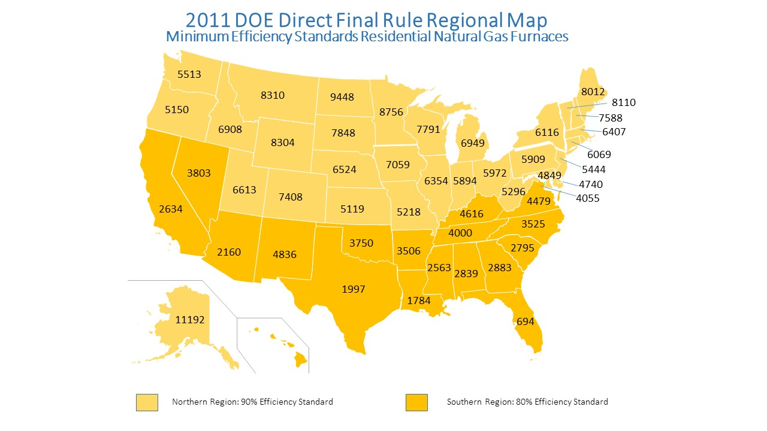
III. Intent of Furnace NOPR
The Energy Policy and Conservation Act of 1975 (EPCA), as amended, prescribes energy conservation standards for various consumer products and certain commercial and industrial equipment, including residential furnaces. EPCA also requires the U.S. Department of Energy (DOE) to periodically determine whether more-stringent, amended standards would be technologically feasible and economically justified, and would save a significant amount of energy. In this rulemaking, DOE proposes amended energy conservation standards for residential non-weatherized gas furnaces (NWGFs) and mobile home gas furnaces (MHGFs), in partial fulfillment of a court-ordered remand of DOE’s 2011 rulemaking for these products. Note* MHGFs represent only 5% of the California furnace market.

In accordance with these and other statutory provisions discussed in the rulemaking, DOE proposes amended energy conservation standards for NWGFs and MHGFs. The current AFUE standard for these furnaces is 78%. The proposed standards for minimum AFUE are significantly higher and are shown below.

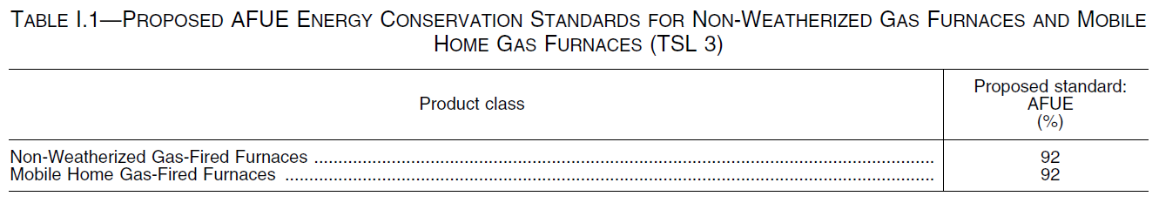

IV. Background, History and Impact

EPCA established the energy conservation standards that apply to most residential furnaces currently being manufactured. The original standards, which are still in place for a number of product classes (including all product classes except for non-weatherized oil-fired furnaces), consisted of a minimum AFUE of 75 percent for mobile home furnaces and a minimum AFUE of 78 percent for all other furnaces, except ‘‘small’’ gas furnaces (those having an input rate of less than 45,000 Btu per hour), for which DOE was directed to prescribe a separate standard. The standard for mobile home furnaces has applied to products manufactured for sale in the United States, or imported into the United States, since September 1, 1990, and the standard for most other furnaces has applied to products manufactured or imported since January 1, 1992. On November 17, 1989, DOE published a final rule in the Federal Register adopting the current standard for ‘‘small’’ gas furnaces, which consists of a minimum AFUE of 78 percent that has applied to products manufactured or imported since January 1, 1992.

EPCA also required DOE to conduct two rounds of rulemaking to consider amended standards for residential furnaces a requirement subsequently expanded to encompass a six-year look back review of all covered products . In a final rule published on November 19, 2007 (November 2007 final rule), DOE prescribed amended energy conservation standards for residential furnaces manufactured on or after November 19, 2015. The November 2007 final rule revised the energy conservation standards for non-weatherized gas furnaces to 80 percent AFUE, weatherized gas furnaces to 81 percent AFUE, mobile home gas furnaces to 80 percent AFUE, and nonweatherized oil-fired furnaces to 82 percent AFUE. Subsequently, on October 31, 2011, DOE published a notice of effective date and compliance dates to confirm amended energy conservation standards and compliance dates contained in a June 27, 2011 direct final rule for residential central air conditioners and residential furnaces. These two rulemakings represented the first and the second, respectively, of the two rulemakings required to consider amending the standards for furnaces.

The June 2011 direct final rule and October 2011 notice of effective date and compliance dates amended, the energy conservation standards and compliance dates for three product classes of residential furnaces (non-weatherized gas furnaces, mobile home gas furnaces, and non-weatherized oil furnaces). The existing standards were left in place for three classes of residential furnaces weatherized oil-fired furnaces, mobile home oil-fired furnaces, and electric furnaces). Compliance with the energy conservation standards promulgated in the June 2011 direct final rule was to be required on May 1, 2013 for nonweatherized furnaces and on January 1, 2015 for weatherized furnaces.

After publication of the October 2011 notice, the American Public Gas Association (APGA) sued DOE invalidate the rule as it pertained to non-weatherized gas furnaces. The parties to the litigation engaged in settlement negotiations which ultimately led to filing of an unopposed motion on March 11, 2014, seeking to vacate DOE’s rule in part and to remand to the agency for further rulemaking. On April 24, 2014, the Court granted the motion and ordered that the standards established for non-weatherized gas furnaces and mobile home gas furnaces be vacated and remanded to DOE for further rulemaking.

Impacts of the Rulemaking
The rulemaking has been a long time in the making and as such, the DOE has been able to develop an extremely comprehensive cost effectiveness analysis on the impacts of increasing the standards to 92% AFUE. The DOE’s findings reflect a positive benefit to the consumer in most of the population and show a payback of up to 7 years (see chart below). The analysis that they conducted consisted of 10,000 “random” calculation models of different States, climate zones and economic areas. The life-span attributed to the condensing furnace is 21.5 years. Although the DOE acknowledges that there is a somewhat substantial percentage of consumers that will be negatively impacted they maintain that this rule is in the best interest of all involved.
The logistics of moving from a non-condensing furnace to a condensing furnace are significant in that the infrastructure to accommodate the more sophisticated technology are more costly and the structure in which they are installed must be able to accommodate a specific type of venting system. In the new construction market this will cause up to 40% fuel switching due to the increased cost of installation of a natural gas condensing furnace. It will become more economical and easy to install electric space heating instead. In the retrofit market, homeowners needing to replace their furnaces will have to absorb a higher cost to move to a condensing furnace, retrofit the infrastructure for the more sophisticated venting and oftentimes result in an orphaned water heater.
The impact to SoCalGas could be significant. The Gas Technology Institute (GTI) conducted a survey to determine the level of potential for fuel switching and the California results are significant:
- up to 40% fuel switching potential in the residential new construction market
- up to 23% fuel switching potential in the residential retrofit market (includes low income)
And finally, this amendment will eliminate a product class by disallowing non-condensing furnaces in the market after the year 2021.
This rulemaking attempts to address benefits and costs to consumers, impact on manufacturers and national benefits, including energy conservation and emissions reductions however, the DOE’s own analysis admits an overall negative societal benefit to up to 23% of the National population. Stakeholders have concerns that these costs, benefits and impacts are not accurately portrayed and that a 92% AFUE standard will have unintended and significant consequences. Lack of transparency on assumptions, data and methodologies are also in question
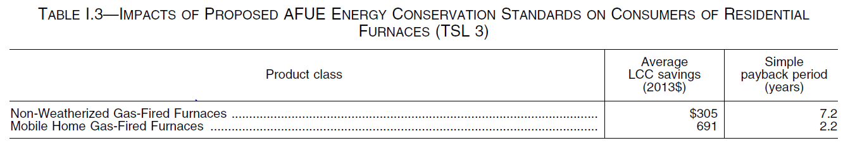

National Benefits
DOE’s analysis of national benefits of the proposed 92% AFUE standard for furnaces finds significant energy savings and emissions reductions. The assumptions and methodologies used to reach the conclusions in the chart below are in question and being challenged.
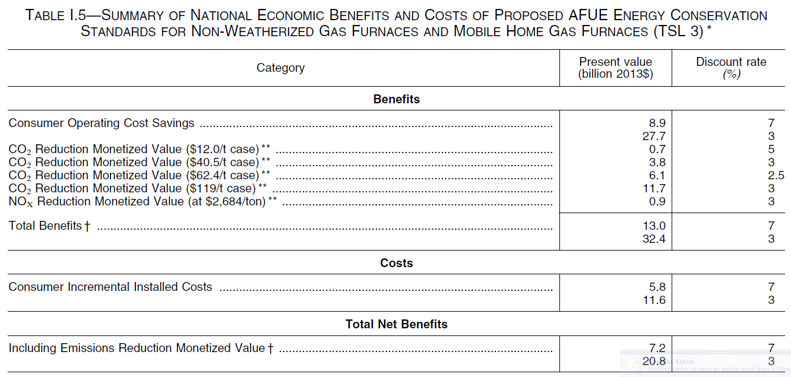

V. Timeline of Events

VI. External Actors:

Considering the length of time for this rulemaking to evolve and come to fruition it is somewhat remarkable that the same market actors have remained involved. The following stakeholders have played some significant role in this action over the years:

American Gas Association:
- Recognized threat to natural gas industry with direct final rule in 2011
- Initiated negotiations to “fix” the rule to minimize the impact on the gas industry as well as the consumer, who may be negatively impacted by the rule
- Responded to 2015 Notice of Proposed Rulemaking by enlisting the help of the Gas Technology Institute to conduct a thorough review of the DOE’s cost effectiveness analysis including methodologies, inputs and assumptions
- Initiated coalition building among their members and like-minded stakeholders
- Developed teams to address legislative action and began lobbying to fix the rule within the legislative process
- Preparing for future litigation

American Public Gas Association:
- Successfully sued DOE in 2011 based on DOE procedural errors
- Combined efforts with AGA in proposing legislation to permanently fix furnace action

Air Conditioning, Heating and Refrigeration Institute (AHRI):
- Trade organization to the furnace manufacturers
- Actively opposing furnace rule (providing comments and attending meetings)
- Opposing some options put forth by the AGA/APGA staffs
- Advocating specifically for their manufacturers

Alabama Gas Light (AGL):
- Member of coalition of support
- Providing comments to docket
- Testified in Congress against the furnace rule

Leclede Gas Company
- Member of coalition of support
- Providing comments to docket
- Conducted independent analysis of DOE’s claims
- Sharing finding with coalition members

Gas Technology Institute (GTI):
- Hired by AGA and APGA to conduct all analyses of DOE’s assessment
- Will release first draft report on Monday, May 18th

VII. Internal Actions:

In response to the DOE’s release of the Furnace NOPR, SoCalGas decided to conduct a preliminary analysis of the cost effectiveness calculations specific to SoCalGas customers/service territory. That cursory assessment resulted in SoCalGas consultant’s identifying enough inconsistencies in the data to warrant a more in-depth assessment. Some indicators of the need to proceed included:
- Significant differential in the installed cost of condensing furnaces
- Potential for fuel switching in California
- Estimates of energy costs inconsistent with historical and factual costs in California

SoCalGas has undertaking the following actions to date:
- Hired an independent consultant to:
  - replicate the DOE analysis using California only data
  - Run sensitivity analysis of the DOE’s data
  - Examine the methodology used by DOE in their analysis
  - Examine the inputs used by DOE for validity
- Submitted an official request for extension of comment period
  - DOE granted a 30 day extension as of May 12, 2015

Met with SoCalGas’ congressional members staffs to educate them on concerns with DOE’s proposed rule.

Based on the final conclusions SoCalGas will either support the DOE’s recommendation or prepare official comments indicating opposition to the action and request that it be rescinded.

The initial report from the SoCalGas consultant was received on Tuesday, May 12th and preliminary findings were:

1 DOE assumes that incremental cost of a 92% condensing furnace is zero or negative. This results in immediate payback for the high efficiency furnace. Nothing is further from the truth. Our own survey indicates that high efficiency condensing furnaces can cost from $385 higher for smaller furnace sizes to up to $550 higher for larger furnaces.

2 Doe assumes that the retrofit market is approximately 75% on average across USA. This may not be a good assumption. In Southern California, assuming SoCalGas has 4 million residential meters, with an average life of 20 years, the replacement market is 200,000 units whereas residential housing starts are running well below 30,000 units/year. Thus the replacement market is 85% in California.

3 Three major sets of assumptions are being checked for appropriateness. They are Energy Price Index, Product Price Trend, and Fuel Switching Assumption. Additional investigations are planned on these assumptions.

For instance is the AEO forecast the only forecast of nationwide average rates of gas and electricity? There could be more optimistic or pessimistic forecasts available from other sources. Also the forecasts for California could be much higher because of higher utilization of Nuclear, low availability of hydro, use of peaking plants and other costs of fuel and emissions. This could change the results.

DOE assumes a decreasing price trend of high efficiency furnaces. The trend needs to be studied. If the rule is implemented, initially due to retooling and increased demand, prices could actually rise for high efficiency furnaces until manufacturers figure out economies of scale.

DOE’s assumptions of reference fuel switching should be investigated. With the availability of tax credits for solar PV, and the rapid price drop of PV systems and the introduction of residential battery by Tesla, the fuel switching could get accelerated in new construction homes and in existing homes.

4 DOE ‘s analysis indicates an average Simple Pay Back (SPB) of 12.9 years for the high efficiency furnace. SoCalGas’s own analysis indicate that depending on the economic assumption scenarios, the SPB for high efficiency furnaces could be higher than 20 years, exceeding the average life of a furnace. When these assumptions are applied, the Life Cycle Cost could be very high.

Orphaned Water Heater - If an old “atmospherically-vented” gas water heater is not replaced with a high-efficiency “direct-vented” unit when the furnace/boiler is upgraded, the water heater venting can become “orphaned” and lead to a potentially dangerous carbon monoxide hazard.

